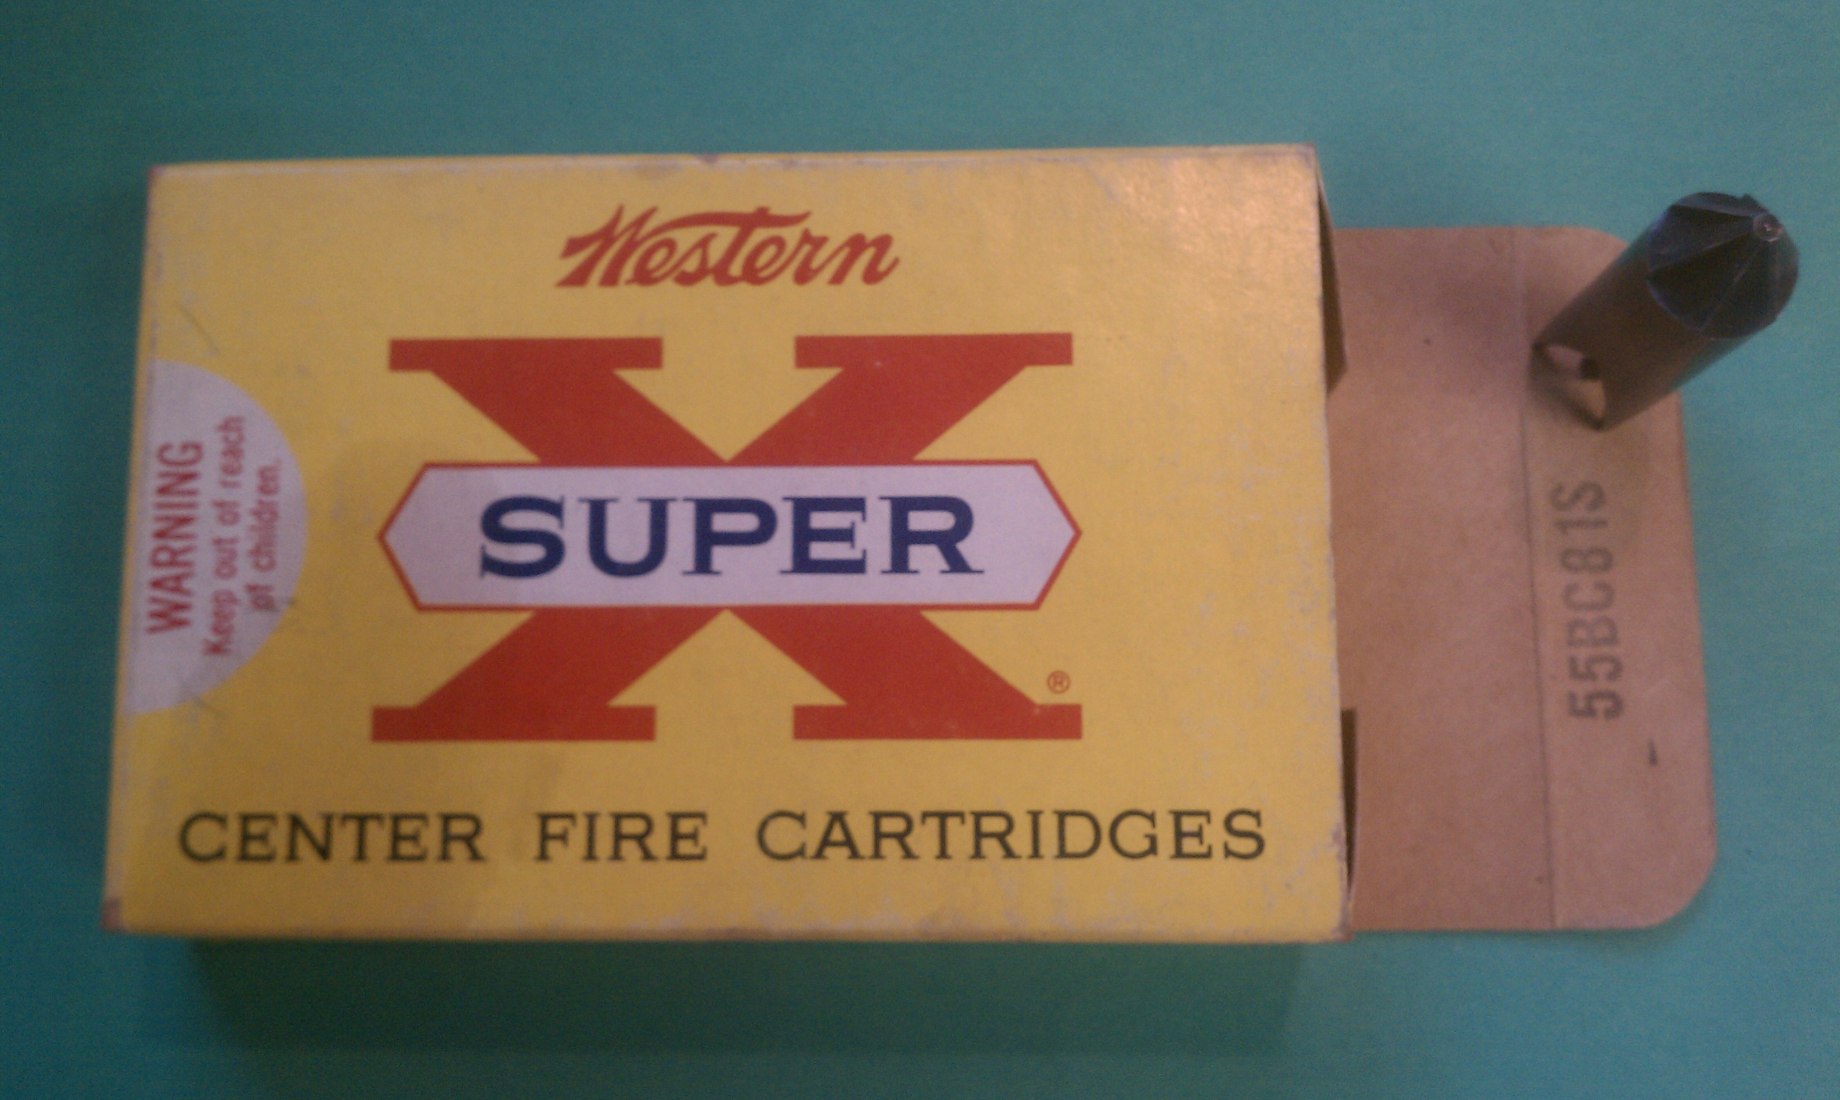

Post-1961/Has "Keep out of reach of children" warning. In lot number, BC81 equates to 18 March 1968.

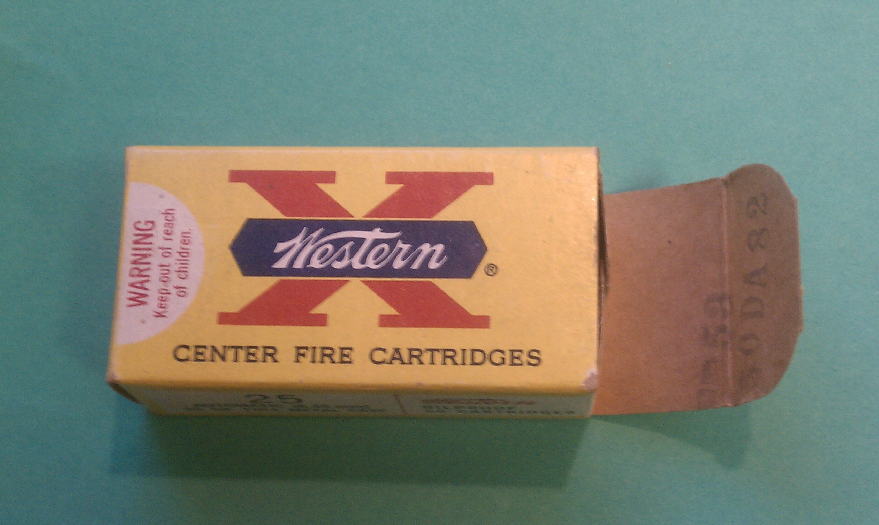

In lot number DA82 equates to 28 January 1970.

3.0 1975-1981

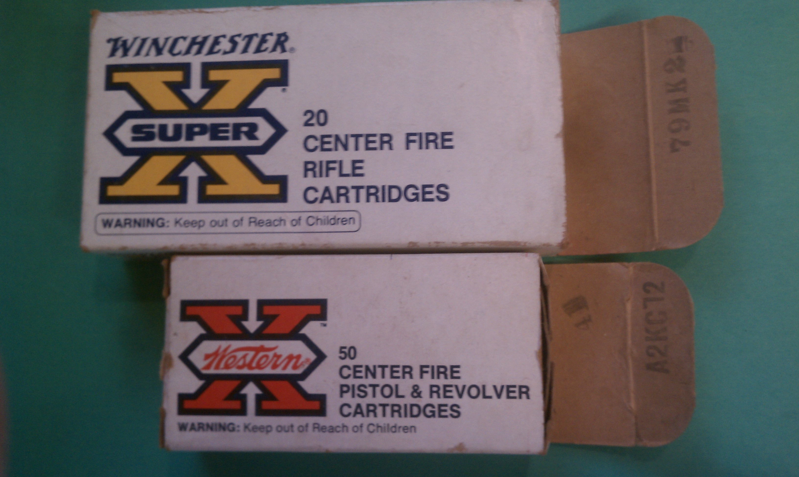

I have only three boxes from the 1975-1978 timeframe. I found no tray in the Winchester 30-30 box (top, dated 2 September 1977), and the 380 Auto ammo that came in the bottom box, dated 27 March 1975, was packed one-up-one-down in an open tray. A Western 38 Special red X box from 20 May 1978 has a plain white styrofoam tray. A collectors resource indicates the white box with yellow X was introduced in 1974 and in use until 1977 when superceded by the white box with red X , in use from 1978-1980. Considering the 1975 red X Western 380 Auto box, that resource needs review. The most recent Western box I have is from 1978 altho the last Winchester-Western catalogs in 1981 show white ammunition boxes of this style with Winchester-Western over a red X.

