4.0 1983-1996

4.1 Standard Commercial Orange-Red Banner White Box

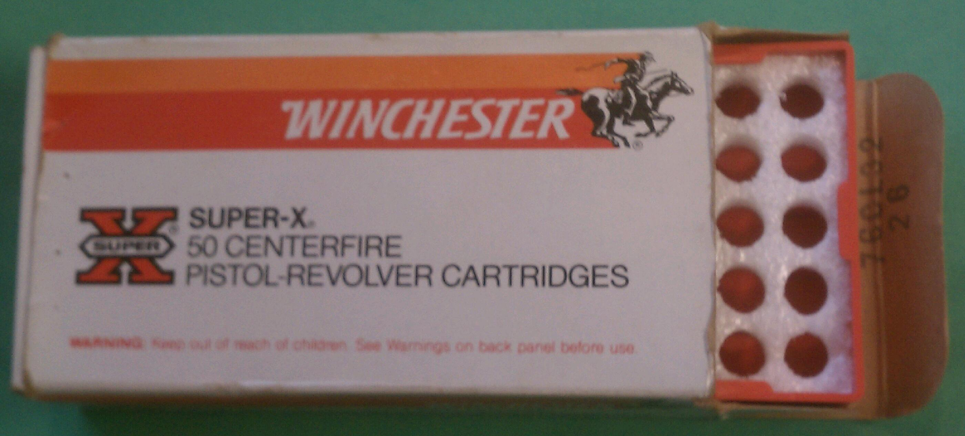

Winchester's white box with orange and red banner was produced from 1983 to 1996. Initially it had a red plastic tray with foam insert (pictured) -- the best tray ever IMHO. Later, starting sometime in 1994, pistol caliber boxes had a white paperboard tray with holes -- the worst tray ever IMHO.

4.2 Winchester Supreme Orange-Red Banner Black Box

4.2.1 Black Talon

My single Winchester Supreme/Black Talon 9mm Luger/147-gr SXT box, lot number equating to 12 October 1992. When originally recovered, it was covered in white sticky labels covering all mention of "Black Talon." The 20-round tray is black plastic with white foam insert.

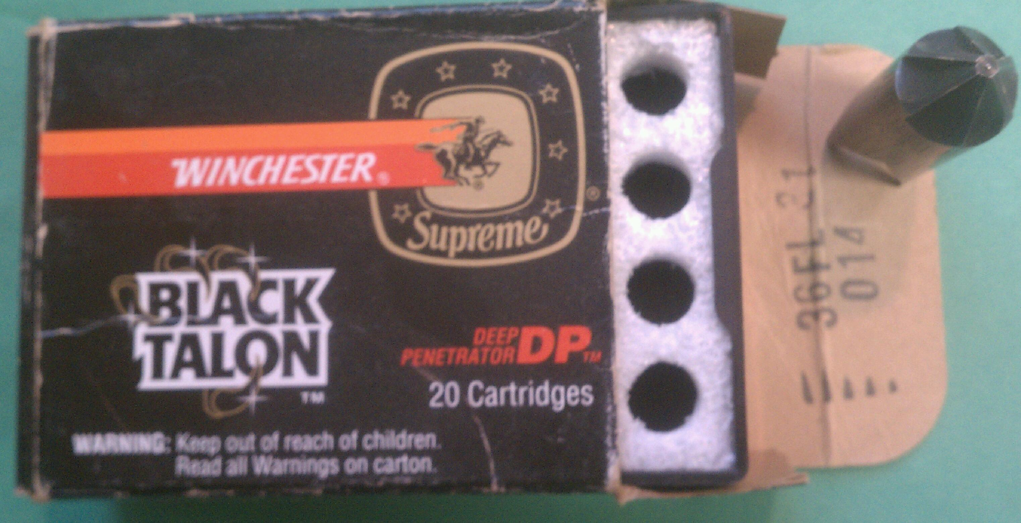

4.2.2

Another Supreme box, this one for 308 WIN. Lot number BE81 equates to 18 May 1988. It, too, has the black plastic tray with white foam insert.

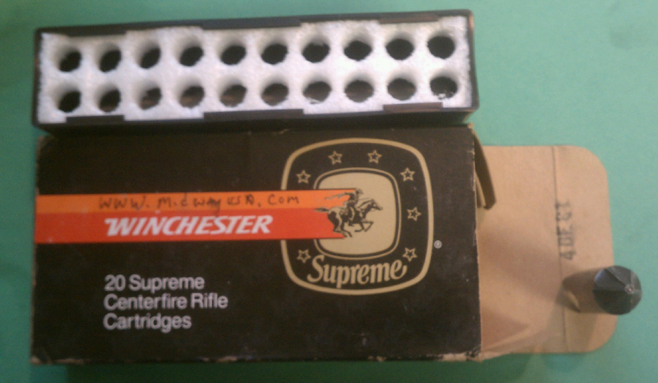WWB (Winchester White Box/Q-Line/USA-brand)

4.3 Ranger

Winchester's Law Enforcement (Ranger) ammo also came in orange-red banner boxes during this time.

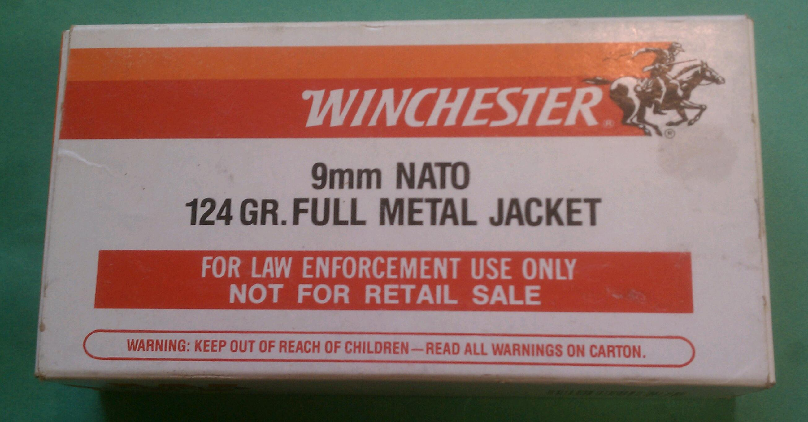

9mm Luger Ranger box with lot number 76DC70 equating to 07 March 1990.

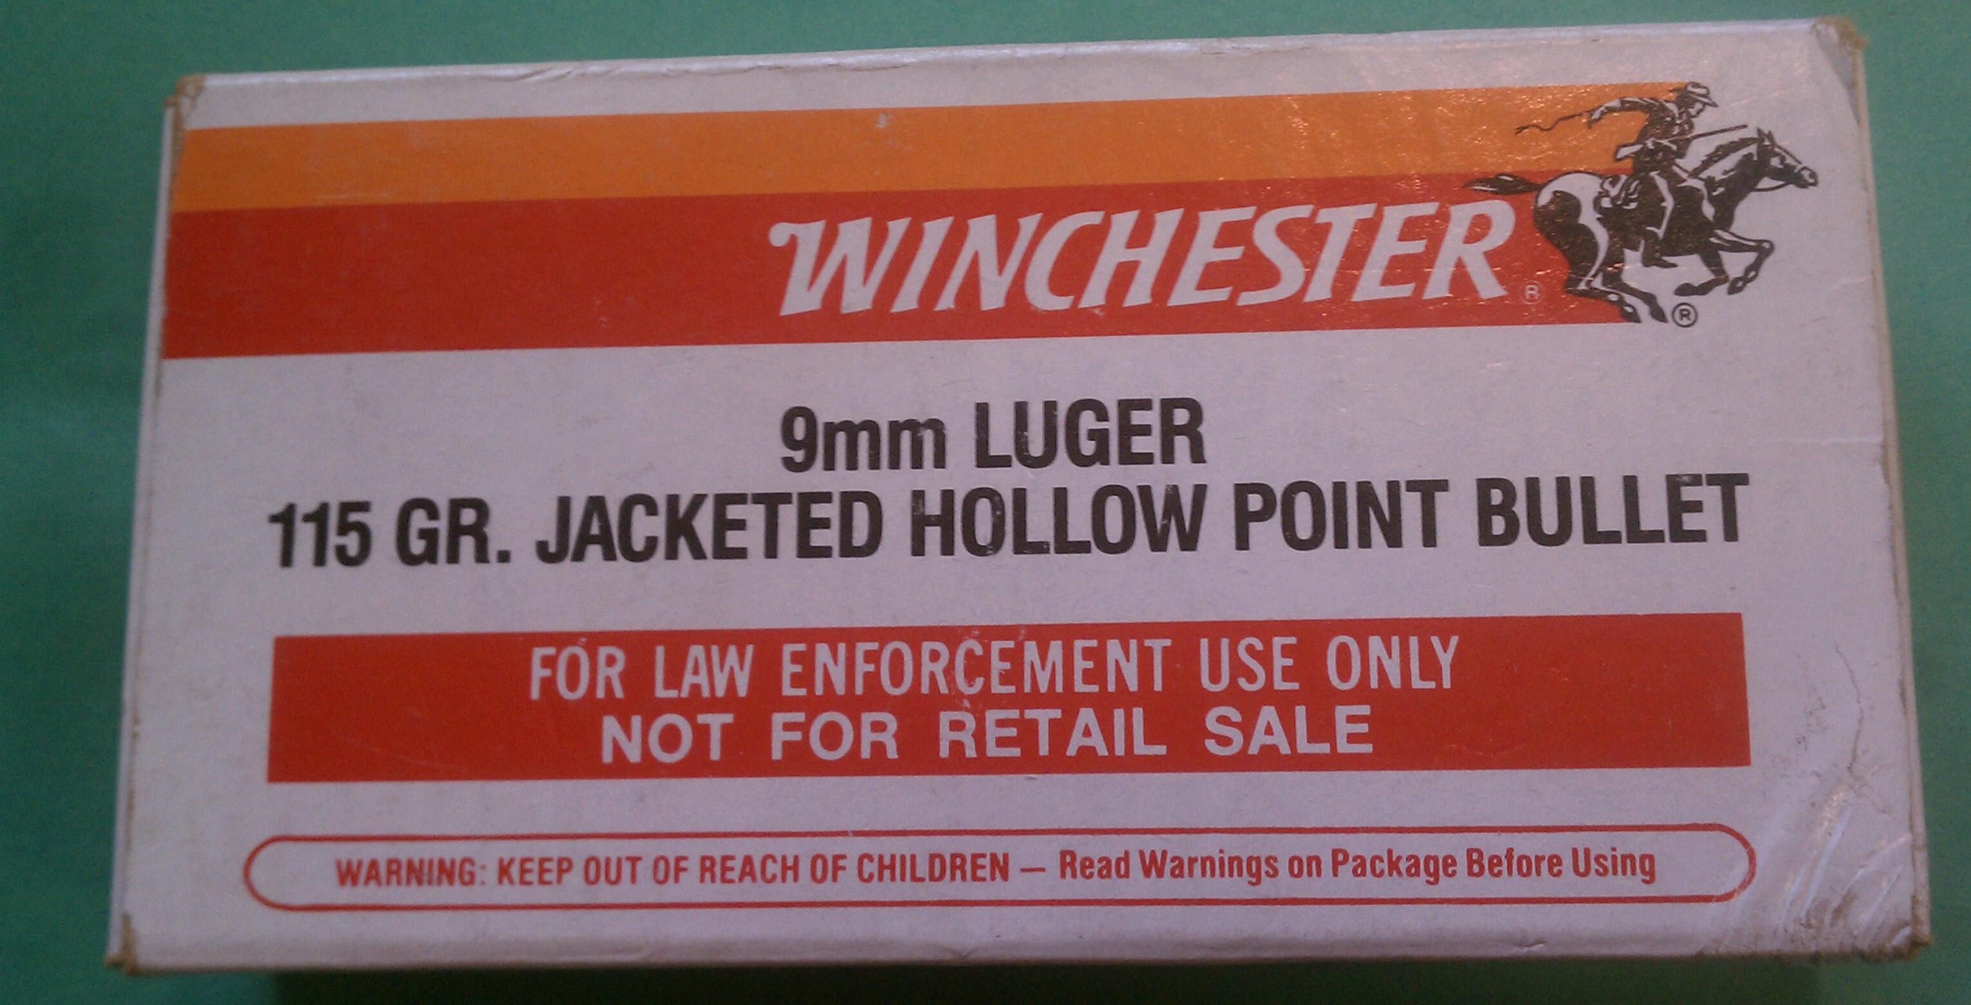

Another Ranger 9mm Luger box lot number 33GL62 equating to 26 October 1993. Both boxes contained red plastic trays with white foam inserts.

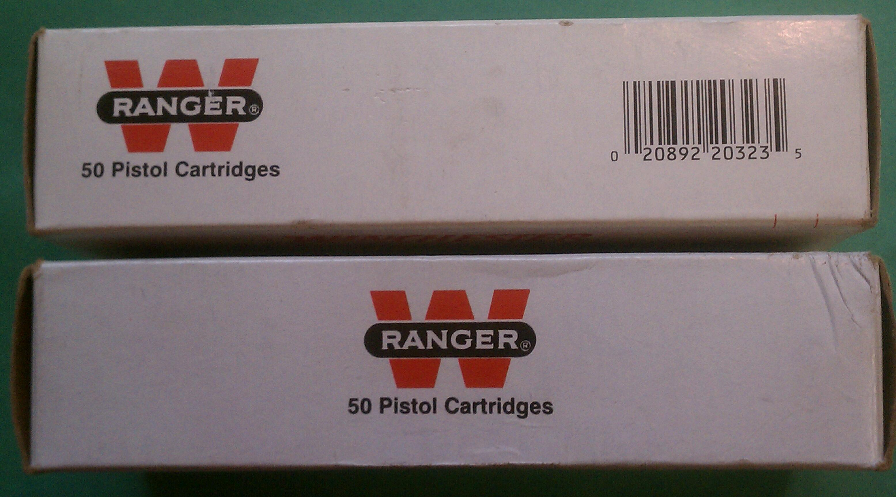

The sides of the boxes. 1993 box (top) has Ranger logo and UPC code, the 1990 box (lower) just has Ranger logo.

