4.4 Winchester White Box

4.4.1 1983-1993

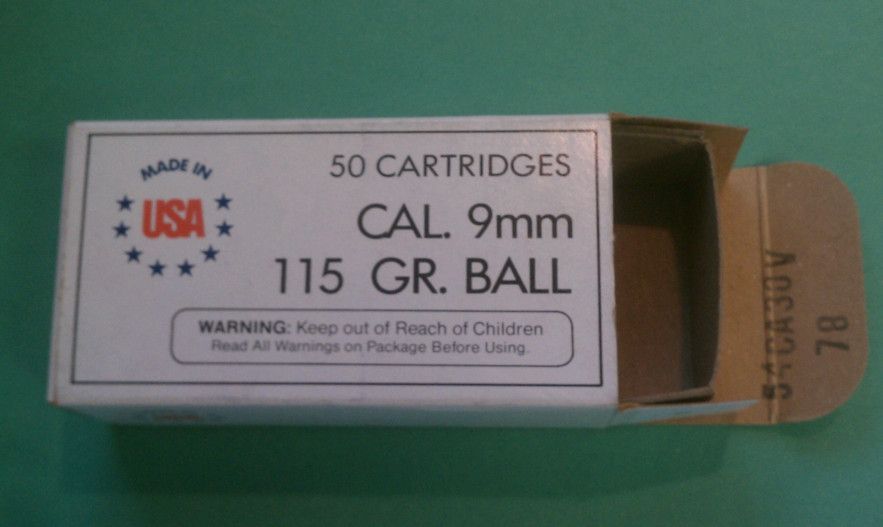

Winchester's initial Q-line (also known as WWB/Winchester White Box and USA-brand) handgun ammo was packed one-up-one-down in open trays. As you can see, the box is quite plain and lacks the Winchester brand name on top. My earliest box is from 1985 with 9mm Luger ammo headstamped WCC (over) 1985. Since I also have 9mm Luger ammo headstamped WCC (over) 1983, I assume this style goes back to 1983.

4.4.2 1994-1996

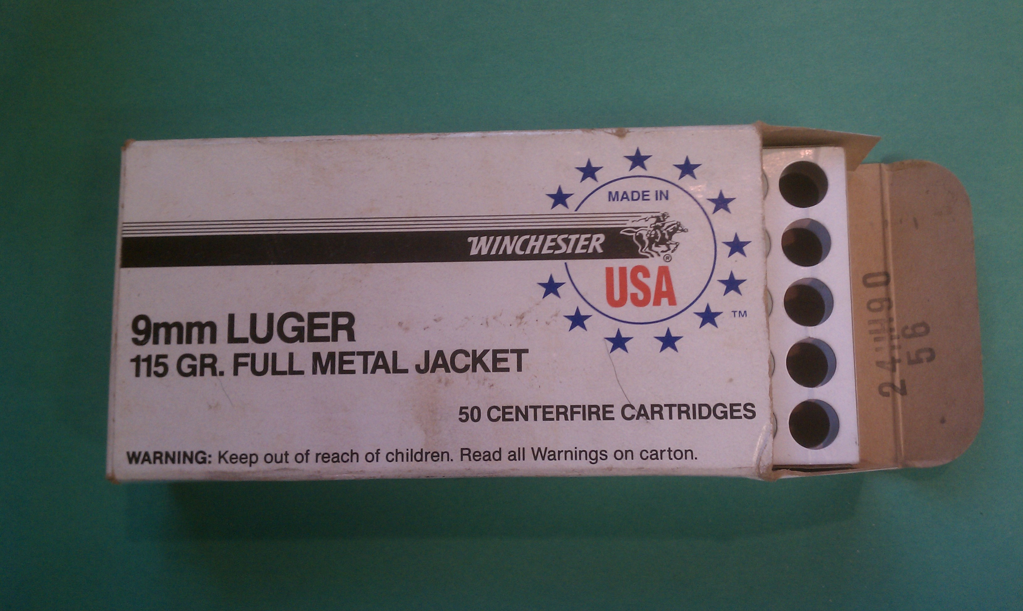

4.4.3 The White Tray

Winchester changed its WWB box style in 1994 and packed ammo in a white paperboard tray with holes (pictured above). I have, however, two 40 S&W boxes (below) from 1994 and 1995 that have white plastic trays.

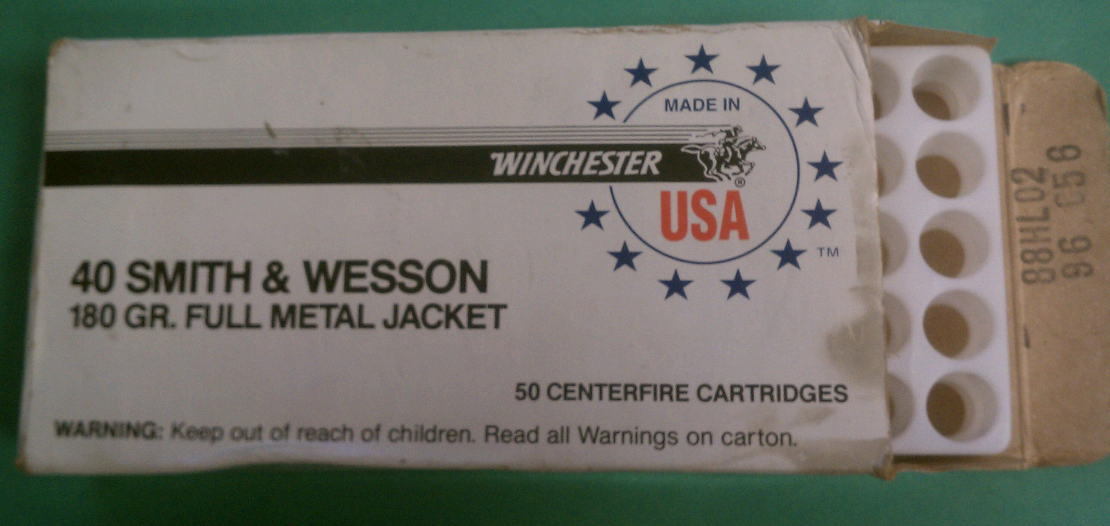

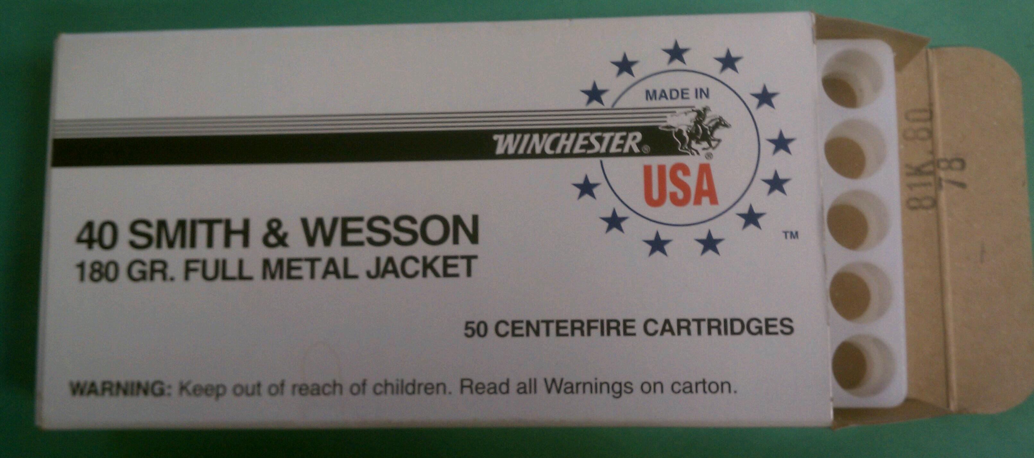

The top box, lot number HL02 equating to 20 October 1995, holds a rather fragile opaque white plastic (polystyrene?) tray which could hold either 40 S&W or 45 AUTO ammo. The bottom box, lot number KF08 equating to 08 June 1996, holds an equally fragile, more transparent, otherwise identical, white plastic tray.

5.0 1997-2011

5.1 Standard Commercial --The Plain Grey Box

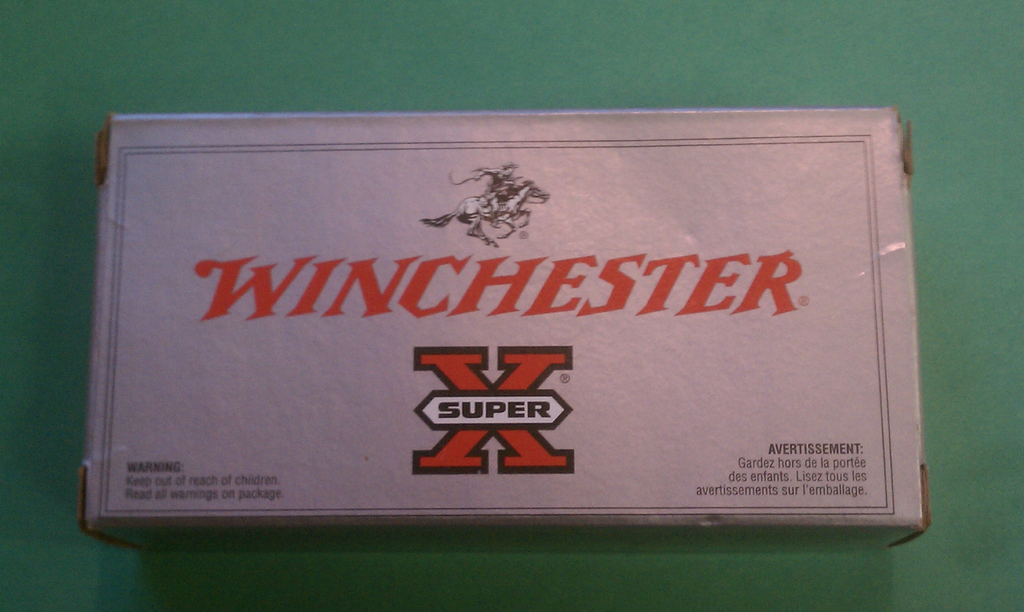

Winchester changed its standard commercial ammo box background color to grey and adopted a plain design around 1997. It also resumed using styrofoam trays, which have a green-grey tint.

5.2 Winchester Supreme Plain Black Box

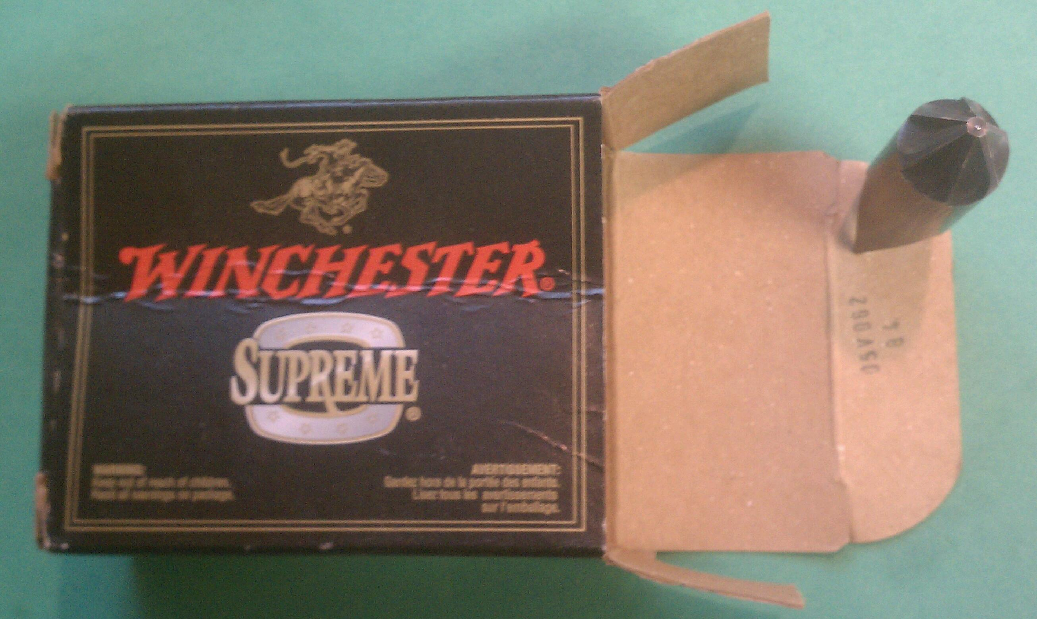

A 9mm Luger/147-gr SXT (same designator as Black Talon (above)) box with lot number equating to 25 April 2004. No cases or tray, but presume tray was styrofoam.

