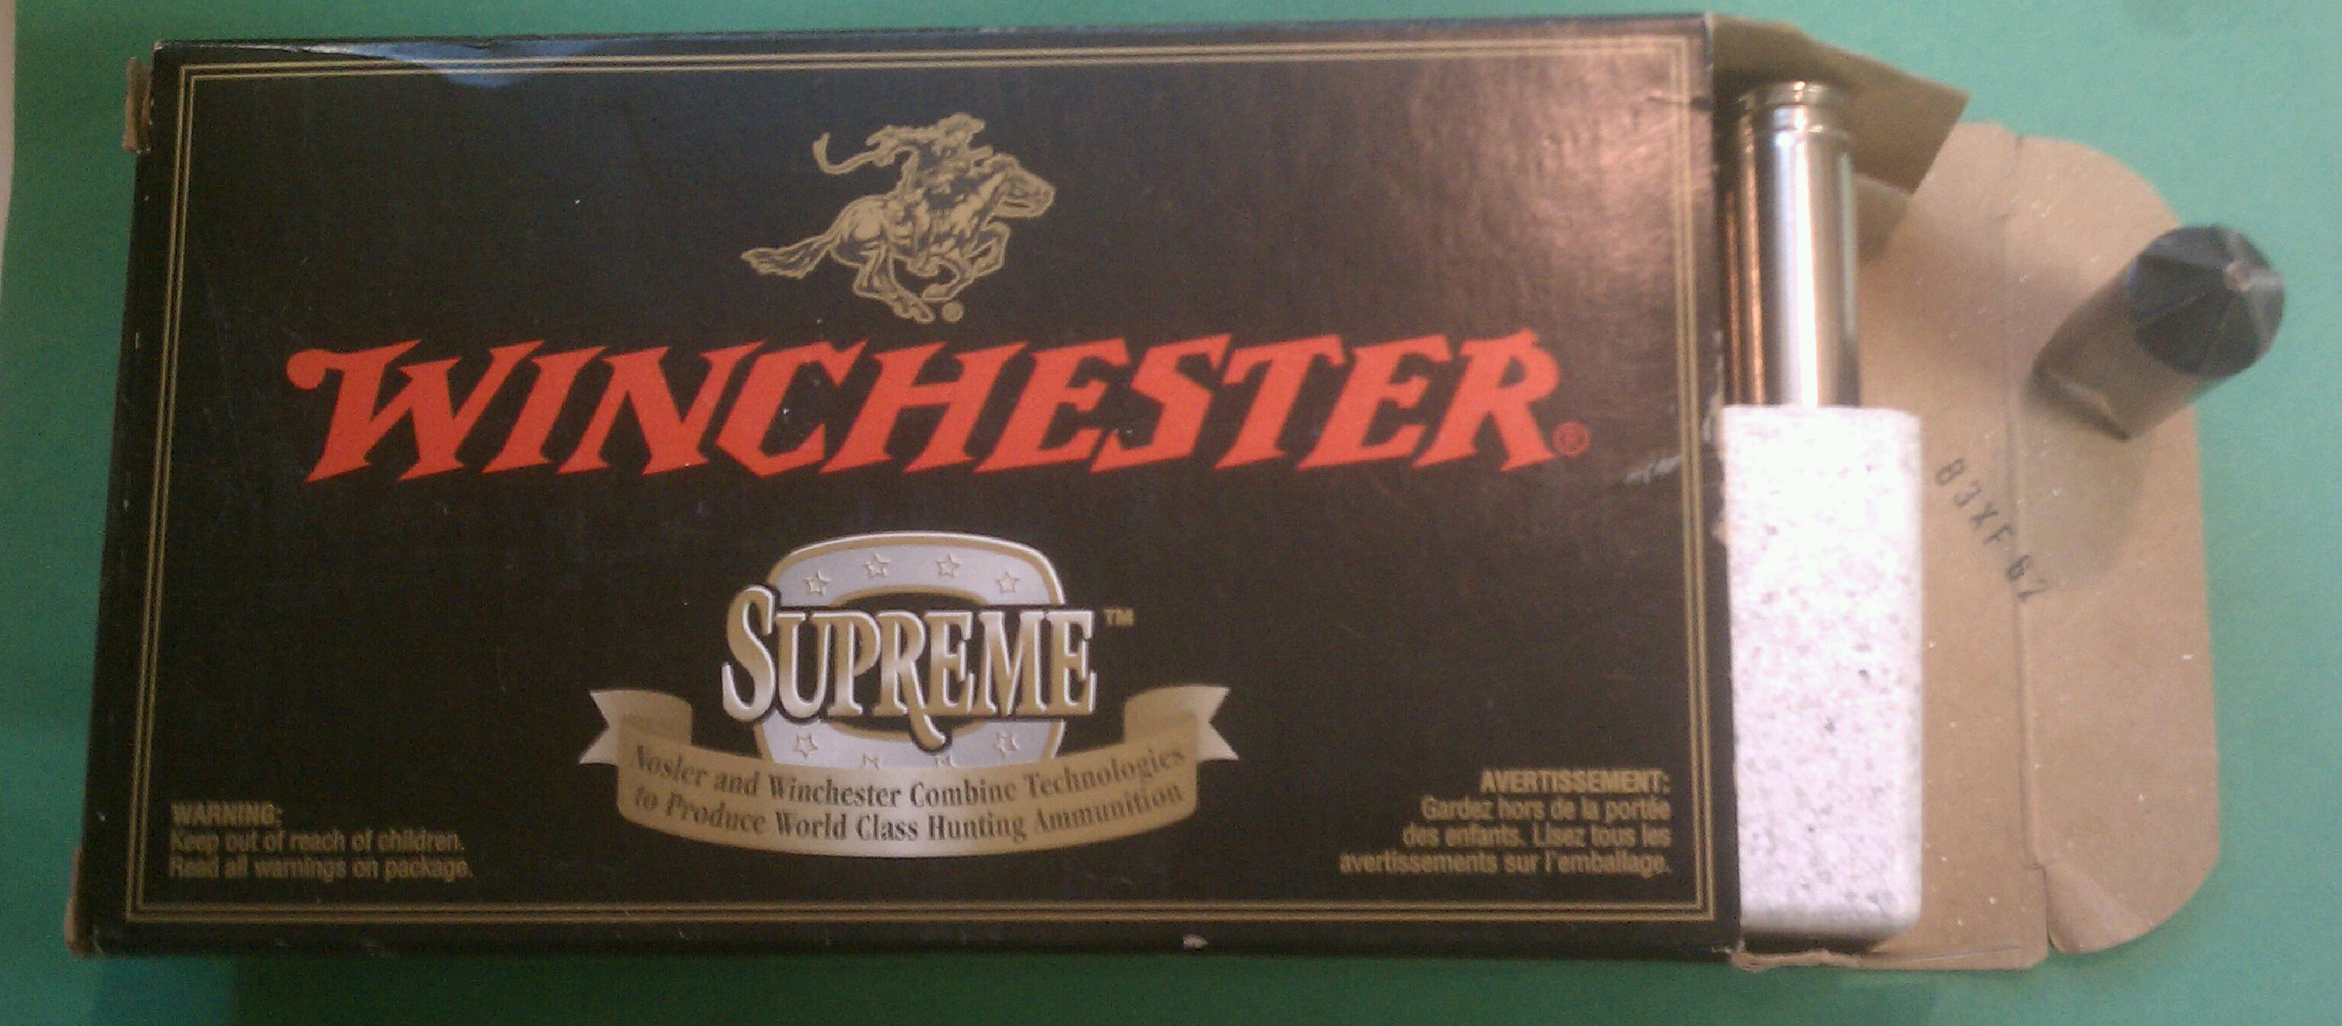

A 7mm REM MAG box with lot number equating to 26 June 2006. Nickel-plated cases headstamped W-W SUPER, styrofoam tray.

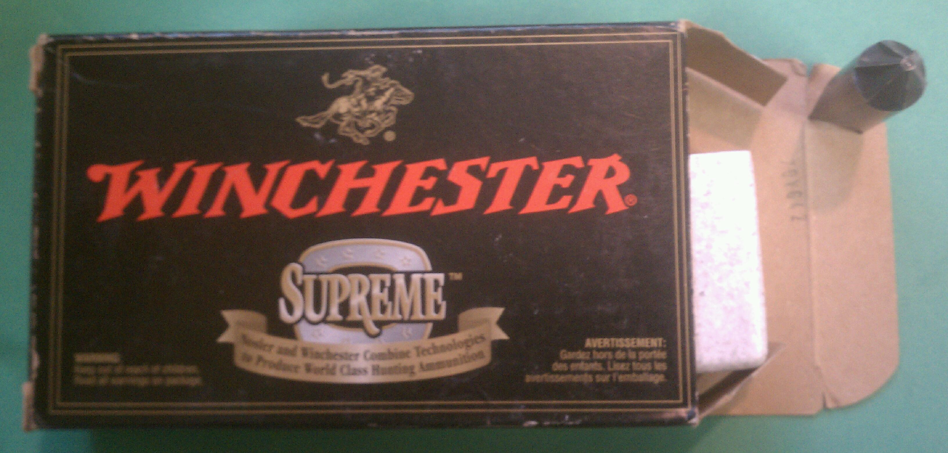

A 308 WIN box with lot number equating to 24 July 2007. No cases, but it does have a styrofoam tray.

5.3 Ranger

The design and color on the few Winchester Ranger boxes I have from this era is a radical departure from the others.

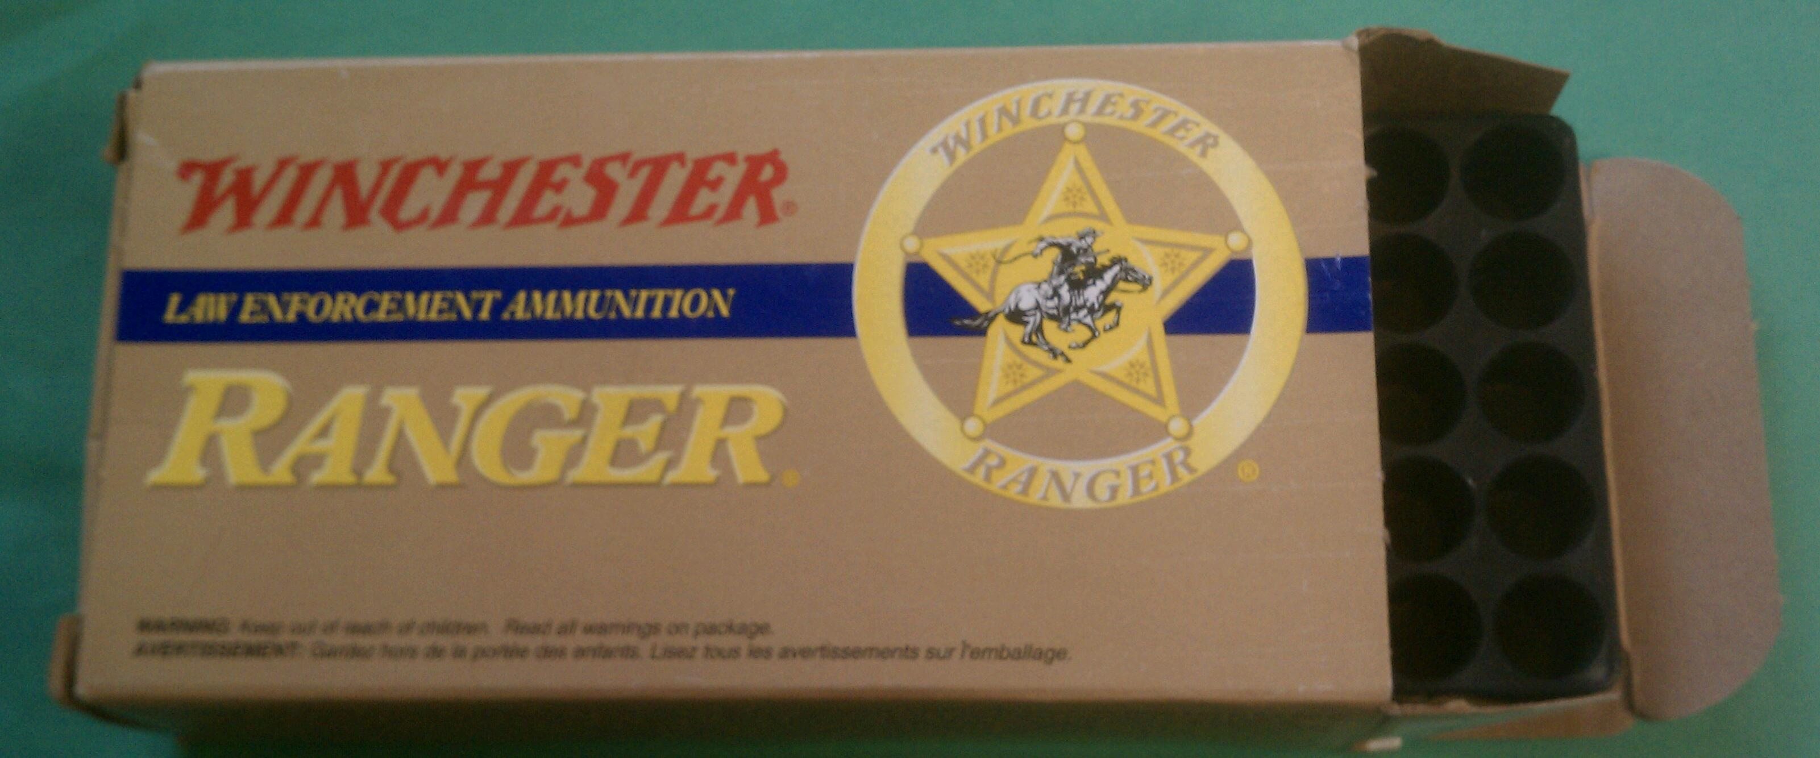

This Ranger 40 S&W box is lot number 31CB52 equating to 25 February 2009. Most Ranger boxes of this style I have seen have a styrofoam tray but a few have black plastic trays, similar to the white trays found in 1994-1995 WWB 40 S&W boxes described previously.

5.4 WWB

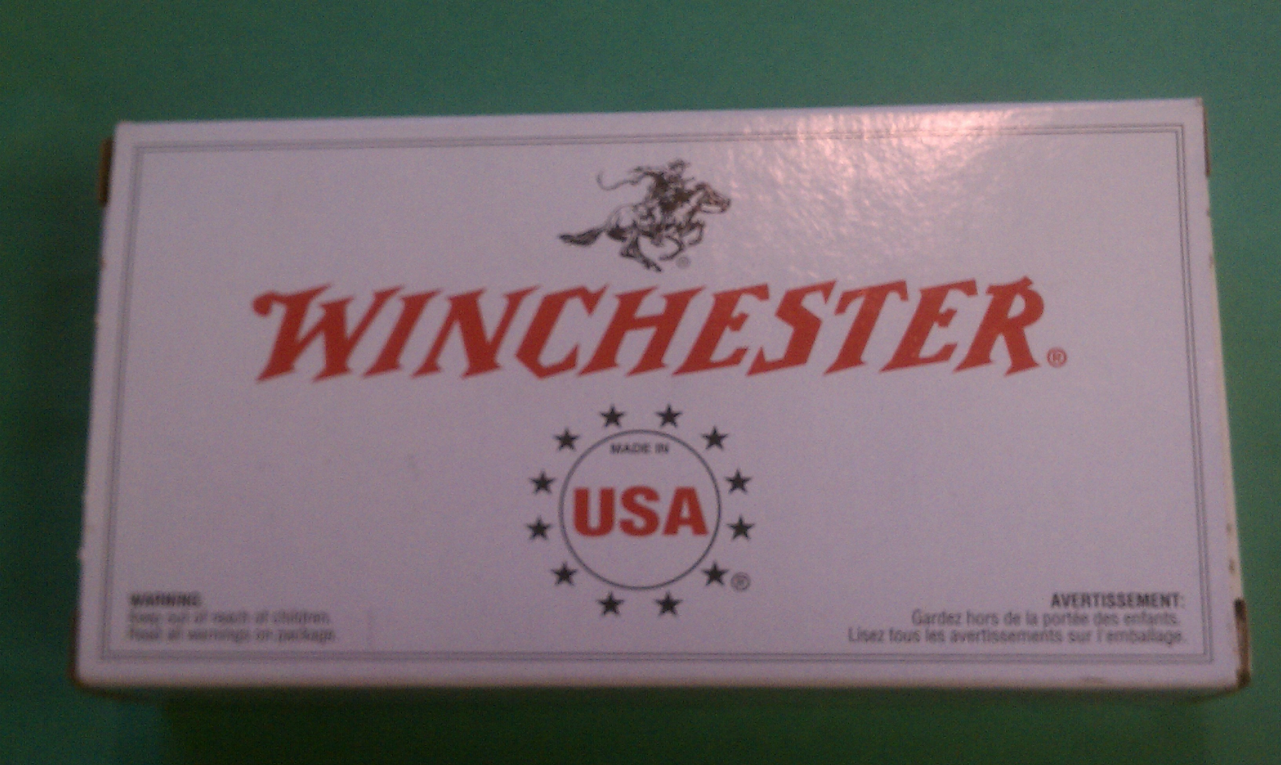

Typical WWB 1997-2011.

5.4.1 S&B-made WWB

A subset of WWB is those made in the Czech Republic by the Sellier & Bellot company for Winchester beginning about 2000. Limited calibers -- 45 AUTO and 380 AUTO is all that I've seen. Note: no "Made in USA", "Made in Czech Republic" on side of box with appropriate European proof house and C.I.P. marks, boxes the same size as S&B product with the same black plastic 25-round trays, two trays per 50-round box. Dateable only by box style as S&B's lot numbers are undeciphered.

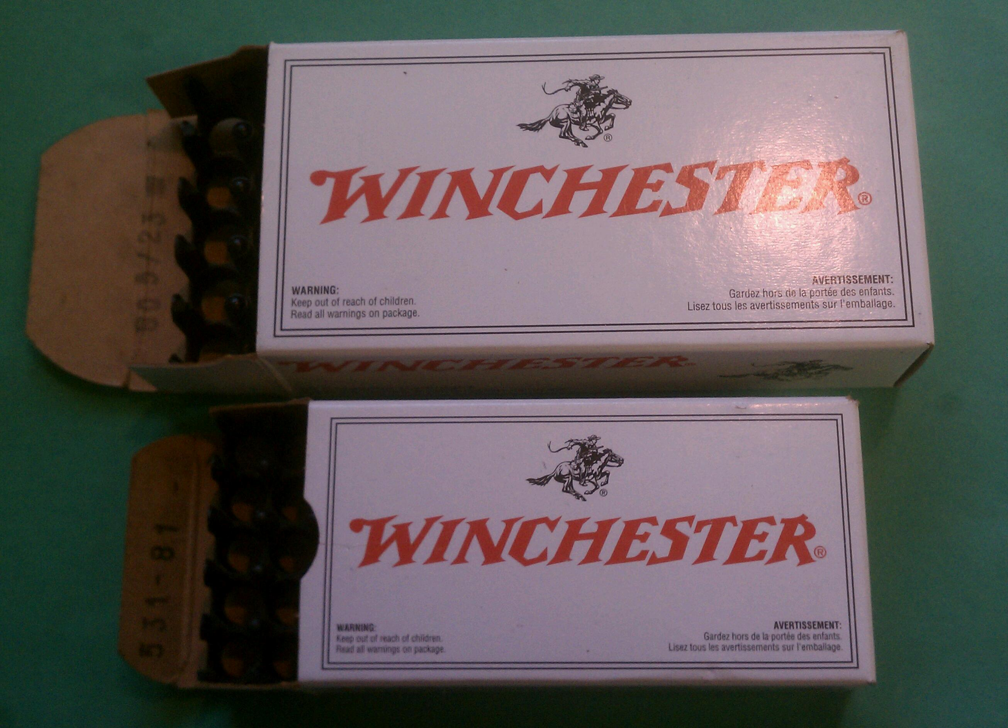

5.4 SXZ Red Box 2008-2011

Beginning in January 2008, and universally reported to be sold exclusively at BassPro, Winchester's SXZ personnel protection and SXZ training ammo comes in a red box. Calibers 380 Auto, 9mm Luger, 40 S&W, 45 Auto, 12-ga, and 410. I also remember seeing a 38 Special SXZ box.

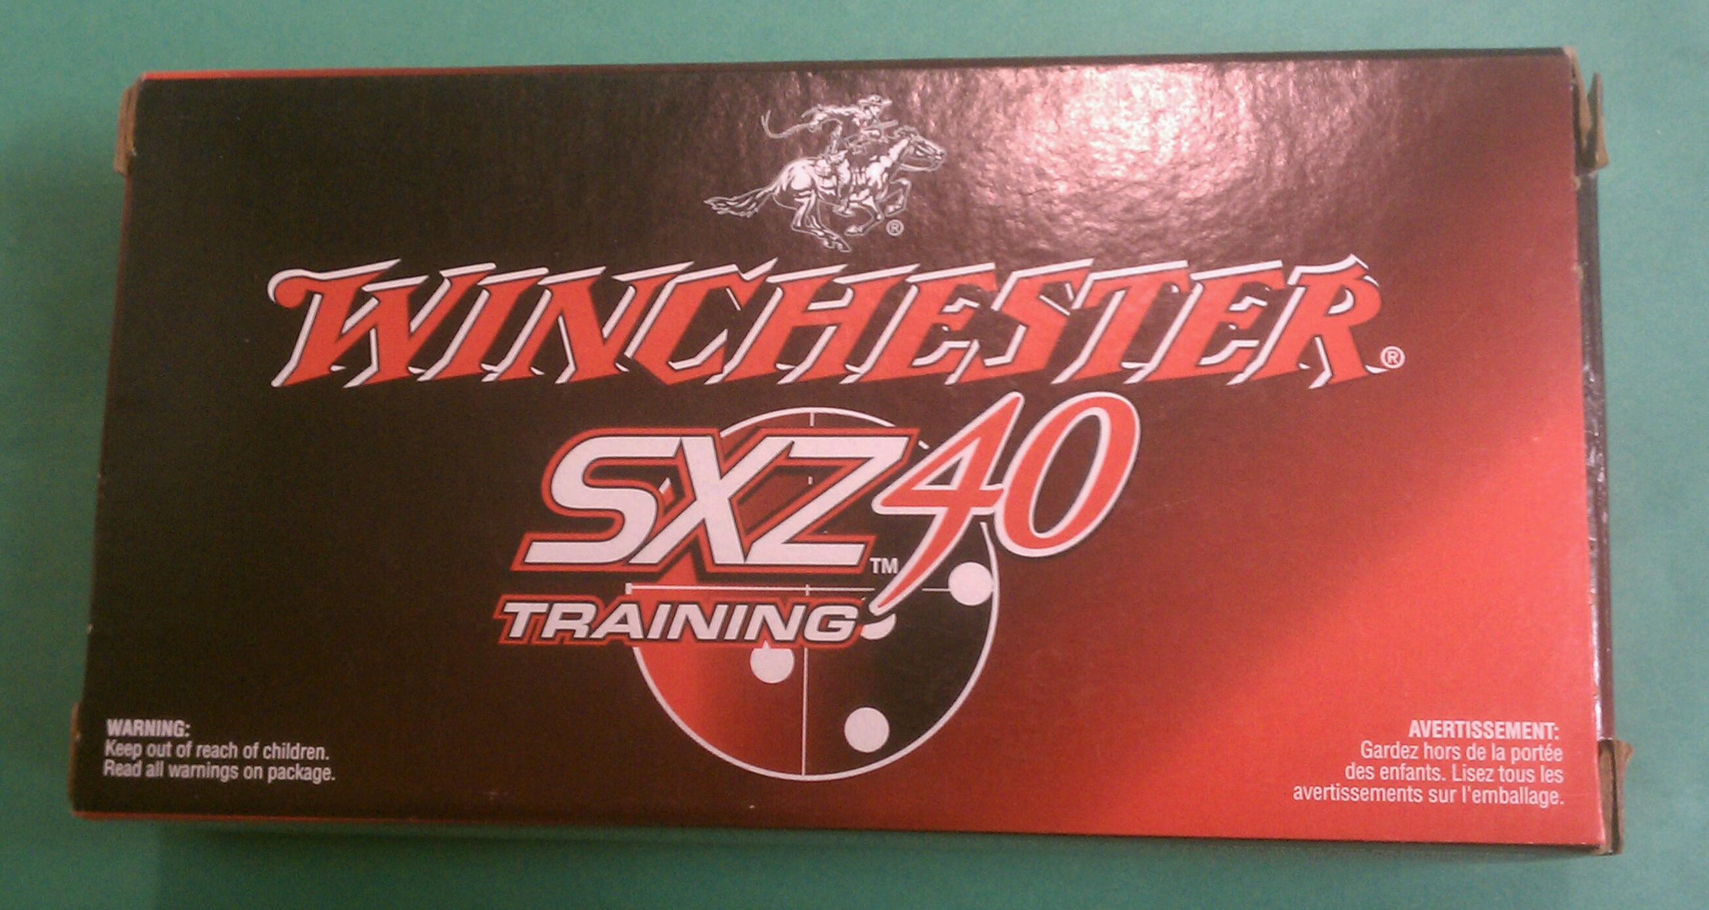

My three oldest SXZ boxes are from the 2nd, 3rd, and 4th of January 2008 and latest is from 13 April 2011

