5.5 Military boxes 1987-2012

Winchester's military boxes for 9mm Luger haven't changed much between 1987 (top) and 2012 (bottom). Interestingly, the top box was produced by the RockTenn Company -- the same company that has produced Remington boxes and trays for decades -- and contains the same white styrofoam tray found in Remington 38 Special boxes of that time.

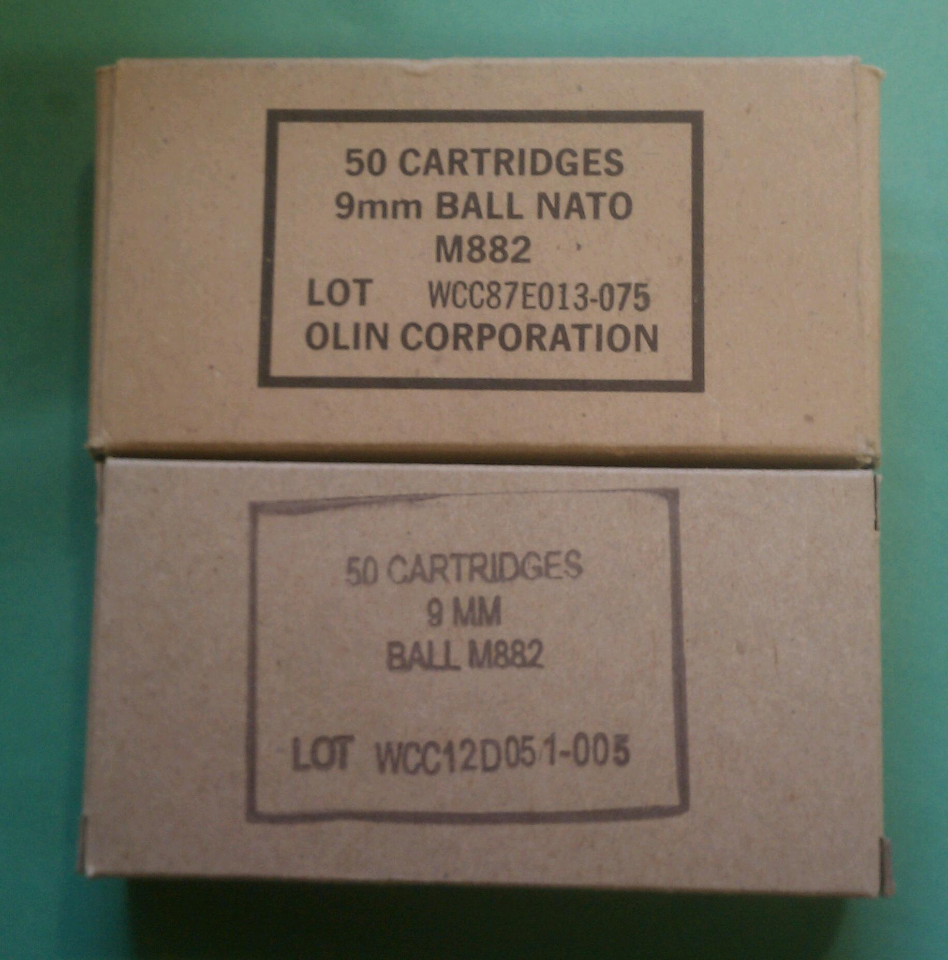

6.0 2011-Present

6.1 Standard Commercial -- The New Grey Box.

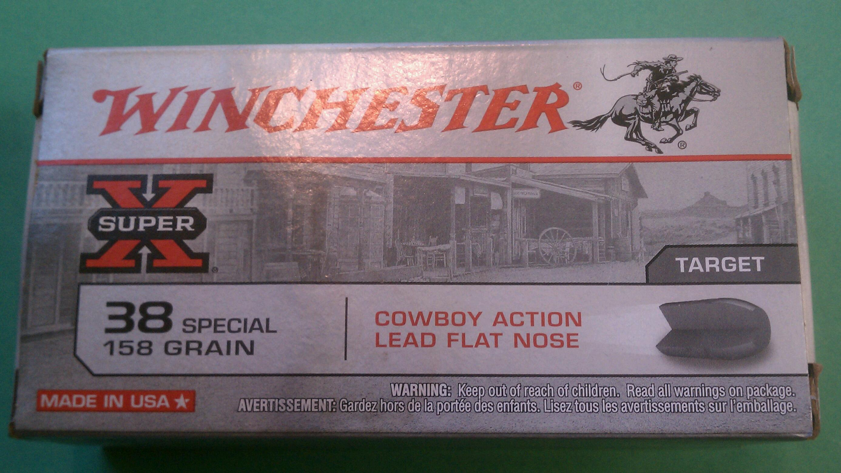

Printing of Winchester's new design grey box began in mid-2011. Winchester continued using styrofoam trays.

6.2 WWB

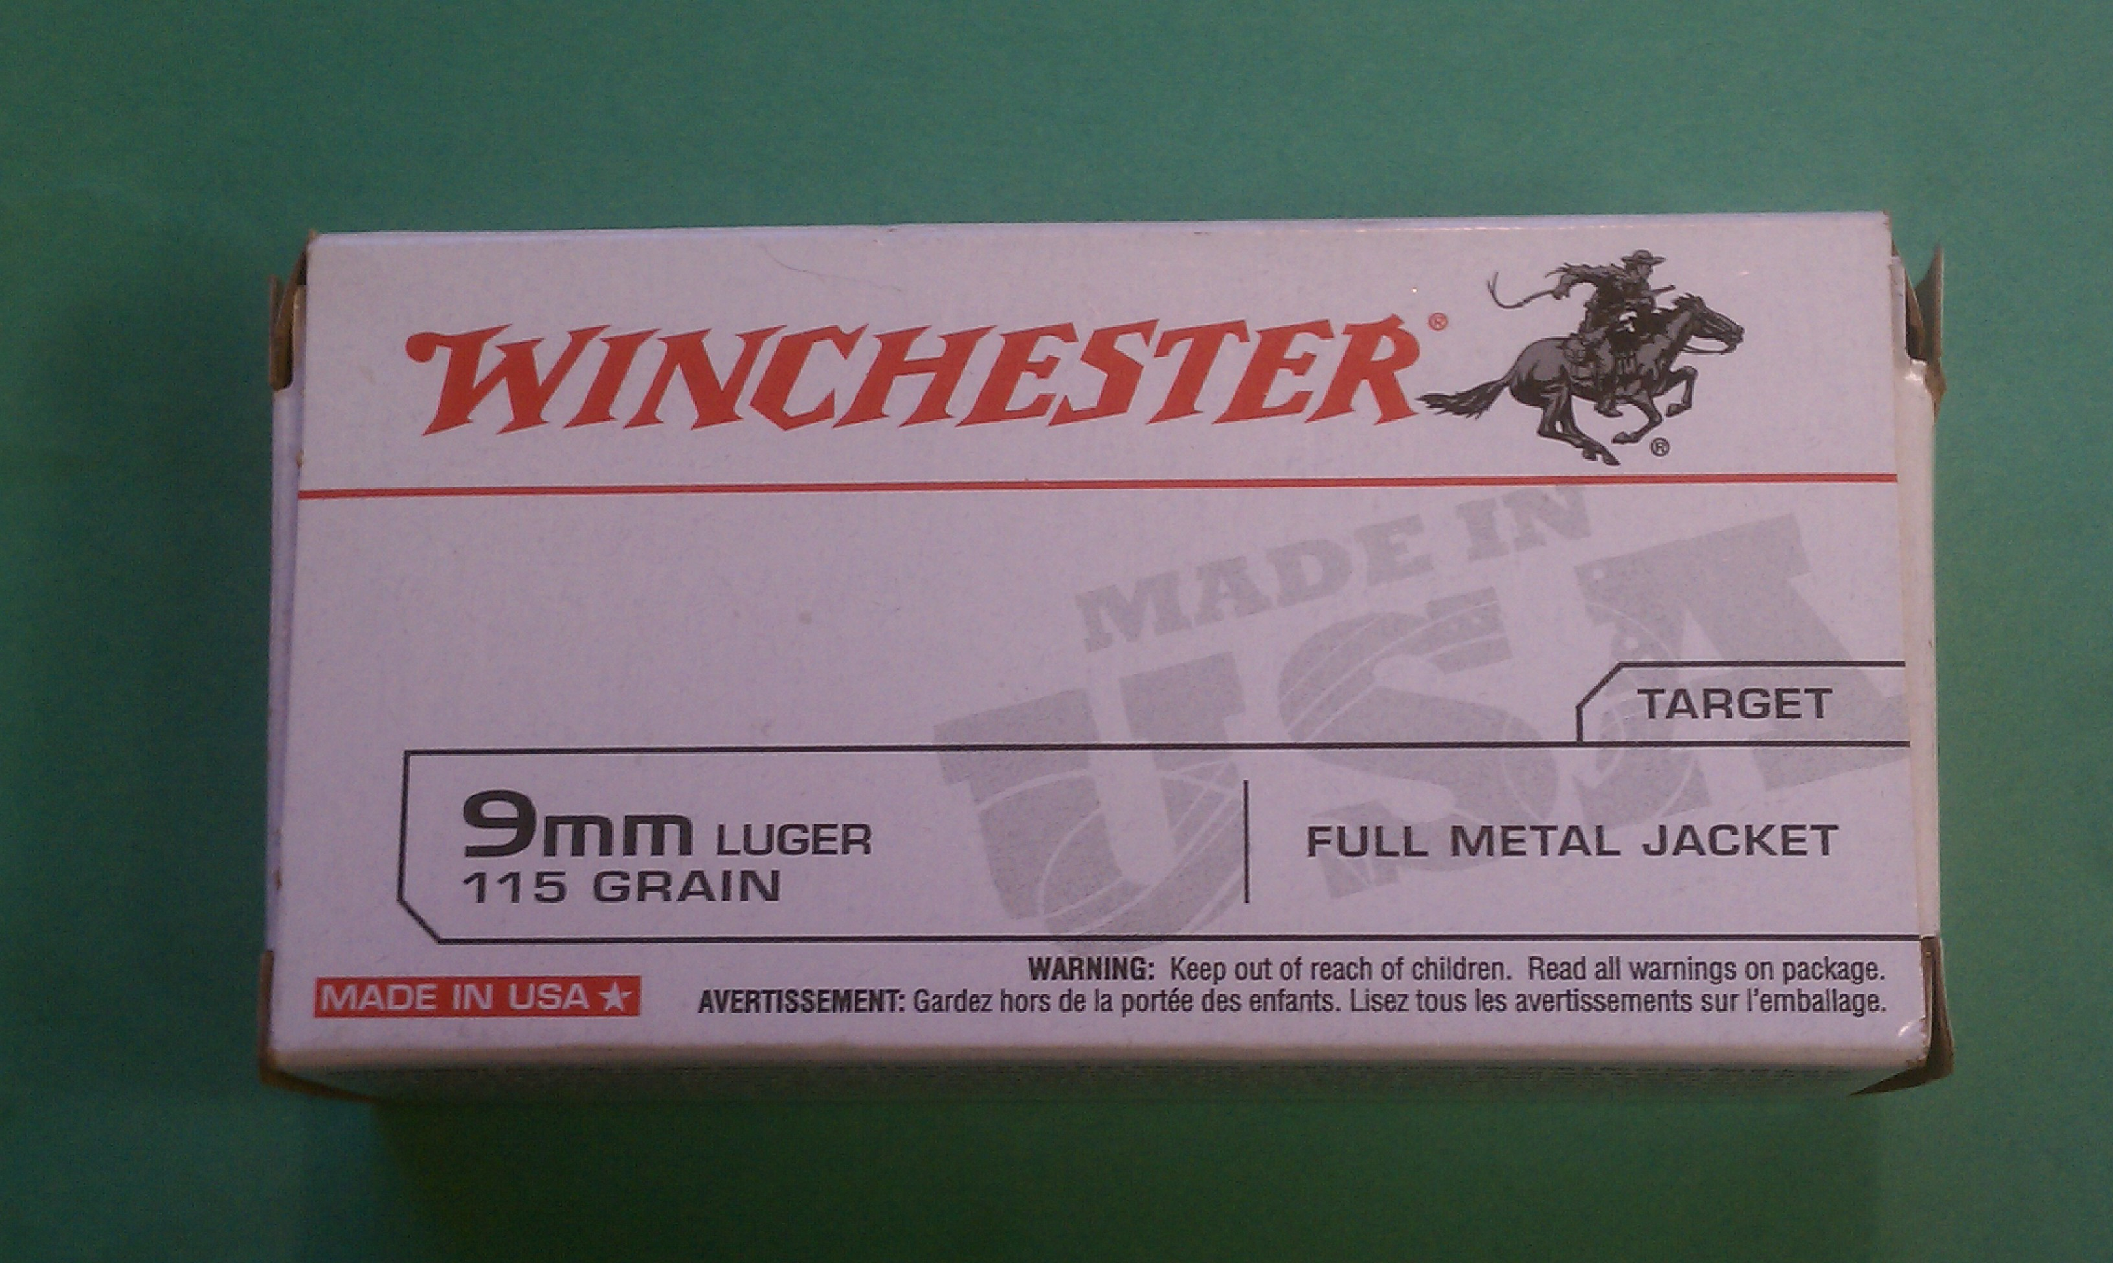

6.2.1 S&B-made WWB/WWB Metric Calibers

Not only made in 45 AUTO, also made in former-Soviet Union calibers like 9x18mm Makarov, 7.62x25mm Tokarev, and 7.62x54mm Russian. Note: S&B color-coded trays, green for 9mm Makarov, grey for 7.62x25 Tokarev. No "Made in USA" but "Made in Czech Republic" on side of box.

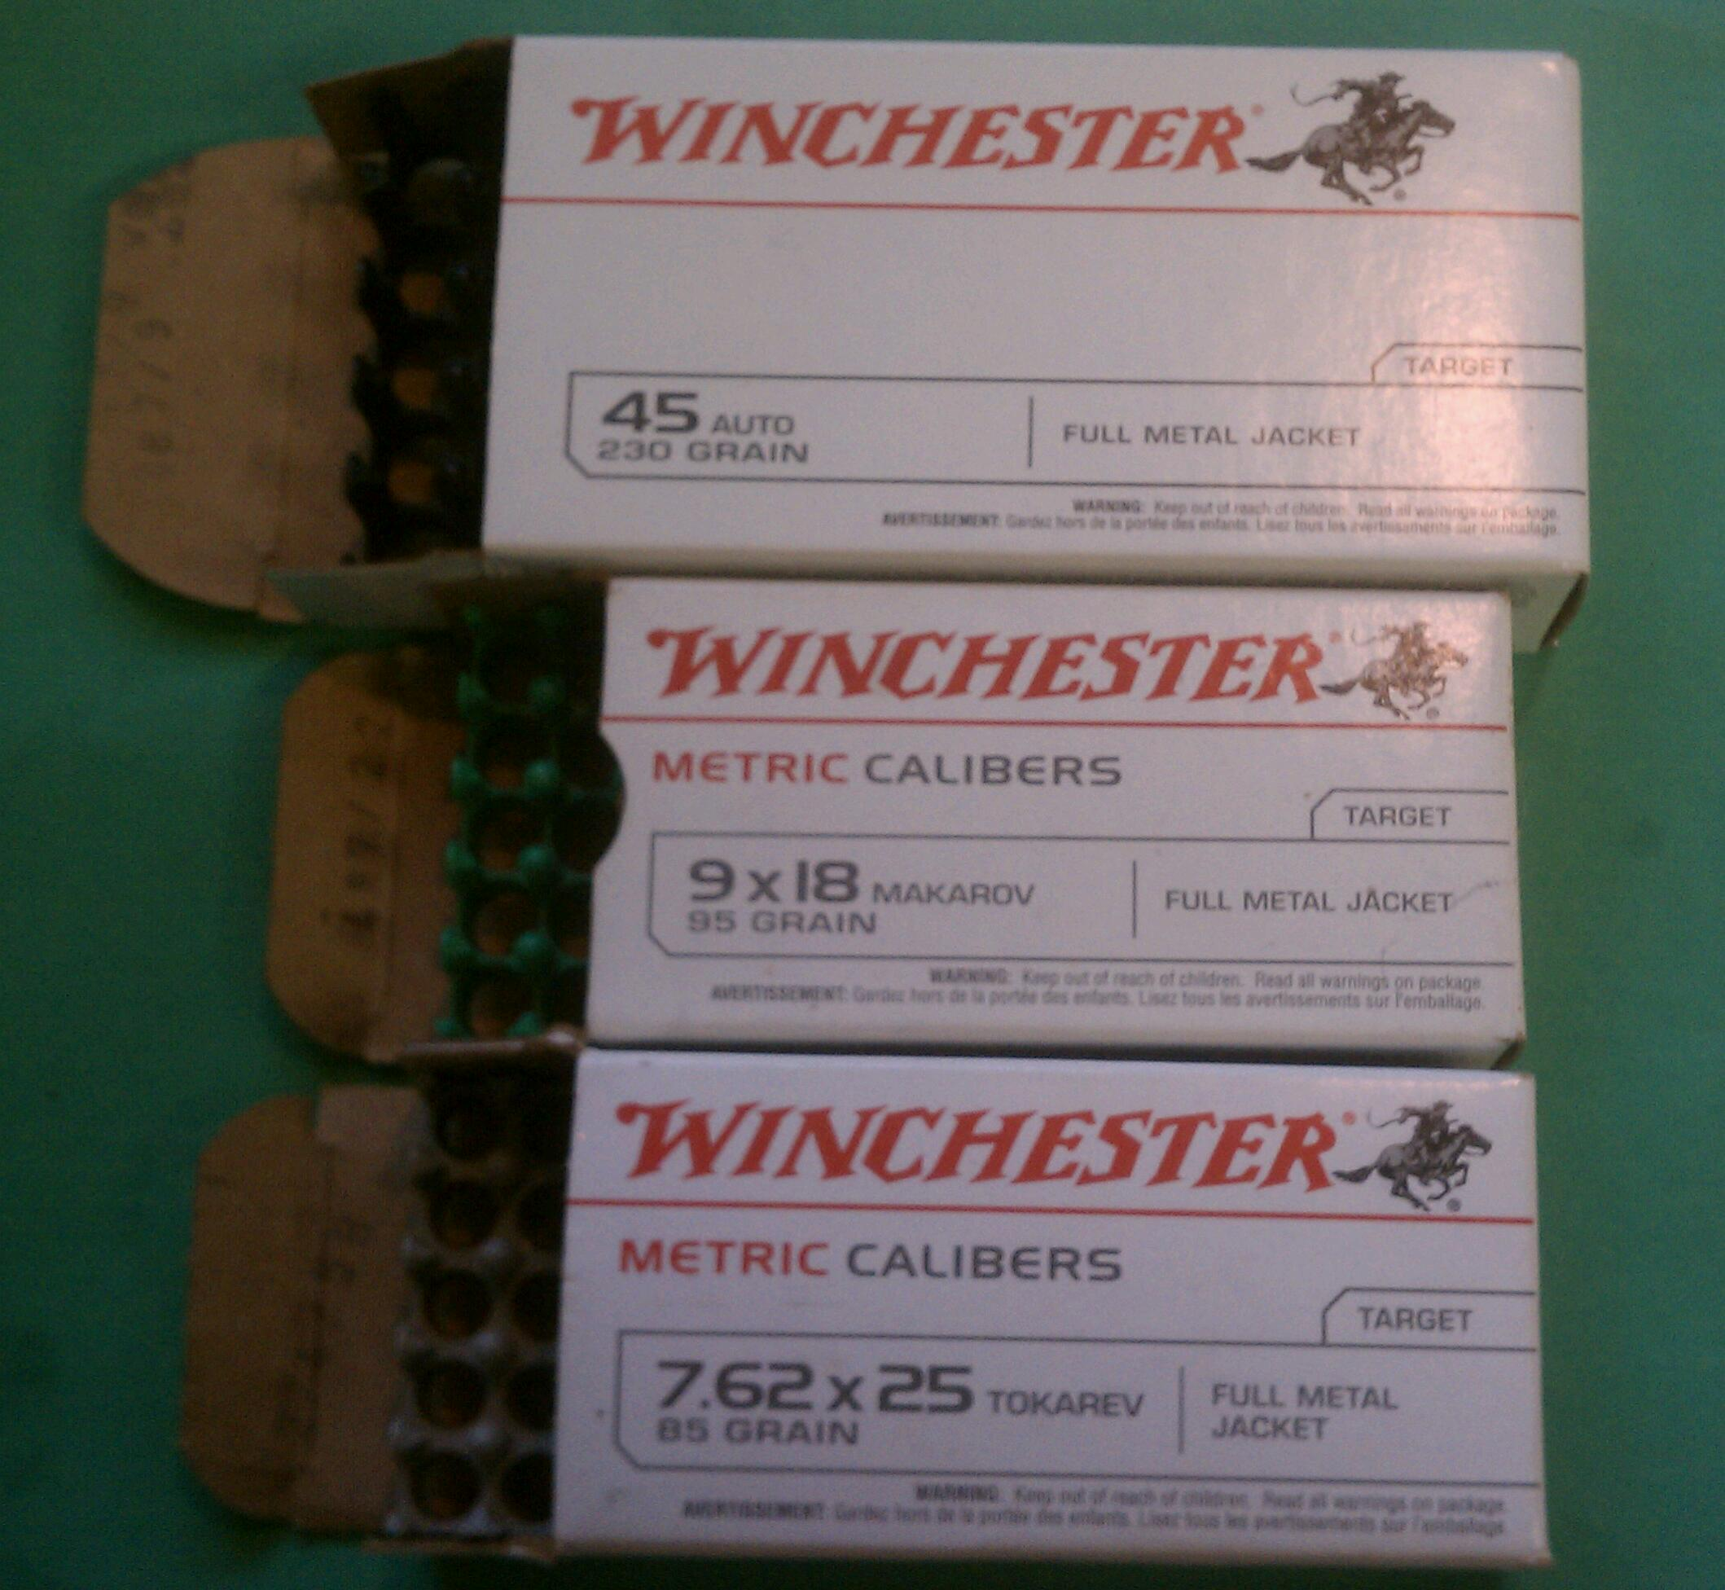

6.3 SXZ

Recent ads show an updated SXZ red box similar to the 2011-present new grey and latest WWB box design, but I don't have any.

