System Requirements Specification

for

AutoPen

**Version 4.1 Approved**

**Prepared by Michael Allen**

**AutoPen**

**11/21/2023**

**Table of Contents**

**Revision History** iii

**1. Introduction** 1

1.1 Purpose 1

1.2 Document Conventions 1

1.3 Intended Audience and Reading Suggestions 1

1.4 Product Scope 1

1.5 References1

**2. Overall Description** 2

2.1 Product Perspective 2

2.2 Product Functions 2

2.3 User Classes and Characteristics 2

2.4 Operating Environment 2

2.5 Design and Implementation Constraints 3

2.6 User Documentation 3

2.7 Assumptions and Dependencies3

**3. External Interface Requirements** 4

3.1 User Interfaces 4

3.2 Hardware Interfaces 4

3.3 Software Interfaces 5

3.4 Communications Interfaces5

**4. System Features** 5

4.1 System Feature: Automated Penetration Testing 5

4.2 System Feature: User Profile Management6

**5. Other Nonfunctional Requirements** 7

5.1 Performance Requirements 7

5.2 Safety Requirements 7

5.3 Security Requirements 7

5.4 Software Quality Attributes 8

5.5 Business Rules 8

**6. Other Requirements** 9

**Appendix A: Glossary** 9

**Appendix B: Analysis Models** 10

**Appendix C: To Be Determined List** 12

# 

# Revision History

|  |  |  |  |
| --- | --- | --- | --- |
| **Name** | **Date** | **Reason For Changes** | **Version** |
| Michael Allen | 9/21/23 | Section 1 and 2 | 1.0 |
| Michael Allen | 9/26/23 | Section 4 and 5 | 1.1 |
| Michael Allen | 9/28/23 | Section 3 and 6 | 1.2 |
| Caleb Hall | 9/29/23 | Editing and formatting | 1.3 |
| Myles Scott | 10/26/23 | Changes to reflect design modifications | 2.0 |
| Caleb Hall | 10/31/23 | Editing | 2.1 |
| Michael Allen | 10/31/23 | Editing | 2.1 |
| Myles Scott | 11/21/23 | UI Screen | 3.1 |
| Caleb Hall | 11/21/23 | System diagram, operating environment, editing | 3.2 |
| Joshua Buscher | 2/5/24 | Updating for second semester | 4.0 |
| Caleb Hall | 2/5/24 | Editing, applying change in scope | 4.1 |

# Introduction

## Purpose

The purpose of this product is to provide an interface to allow users to apply penetration testing to their website in order to locate possible vulnerabilities in design. This SRS covers both the integrated testing suite and the website that will be used to access said application.

## Document Conventions

1. The document will be in Times New Roman size 12 font.
2. The requirements have their own authority.

## Intended Audience and Reading Suggestions

This documentation on AutoPen is designed specifically for web developers and web testers as users of this system.

The rest of the document is organized as follows. Section 1 provides an initial overview of the document, explaining its purpose, conventions, and scope. Section 2 delves into a comprehensive understanding of the product, its functions, characteristics, and constraints. Section 3 details the specifications for how the system interacts with its users, hardware, other software, and communications networks. Section 4 describes individual features or functionalities of the system in depth. Section 5 enumerates the system's performance, safety, security, quality, and business rules ensuring it meets established standards and stakeholder expectations. Section 6 contains additional information in appendixes.

## Product Scope

With the need for stronger, faster security with the increase of cybersecurity threats, AutoPen aims to revolutionize the field of penetration testing by leveraging BurpSuite to conduct automated, comprehensive penetration tests. The primary objective is to provide businesses and organizations with a quick, cost-effective and thorough way to identify and rectify potential vulnerabilities in their networks and systems.

## References

* The URL of the web application is https://www.autopentest.net/
* Jira site for agile sprint planning can be found at: <https://autopentest.atlassian.net/jira/software/projects/PEN/boards/1>
* Documentation for BurpSuite, the APT used to run penetration testing, can be found at: <https://portswigger.net/burp/documentation>
* Github for the project can be found at: <https://github.com/Caleb-Hall-1015/AutoPen>

# Overall Description

## Product Perspective

The integration of automated penetration testing represents a new paradigm shift in the field of cybersecurity. By replacing manual systems and innovating with advanced technologies, organizations can enhance their security posture, reduce vulnerabilities, and stay ahead of potential cyber threats. The increased efficiency, accuracy, and scalability offered by automated penetration testing make it an indispensable tool in today's digital landscape. Embracing automation in penetration testing is not only a step towards better security but also a strategic investment in the long-term success and resilience of an organization's IT infrastructure.

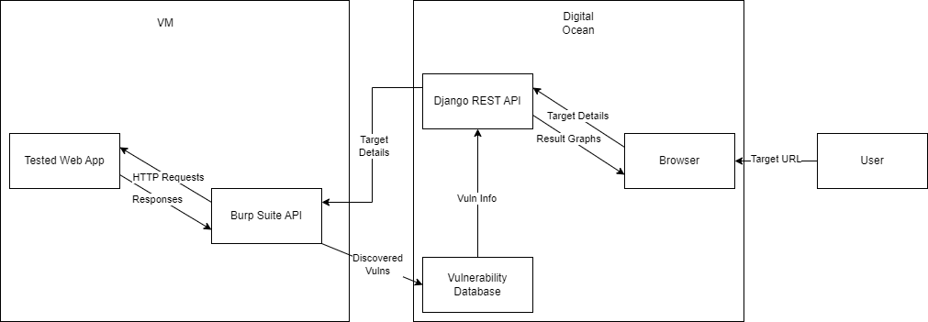

**Figure 1: System Diagram**

## Product Functions

1. The product must allow users to test a website for vulnerabilities
2. The product must be a functional website, allowing any user to visit using the internet

## User Classes and Characteristics

The users fall into two categories: end user and internal developer. End users are the web app developers who are testing their own site. Internal developers are AutoPen employees. End users only have read/write permissions on their own profiles, while internal developers have admin access across the site. Both classes are equally important to satisfy.

## Operating Environment

To effectively utilize the required system, the user must have the following operating environment:

1. Any form of computer that can run a web page
   1. Windows, Apple, or Linux Desktop/Laptop
   2. Android or Apple Mobile Smartphone
2. Stable Internet Connection
   1. At least 1 Mb/s
3. Up-To-Date Website/Web Browser
   1. Latest version of Chrome, Firefox, Safari, or equivalent browser

## Design and Implementation Constraints

The design and implementation of AutoPen must consider the potential legal and ethical constraints associated with the device. By addressing these concerns, such as intellectual property rights, privacy, consumer protection, plagiarism, and human interaction, AutoPen can be developed and used responsibly. It is crucial to prioritize legal compliance and ethical considerations to ensure the successful integration and acceptance of AutoPen in various industries and domains.

Time is another constraint, as the full software development lifecycle must fall within a single academic year. From project vision to final deliverable, this project can take no longer than 10 calendar months, limiting the scope and depth of the project.

A third constraint is financing. Limited funds dictate that all tools used are either provided by the university, or are available for a generally low price. As such, the project is unable to offer the full gamut of cybersecurity tools, rather it relies on the professional version of BurpSuite and the basic tier of DigitalOceans. However, even the usage of the latter is coming into question because of lack of funds. This limits the compute performance of the AutoPen.

The final constraint is skill, as the team is made up of intermediately skilled software engineers. As such, development of in-house penetration testing tools and advanced algorithms is not feasible.

## User Documentation

An instruction panel and video tutorial will be implemented into our website. The AutoPen website aims to enhance user experience, provide clear guidance, and support users throughout their penetration testing journey. This addition will ensure that users can effectively utilize the platform's capabilities and maximize the benefits of automated penetration testing.

## Assumptions and Dependencies

1. The system shall use the Burp Suite API for vulnerability and penetration testing services.
2. The system shall be legal.
3. The system shall use a hosting platform that has integrated or allows the import of virtual machines.
4. The system must use a hosting platform that has the ability to host back-end algorithm tasks.
5. The system shall use a third-party vulnerability database to retrieve vulnerability metrics.
6. The system shall use Django REST API to generate visual references to display.

# External Interface Requirements

## User Interfaces

**Sample Screens:** The main interface will have input fields for target specifications, a "Start Test" button, progress bar, and a results display area.

**GUI Standards:** The interface will follow modern web application design principles, ensuring ease of use and intuitive navigation.

**Layout Constraints:** The site should be responsive to fit various screen sizes, including mobile devices.

**Standard Buttons:** Every screen will have "Help," "Home," and "Settings" buttons.

Keyboard Shortcuts: "CTRL + H" for help, "CTRL + S" to start a test.

**Error Messages:** Errors will appear as red pop-up banners at the top of the screen with concise explanations.

**Components with UI:** Main dashboard, settings, results page, and user profile.

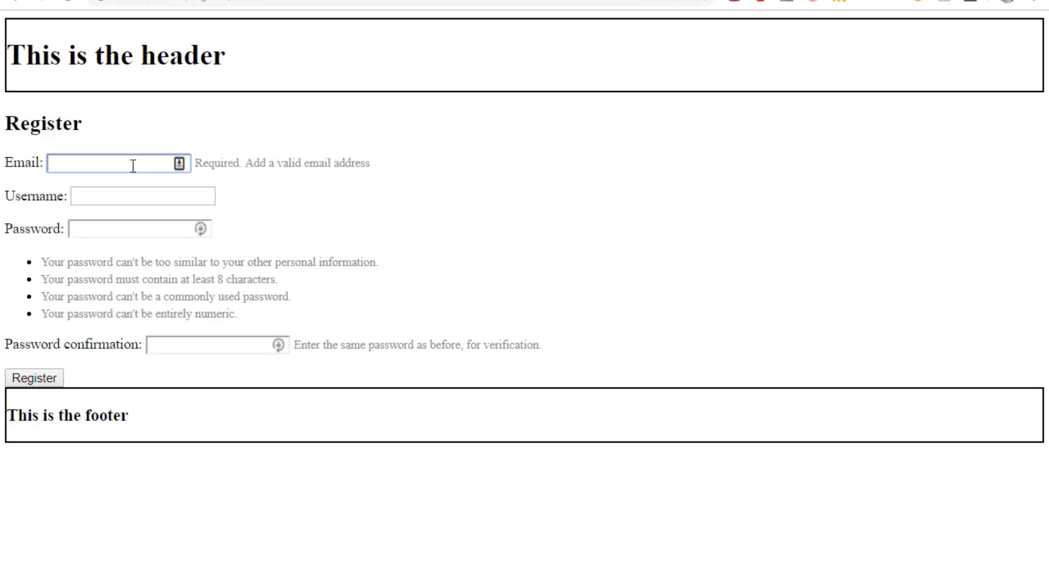

**Figure 2: Example User Interface Screen**

## Hardware Interfaces

**Supported Devices:** Users can access the website using PCs, laptops, tablets, and mobile phones.

**Data & Control Interactions:** As the application is hosted on Siteground's web hosting, interaction is primarily through the website's servers with 20 GB web space.

**Communication Protocols:** Secure HTTP (HTTPS) for web communications and WebSockets for real-time updates.

## Software Interfaces

**Connected Software:**

Database: Hosted on Sitegrounds, specific database details to be determined.

Operating Systems: Sitegrounds' web hosting environment. Kali Linux.

Backend Language & Libraries: Python 3.11 with its standard and third-party libraries.

**Data In/Out:**

Incoming: User credentials, target specifications, user configurations.

Outgoing: Test results, progress updates, error messages.

**Services & Communications:** RESTful API for communication between frontend and backend. API documentation available in a separate document.

**Shared Data Mechanism:** Given the constraints of web space, optimizing data storage and retrieval will be crucial. Database caching strategies will be implemented for efficiency.

## Communications Interfaces

**Functions:** Email notifications, web browser alerts, server-to-server communications.

**Message Formatting:** JSON for data interchange.

**Communication Standards:** Secure FTP (SFTP) for file transfers, HTTPS for secure web communications, specific to Sitegrounds' configurations.

**Security/Encryption:** All communications will be encrypted using TLS 1.3 or as supported by Sitegrounds.

**Data Transfer Rates:** Optimized for broadband connections, minimum recommended speed of 5Mbps.

**Synchronization:** WebSocket for real-time data synchronization between client and server, depending on Sitegrounds' support.

# System Features

## System Feature: Automated Penetration Testing

**4.1.1 Description and Priority**

This section uses a score from 1 to 10 where 1 is the worst and 10 is the highest

Benefits: 9 (Significant user value)

Penalty: 4 (Users may opt for competitors if not implemented well)

Cost: 7 (Complex to implement, but feasible)

Risk: 8 (Potential for misuse or false results)

**4.1.2 Stimulus/Response Sequences**

1. User inputs target specifications.
2. System validates input and prompts confirmation.
3. User initiates the test.
4. System displays progress and provides real-time updates.
5. System presents results upon completion.

**4.1.3 Functional Requirements**

REQ-1: System shall allow users to input target specifications.

REQ-2: System shall validate the target specifications for correctness and safety.

REQ-3: System should provide real-time feedback on the penetration testing progress.

REQ-4: System shall display a summary of vulnerabilities detected and potential fixes.

REQ-5: System must handle potential errors, such as unreachable targets, gracefully by notifying the user.

REQ-6: Ensure user authentication before initiating any penetration tests.

## System Feature: User Profile Management

**4.1.1 Description and Priority**

Allows users to create, edit, and manage their profiles. Priority: Medium

Benefits: 7 (Enhances user experience)

Penalty: 5 (Users might be dissatisfied with static profile settings)

Cost: 3 (Standard feature in web applications)

Risk: 7 (Data privacy concerns)

**4.1.2 Stimulus/Response Sequences**

1. Users will log in or sign up.
2. System presents a dashboard or user profile page.
3. User edits profile information.
4. System validates and saves changes, then confirms with the user.

**4.1.3 Functional Requirements**

REQ-1: System shall provide user registration and login functionality.

REQ-2: System should allow users to edit their profile information, including name, email, and contact details.

REQ-3: System must securely store and encrypt user passwords.

REQ-4: System must allow password recovery through a secure method, such as email verification.

# Other Nonfunctional Requirements

## Performance Requirements

1. The system shall respond to user input, such as starting a penetration test, within 2 seconds under typical load conditions.
2. During the execution of a penetration test, progress updates should be real-time, with no lag exceeding 3 seconds.
3. The system should support simultaneous penetration tests from 100 users without performance degradation.
4. The website should load within 3 seconds under typical network conditions.

Rationale: Quick response and real-time updates are essential for user satisfaction and to maintain trust in the system's effectiveness.

## Safety Requirements

1. The system must strictly adhere to the target specified by the user. Under no circumstances should the system perform penetration tests on websites or domains other than the one specified.
2. The system shall incorporate rate limiting to prevent accidental or intentional flooding of a target, ensuring it adheres to ethical testing norms.
3. The system should provide clear disclaimers and guidance to users on ethical use, ensuring they have the necessary permissions to test the target website.

Reference: Adherence to international cybersecurity guidelines and standards, such as the OWASP testing guide, is mandatory to ensure the product's safety.

## Security Requirements

1. All user data, especially login credentials, must be encrypted using industry-standard protocols like bcrypt (cryptographic hash function) for password hashing.
2. User sessions should be protected against session hijacking or cookie theft.
3. The system shall implement multi-factor authentication for enhanced user account security.
4. Regular security audits should be conducted to identify and mitigate potential vulnerabilities.
5. All data communication, especially involving user information or test results, should be encrypted using protocols like TLS.

Reference: Adherence to the General Data Protection Regulation (GDPR) and other regional data protection laws is vital to ensure user data privacy and security. The system should also aim for security certifications like ISO/IEC 27001 to establish trustworthiness.

## Software Quality Attributes

1. Adaptability: The software should be able to accommodate changes in penetration testing methodologies or emerging threats with minimal modifications.
2. Availability: Aiming for 99.9% uptime, the system should always be accessible for users when they require penetration testing.
3. Correctness: The penetration testing results should have an accuracy rate of at least 95%, ensuring reliable insights for users.
4. Flexibility: It should be feasible to integrate new tools or functionalities without major architectural changes.
5. Interoperability: The system should be able to seamlessly interact with common third-party platforms or services, if needed, such as vulnerability databases.
6. Maintainability: Developers should be able to fix bugs, make enhancements, or address issues with clear documentation in place and modular code architecture.
7. Portability: While the core application is web-based, any auxiliary tools or scripts should work across different OS platforms.
8. Reliability: During any penetration test, the system should not crash and should handle errors gracefully, providing useful feedback to the user.
9. Reusability: Components of the system, should be designed in a way that they can be used in different contexts or projects.
10. Robustness: The system should handle unexpected inputs or situations without failing, especially considering varied targets for penetration testing.
11. Testability: The system should have provisions to be tested easily, both for individual units and end-to-end functionality.
12. Usability: The user interface should be intuitive with a preference towards ease of use, even if it comes with a slight learning curve.

Preference: Emphasis on usability and correctness for the primary user experience, ensuring they trust the system and can navigate it effortlessly.

## Business Rules

1. Report Access: Only registered and authorized users can view penetration test reports. Unauthorized access attempts should be logged and reported.
2. Role-Based Access Control: Depending on the user role (admin, user, guest, etc.), different levels of system functionalities and data should be accessible. For instance, only admins or creators can modify system configurations, while regular users can only initiate tests and view their own reports.

# Other Requirements

Reuse Objectives

1. Modular Design: Components of the system should be modularly designed for potential reuse in other related projects.
2. API Development: Develop RESTful APIs that can be used internally and potentially opened up for third-party integrations or other projects.

Database Requirements

1. Scalability: The database should be scalable to handle an increasing number of user records and penetration test results.
2. Backup: Regular backups, both incremental and full, should be taken to prevent any data loss.
3. Access Control: Strict role-based access to ensure that only authorized personnel can view or modify the database.

Internationalization Requirements

1. Localization: The system should support multiple languages, starting with English, Spanish, and French.
2. Currency: If there's a payment system in place, it should be able to handle and convert multiple currencies.
3. Time Zones: User profiles and scheduling features should consider user time zones for accurate timing and notifications.

Legal Requirements

1. Data Protection: Adhere to international data protection regulations like GDPR (General Data Protection Regulation) for European users and CCPA (California Consumer Privacy Act) for California residents.
2. Ethical Use: The tool's capabilities must not be misused, and users must have necessary permissions to conduct penetration tests on the target.
3. Licensing: Any third-party tools, libraries, or services used should be properly licensed, and their terms and conditions should be followed.

Accessibility Requirements

1. Web Standards: The website should be designed following W3C Web Content Accessibility Guidelines (WCAG) to ensure that it's usable by people with disabilities.
2. Contrast and Font: Adequate contrast ratios and readable fonts should be used to cater to users with vision impairments.
3. Keyboard Navigation: The site should be navigable using just the keyboard, aiding users with mobility impairments.

# Appendix A: Glossary

1. Penetration Testing (Pentest): The practice of testing a computer system, network, or web application to find vulnerabilities that attackers could exploit.
2. SRS: Software Requirements Specification. A document that describes the features, behaviors, and attributes of a software system.
3. TLS: Transport Layer Security. A protocol ensuring privacy and data security between two communicating applications.
4. RESTful API: Representational State Transfer. A set of rules that developers follow when they create their API, allowing for interaction between systems using HTTP.

# Appendix B: Analysis Models

**Stakeholders:**

* + **Users (Registered and Unregistered)**
  + **Developers and IT Administrators**
  + **External vulnerability databases**
  + **Payment gateway providers**
  + **Hosting service providers**

**Use Cases:**

* + **User Registration:**
    1. **Actors:** Unregistered Users
    2. **Description:** Users can register for an account by providing their username, email, password, and optional profile details. The system validates and stores this information in the database.
    3. **Pre-conditions:** None
    4. **Post-conditions:** User data stored in the system.
  + **User Login:**
    1. **Actors:** Registered Users
    2. **Description:** Registered users can log in by providing their credentials. The system verifies the credentials and grants access if they are correct.
    3. **Pre-conditions:** User account exists.
    4. **Post-conditions:** User logged in, session established.
  + **Initiate Penetration Test:**
    1. **Actors:** Authenticated Users
    2. **Description:** Users can configure and initiate penetration tests by providing a target URL and test depth. The system processes the request and initiates the test.
    3. **Pre-conditions:** User logged in.
    4. **Post-conditions:** Penetration test initiated.
  + **Generate Test Report:**
    1. **Actors:** Authenticated Users
    2. **Description:** After the penetration test is completed, users can request a report containing information about vulnerabilities detected, severity levels, and suggested fixes. The system generates the report.
    3. **Pre-conditions:** Penetration test completed.
    4. **Post-conditions:** Report generated, user can download it.
  + **Payment for Premium Features:**
    1. **Actors: Registered Users**
    2. **Description:** Users can make payments for premium features or services using a payment gateway. The system processes the payment and grants access to premium features.
    3. **Pre-conditions:** User logged in and requested premium features.
    4. **Post-conditions:** Payment processed, premium features accessible.
  + **External Vulnerability Database Query:**
    1. **Actors: "AutoPen" System**
    2. **Description:** The system queries an external vulnerability database to retrieve vulnerability definitions, metadata, severity rankings, and suggested mitigation measures.
    3. **Pre-conditions:** Request for vulnerability data.
    4. **Post-conditions:** Vulnerability data retrieved and stored.
  + **Cloud Storage for Report Storage:**
    1. **Actors:** "AutoPen" System
    2. **Description:** The system interfaces with cloud storage to upload, store, and retrieve penetration test reports.
    3. **Pre-conditions:** Request to store or retrieve reports.
    4. **Post-conditions**: Reports stored or retrieved from cloud storage.
  + **System Notification:**
    1. **Actors:** "AutoPen" System
    2. **Description:** The system sends notifications to users for various events, such as test completion, updates, or alerts.
    3. **Pre-conditions:** Event triggering notification.
    4. **Post-conditions**: Notification sent to the user.

**Use Case Relationships:**

* + "User Registration" and "User Login" are prerequisites for all user-related use cases.
  + "Generate Test Report" is dependent on the completion of "Initiate Penetration Test."
  + "Payment for Premium Features" is initiated by user request.
  + "Initiate Penetration Test," "Generate Test Report," and "Payment for Premium Features" require an authenticated user session.
  + "External Vulnerability Database Query" and "Cloud Storage for Report Storage" are integral components of the system architecture, interacting with the core functionalities.
  + "System Notification" is triggered by various system events and interacts with all user-related use cases.

**System Boundaries:**

* + The system interacts with external entities, including external vulnerability databases, payment gateways, and cloud storage services.
  + Users interact with the system via a web-based interface, which includes data entry screens and data display screens.
  + The system operates within a cloud-based environment, including cloud servers for hosting and data storage.

**Non-Functional Requirements:**

* + Security and compliance with legal constraints, including access control, encryption, and adherence to relevant laws and regulations.
  + Scalability to handle increased user load and data storage needs.
  + Availability to ensure that the system is accessible and operational.
  + Performance to provide efficient penetration testing and report generation.
  + Usability with a user-friendly web interface.
  + Reliability for accurate and consistent penetration testing results.
  + Maintainability for ongoing updates, patches, and system enhancements.

# Appendix C: To Be Determined List

1. Database Selection: Specific database technology to be used hasn't been finalized.
2. Third-Party Integration: Deciding on whether to integrate third-party vulnerability databases directly.
3. Pricing Model: How users will be charged for the service is TBD.
4. Notification System: How and when users receive notifications about test results or system updates.
5. User Data Retention Policy: Duration and conditions under which user data and reports will be stored.

(These are placeholders and might change based on the actual pending decisions in a real-world project.)