Acoustics Lab Four Report
4/19/2025

Caleb Young
Department of Science and Engineering
University of Central Arkansas
Conway AR, United State of America
cyoung24@cub.uca.edu

Abstract:

This lab introduces an experiment and theory regarding a Helmholtz resonator. This will be used to determine the resonance frequencies at different volumes and effective length of the neck compared to the physical neck.

Table of Contents:

- Introduction

- Theory

- Experimental Procedure

- Results

- Discussion

- Conclusions

- References

- Introduction:

The objective of this lab is to determine the resonance frequencies of a Helmholtz resonator experimentally as the volume is changed. The resulting data collected will be used to determine the effective length of the neck and compare it to the physical hand measurement of the neck.

Equipment List & Setup:
ITEM | NEEDED
Microphone | 1
Ring stand and clamp | 1
Digital oscilloscope | 1
Digital calipers | 1
100 mL beaker | 1
2 L boiling flask | 1

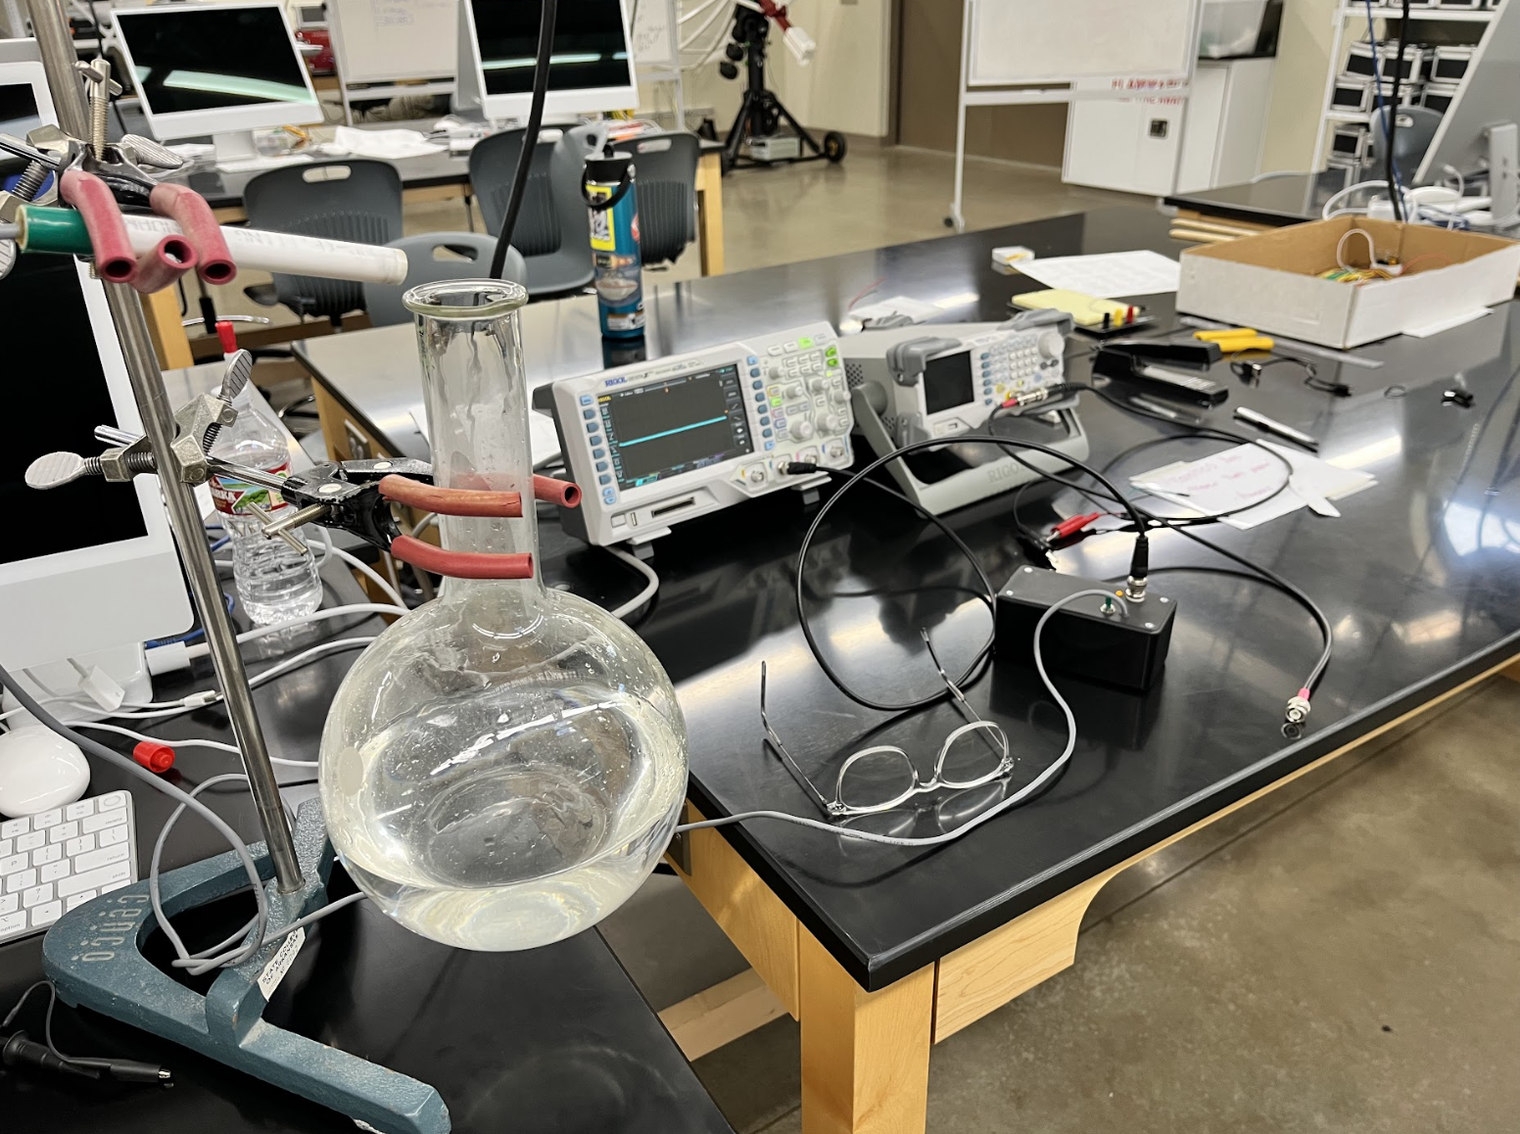

Figure 1: Experimental Setup and Helmholtz resonator.
- Theory:

- Background:
A Helmholtz resonator consists of a volume and a connecting duct (neck) as illustrated in Figure 2. We can use a lumped element approach to modeling the Helmholtz resonator if its physical dimensions are small with respect to the wavelength. In this case, the wavelength is the lowest frequency mode of oscillation, i.e. the Helmholtz mode. Recall from our discussion in class as well as reading the textbook that the Helmholtz angular resonance frequency is given by,
$$ω_{0}=c\sqrt{\frac{A}{VΔx}}$$
where A is the cross-sectional area of the neck, V is the volume of the cavity, ∆x is the neck length and c is the speed of sound in air at room temperature (346 m/s). We can write the angular frequency as ω = 2πf.

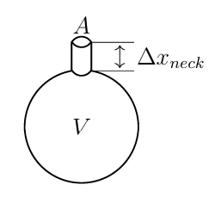
Figure 2: Physical dimensions of the Helmholtz resonator.

For ease of use we will adjust equation 1 as:
$${Δx}_{eff}=(\frac{c}{2πf_{exp}})\frac{A}{V}$$

- Experimental Procedure:

We will be using another equation that looks like slope intercept form to do our calculations. We can experimentally measure $f_{exp}$ for different volumes, V, and plot the data as the author of “Understanding Acoustics” does on page 380 Figure 8.17. The slope of the data is the effective neck length. Note: the experimentally measured frequencies are related to the period by T = 1/f, thus, we have:
$$\left(\frac{c^{2}}{4π^{2}}A\right)T_{i}^{2}=Δx_{eff}(V-ΔV_{i})$$
where ${ΔV}_{i}$ is the change in volume and $T_{i}$ is the period for the i-th measurement. This theoretical relationship looks like the equation for a straight line: $y=mx+b$.

The 4 steps to this lab are below:
- Take approximately 10 data points by gently injecting water into the flask volume and measuring the resonance frequency by blowing over the top of the flask.

- Use your data to make a meaningful plot so that you can make use of Eq 3 to do the analysis.

- Use an appropriate method to determine the slope and intercept with uncertainty of the data. Determine $Δx_{eff}$ from the fit.

- Measure the physical length of the neck with uncertainty. Compare the physical neck to the effective neck length. Are they the same within uncertainty bounds? Why or why not?

- Results:

- Discussion:

- Overall:
This lab overall was exciting since I got to donate some of my old guitar strings to the cause. They ended up working leagues better than the regular hardware store bought steel wire initially provided.
The experiment with the Low E-String should have been done with a shorter distance and heavier weights. That string can handle more tension due to its thickness. The data collected was bad which is why the experiment didn’t pass the agreement check.

- AI-Usage:
The usage of CoPilot inside of VSCode is great. Parts of this lab in my opinion need to be done with your own personal knowledge and reasoning skills. It is important to do this during experimentation as understanding where human error occurs or could happen plays a huge role in experimentation in all areas of study. Now once you’ve collected good sufficient data and know where faults might lie, I believe it is totally reasonable to use AI in creating graphs and summarizing data. Make sure to review its results as I had to correct a few things in mine.

- Conclusions:

- References:

Note: I need help with proper referencing

[1] “Lab 3: Pulse on String”, Dr. Slaton Ph.D., 2026

[2] CoPilot in VSCode, Creating plots and calculations.

