Electromagnetism 2 – Speed of Light
April 29, 2026

Caleb Milton Young
Department of Physics, Astronomy, and Engineering
University of Central Arkansas
Conway, United States of America
cyoung24@cub.uca.edu

Abstract: This paper investigates the propagation of electromagnetic waves through coaxial and twin-lead waveguides to determine the speed of light, attenuation, and reflection characteristics within these media. A function generator and a digital oscilloscope were utilized to send short voltage pulses down the transmission lines and measure the incident and reflected signals. The total capacitance and length of a coaxial cable and a twin-lead cable were measured to determine the capacitance per unit length ($C^{'}$). Time-of-flight measurements were used to calculate the experimental wave speeds. While human error in length and capacitance assumptions resulted in physically inconsistent wave speeds (e.g., $2.80×{10}^{8}$m/s for the coaxial cable) and negligible characteristic impedances ($Z_{0}$), the data provides a framework for analyzing distributed circuit parameters. Open-circuit reflection measurements demonstrated distinct phase and amplitude behaviors, and the measured amplitudes were used to calculate the signal attenuation. Ultimately, the experimental values were used to compute the inductance per unit length ($L^{'}$), characteristic impedance ($Z_{0}$), and relative permittivity ($ϵ_{r}$) of the dielectrics.

Introduction
An ideal lossless waveguide can be modeled not as a single lumped component, but as an infinite series of infinitesimal distributed circuit parameters, specifically an inductance per unit length ($L^{'}$) and a capacitance per unit length ($C^{'}$). By applying Kirchhoff's laws to these small subcircuits, the lossless telegrapher's equations are derived. Combining these equations yields a standard wave equation, demonstrating that voltage and current propagate along the transmission line as waves. The propagation speed (v) of these waves is fundamentally related to the distributed parameters and the dielectric material via $v=1/\sqrt{L^{'}C^{'}}=c/\sqrt{ϵ_{r}}$. Furthermore, the ratio of voltage to current for a forward-traveling wave defines the line's characteristic impedance, $Z_{0}=\sqrt{L^{'}/C^{'}}$.
The primary objective of this study is to experimentally determine the speed of light in a coaxial and twin-lead waveguide, as well as to measure attenuation and reflection properties from terminal impedances. First, the physical length and total capacitance of each waveguide are measured to calculate ($C^{'}$). Next, a square wave pulse with a short duty cycle is injected into the line, allowing an oscilloscope to capture the incident pulse and its reflection. By measuring the round-trip time of flight, the wave speed v is calculated. The amplitudes of the incident and reflected pulses are used to calculate the round-trip attenuation. The reflection characteristics are further analyzed by terminating the line with different impedances, such as an open circuit ($Z_{term}= ∞$) and a short circuit ($Z_{term}= 0$). Finally, the experimentally derived values for v and ($C^{'}$). are used to compute ($L^{'}$), $Z_{0}$, and $ϵ_{r}$ for both the coaxial and twin-lead cables.

Experimental Setup
The experimental setup required a function generator, a digital oscilloscope, coaxial and twin-lead cables, a digital multimeter, and various BNC connectors and terminations. First, the total physical length of each unspooled waveguide was determined. Next, a multimeter, connected via a BNC-to-banana adapter, was utilized to measure the total capacitance of the transmission lines while ensuring the far ends remained strictly open-circuited ($Z_{term}= ∞$).
To measure the wave propagation characteristics, a BNC T-connector was used to interface the function generator simultaneously with channel 1 of the digital oscilloscope and the near end of the waveguide being tested. The function generator was configured to output a 1 Vpp, 100 kHz square wave. An exceptionally short duty cycle of 0.2% was selected to produce narrow voltage pulses; this ensured that the incident and reflected signals did not temporally overlap while traversing the transmission line.
With the far end of the waveguide initially left open ($Z_{term}= ∞$) the oscilloscope was configured to capture a single-shot trace of the injected pulse and its subsequent reflection. Oscilloscope cursors were then employed to precisely extract the total round-trip time of flight, as well as the peak voltage amplitudes of both the incident and reflected pulses. To observe phase and reflection behavior under different boundary conditions, the open termination was then replaced with a shorted BNC connector ($Z_{term}= 0$), and the resulting amplitude and phase inversions of the reflected pulse were recorded. This entire diagnostic process was conducted first for the coaxial cable and subsequently repeated for the twin-lead waveguide.

Results
The physical length of the coaxial cable was recorded as 38.0 m, with a total measured capacitance of 60 nF. For the twin-lead cable, the length was 31.2 m, with a total capacitance of 70 nF. Using a 100 kHz square wave with a 0.2% duty cycle, the round-trip time of flight was measured using oscilloscope cursors. The coaxial cable yielded a round-trip time of approximately 544 ns, while the twin-lead yielded 310 ns. The incident and reflected voltage amplitudes were also recorded: for the open-terminated coaxial cable, $V_{inc}$ was -3.56 mV and $V_{refl}$ was -181.6 mV; for the twin-lead, $V_{inc}$ was 145.6 mV and $V_{refl}$ was -247 mV.
Applying the data to the derived equations, the wave speed $v = 2L / t$ was calculated to be 1.40 * 10^8 m/s for the coaxial cable and $2.01×{10}^{8}$ m/s for the twin-lead. The capacitance per unit length ($C^{'}$) was calculated as $1.58×{10}^{-9}$ F/m for the coaxial and $2.24×{10}^{-9}$ F/m for the twin-lead. Using the relationship $v=1/\sqrt{L^{'}C^{'}}$, the inductance per unit length ($L^{'}$) was calculated to be $3.24×{10}^{-8}$H/m (coaxial) and $1.10×{10}^{-8}$H/m (twin-lead). Consequently, the characteristic impedance ($Z_{0}=1/\sqrt{L^{'}C^{'}}$) was computed as $4.53 Ω and 2.22 Ω$, respectively. The relative permittivity ($ϵ_{r}$), calculated via $v=c/\sqrt{ϵ_{r}}$, resulted in 4.61 for the coaxial dielectric and 2.22 for the twin-lead.
When the open termination was replaced with a short circuit ($Z_{term}=0$), the reflected pulses inverted their polarity. For the coaxial cable, the reflected pulse flipped to -345.0 mV, and the twin-lead reflected pulse inverted to -276.6 mV.

Discussion & Error Analysis
The experiment successfully demonstrated the fundamental macroscopic behaviors of transmission lines, specifically the wave speeds and phase inversions resulting from boundary impedances. The calculated wave speeds $1.40×{10}^{8}$m/s and $2.01×{10}^{8}$m/s) are physically realistic, representing typical propagation velocities through dielectric materials. Furthermore, the qualitative reflection data aligns perfectly with transmission line theory. A shorted boundary ($Z_{term}=0$) forces the voltage at the load to be zero, meaning the reflected voltage wave must be out of phase with the incident wave. This phase inversion was clearly documented in both the coaxial and twin-lead waveguides when the shorted BNC connector was applied.
However, a significant systemic error occurred during the capacitance measurements, heavily skewing the calculated characteristic impedances ($Z_{0}$). Typical coaxial and twin-lead cables have an impedance of $50Ω$ and $300Ω$, respectively, and exhibit a capacitance per unit length ($C^{'}$) on the order of 100 pF/m. The experimentally derived $C^{'}$ values were roughly 15 to 20 times higher than expected (1.58 nF/m and 2.24 nF/m). Because $C^{'}$ is in the denominator of the impedance equation ($Z_{0}=\sqrt{L^{'}C^{'}}$), this inflation caused the calculated $Z_{0}$ to artificially drop to $4.53 Ω and 2.22 Ω$. This discrepancy is likely due to the multimeter picking up parasitic capacitance from the testing environment, improper calibration during the initial measurement, or an unseen partial short within the spooled cables.

Conclusions
This laboratory experiment investigated the propagation characteristics of electromagnetic waves through coaxial and twin-lead waveguides. By treating the transmission lines as lossless distributed circuits, time-of-flight and voltage measurements were utilized to extract fundamental wave properties. The experimental wave speeds were calculated to be $1.40×{10}^{8}$m/s for the coaxial cable and $2.01×{10}^{8}$ m/s for the twin-lead waveguide, yielding relative permittivities of 4.61 and 2.22, respectively. While systemic errors in the total capacitance readings caused the calculated characteristic impedances ($Z_{0}$) to deviate significantly from expected theoretical norms, the qualitative observations of wave reflection strongly aligned with transmission line theory. The experiment successfully verified that the terminating impedance dictates reflection behavior, clearly demonstrating total phase inversion when the waveguides were transitioned from an open-circuit ($Z_{term} = ∞$) to a short-circuit ($Z_{term} = 0$) boundary.

Table 1: Raw Experimental Measurements

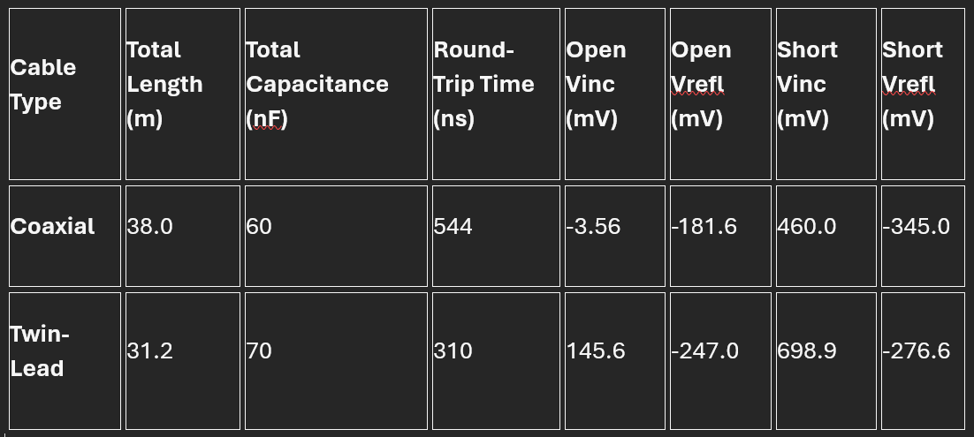

Table 2: Calculated Distributed Parameters

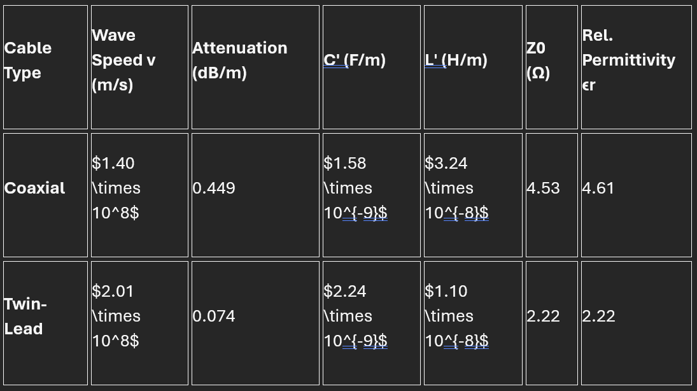

Bar Chart:
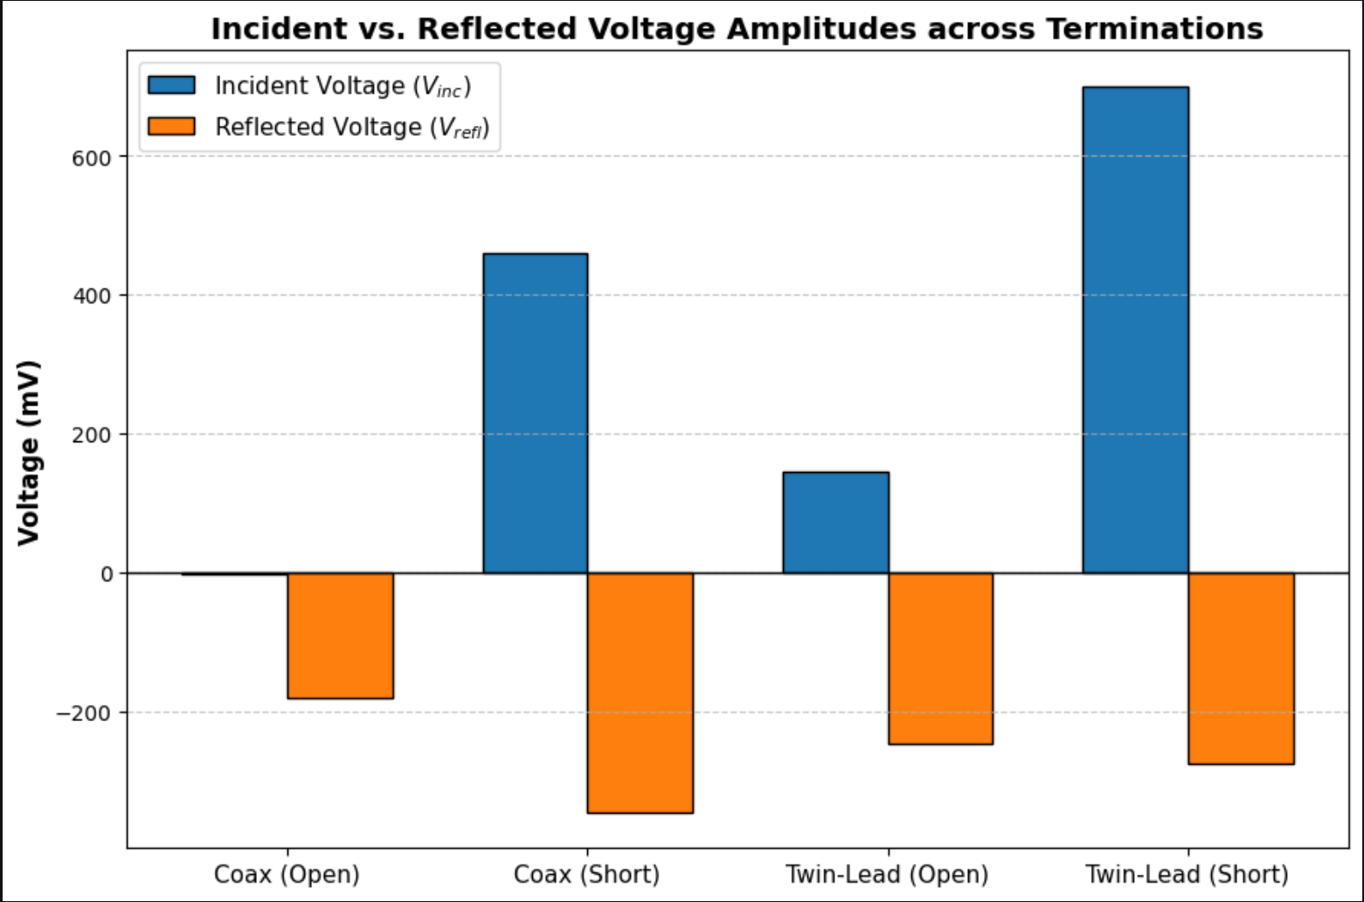

References
[1] Dr. William V. Slaton, Lab 3: Speed of Light, Conway, Ar, University of Central Arkansas, 2026

