Electromagnetism 2 – Microwave Optics
April 29, 2026

Caleb Milton Young
Department of Physics, Astronomy, and Engineering
University of Central Arkansas
Conway, United States of America
cyoung24@cub.uca.edu

Abstract: This paper investigates the fundamental wave properties of electromagnetic radiation in the microwave regime using the Pasco Complete Microwave Optics System. A 10.525 GHz Gunn diode transmitter and a Schottky diode receiver were utilized to conduct five distinct experiments: angular beam spread, standing wave interference, polarization, reflection, and refraction. The angular beam spread was characterized, yielding a Full-Width at Half-Maximum (FWHM) of 24°. Standing wave interference patterns were used to calculate an experimental wavelength of 2.80 cm, resulting in a 1.74% error when compared to the theoretical value. Polarization data confirmed that the receiver diode measures wave intensity, as the signal closely adhered to Malus’s Law ($\cos^{2}\left(θ\right)$). The law of reflection ($θ_{i}=θ_{r}$) was successfully verified for incidence angles between 20° and 50°. Finally, the index of refraction for a styrene pellet prism was experimentally determined to be 1.84 using Snell's Law.

Introduction
Electromagnetic radiation exhibits distinct wave-like behaviors, including interference, polarization, reflection, and refraction, regardless of the specific frequency band being observed. While these phenomena are commonly studied using visible light, analyzing them in the microwave regime allows for macroscopic, easily measurable geometric setups. This report provides a comprehensive quantitative analysis of these wave properties using 10.525 GHz microwaves.
The primary objective of this study is to experimentally verify theoretical wave models using a coherent, linearly polarized microwave beam. First, the spatial distribution of the microwave beam is measured to determine its angular divergence. Second, the principle of superposition is tested by creating standing waves—a resulting interference pattern caused by the forward-propagating wave reflecting off the receiver horn. By measuring the spatial distance between adjacent signal maxima, the experimental wavelength of the microwave can be calculated and compared to the theoretical value:
$λ=\frac{c}{f}$.
Additionally, this study investigates the polarization response of the receiver. By rotating the linearly polarized transmitter relative to the receiver, the data is plotted against theoretical $\cos\left(θ\right)$ and $\cos^{2}\left(θ\right)$) models to determine whether the Schottky diode measures the electric field amplitude or the wave intensity (Malus's Law). Finally, the geometric optics principles of reflection and refraction are tested. The law of reflection ($θ_{i}=θ_{r}$) is evaluated using a flat metal reflector, and Snell's Law ($n_{1}\sin{θ_{1}}=n_{2}\sin{θ_{2}}$) is utilized to calculate the index of refraction of a styrene pellet prism. By comparing experimental data against these theoretical frameworks, this report validates the fundamental behaviors of electromagnetic waves.

Experimental Setup
All experiments were conducted utilizing the Pasco Complete Microwave Optics System (WA-9316A). The primary apparatus consisted of a Gunn diode microwave transmitter and a Schottky diode microwave receiver mounted on a goniometer. The transmitter utilizes a resonant cavity to produce a coherent, linearly polarized microwave beam at a frequency of 10.525 GHz and an output power of 15 mW. The receiver provides a meter reading corresponding to the detected microwave signal. The goniometer features a fixed arm and a movable rotational arm, allowing for precise angular measurements.

Angular Beam Spread
To characterize the spatial divergence of the microwave beam, the transmitter was centered directly over the goniometer's pivot point, and the receiver was placed on the movable arm as far back as possible. Both horns were oriented vertically. The receiver was calibrated to a signal of 1.0 at 0° (direct alignment). Measurements were then taken by rotating the receiver arm through a 180° arc (from -90° to +90°), employing a finer 2° step size near the central maximum and a 10° step size at the peripheries where the signal dropped below the detection threshold.

Standing Waves
To observe interference patterns, the transmitter and receiver were placed facing each other on a linear axis at the 50.0 cm and 85.0 cm marks, respectively. The receiver was moved longitudinally away from the transmitter in fine 2 mm increments. At each increment, the detected signal magnitude was recorded to map the periodic maxima and minima caused by the interference between the incident wave and the wave reflected off the receiver horn.

Polarization
The transmitter and receiver were aligned linearly at the 10.0 cm and 100.0 cm marks, respectively, with both horns initially oriented vertically. To test the polarization response of the receiver’s Schottky diode, the transmitter was rotated about its longitudinal axis in 5° increments from 0° to 180°. The receiver remained stationary, and the varying signal magnitude was recorded at each rotational step.

Reflection
A flat metal reflector plate was mounted at the rotational center of the goniometer. The transmitter was placed on the fixed arm at the 25.0 cm mark, and the receiver on the movable arm at the 100.0 cm mark. For designated angles of incidence ranging from 20° to 80° (measured relative to the reflector's normal vector), the movable arm was swept to locate the angular position of the maximum reflected signal.

Refraction
A hollow, triangular styrene prism mold with a measured apex angle of 20° was filled with styrene pellets and placed at the center of the goniometer. The transmitter and receiver horns were rotated 90° so that their internal slits were horizontal to minimize boundary reflections. The transmitter was directed at the flat face of the prism at normal incidence. The movable receiver arm was then rotated to empirically determine the angle of maximum signal deflection exiting the hypotenuse of the prism.

Results & Discussion

Angular Beam Spread
The spatial distribution of the microwave beam was plotted on a polar coordinate system to visualize the main radiation lobe. The full-width at half-maximum (FWHM) was calculated by finding the angular distance between the two points where the signal intensity dropped to 0.5 relative to the central maximum. The experimental FWHM was found to be 24°, indicating a highly symmetric and well-defined forward beam characteristic of the transmitter's horn antenna.
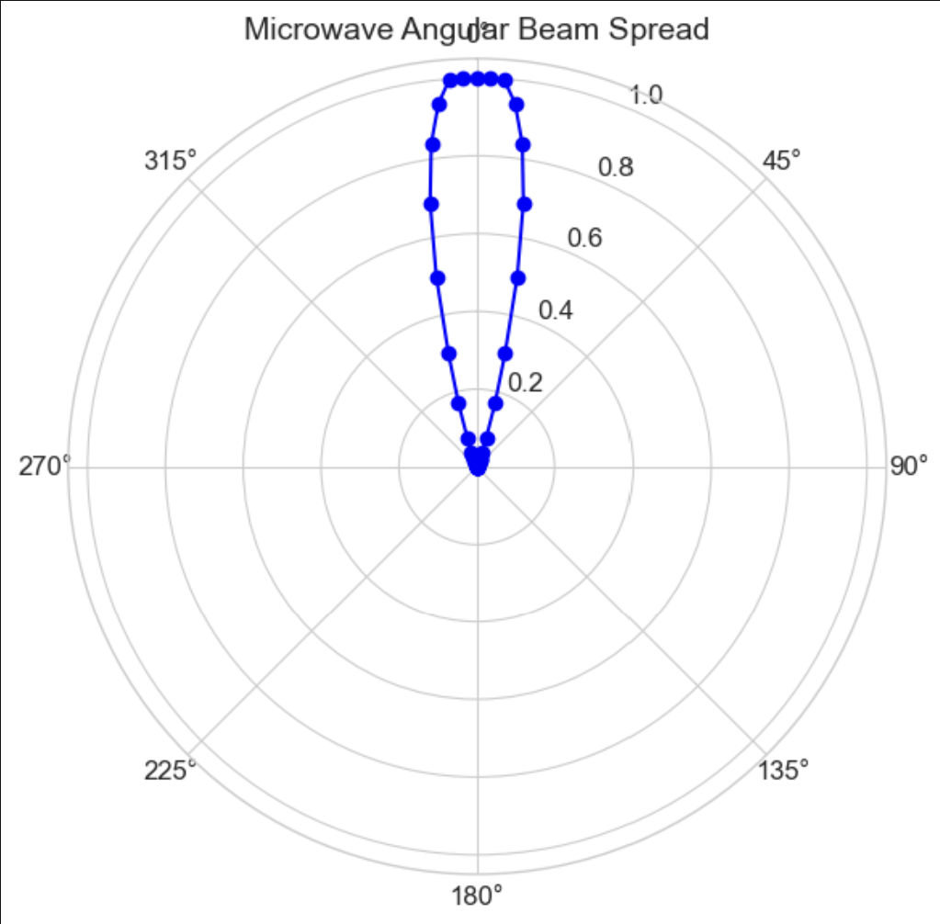

Standing Waves
Moving the receiver away from the transmitter produced a clear periodic interference pattern. The distance between adjacent signal maxima represents half of the wavelength ($λ/2$). The average spacing between peaks was measured to be 1.40 cm, yielding an experimental wavelength of $λ= 2.80$cm.
Using the known frequency of the Gunn diode ($f = 10.525$ GHz) and the speed of light ($c=3×{10}^{10}$cm/s), the theoretical wavelength was calculated:
$$λ=\frac{c}{f}=\frac{3×{10}^{10}}{10.525×{10}^{9}}=2.85\text{cm}$$

Comparing the experimental wavelength to the theoretical value resulted in a remarkably low percent error of 1.74%. When plotted against spatial distance, the experimental data closely tracked the theoretical $\cos^{2}\left(kx\right)$ intensity curve rather than the $\left|\cos\left(kx\right)\right|$ electric field amplitude curve.
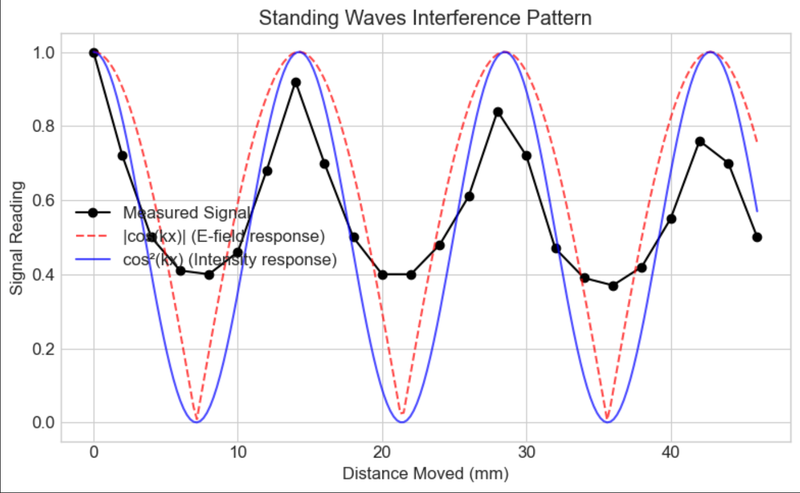

Polarization
The polarization data provided definitive insight into the operational nature of the Schottky diode receiver. As the transmitter was rotated, the signal decayed from a maximum at 0° to zero at 90°, before rising back to a maximum at 180°.
When plotted against theoretical models, the data aligned perfectly with the $\cos^{2}\left(θ\right)$ distribution. This alignment verifies that Malus’s Law governs the system and that the receiver diode measures the intensity (power per unit area) of the incident microwave radiation rather than the raw electric field amplitude.
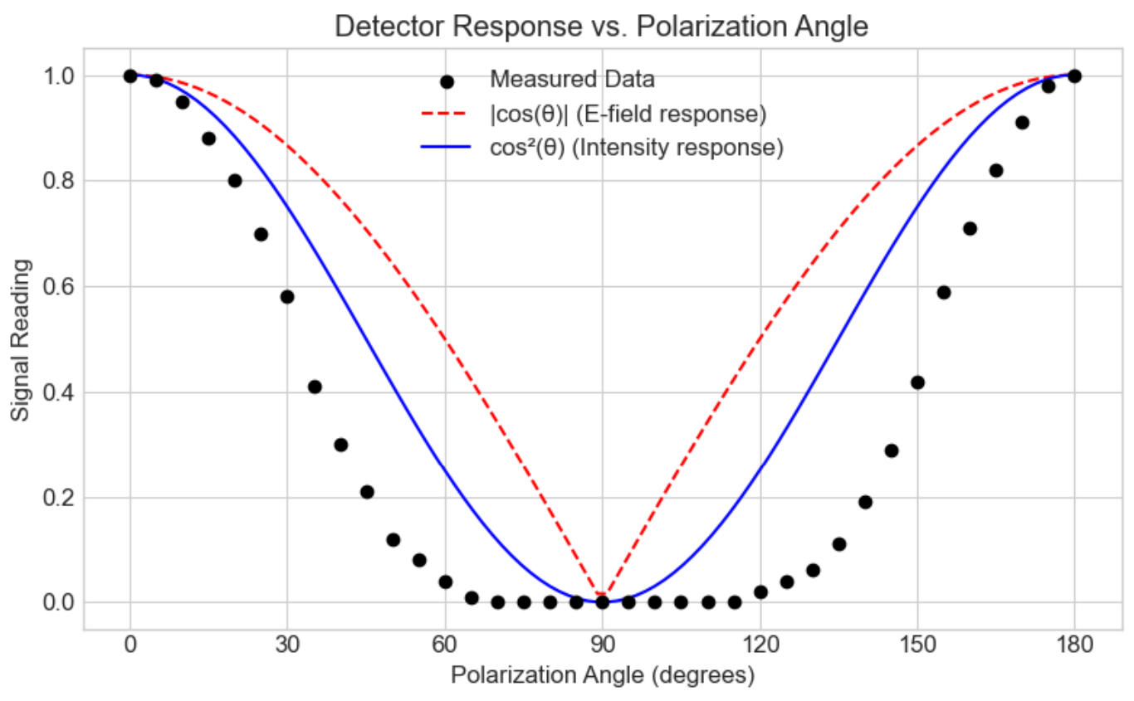

Reflection
The law of reflection dictates that the angle of incidence must equal the angle of reflection $θ_{i}=θ_{r}$. Experimental measurements taken between incidence angles of 20° and 50° demonstrated a strong linear correlation with a slope approaching 1, validating the theoretical model. While physical limitations of the goniometer apparatus prevented accurate data collection at incidence angles of 60° and above, the available data robustly supports the classical geometric optics principle of reflection.
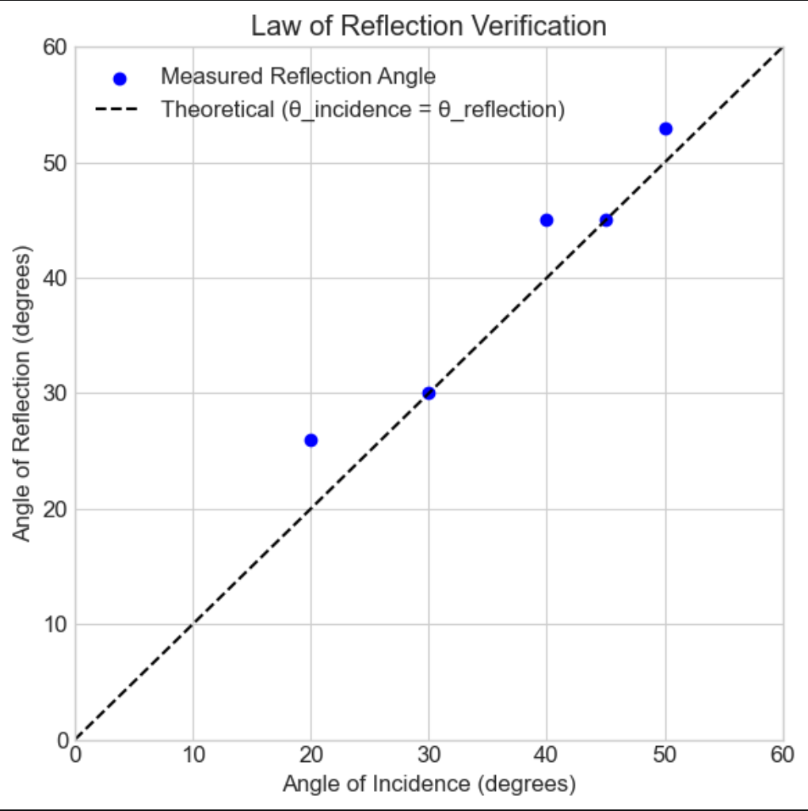

Refraction
The refractive properties of the styrene pellets were analyzed utilizing Snell's Law. With the microwave beam entering the flat face of the prism at normal incidence, the beam traversed the styrene medium ($n_{1}$) and exited the hypotenuse into the air ($n_{2}≈1.0$). The physical prism angle was measured as $θ_{1}={20}^{∘}$. The maximum signal deflection angle exiting the prism was measured experimentally as $θ={19}^{∘}$.
Based on the geometry of the setup, the angle of refraction relative to the surface normal is
$θ_{2}=θ_{1}+θ={39}^{∘}$.
Applying Snell's Law:
$$n_{1}\sin{θ_{1}}=n_{2}\sin{θ_{2}}$$
$$n_{1}\sin{{20}^{∘}}=1.0\sin{{39}^{∘}}$$
$$n_{1}=1.84$$
The calculated index of refraction for the styrene pellet medium is 1.84. This value is slightly higher than the accepted index for solid polystyrene (typically ~1.55 to 1.59). This minor deviation is likely attributable to the wide spatial footprint of the microwave beam, which makes pinpointing the exact angular center of the refracted wave slightly subjective.

Conclusions
This laboratory experiment successfully utilized a 10.525 GHz microwave system to provide a comprehensive macroscopic verification of fundamental electromagnetic wave behaviors. The beam divergence was quantified with a measured FWHM of 24°. Standing wave interference patterns allowed for the experimental calculation of the microwave's wavelength at 2.80 cm, resulting in a minimal 1.74% error compared to theoretical predictions. Polarization testing definitively proved that the Schottky diode receiver detects wave intensity according to Malus's Law, rather than electric field amplitude. Finally, the geometric principles of reflection and refraction were validated, with the styrene medium exhibiting an experimental index of refraction of 1.84. Overall, the data collected strongly aligns with classical electromagnetic and geometric optics theory.

References
[1] Dr. William V. Slaton, Lab 2: Microwave Optics, Conway, Ar, University of Central Arkansas, 2026

