**Computer and Information System**

**Coursework Assessment**

**202010**

**CIS-1203**

**WEB TECHNOLOGIES PROJECT**

|  |  |
| --- | --- |
| **Student HCT ID** | **Student Name** |
|  |  |
|  |  |
|  |  |
|  |  |

Contents

**Company’s Name**: 3

**Company’s Description**: 3

**Purpose of the Website:** 3

**Evaluation of Competitor Websites:** 3

**Site map:** 4

**Roles and Responsibilities** 4

**Wire Frame:** 5

# **Company’s Name**:

Wazishare Solutions Ltd.

# **Company’s Description**:

Wazishare solutions Ltd. Is a company that enables low-income earners to pay their insurance premiums through little accumulation of their airtime daily.

# **Purpose of the Website:**

This Website allows users to get useful information about the company and the locational offices in the region. It allows the users to view the services offered with respect to value and the type of account in which they pay premiums to. The website allows the user to contact the company via a telephone number, direct embedded mail or even a feedback through a contact form and there after send a request.

# **Evaluation of Competitor Websites:**

Please:

“Identify the websites serving the same similar purpose in your areas of jurisdiction”

# **Target Audience:**

This website is design for all adults who are low income earners and pays their insurance premiums to cover medical bills

# **Site map:**

# **Roles and Responsibilities**

|  |  |  |
| --- | --- | --- |
| Student ID | Student Name | Role and Responsibilities |
|  |  | Draft, Design, Company idea |
|  |  | Design, Code, Body Content |
|  |  | Insights, User interaction, Code |
|  |  | Implementation, testing, Debugging |

# **Wire Frame layout:**







# **Storyboard - Screen Shot of draft Home page**

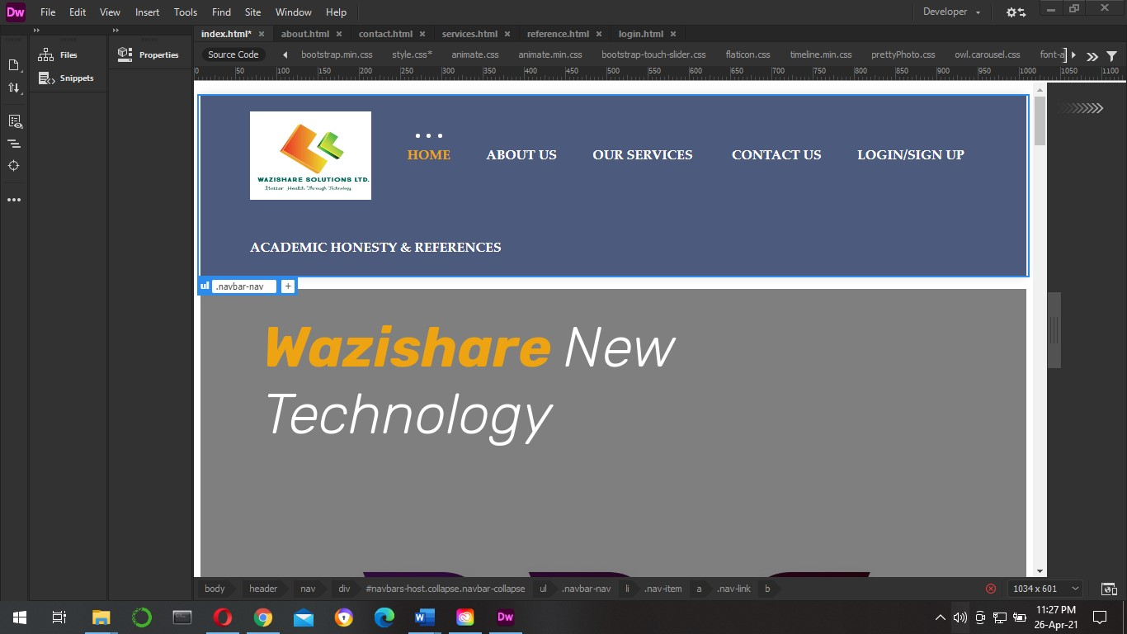

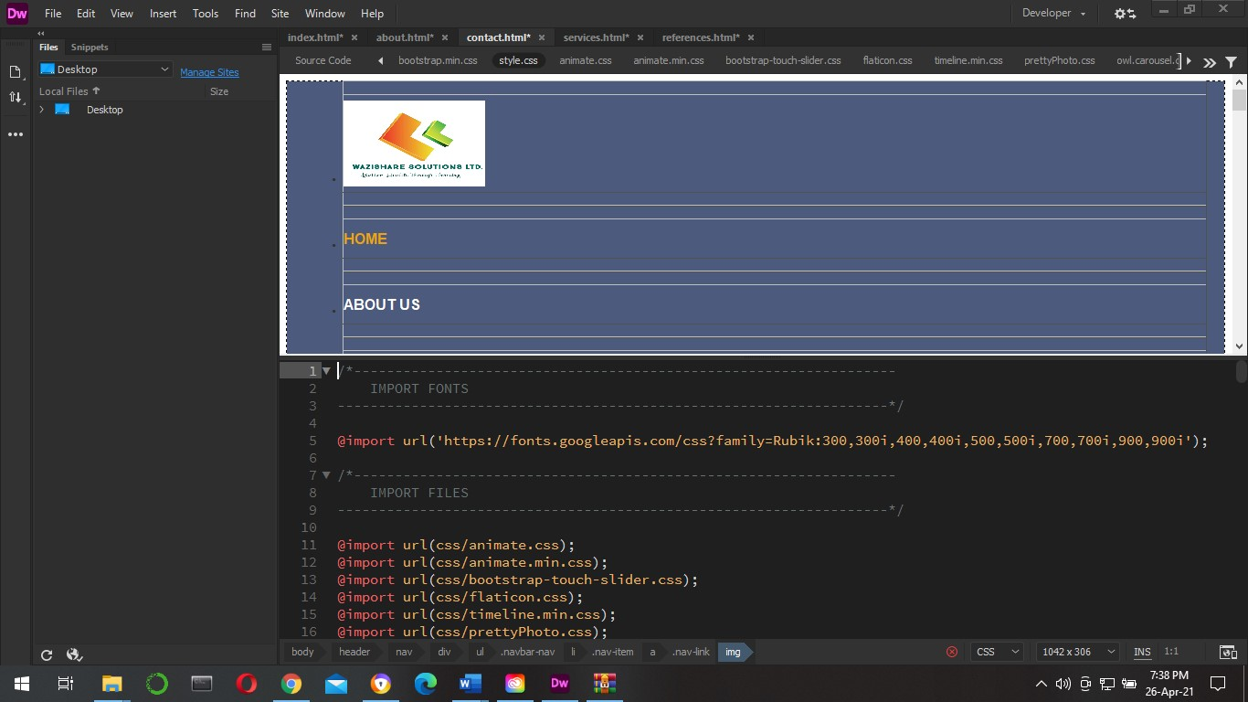

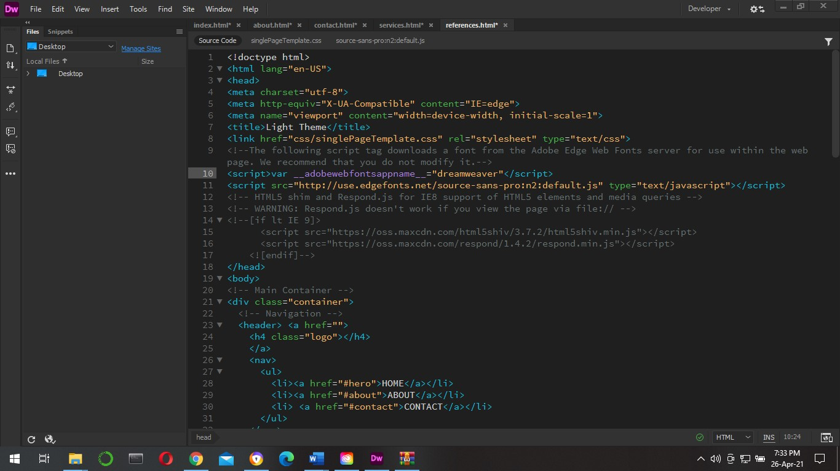

# **References**

(McFarland, 2019)

(Inc., 2005)

(maivald, 2019)

(Carlos Predrinaci, 2011)

(Buchanan, 1989)