Phase 2 – Data Preparation & Analysis

Name: Caleb. S
Department: Mechanical Engineering
Roll no: 2503713811421004
--------------------------------------------------------------------------------------------------------

1. Data Collection
Attribute | Details
Source of Dataset | Provided CSV file: customer_churn_dataset-testing-master.csv (publicly available customer churn dataset)
Dataset Size | 64,374 rows × 12 columns
Number of Features/Columns | 12 total (10 predictor features, 1 identifier, 1 target variable)
Description of Important Attributes
Column | Description
CustomerID | Unique identifier for each customer
Age | Age of the customer (18–65 years)
Gender | Customer gender (Male/Female)
Tenure | Number of months the customer has been with the company (1–60)
Usage Frequency | Frequency of service usage (1–30)
Support Calls | Number of customer support calls made (0–10)
Payment Delay | Number of days payment was delayed (0–30)
Subscription Type | Type of subscription plan – Basic, Standard, or Premium
Contract Length | Duration of contract – Monthly, Quarterly, or Annual
Total Spend | Total amount spent by the customer (100–1000)
Last Interaction | Days since the customer's last interaction (1–30)
Churn | Target variable – 1 if the customer churned, 0 otherwise

2. Data Cleaning
- Missing-Value Handling: The dataset was checked column-by-column for null/missing values using df.isnull().sum(); no missing values were found across any of the 12 columns, so no imputation was required.
- Duplicate Removal: The dataset was checked for duplicate rows using df.duplicated().sum(); zero duplicate records were found, confirming each row represents a unique customer entry.
- Outlier Handling: Numerical columns (Age, Tenure, Support Calls, Payment Delay, Total Spend) were examined using box plots and the Interquartile Range (IQR) method. Values fall within realistic, bounded ranges (e.g., Age: 18–65, Support Calls: 0–10), indicating the dataset is largely free of extreme outliers, so no rows required removal.
- Incorrect/Inconsistent Data Handling: Data types were verified for each column (numerical fields stored as integers, categorical fields as strings). Categorical columns (Gender, Subscription Type, Contract Length) were checked for consistent labelling/spelling, and CustomerID was verified to contain unique, sequential values with no formatting anomalies.

3. Exploratory Data Analysis (EDA)
Descriptive Statistics
Feature | Mean | Std Dev | Min | Median | Max
Age | 41.97 | 13.92 | 18 | 42 | 65
Tenure | 31.99 | 17.10 | 1 | 33 | 60
Usage Frequency | 15.08 | 8.82 | 1 | 15 | 30
Support Calls | 5.40 | 3.11 | 0 | 6 | 10
Payment Delay | 17.13 | 8.85 | 0 | 19 | 30
Total Spend | 541.02 | 260.87 | 100 | 534 | 1000
Last Interaction | 15.50 | 8.64 | 1 | 15 | 30
Univariate Analysis
Individual feature distributions were examined to understand their shape and spread. The Churn target variable is fairly balanced, with 33,881 customers (52.6%) not churning and 30,493 customers (47.4%) churning. Age is roughly uniformly distributed between 18 and 65 years. Support Calls and Payment Delay show right-skewed patterns, with a meaningful proportion of customers having low support-call counts and minimal payment delays, and a smaller group with high values in both.
Bivariate/Multivariate Analysis
Relationships between individual features and the target variable (Churn) were explored. Customers with higher Payment Delay and a greater number of Support Calls show a noticeably higher tendency to churn, suggesting these are strong behavioural risk indicators. Contract Length also shows an association with churn, with monthly-contract customers churning more often than annual-contract customers. Total Spend and Usage Frequency show a mild negative relationship with churn, customers who spend more and use the service more frequently are somewhat less likely to churn.
Correlation Analysis
A Pearson correlation analysis was performed on all numerical features against the Churn target. Payment Delay shows the strongest positive correlation with churn (r ≈ 0.56), followed by Support Calls (r ≈ 0.30) and Tenure (r ≈ 0.20). Usage Frequency (r ≈ -0.12) and Total Spend (r ≈ -0.08) show weak negative correlations, while Age and Last Interaction show negligible correlation with churn. These results guide feature selection for the predictive modelling stage.

4. Data Visualization
Bar Chart – Churn Count by Subscription Type
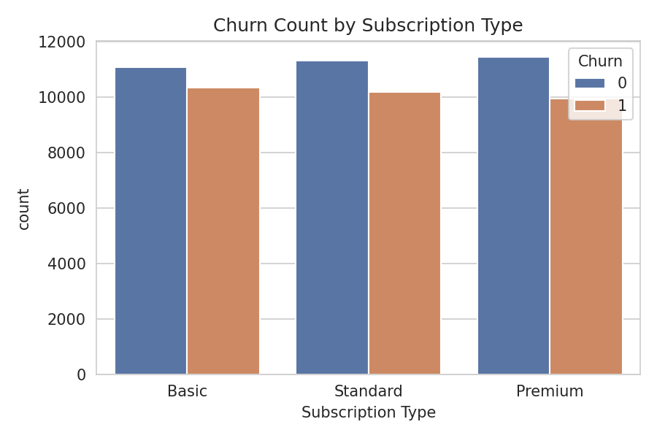
Figure 1: Distribution of churned vs. retained customers across Basic, Standard, and Premium subscription tiers.
Histogram – Age Distribution
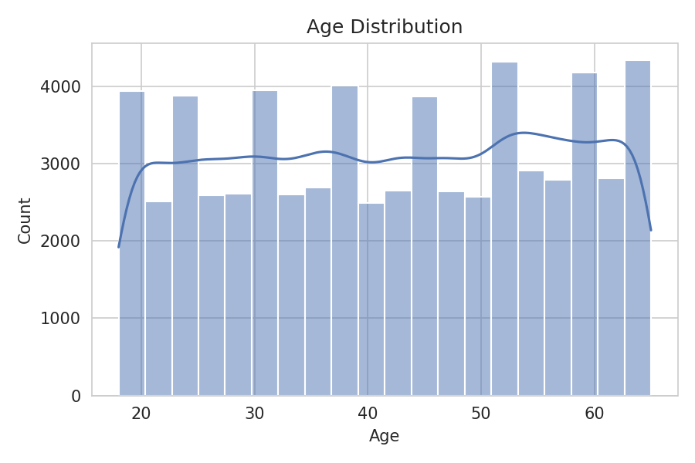
Figure 2: Frequency distribution of customer age, showing a broadly uniform spread between 18 and 65 years.

Box Plot – Total Spend by Churn Status
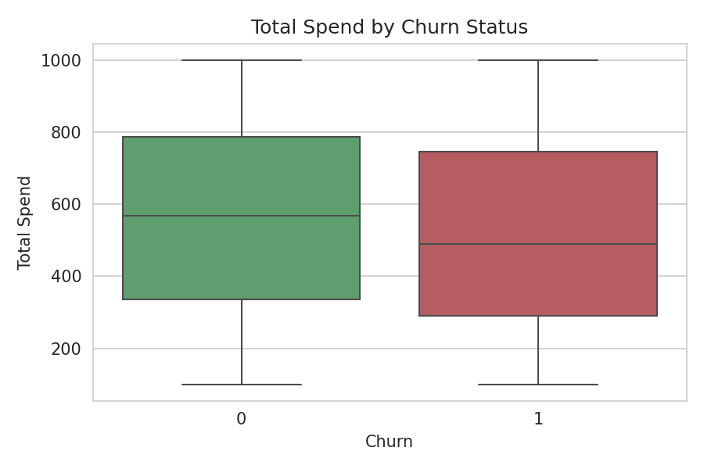
Figure 3: Comparison of total spend distribution between churned and non-churned customers, highlighting median, quartiles, and spread.
Scatter Plot – Tenure vs. Total Spend
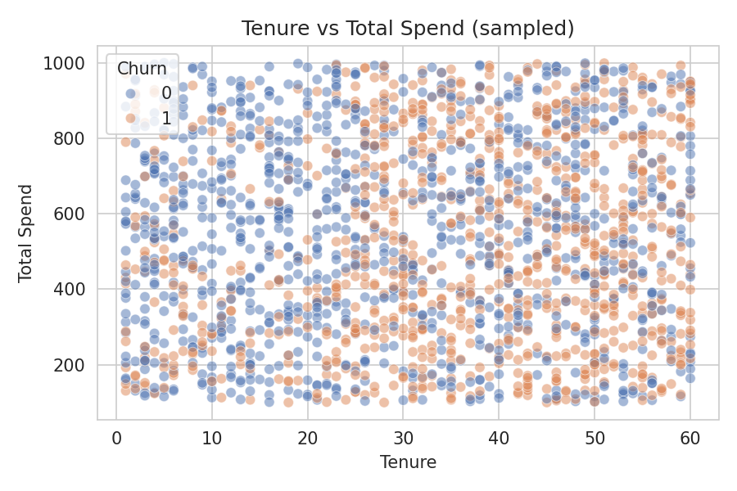
Figure 4: Relationship between customer tenure and total spend (sampled), coloured by churn status.

Heatmap – Correlation Matrix
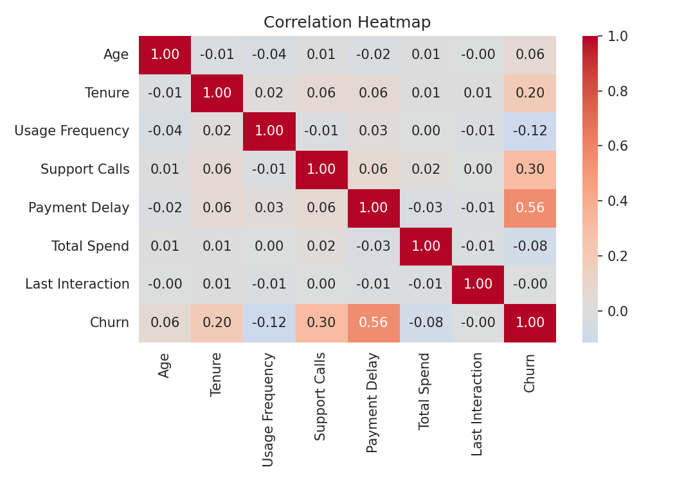
Figure 5: Pairwise Pearson correlation between all numerical features, including the target variable Churn.
Pie Chart – Overall Churn Proportion
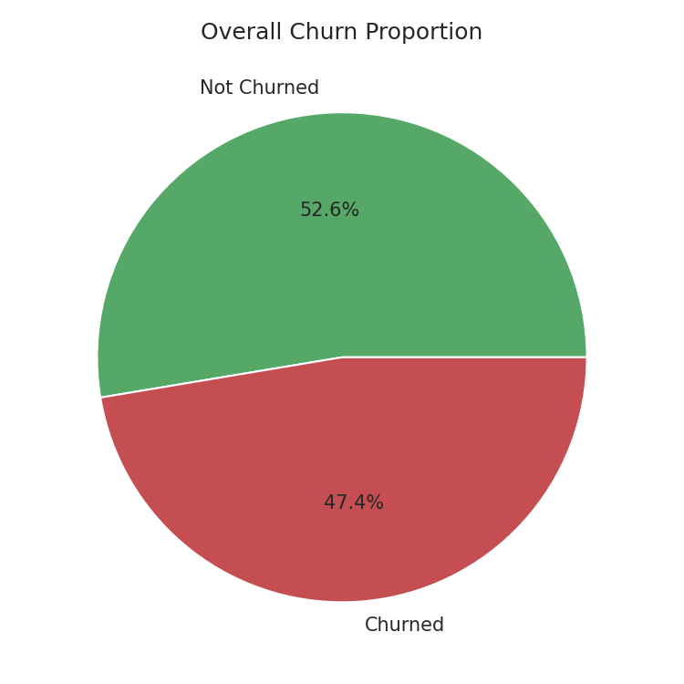
Figure 6: Overall proportion of churned vs. retained customers in the dataset.

