Phase 3 – MODEL DEVELOPMENT

Name: Caleb. S
Department: Mechanical Engineering
Roll no: 2503713811421004
--------------------------------------------------------------------------------------------------------

1. Problem Definition
Task A — Churn Classification
Predict whether a customer will discontinue their subscription (Churn = 1) or remain active (Churn = 0), based on their demographic and behavioural attributes. This is a supervised binary classification problem, since the target variable takes exactly two discrete classes.
Task B — Total Spend Regression
Predict a customer's Total Spend (a continuous dollar value, ranging $100–$1,000 in this dataset) based on their remaining attributes, including whether they churned. This is a supervised regression problem, since the target is a continuous numeric quantity rather than a discrete class label. Modelling spend is useful for estimating customer value and prioritizing retention efforts on high-value at-risk customers.

2. Feature Selection
Task A — Selected Features (10 predictors) and Target
- Age, Gender, Tenure, Usage Frequency, Support Calls, Payment Delay, Subscription Type, Contract Length, Total Spend, Last Interaction
- Target variable: Churn (binary: 1 = churned, 0 = retained)
CustomerID was dropped as it is a unique identifier with no predictive value. All ten remaining attributes were retained, since Phase 2's correlation analysis showed each has a measurable relationship with churn; Payment Delay and Support Calls were expected to dominate given their strong correlation with the target.
Task B — Selected Features (9 predictors) and Target
- Age, Gender, Tenure, Usage Frequency, Support Calls, Payment Delay, Subscription Type, Contract Length, Last Interaction, Churn
- Target variable: Total Spend (continuous, $100–$1,000)
For this task, Total Spend moves from being a predictor (as it was in Task A) to being the target, and Churn moves from target to predictor — since whether a customer has already churned is a legitimate, known input when estimating their lifetime spend. CustomerID was again excluded for the same reason as above.
Categorical Encoding & Scaling (both tasks)
Gender, Subscription Type, and Contract Length were label-encoded to numeric form so that all models could consume them. Features were standardized (zero mean, unit variance) before training the linear models (Logistic Regression, Linear Regression), since these are sensitive to feature scale; the tree-based models (Decision Tree, Random Forest) were trained on unscaled features, as they are scale-invariant by construction.

3. Algorithm Selection
Task A — Classification Algorithms
- Logistic Regression – interpretable linear baseline for binary classification
- Decision Tree Classifier – non-linear, rule-based model that captures threshold effects
- Random Forest Classifier – ensemble of decision trees that reduces overfitting and improves generalization
Logistic Regression provides a fast, interpretable baseline. The Decision Tree was included because churn is often driven by threshold behaviour (e.g., "more than N days of payment delay"), which trees capture naturally. Random Forest was included as it typically outperforms a single tree by averaging over many trees trained on bootstrapped samples, reducing variance and overfitting.
Task B — Regression Algorithms
- Linear Regression – interpretable linear baseline for continuous-value prediction
- Random Forest Regressor – ensemble of regression trees that captures non-linear relationships
Linear Regression was chosen as the standard baseline for regression tasks, modelling Total Spend as a weighted linear combination of the input features. The Random Forest Regressor was chosen as the non-linear counterpart, since it can capture interaction effects between features (e.g., the relationship between tenure and spend may differ across subscription types) that a purely linear model cannot represent.

4. Model Development
Python Implementation — Data Preparation
train_raw = pd.read_csv('customer_churn_dataset-training-master.csv').dropna()
test_raw = pd.read_csv('customer_churn_dataset-testing-master.csv').dropna()
combined = pd.concat([train_raw, test_raw], ignore_index=True)
combined = combined.drop_duplicates(subset=['CustomerID'], keep='first')

for col in ['Gender', 'Subscription Type', 'Contract Length']:
combined[col] = LabelEncoder().fit_transform(combined[col])
Task A — Classification: Training & Testing
X = combined[feat_cols_clf]
y = combined['Churn'].astype(int)
X_train, X_test, y_train, y_test = train_test_split(
X, y, test_size=0.2, random_state=42, stratify=y)

lr = LogisticRegression(max_iter=1000, random_state=42).fit(X_train_scaled, y_train)
dt = DecisionTreeClassifier(max_depth=8, random_state=42).fit(X_train, y_train)
rf = RandomForestClassifier(n_estimators=150, max_depth=10, random_state=42).fit(X_train, y_train)

pred_lr, pred_dt, pred_rf = lr.predict(X_test_scaled), dt.predict(X_test), rf.predict(X_test)
Task B — Regression: Training & Testing
Xr = combined[feat_cols_reg]
yr = combined['Total Spend']
Xr_train, Xr_test, yr_train, yr_test = train_test_split(
Xr, yr, test_size=0.2, random_state=42)

linreg = LinearRegression().fit(Xr_train_scaled, yr_train)
rfreg = RandomForestRegressor(n_estimators=150, max_depth=12, random_state=42).fit(Xr_train, yr_train)

pred_lin, pred_rfreg = linreg.predict(Xr_test_scaled), rfreg.predict(Xr_test)
Both tasks use an 80/20 train-test split on the consolidated 442,211-row dataset — 353,768 training rows and 88,443 testing rows — with the classification split stratified to preserve the churn/non-churn ratio in both partitions.

5. Model Evaluation
Two different families of metrics are required because the two tasks answer different kinds of question: classification metrics assess how well discrete labels are assigned, while regression metrics assess how close continuous predictions are to actual values.
Task A — Classification Metrics (Accuracy / Precision / Recall / F1-Score)
All four metrics are derived from the confusion matrix, which cross-tabulates predicted vs. actual class:
Accuracy = (TP + TN) / (TP + TN + FP + FN)
Precision = TP / (TP + FP)
Recall = TP / (TP + FN)
F1-Score = 2 × (Precision × Recall) / (Precision + Recall)
Precision matters when a false positive (predicting churn for a loyal customer) is costly — it measures how trustworthy a "churn" prediction is. Recall matters when a false negative (missing a customer who actually churns) is costly — it measures how many true churners are actually caught. F1-Score balances the two into a single number, which is useful here since missing an early sign of churn and wasting a retention offer are both real costs.
Model | Accuracy | Precision | Recall | F1-Score
Logistic Regression | 84.95% | 0.8777 | 0.8538 | 0.8656
Decision Tree | 98.81% | 0.9981 | 0.9808 | 0.9894
Random Forest | 99.35% | 0.9981 | 0.9905 | 0.9943
Confusion Matrices
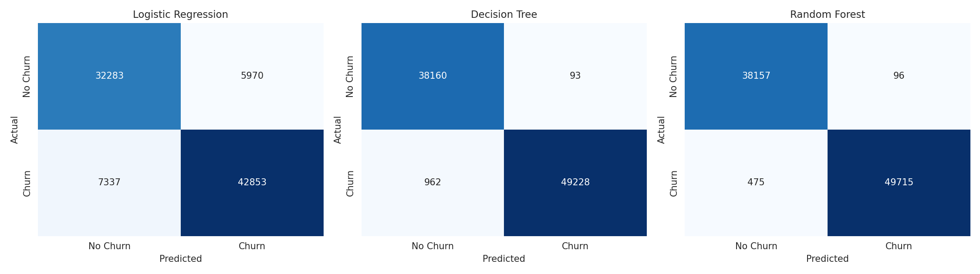
Figure 1: Confusion matrices for all three classifiers on the held-out test set (88,443 customers).
Logistic Regression, constrained to a linear decision boundary, produces the most errors — 5,970 false positives and 7,337 false negatives — since churn in this data depends on threshold effects (e.g., payment delay crossing a certain number of days) that a straight-line boundary cannot represent well. The Decision Tree sharply reduces both error types (93 false positives, 962 false negatives), and the Random Forest improves further still, misclassifying only 571 of 88,443 customers (96 false positives, 475 false negatives) — the fewest of the three.
Per-Class Breakdown (Random Forest)
Class | Precision | Recall | F1-Score | Support
No Churn (0) | 0.99 | 1.00 | 0.99 | 38,253
Churn (1) | 1.00 | 0.99 | 0.99 | 50,190
The Random Forest performs almost identically well on both classes, which confirms the strong overall metrics are not being propped up by good performance on only the majority class — an important check given the classes are not perfectly balanced (56.7% churn rate in the underlying pooled data).
Task B — Regression Metrics (MAE / MSE / RMSE / R²)
These metrics quantify how close predicted Total values are to actual values:
MAE = (1/n) Σ |yᵢ − ŷᵢ| — average absolute error
MSE = (1/n) Σ (yᵢ − ŷᵢ)² — average squared error;
RMSE = √MSE — squared error brought back
R² = 1 − (SS_residual / SS_total) — proportion of variance in Total explained by the model
Model | MAE ($) | MSE | RMSE ($) | R² Score
Linear Regression | 181.94 | 47,343.07 | 217.58 | 0.1859
Random Forest Regressor | 179.39 | 46,293.20 | 215.16 | 0.2040
Actual vs. Predicted Value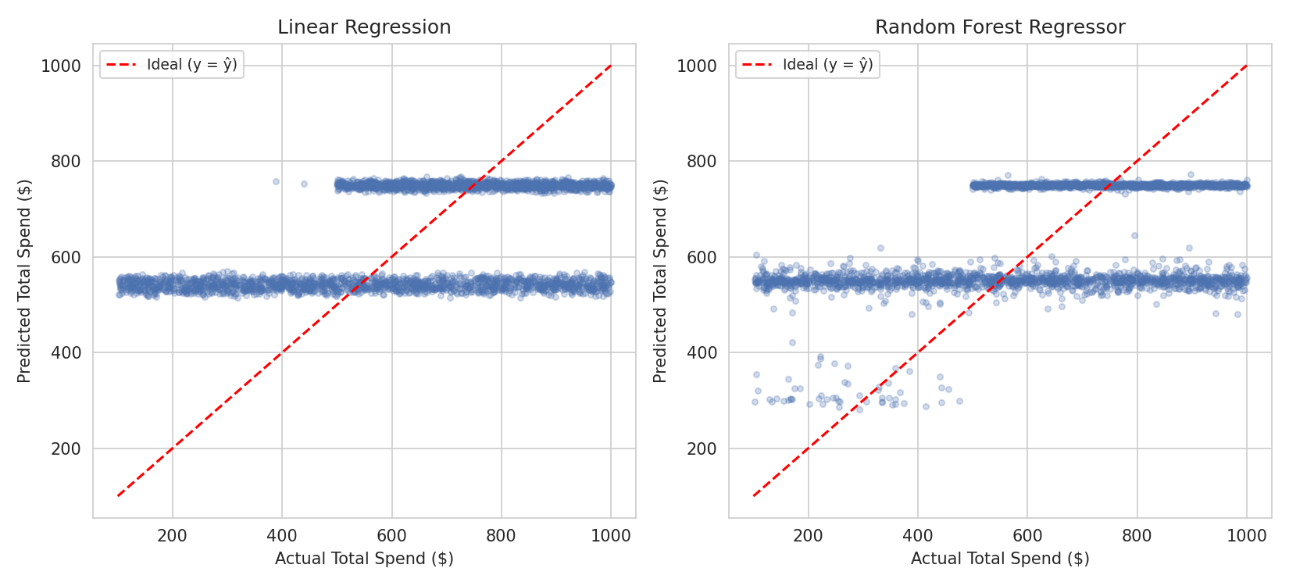
Figure 2: Actual vs. predicted Total Spend for both regression models (3,000-point sample from the test set); the red dashed line marks perfect prediction.

6. Model Comparison
Task A — Classification Comparison
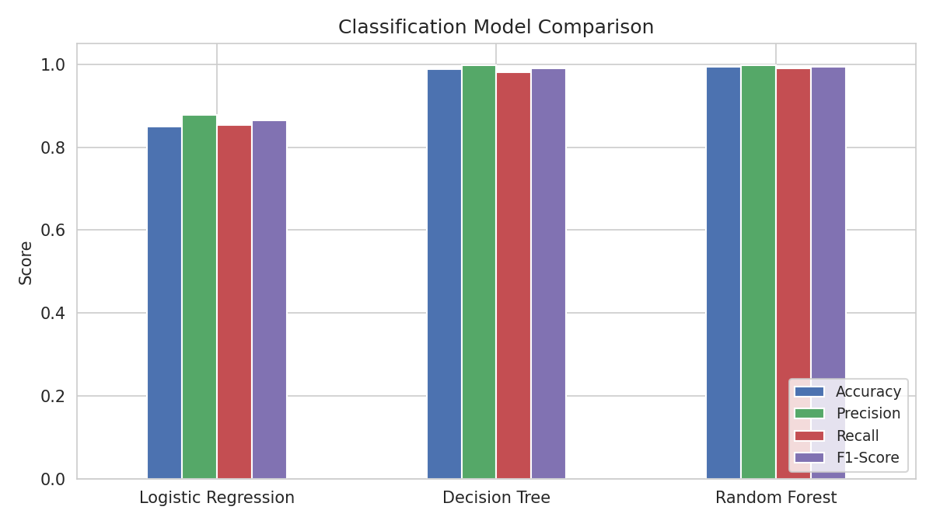
Figure 3: Accuracy, Precision, Recall, and F1-Score compared across all three classifiers.
Logistic Regression trails the other two models across every metric (84.95% accuracy), confirming that churn in this dataset is not fully linearly separable. The Decision Tree performs strongly (98.81% accuracy), and the Random Forest is the best performer on every metric (99.35% accuracy, 0.9981 precision, 0.9905 recall, 0.9943 F1-score), consistent with its ability to average over many trees and reduce the overfitting risk that a single deep tree carries.
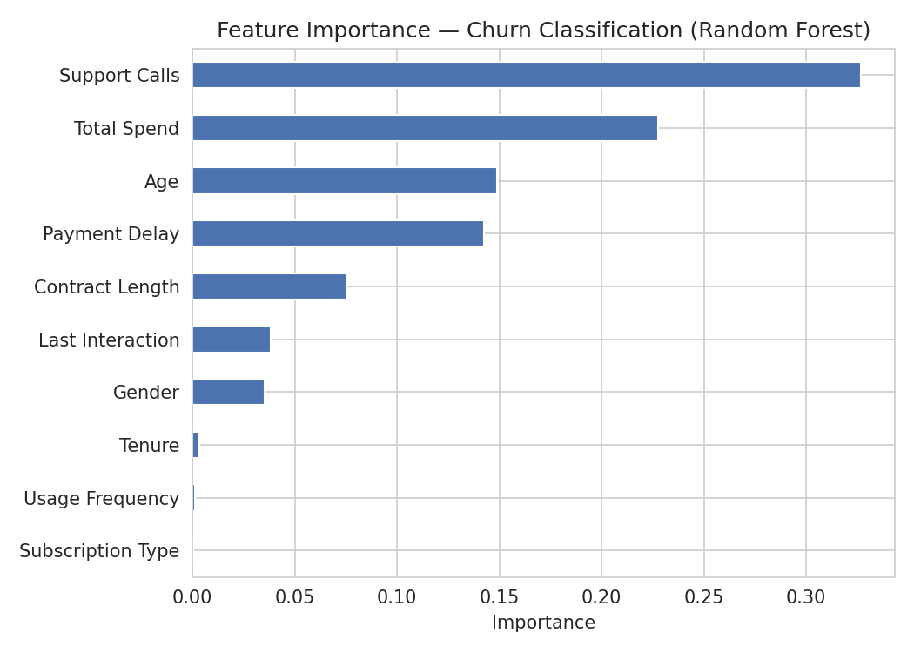
Figure 4: Feature importance for churn classification (Random Forest) — Support Calls, Total Spend, Age, and Payment Delay dominate.
Support Calls (32.7%) is the single strongest predictor of churn in the pooled dataset, ahead of Total Spend (22.7%), Age (14.9%), and Payment Delay (14.2%) — together these four features account for over 84% of the Random Forest's total decision-making weight.
Task B — Regression Comparison
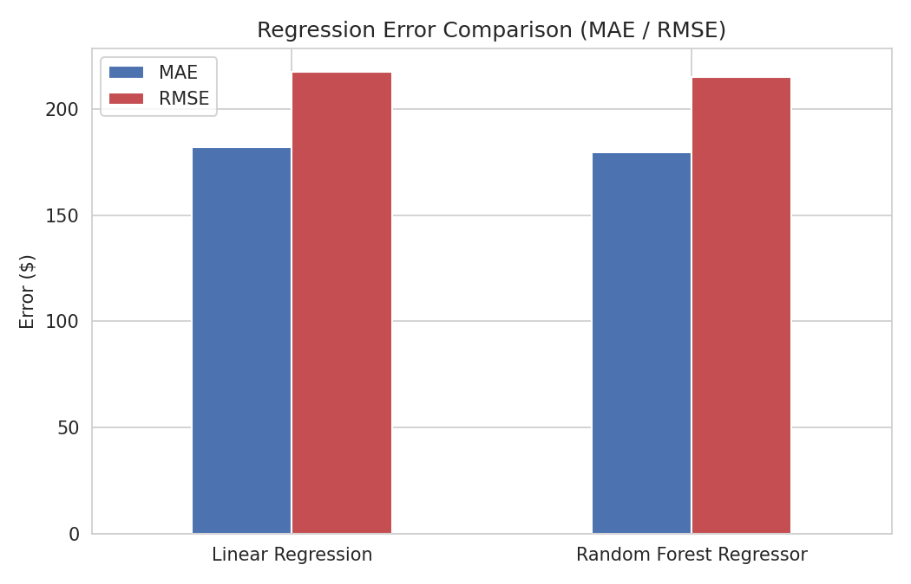
Figure 5: MAE and RMSE compared between Linear Regression and Random Forest Regressor.
The Random Forest Regressor edges out Linear Regression on every metric, but only marginally — roughly $2.50 lower MAE and an R² about 0.018 higher. This narrow gap suggests the relationship between the input features and Total Spend is close to linear (or too weak for a non-linear model to meaningfully exploit further), unlike the churn classification task, where the non-linear models pulled sharply ahead.
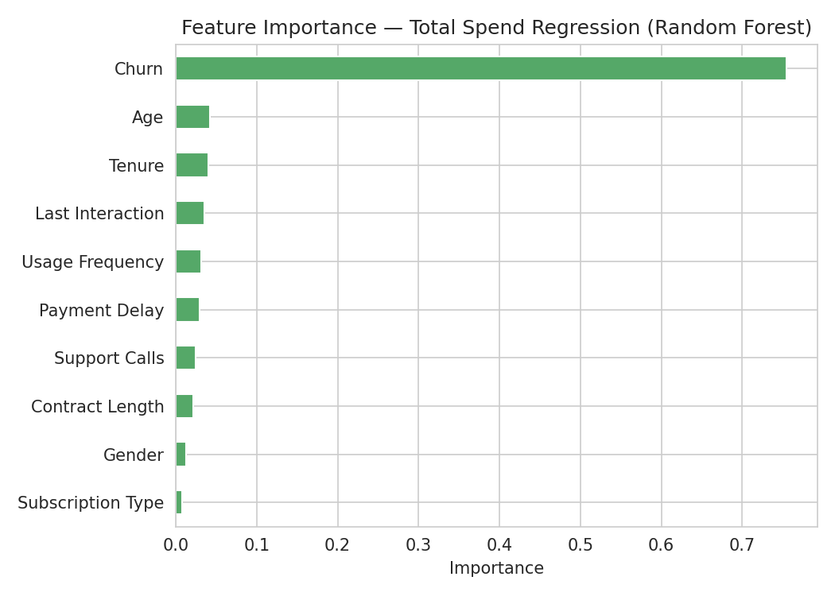
Figure 6: Feature importance for Total Spend regression (Random Forest) — Churn status dominates, with all other features contributing modestly.
Churn status alone accounts for 75.5% of the Random Forest Regressor's decision-making weight, far more than any other feature — likely because churned and retained customers occupy systematically different spend ranges in this dataset. Age, Tenure, Last Interaction, and Usage Frequency each contribute modestly (3–4% apiece), while Subscription Type and Gender contribute the least.
Overall Best-Performing Models
- Classification: Random Forest Classifier — 99.35% accuracy, the strongest and most balanced performer across precision, recall, and F1-score, and recommended for deployment in a churn early-warning system.
- Regression: Random Forest Regressor — marginally better than Linear Regression on all four metrics, though both models leave the majority of Total Spend's variance unexplained, suggesting spend is only weakly determined by the behavioural attributes captured in this dataset and would benefit from additional features (e.g., purchase category, transaction-level data) in future work.

FULL CODE:
import pandas as pd
import numpy as np
from sklearn.model_selection import train_test_split
from sklearn.preprocessing import LabelEncoder, StandardScaler
from sklearn.linear_model import LogisticRegression, LinearRegression
from sklearn.tree import DecisionTreeClassifier
from sklearn.ensemble import RandomForestClassifier, RandomForestRegressor
from sklearn.metrics import (
accuracy_score, precision_score, recall_score, f1_score,
confusion_matrix, classification_report,
mean_absolute_error, mean_squared_error, r2_score
)

train_raw = pd.read_csv('customer_churn_dataset-training-master.csv').dropna()
test_raw = pd.read_csv('customer_churn_dataset-testing-master.csv').dropna()

combined = pd.concat([train_raw, test_raw], ignore_index=True)
combined = combined.drop_duplicates()
combined = combined.drop_duplicates(subset=['CustomerID'], keep='first')

print("Combined dataset shape:", combined.shape)
print("Overall churn rate:", combined['Churn'].mean())

df = combined.copy()

le_gender = LabelEncoder()
le_sub = LabelEncoder()
le_contract = LabelEncoder()

df['Gender'] = le_gender.fit_transform(df['Gender'])
df['Subscription Type'] = le_sub.fit_transform(df['Subscription Type'])
df['Contract Length'] = le_contract.fit_transform(df['Contract Length'])

feat_cols_clf = [
'Age', 'Gender', 'Tenure', 'Usage Frequency', 'Support Calls',
'Payment Delay', 'Subscription Type', 'Contract Length',
'Total Spend', 'Last Interaction'
]

X = df[feat_cols_clf]
y = df['Churn'].astype(int)

X_train, X_test, y_train, y_test = train_test_split(
X, y, test_size=0.2, random_state=42, stratify=y
)

scaler = StandardScaler().fit(X_train)
X_train_scaled = scaler.transform(X_train)
X_test_scaled = scaler.transform(X_test)

lr = LogisticRegression(max_iter=1000, random_state=42)
lr.fit(X_train_scaled, y_train)

dt = DecisionTreeClassifier(max_depth=8, random_state=42)
dt.fit(X_train, y_train)

rf = RandomForestClassifier(n_estimators=150, max_depth=10, random_state=42, n_jobs=-1)
rf.fit(X_train, y_train)

pred_lr = lr.predict(X_test_scaled)
pred_dt = dt.predict(X_test)
pred_rf = rf.predict(X_test)

classifiers = {
'Logistic Regression': pred_lr,
'Decision Tree': pred_dt,
'Random Forest': pred_rf
}

print("\n=== CLASSIFICATION RESULTS ===")
for name, pred in classifiers.items():
print(f"\n--- {name} ---")
print("Accuracy: ", round(accuracy_score(y_test, pred), 4))
print("Precision:", round(precision_score(y_test, pred), 4))
print("Recall: ", round(recall_score(y_test, pred), 4))
print("F1-Score: ", round(f1_score(y_test, pred), 4))
print("Confusion Matrix:\n", confusion_matrix(y_test, pred))
print(classification_report(y_test, pred, target_names=['No Churn', 'Churn']))
importances_clf = pd.Series(rf.feature_importances_, index=feat_cols_clf)
print("\nFeature Importance — Churn Classification:")
print(importances_clf.sort_values(ascending=False))

feat_cols_reg = [
'Age', 'Gender', 'Tenure', 'Usage Frequency', 'Support Calls',
'Payment Delay', 'Subscription Type', 'Contract Length',
'Last Interaction', 'Churn'
]

Xr = df[feat_cols_reg]
yr = df['Total Spend']

Xr_train, Xr_test, yr_train, yr_test = train_test_split(
Xr, yr, test_size=0.2, random_state=42
)

scaler_r = StandardScaler().fit(Xr_train)
Xr_train_scaled = scaler_r.transform(Xr_train)
Xr_test_scaled = scaler_r.transform(Xr_test)

linreg = LinearRegression()
linreg.fit(Xr_train_scaled, yr_train)

rfreg = RandomForestRegressor(n_estimators=150, max_depth=12, random_state=42, n_jobs=-1)
rfreg.fit(Xr_train, yr_train)

pred_lin = linreg.predict(Xr_test_scaled)
pred_rfreg = rfreg.predict(Xr_test)

regressors = {
'Linear Regression': pred_lin,
'Random Forest Regressor': pred_rfreg
}

print("\n\n=== REGRESSION RESULTS (Target: Total Spend) ===")
for name, pred in regressors.items():
mae = mean_absolute_error(yr_test, pred)
mse = mean_squared_error(yr_test, pred)
rmse = np.sqrt(mse)
r2 = r2_score(yr_test, pred)
print(f"\n--- {name} ---")
print(f"MAE: ${mae:.2f}")
print(f"MSE: {mse:.2f}")
print(f"RMSE: ${rmse:.2f}")
print(f"R2: {r2:.4f}")

importances_reg = pd.Series(rfreg.feature_importances_, index=feat_cols_reg)
print("\nFeature Importance — Total Spend Regression:")
print(importances_reg.sort_values(ascending=False))

