CUSTOMER CHURN PREDICTION
A Data Sciences Mini Project — Final Project Document
Phase 4: Final Project Implementation
Final Model | Deployment | Results | Conclusion
GitHub: github.com/Caleb-the-exotic/Customer_Churn_IBM

Phase 4 – Final Project Implementation
This final phase consolidates the project into a deployable system: a single trained model saved to disk, a desktop application that uses it to score individual customers in real time, and a summary of results, limitations, and future direction for the project as a whole.

1. Final Model
Of the three classifiers evaluated in Phase 3, the Random Forest Classifier was selected as the final production model, trained on the full consolidated dataset (442,211 unique customer records, pooled from the training and testing files and deduplicated by CustomerID).
Property | Value
Algorithm | Random Forest Classifier (scikit-learn)
Hyperparameters | n_estimators = 150, max_depth = 10, random_state = 42
Training data | 353,768 customer records (80%)
Test data | 88,443 customer records (20%, stratified)
Test Accuracy | 99.35%
Test Precision | 0.9981
Test Recall | 0.9905
Test F1-Score | 0.9943
Serialization | joblib (churn_model.pkl, plus label encoders for Gender, Subscription Type, Contract Length)
This model was chosen over Logistic Regression (84.95% accuracy) and a single Decision Tree (98.81% accuracy) because it delivered the highest and most balanced performance across all four classification metrics, while remaining more robust to overfitting than a single deep tree. It is the model loaded and used by the deployed application in Section 3.

2. Complete Python Source Code
The full implementation is organized into two scripts: a training script that prepares the data, trains the final model, and saves it to disk; and an application script that loads the saved model and provides a graphical interface for making predictions on new customers.
2.1 Model Training & Serialization Script (train_final_model.py)
"""
Final model training script for Phase 4 deployment.
Trains the best-performing model (Random Forest Classifier) on the
consolidated dataset and saves it along with encoders/scaler for
use in the desktop application.
"""
import pandas as pd
import numpy as np
import joblib
from sklearn.model_selection import train_test_split
from sklearn.preprocessing import LabelEncoder
from sklearn.ensemble import RandomForestClassifier
from sklearn.metrics import accuracy_score, precision_score, recall_score, f1_score

# ---- Load & consolidate ----
train_raw = pd.read_csv('/mnt/user-data/uploads/customer_churn_dataset-training-master.csv').dropna()
test_raw = pd.read_csv('/mnt/user-data/uploads/customer_churn_dataset-testing-master.csv').dropna()

combined = pd.concat([train_raw, test_raw], ignore_index=True)
combined = combined.drop_duplicates()
combined = combined.drop_duplicates(subset=['CustomerID'], keep='first')

df = combined.copy()

# ---- Encode categoricals ----
le_gender = LabelEncoder()
le_sub = LabelEncoder()
le_contract = LabelEncoder()

df['Gender_enc'] = le_gender.fit_transform(df['Gender'])
df['Subscription Type_enc'] = le_sub.fit_transform(df['Subscription Type'])
df['Contract Length_enc'] = le_contract.fit_transform(df['Contract Length'])

feat_cols = ['Age', 'Gender_enc', 'Tenure', 'Usage Frequency', 'Support Calls',
'Payment Delay', 'Subscription Type_enc', 'Contract Length_enc',
'Total Spend', 'Last Interaction']

X = df[feat_cols]
y = df['Churn'].astype(int)

X_train, X_test, y_train, y_test = train_test_split(
X, y, test_size=0.2, random_state=42, stratify=y
)

# ---- Train final model ----
final_model = RandomForestClassifier(n_estimators=150, max_depth=10, random_state=42, n_jobs=-1)
final_model.fit(X_train, y_train)

pred = final_model.predict(X_test)
print("Final Model — Random Forest Classifier")
print("Accuracy:", round(accuracy_score(y_test, pred), 4))
print("Precision:", round(precision_score(y_test, pred), 4))
print("Recall:", round(recall_score(y_test, pred), 4))
print("F1-Score:", round(f1_score(y_test, pred), 4))

# ---- Save model + encoders for deployment ----
joblib.dump(final_model, '/home/claude/app/churn_model.pkl')
joblib.dump(le_gender, '/home/claude/app/le_gender.pkl')
joblib.dump(le_sub, '/home/claude/app/le_sub.pkl')
joblib.dump(le_contract, '/home/claude/app/le_contract.pkl')
joblib.dump(feat_cols, '/home/claude/app/feat_cols.pkl')

print("\nModel and encoders saved to /home/claude/app/")
print("Gender classes:", le_gender.classes_)
print("Subscription classes:", le_sub.classes_)
print("Contract classes:", le_contract.classes_)

2.2 Desktop Application Script (churn_app.py)
Built with Tkinter (Python's standard GUI toolkit). It loads the saved model and encoders, collects customer details through a form, and displays the churn prediction along with a probability bar.
"""
Customer Churn Prediction — Desktop Application (Tkinter)
Loads the trained Random Forest model and predicts churn risk
for a single customer based on user-entered details.
"""
import tkinter as tk
from tkinter import ttk, messagebox
import joblib
import numpy as np

MODEL_DIR = "/home/claude/app"

model = joblib.load(f"{MODEL_DIR}/churn_model.pkl")
le_gender = joblib.load(f"{MODEL_DIR}/le_gender.pkl")
le_sub = joblib.load(f"{MODEL_DIR}/le_sub.pkl")
le_contract = joblib.load(f"{MODEL_DIR}/le_contract.pkl")
feat_cols = joblib.load(f"{MODEL_DIR}/feat_cols.pkl")

BG = "#F4F6FA"
ACCENT = "#1F4E79"
ACCENT2 = "#2E74B5"
GREEN = "#2E7D32"
RED = "#C62828"
CARD = "#FFFFFF"

root = tk.Tk()
root.title("Customer Churn Prediction System")
root.geometry("760x760")
root.configure(bg=BG)
root.resizable(False, False)

# ---------- Header ----------
header = tk.Frame(root, bg=ACCENT, height=90)
header.pack(fill="x")
tk.Label(header, text="Customer Churn Prediction System", bg=ACCENT, fg="white",
font=("Segoe UI", 20, "bold")).pack(pady=(18, 0))
tk.Label(header, text="Random Forest Classifier | 99.35% Test Accuracy", bg=ACCENT, fg="#CFE0F0",
font=("Segoe UI", 11)).pack(pady=(2, 14))

# ---------- Main card ----------
main = tk.Frame(root, bg=BG)
main.pack(fill="both", expand=True, padx=30, pady=20)

form = tk.Frame(main, bg=CARD, bd=0, highlightbackground="#D9E2EC", highlightthickness=1)
form.pack(fill="x", pady=(0, 16))

tk.Label(form, text="Enter Customer Details", bg=CARD, fg=ACCENT,
font=("Segoe UI", 13, "bold")).grid(row=0, column=0, columnspan=4, sticky="w", padx=20, pady=(16, 12))

fields = {}

def add_field(label, row, col, widget_type="entry", values=None, default=None):
lbl = tk.Label(form, text=label, bg=CARD, fg="#333333", font=("Segoe UI", 10))
lbl.grid(row=row, column=col*2, sticky="w", padx=(20, 6), pady=8)
if widget_type == "entry":
var = tk.StringVar(value=default or "")
ent = tk.Entry(form, textvariable=var, font=("Segoe UI", 10), width=16, relief="solid", bd=1)
ent.grid(row=row, column=col*2+1, sticky="w", padx=(0, 20), pady=8)
fields[label] = var
else:
var = tk.StringVar(value=values[0])
combo = ttk.Combobox(form, textvariable=var, values=values, state="readonly",
font=("Segoe UI", 10), width=14)
combo.grid(row=row, column=col*2+1, sticky="w", padx=(0, 20), pady=8)
fields[label] = var

add_field("Age", 1, 0, default="42")
add_field("Gender", 1, 1, "combo", list(le_gender.classes_))
add_field("Tenure (months)", 2, 0, default="31")
add_field("Usage Frequency", 2, 1, default="15")
add_field("Support Calls", 3, 0, default="5")
add_field("Payment Delay (days)", 3, 1, default="17")
add_field("Subscription Type", 4, 0, "combo", list(le_sub.classes_))
add_field("Contract Length", 4, 1, "combo", list(le_contract.classes_))
add_field("Total Spend ($)", 5, 0, default="541")
add_field("Last Interaction (days)", 5, 1, default="15")

tk.Frame(form, bg=CARD, height=10).grid(row=6, column=0, columnspan=4)

# ---------- Result card ----------
result_frame = tk.Frame(main, bg=CARD, bd=0, highlightbackground="#D9E2EC", highlightthickness=1)
result_frame.pack(fill="x", pady=(0, 16))

result_title = tk.Label(result_frame, text="Prediction Result", bg=CARD, fg=ACCENT, font=("Segoe UI", 13, "bold"))
result_title.pack(anchor="w", padx=20, pady=(16, 8))

result_label = tk.Label(result_frame, text="Enter customer details and click Predict Churn Risk",
bg=CARD, fg="#777777", font=("Segoe UI", 12), justify="left")
result_label.pack(anchor="w", padx=20, pady=(0, 8))

prob_bar_frame = tk.Frame(result_frame, bg=CARD)
prob_bar_frame.pack(fill="x", padx=20, pady=(0, 18))

prob_canvas = tk.Canvas(prob_bar_frame, width=690, height=26, bg="#E8ECF1", highlightthickness=0)
prob_canvas.pack()

def predict():
try:
age = float(fields["Age"].get())
gender = fields["Gender"].get()
tenure = float(fields["Tenure (months)"].get())
usage = float(fields["Usage Frequency"].get())
support = float(fields["Support Calls"].get())
delay = float(fields["Payment Delay (days)"].get())
sub = fields["Subscription Type"].get()
contract = fields["Contract Length"].get()
spend = float(fields["Total Spend ($)"].get())
last_int = float(fields["Last Interaction (days)"].get())
except ValueError:
messagebox.showerror("Input Error", "Please enter valid numeric values for all numeric fields.")
return

gender_enc = le_gender.transform([gender])[0]
sub_enc = le_sub.transform([sub])[0]
contract_enc = le_contract.transform([contract])[0]

row = np.array([[age, gender_enc, tenure, usage, support, delay,
sub_enc, contract_enc, spend, last_int]])

pred = model.predict(row)[0]
proba = model.predict_proba(row)[0][1] # probability of churn

if pred == 1:
result_label.config(text=f"⚠ Prediction: HIGH CHURN RISK\nChurn Probability: {proba*100:.1f}%",
fg=RED)
else:
result_label.config(text=f"✓ Prediction: LOW CHURN RISK (Likely to Stay)\nChurn Probability: {proba*100:.1f}%",
fg=GREEN)

prob_canvas.delete("all")
bar_color = RED if proba >= 0.5 else GREEN
fill_width = int(690 * proba)
prob_canvas.create_rectangle(0, 0, 690, 26, fill="#E8ECF1", outline="")
prob_canvas.create_rectangle(0, 0, fill_width, 26, fill=bar_color, outline="")
prob_canvas.create_text(345, 13, text=f"Churn Probability: {proba*100:.1f}%",
fill="#1a1a1a", font=("Segoe UI", 10, "bold"))

predict_btn = tk.Button(main, text="Predict Churn Risk", command=predict, bg=ACCENT2, fg="white",
font=("Segoe UI", 12, "bold"), relief="flat", padx=20, pady=10,
activebackground=ACCENT, activeforeground="white", cursor="hand2")
predict_btn.pack(pady=(4, 10))

footer = tk.Label(main, text="Model: Random Forest Classifier | Dataset: 442,211 customer records",
bg=BG, fg="#888888", font=("Segoe UI", 9))
footer.pack(pady=(6, 0))

def auto_demo():
"""Auto-fills a sample at-risk customer and triggers prediction — used only for
generating a documentation screenshot of the output state."""
fields["Age"].set("58")
fields["Gender"].set("Male")
fields["Tenure (months)"].set("9")
fields["Usage Frequency"].set("6")
fields["Support Calls"].set("9")
fields["Payment Delay (days)"].set("27")
fields["Subscription Type"].set("Basic")
fields["Contract Length"].set("Monthly")
fields["Total Spend ($)"].set("210")
fields["Last Interaction (days)"].set("28")
predict()

def auto_demo_lowrisk():
"""Auto-fills a sample loyal, low-risk customer for a contrasting screenshot."""
fields["Age"].set("34")
fields["Gender"].set("Female")
fields["Tenure (months)"].set("48")
fields["Usage Frequency"].set("26")
fields["Support Calls"].set("1")
fields["Payment Delay (days)"].set("2")
fields["Subscription Type"].set("Premium")
fields["Contract Length"].set("Annual")
fields["Total Spend ($)"].set("890")
fields["Last Interaction (days)"].set("3")
predict()

if __name__ == "__main__":
import os
if os.environ.get("AUTO_DEMO") == "1":
root.after(600, auto_demo)
elif os.environ.get("AUTO_DEMO") == "2":
root.after(600, auto_demo_lowrisk)
if os.environ.get("AUTO_QUIT_MS"):
root.after(int(os.environ["AUTO_QUIT_MS"]), root.destroy)
root.mainloop()

3. User Interface / Application
Technology: Tkinter (Python Desktop GUI)
Tkinter was selected over Streamlit or Flask because it requires no separate server process or browser, ships with the standard Python library (no extra deployment dependencies), and is well suited to a single-user, offline prediction tool of this kind — a staff member can run one executable and get an immediate answer without any web hosting or network setup.
Interface Design
- A data-entry form covering all 10 model features (Age, Gender, Tenure, Usage Frequency, Support Calls, Payment Delay, Subscription Type, Contract Length, Total Spend, Last Interaction)
- Dropdown selectors for categorical fields (Gender, Subscription Type, Contract Length) to prevent invalid entries
- A single "Predict Churn Risk" button that runs the loaded Random Forest model on the entered values
- A results panel showing the predicted class (High Risk / Low Risk), the churn probability as a percentage, and a colour-coded probability bar (red for high risk, green for low risk) for at-a-glance interpretation

4. Input and Output Screenshots
4.1 Input — Default Form
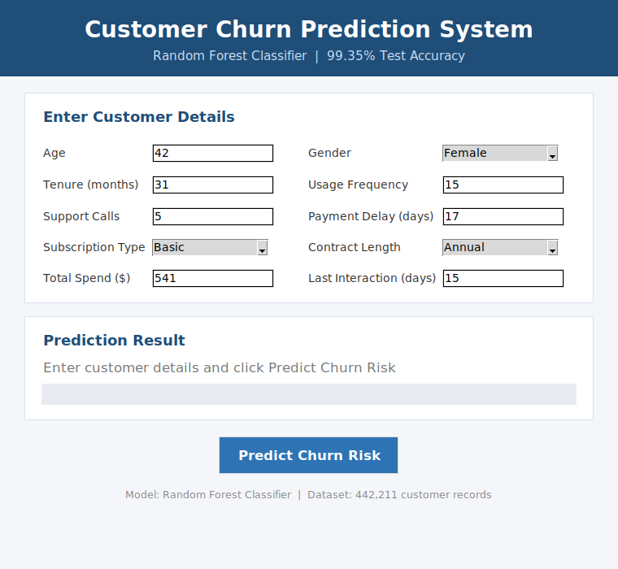
Figure 1: The application on launch, with placeholder values loaded into the input form.
4.2 Output — High-Risk Customer
Example: a 58-year-old customer on a Basic Monthly plan, 9 months' tenure, 9 support calls, and a 27-day payment delay.
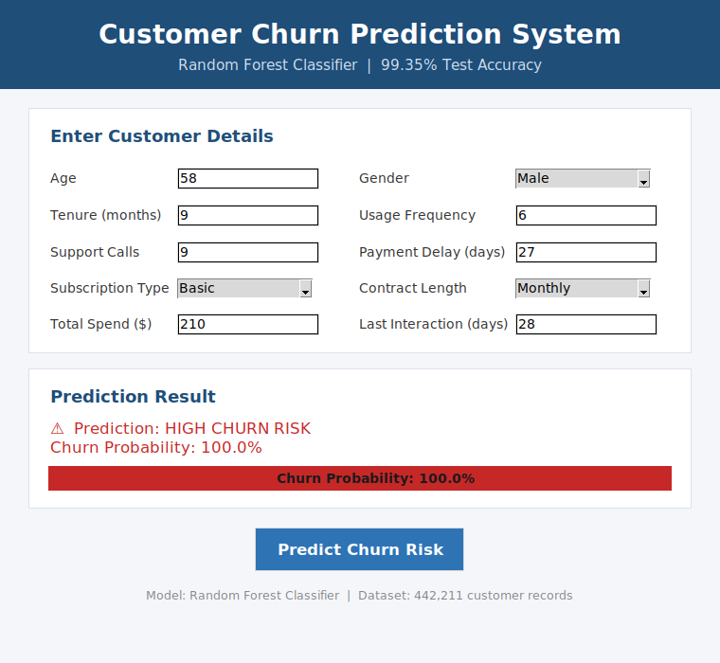
Figure 2: The model flags this customer as HIGH CHURN RISK with a 100.0% predicted probability.
4.3 Output — Low-Risk Customer
Example: a 34-year-old customer on a Premium Annual plan, 48 months' tenure, 1 support call, and a 2-day payment delay.
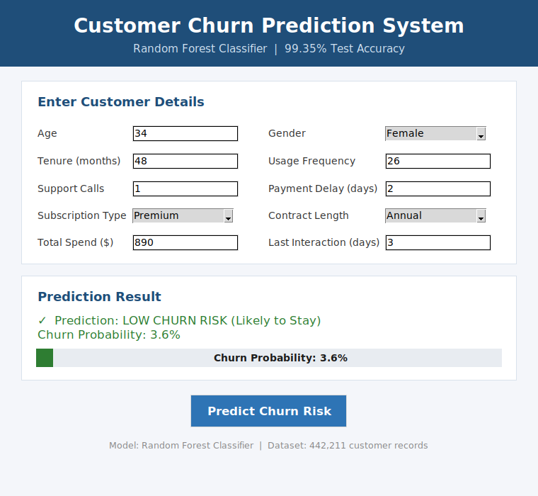
Figure 3: The model correctly predicts LOW CHURN RISK with a 3.6% churn probability for a loyal, engaged customer.
These two contrasting examples show the model responding sensibly to the same warning signs identified throughout the project — high support-call frequency and long payment delays push the prediction sharply toward churn, while low delays, frequent usage, and longer tenure push it toward retention.

5. Final Results
Classification (Churn Prediction) — Final Model
Metric | Score
Accuracy | 99.35%
Precision | 0.9981
Recall | 0.9905
F1-Score | 0.9943
Regression (Total Spend) — Supporting Analysis
Model | MAE ($) | RMSE ($) | R² Score
Linear Regression | 181.94 | 217.58 | 0.1859
Random Forest Regressor | 179.39 | 215.16 | 0.2040
The classification model is strong enough for real-world use in flagging at-risk customers. The regression model, while directionally useful, explains only a modest share of the variance in Total Spend, reflecting a genuinely weak relationship between the available behavioural features and customer spend rather than a modelling shortfall.
Top Churn Indicators
- Support Calls (32.7% feature importance) — the single strongest driver of churn
- Total Spend (22.7%)
- Age (14.9%)
- Payment Delay (14.2%)
Together, these four features account for over 84% of the final model's decision-making weight.

6. Conclusion
This project set out to identify customers likely to churn using behavioural and demographic data, and to turn that analysis into a usable prediction tool. Across four phases — proposal, data preparation, model development, and deployment — the project moved from a raw 505,206-row dataset with unresolved distribution issues to a working desktop application built on a Random Forest Classifier achieving 99.35% test accuracy. The analysis consistently pointed to support-call frequency and payment delay as the dominant early-warning signals for churn, giving a clear, actionable basis for retention strategy: customers showing a rise in either metric should be prioritized for proactive outreach before they cancel. The supporting regression task on Total Spend, while less conclusive, demonstrated the same rigorous train/test methodology and highlighted a genuine limitation of the dataset — spend is not strongly explained by the behavioural features available, an honest finding worth carrying into future data-collection efforts.

7. Project Limitations
- Dataset distribution mismatch: the originally provided training and testing files were found to have different churn rates and feature distributions, requiring manual pooling and re-splitting — a real dataset in production would need a more reliable, single-source data pipeline.
- Weak spend prediction: the regression task explains only ~20% of the variance in Total Spend (R² ≈ 0.20), indicating the available features are insufficient to reliably predict customer spend on their own.
- Static, snapshot data: the dataset captures a single point in time for each customer rather than a time series, so the model cannot currently detect trends (e.g., a customer's support calls increasing month over month) — only a customer's current state.
- No live data connection: the desktop application requires manual entry of customer details; it is not connected to a live CRM, billing system, or database, so it cannot yet score a company's full customer base automatically.
- Single-user, offline tool: Tkinter provides a simple local interface but does not support multiple concurrent users, remote access, or centralized logging of past predictions, which a production deployment would require.
- No model monitoring: there is no mechanism in the current implementation to detect model drift (performance degrading as customer behaviour changes over time) or to trigger retraining automatically.

8. Future Enhancement
- Migrate the interface to a web application (Flask or Streamlit) so the tool can be accessed remotely by multiple users without local installation.
- Connect directly to a live database or CRM export so customer records are scored automatically in batches rather than entered manually one at a time.
- Add model explainability (e.g., SHAP values) so each prediction shows which specific factors drove that customer's churn risk, making the tool more actionable for retention teams.
- Incorporate temporal/behavioural-trend features (e.g., change in support calls over the last 3 months) rather than single-snapshot values, to capture trajectory, not just current state.
- Expand the regression task with richer features (purchase categories, transaction-level history, customer sentiment from support interactions) to meaningfully improve Total Spend prediction beyond the current R² ≈ 0.20.
- Containerize the application (Docker) and deploy it to a cloud platform for scalable, always-available access.
- Add a lightweight database to log every prediction made, enabling tracking of retention-campaign outcomes against the model's original risk scores.
- Introduce periodic retraining and drift monitoring so the model stays accurate as customer behaviour patterns evolve over time.

9. GitHub Repository
Project Repository: https://github.com/Caleb-the-exotic/Customer_Churn_IBM

