% Circuit 1

E0 = 10;

R1 = 12000;

R2 = 15000;

R3 = 4300;

C = 0.000000022;

E = E0\*(R1/(R1+R2+R3));

Rth = R2\*(R1+R3)/(R2+(R1+R3));

Ith = E/Rth;

tau = Rth\*C;

t = 0:tau/100:2\*tau;

Vc = E.\*(1 - exp(-t./tau));

I2 = Vc./R2;

Ic = (E./Rth).\*exp(-t./tau)

I3 = I2 + Ic;

Vo = R3.\*I3;

subplot(1,3,1)

plot(t,Vo)

subplot(1,3,2)

plot(t,Vc)

subplot(1,3,3)

plot(t,Ic)

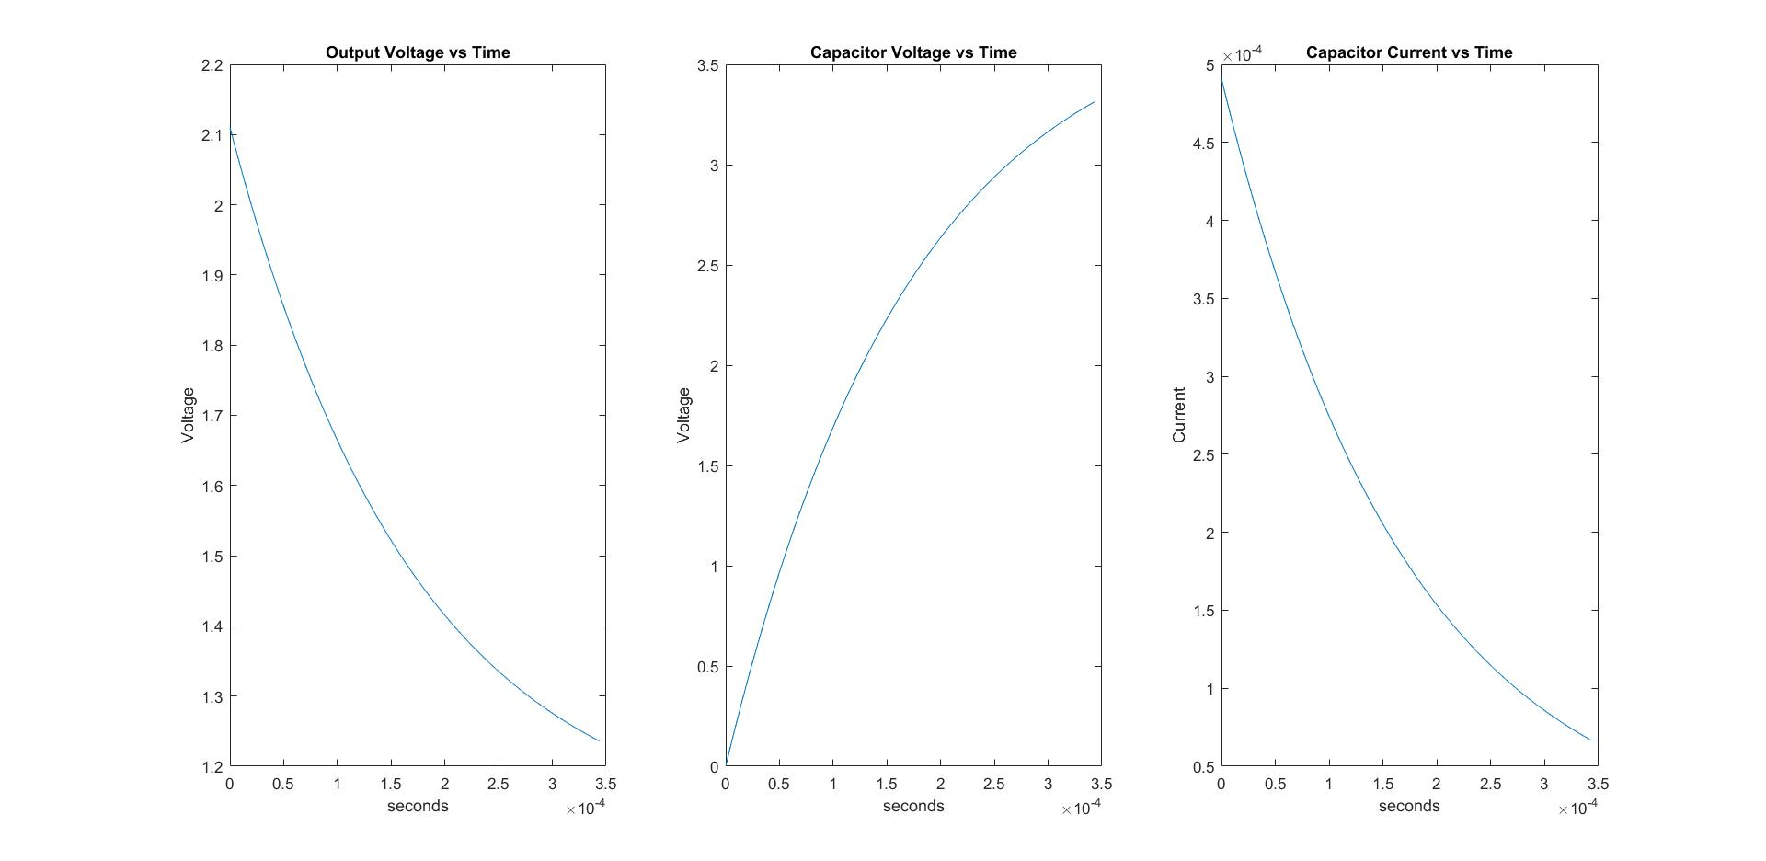

% Circuit 2

E0 = 10;

R1 = 12000;

R2 = 15000;

R3 = 4300;

L = 0.003

E = E0\*(R1/(R1+R2+R3));

R = R2\*(R1+R3)/(R2+(R1+R3));

I = E./R;

tau = R/L;

t = 0:tau/100:2\*tau;

Il = I.\*(1 - exp(-t./tau));

Vl = (I.\*R).\*exp(-t./tau)

I2 = Vl./R2;

I3 = I2 + Il;

Vo = R3.\*I3;

subplot(1,3,1)

plot(t,Vo)

subplot(1,3,2)

plot(t,Vl)

subplot(1,3,3)

plot(t,Il)

