Assignment 11 – Project Risk Management
Caleb Barrows
1. Microsoft Security Risk Management Guide
I looked at the Microsoft Security Risk Management Guide and compared it to the risk management planning topics in the chapter.
The guide is about security risk, not every kind of project risk. It has four phases. Assessing Risk includes planning the assessment, gathering data, and prioritizing the risks. It uses both a summary level and a detailed level, and it mixes qualitative and quantitative analysis. Conducting Decision Support is where the team picks controls, estimates the cost, and decides whether to control, accept, transfer, or avoid the risk. Implementing Controls is carrying out those plans. Measuring Program Effectiveness checks if the program is working. The guide uses a security risk scorecard for that step.
Those phases match most of the steps in the text. Planning the assessment is like planning risk management. Gathering data is like identifying risks. Prioritizing risks with qualitative and quantitative methods matches qualitative and quantitative risk analysis. Choosing to control, accept, transfer, or avoid a risk is planning the response. Putting the controls in place and measuring the program match implementing the responses and monitoring risks.
The guide does not cover everything in the chapter. It stays on security threats. It does not talk about schedule, cost, or scope risks on a project. It also does not use tools like a decision tree or expected monetary value. The guide discusses controlling, accepting, transferring, or avoiding a risk. These options overlap with the textbook’s risk response strategies. The guide applies them to information security risks.
The guide does address most of the risk management planning steps, but only for security risk. It would help with the security part of a project. It would not be enough by itself to plan risk for a whole project.
2. Expected monetary value
All four projects have a positive EMV. The up-front investments are not recovered, so they are shown as negative profits. EMV is the chance of each outcome times the profit, added together.
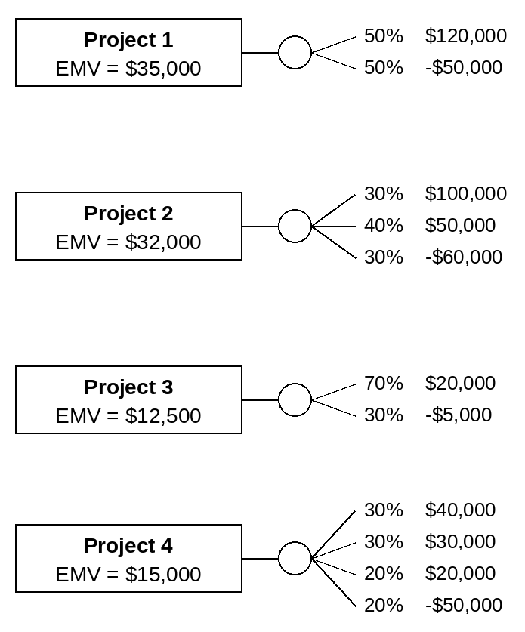
Project 1
EMV = (0.50 x $120,000) + (0.50 x -$50,000)
EMV = $60,000 - $25,000 = $35,000
Project 2
EMV = (0.30 x $100,000) + (0.40 x $50,000) + (0.30 x -$60,000)
EMV = $30,000 + $20,000 - $18,000 = $32,000
Project 3
EMV = (0.70 x $20,000) + (0.30 x -$5,000)
EMV = $14,000 - $1,500 = $12,500
Project 4
EMV = (0.30 x $40,000) + (0.30 x $30,000) + (0.20 x $20,000) + (0.20 x -$50,000)
EMV = $12,000 + $9,000 + $4,000 - $10,000 = $15,000
Which projects I would bid on
I would bid on Project 1 and Project 3. I would not bid on Project 2 or Project 4.
Project 1 has the highest EMV at $35,000. There is an equal chance of making $120,000 or losing $50,000. I would take that risk because the expected value is the best of the four projects.
Project 2 is close, with an EMV of $32,000, but I would not bid on it. There is a 30 percent chance of losing $60,000. That is the biggest loss in the table, and I am not comfortable with that chance.
Project 3 has the lowest EMV at $12,500, but I would still bid. There is a 70 percent chance of making $20,000, and the worst case is only losing $5,000. That fits my risk tolerance better than a project with a large possible loss.
Project 4 has an EMV of $15,000. I would not bid. A 20 percent chance of losing $50,000 is too much when the expected value is less than half of Project 1.

