Assignment 10 – Project Communications Management
Caleb Barrows
1. Communication channels
How many different communication channels does a project team with six people have? How many more communication channels would there be if the team grew to 10 people?
The formula is n(n-1)/2.
Six people: 6(5)/2 = 15 communication channels.
Ten people: 10(9)/2 = 45 communication channels.
45 - 15 = 30, so there would be 30 more communication channels.
2. Kanban board
T1 is already done. Ted is working on T2. T4, T5, and T6 have not been assigned yet.
To Do | In Progress | Done
T4 | T2 (Ted) | T1
T5
T6
3. Burndown chart
Days are on the horizontal axis and remaining effort is on the vertical axis.
Sprint Day | Remaining effort (story points)
1 | 75
2 | 55
3 | 45
4 | 0
5 | 0
6 | 0
7 | 0
8 | 0

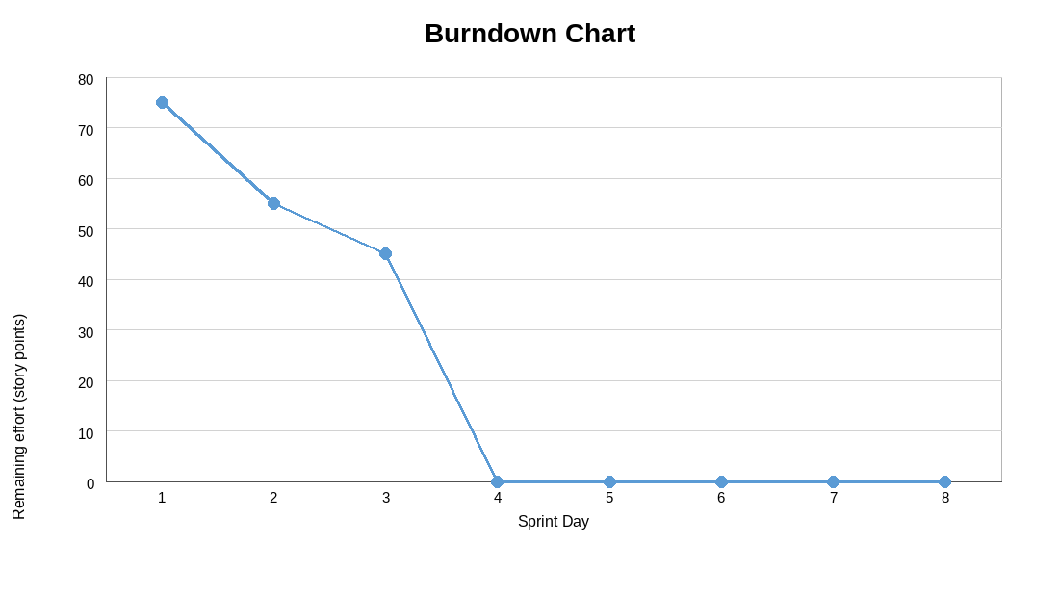
Average velocity
Average velocity = (Remaining effort Day 1 - Remaining effort Current Day) / (Current Day - Day 1)
Current day is day 3.
(75 - 45) / (3 - 1) = 30 / 2 = 15 story points per day.
Expected completion date
Expected completion date = Current Day + (Remaining effort / Average velocity)
3 + (45 / 15) = 3 + 3 = day 6.

