1. Ian
2. Owl
3. Mango
4. April -1
5. Canada
6. Tyson
7. Kyoto
8. Squash
9. University Collage (UC)
10. Borwick

Step 1. Inserting Ian

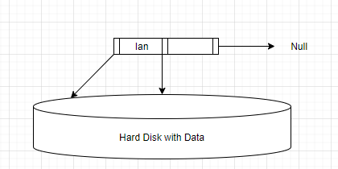

Step 2. Inserting Owl

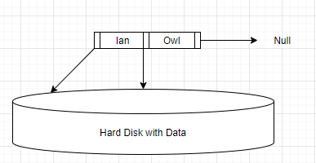

Step 3. Inserting Mango

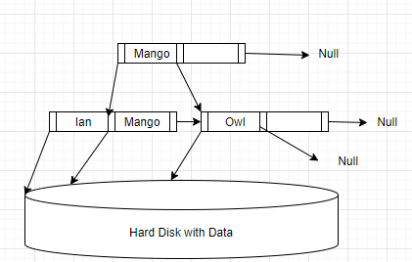

Step 4. Inserting April

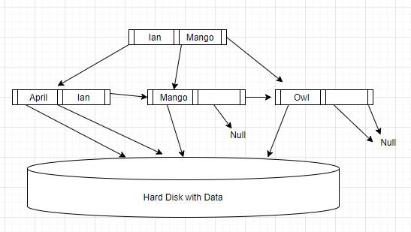

Step 5. Inserting Canada

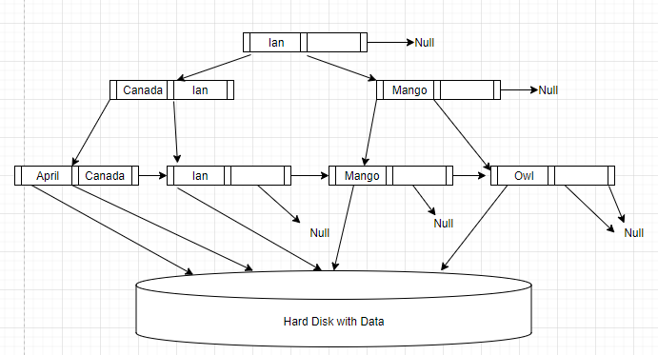

Step 6. Inserting Tyson

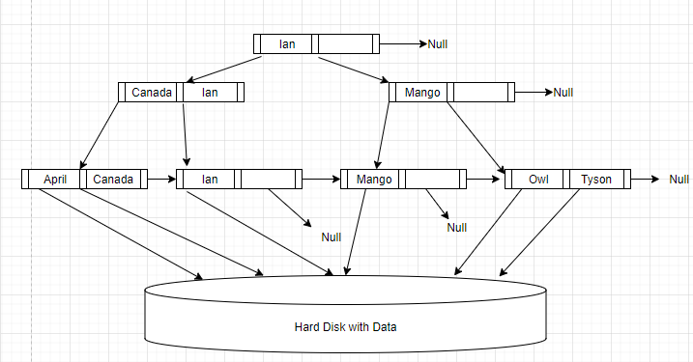

Step 7. Inserting Kyoto

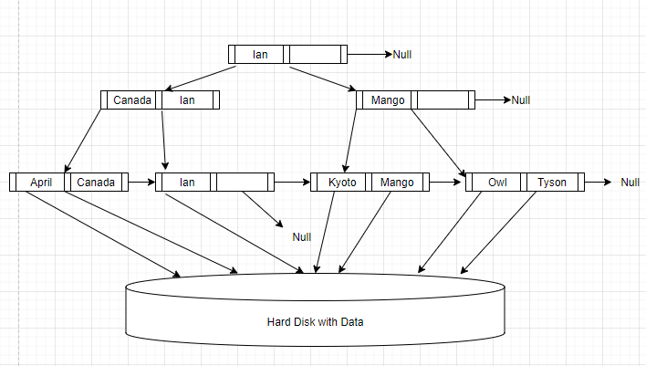

Step 8. Inserting Squash

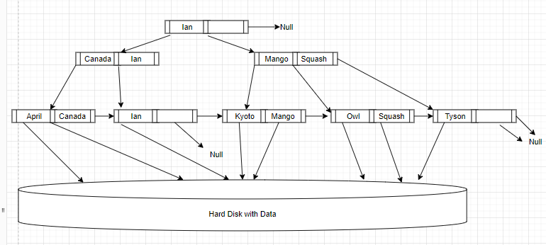

Step 9. Inserting University Collage (UC) 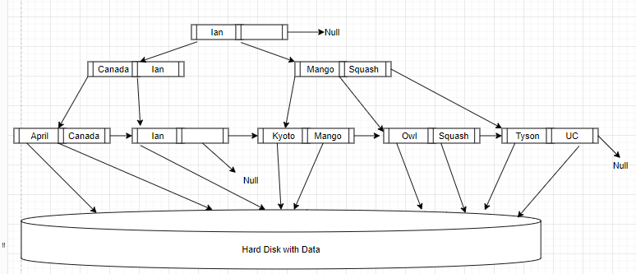

Step 10: Inserting Borwick

