

As Built
  - Project or Customer Name
16 July 2025
DOCUMENT NUMBER: 12345
The descriptions of other companies' products in this document, if any, are provided solely for the convenience of aiding understanding and should not be considered authoritative or an endorsement by Enterprisecloud. For authoritative descriptions of any non-Enterprisecloud products or services described herein, please consult the products' respective manufacturers. © 2025 Enterprisecloud. All rights reserved. This document contains confidential information that is proprietary to Enterprisecloud. Any use or distribution of these materials without the express authorisation of Enterprisecloud is strictly prohibited.

Document History
Revision History
Revision # | Revision Date | Summary of Changes | Author

Reference Documents
Document Name | Version | Author

Contents
1. Introduction 5
2. Solution Overview 6
3. Environments 8
4. PowerApps Solutions 9
4.1 Solution: [Provide Name] 9

4.1.1 Apps: 9

4.1.2 Global Choices 9

4.1.3 Tables: 9

4.1.4 Web Resources: 10

4.1.5 Cloud Flows (Power Automate Flows): 10

4.1.6 Processes: 12

4.1.7 Agents: 13

4.1.8 Plugins: 13
5. Data Model and Table Customisations 15
5.1 Table Name 15

5.1.1 Columns (fields) Created 15

5.1.2 Forms Created / Customised 16

5.1.3 Business Rules 16
6. App-Specific Configuration 18
7. Power Pages 20
8. Active Directory B2C 21
8.1 Azure Active Directory B2C Configuration - User Flows 21

8.1.1 User Onboarding – Registration Flow 21
9. Deployment Pipelines and Repo 22
9.1 Repo 22
9.2 Deploy Power Apps Portal 22

9.2.1 Main Pipeline Configuration - azure-pipelines.yml 23
10. API Specification 24
10.1 Internal APIs 24

10.1.1 Environment URLs 24

10.1.2 Sample API 24
11. Document Sign Off 26

Document Guidance
Please remove this section in its entirety, as it serves as internal guidance on how to structure this document.
To standardise how Enterprisecloud produces documents that communicate with our clients. Guidance is offered in green; it should be removed. The text in black is placeholder text that needs to be updated.
Please use the Heading and Document style formatting in this document.
Document Area | Style
Paragraph text | 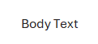  All paragraph text and table text should be Aptos size 10.
Headings
Tables | Use the “Plain Tables” and the selection highlighted below:  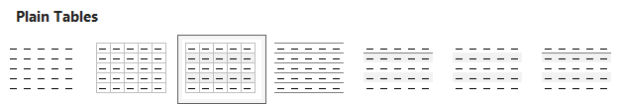  Ensure you turn off “First Column” in the Table Style Options:  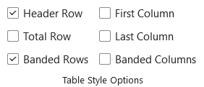
Lists and Bullets
Very Important: If you copy and paste text, paste it as plain text by right-clicking, and then selecting the plain text option below:
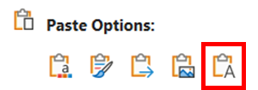
This will ensure that all documents have standardised fonts, sizes and that the document reads correctly, with appropriate navigation applied. If you paste text using CTRL-V, it retains the source document's formatting, which will break this document template.

Introduction
This document provides a detailed recordal of the changes and enhancements made to the Power Platform solution implemented for [Company] for the project: [Enter project name here].

Solution Overview
The diagram below shows a solution overview diagram of the solution components implemented in the project:
Note: Start with a solution overview diagram followed by a description of each solution component and the features that it contributes to the overall solution. Use the original architectural overview diagram and component breakdown you created in the Functional and Technical Design as a reference.
[Insert Architectural Diagram here]
Example below

Each of the above architectural components are further described below:
Component | Description
List each component in the architecture diagram, examples provided in green below: | Provide a description of the function of each component in your architecture diagram, examples provided in green below:
Power Pages | Power Pages is Microsoft’s solution for building low-code business websites with options for interacting with data in the Microsoft Dataverse. Power pages provides the scaffolding for client portal solution. Reasons for selecting this platform include simplified interaction with Dataverse data, scalability, and integration with Azure B2C.
Dataverse | Dataverse is the data service used by the Client Delivery App and other business applications across Customer. The Dataverse provides secure storage and management of business data along with seamless integration with power apps and power automate flow.
Power Automate | Power Automate is a workflow service that enables automation. In this solution, Power Automate is used to perform long running data maintenance jobs, synchronise data with other services, and automate business processes such as notifying users when portal files …
Component 1 | Component Description
Component 2 | Component Description

Environments
For the purposes of this project, the following environments were configured:
Name | URL | Purpose

PowerApps Solutions
Provide a detailed overview of the PowerApps solutions built during this project. Include tables, plugins, workflows, Power Automate flows etc. Make sure to include sequence and layering information.
The PowerApps Solutions configured in this project are seen below:

Solution: [Provide Name]
Display Name:
Type: Unmanaged
Publisher:
Publisher Prefix:
Installed On:

This solution houses the following functionality and customisations:

Apps:
The following apps were included in this solution:
- App 1
- App 2

Global Choices
The following global choices have been configured to support new column creation on existing and new tables for various functional requirements:

Global Choice Name
Display Name:
Use: On the Table [table name] to [provide purpose]
Schema Name:
Choices:
- One
- Two
- Three

Tables:
The list of tables below were included in this solution. Take note of the table customisation detail in the “Data Model and Table Customisations” section later in this document for more details.
- Table 1
- Table 2

Web Resources:
The following web resources were implemented in the project:
Name | Type | Purpose

Note: where web resources include custom code, break those down into more detail below, provide screenshots of the UX delivered and explain the functionality.

Cloud Flows (Power Automate Flows):
A list of flows included in this solution are seen below:
- Flow 1
- Flow 2

Each flow is now fully described below:

Flow 1: Sample Power Automate Flow
This Power Automate flow is triggered when the MFA switch on a contact record is set to true or false and where a contact has already been synchronized with B2C.
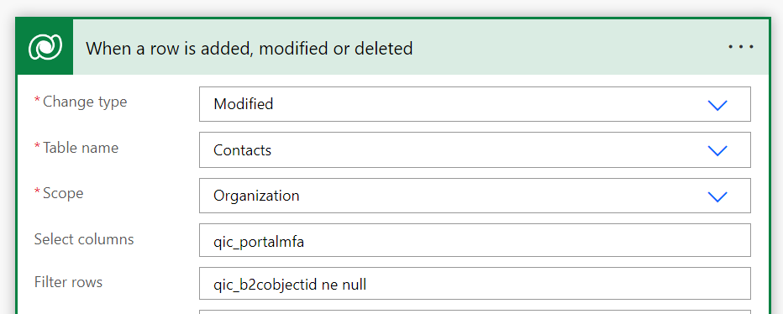
The steps in this Power Automate Flow are as follows:
- Retrieve secret required for authentication with Microsoft Graph
- Retrieve Active Directory Tenant ID, GroupID, and ClientID from site settings in Dataverse.
- Retrieve access token for interacting with Microsoft Graph
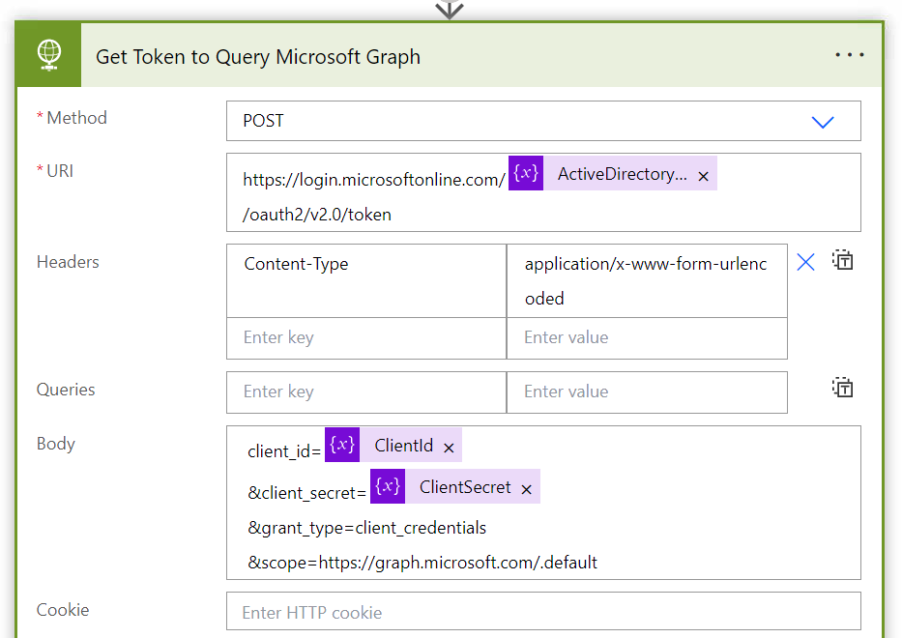
- Query Microsoft Graph to see if this contact is a member of the exclusion group in B2C. NOTE: Members of this group are excluded from MFA requirements. This exclusion was achieved by configuring a conditional access policy as described earlier in this document.
- Depending on the state of the MFA switch – add or remove the contact from the MFA exclusion group. NOTE: the Microsoft graph returns an error when querying for group membership when the user object is not a member of the group. This error state is used to infer “zero” if the correct error message is returned. Any other error message will leave the flow in a failed state. This condition is shown on the screen clipping below:
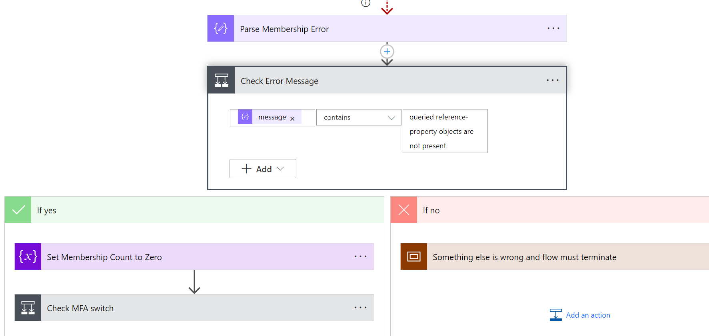

Flow Error Handling
All Power Automate Flows have been implemented within the following template:
1
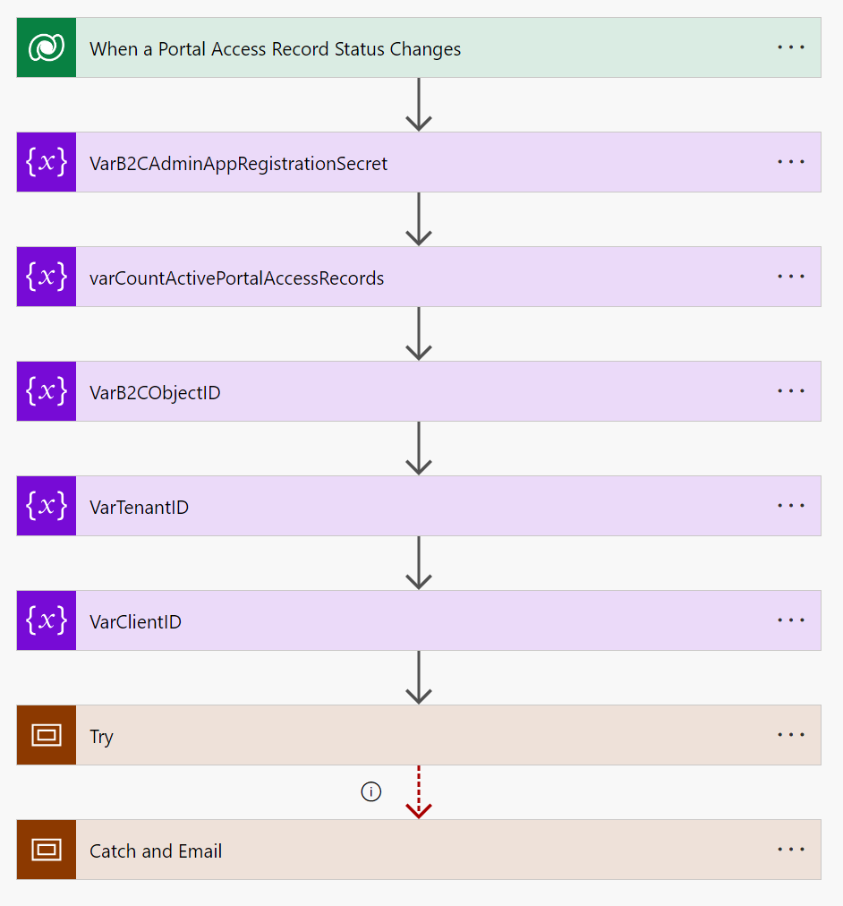
3
4
2
The sections are as follows:
- Trigger
This is the condition that causes the flow to fire
- Variable Declarations
This is where variables that will be set inside of the “try” scope are declared
- Try Scope
All flow logic resides within the “try” scope. The “catch and email” scope is configured to run on failure within this scope.
- Catch Scope
The “catch and email” scope reaches out to an environment variable for an email address and sends an email to an admin user with information about the failed flow.

Processes:
A list of flows included in this solution are seen below:
- Process 1
- Process 2

Each workflow process is now fully described below:
Provide a detailed description of each workflow built. Descriptions should include screenclippings that clearly show tables, triggers, deployment choices etc.
The description should clearly indicate what the workflow does.

Sample Workflow
This workflow is configured to run asynchronously when a [portal file] is created or when the [publish status] field changes.
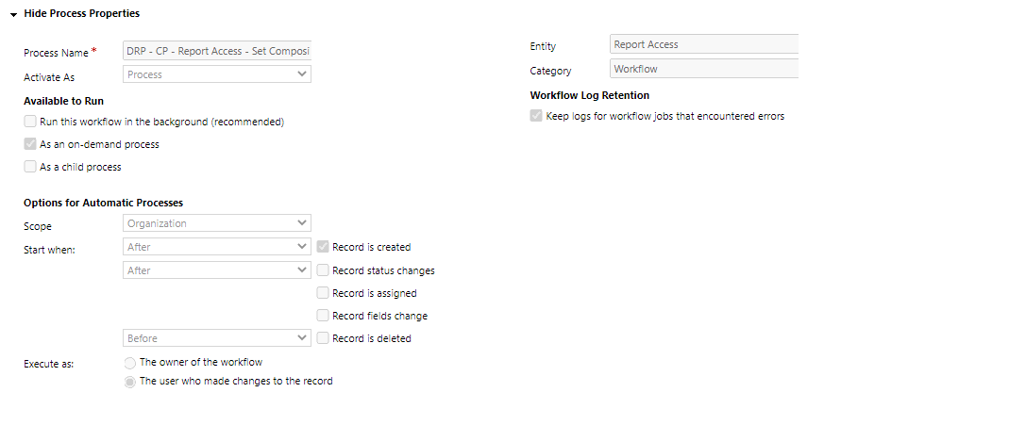
This workflow is responsible for the following:
- If a form or general file is published
  - Set published by and published date
  - Create an associated [portal log] record
  - Perform …

Agents:
A list of agents setup in this solution are seen below:
- Agent 1
- Agent 2

Each agent is now fully described below:

Sample Agent

Plugins:
Provide detailed pseudocode, deployment information, and a description of each plugin's functionality – including information about where it is used.
The following Plugins were setup in the implementation:

Sample Plugin
Type: Custom Workflow Activity
Workflow: DRP - CP - PortalFile – Publish
Trigger: Portal file create, unpublish of portal file
The delete file access is a custom workflow activity that queries for all file access records linked to the portal file that causes the plugin to fire. Query shown below

<fetch version='1.0' output-format='xml-platform' mapping='logical' distinct='false'>
<entity name='ec_fileaccess'>
<attribute name='ec_fileaccessid' />
<filter type='and'>
<condition attribute='ec_portalfile' operator='eq' uitype='ec_portalfile'
value='{0}' />
</filter
</entity
</fetch>

Each file access object returned from Dataverse is mapped to a simplified file access object (class described briefly above) and added to a list. The list is serialized, and broken into chunks of 1000 before being sent to power automate flow for processing by creating a [file access maintenance job] record. The power automate flow is responsible for the deletion in Dataverse.

Data Model and Table Customisations
Provide an ER Diagram that includes all tables included or customised as part of this solution. Sample diagram below. Details about each table (forms, views, columns) will be provided later. Use the Data Model table from the Functional and Technical Design document and update it with actual implementation notes.
The following Entity Relationship Diagram shows the tables we have implemented in the solution:
[Enter diagram here]

The table below describes each table.
Table | Description
List each table in the new data model, for example:  Account | Provide a description of the data the table will hold in the future-state solution, for example:  Houses all Customer Business Profile data
Table 1 | Table Description
Table 2 | Table Description

Each table is now fully broken down below:

Table Name

Columns (fields) Created
The following table details columns that were created or customised in the implementation.
Please Note that standard columns are not documented.

Display Name | Schema Name | Data Type | Details
Contact Type | ec_ContactType | Choice  Linked to Global Choice: ec_ContactType | Setup with the following choices:  - Choice 1  - Choice 2  - Choice 3

Forms Created / Customised
The following forms were created or customised in the implementation:

Form 1
Provide screen clippings of the forms setup. If standard forms have been used, highlight the section of the form that has been customised. Show all tabs in the form that have been customised or configured. Example below:
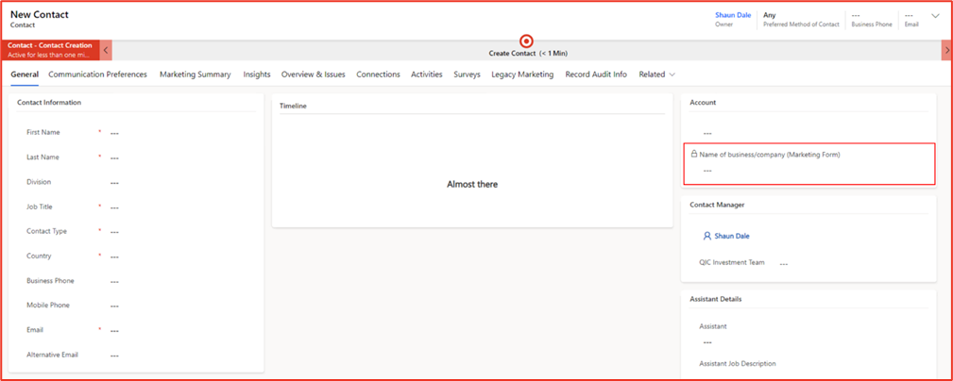

Business Rules
The following Business Rules have been configured on the [table name] table:
Type (Scope) | Name | Logic
Table | All QIC Comms Unsubscribe – EU Contacts | IF  All QIC Comms equals "Do Not Allow" AND EU Contact equals "Yes"  THEN  Set GDPR Optout to "Yes"

App-Specific Configuration
This section should detail specific configurations and setups in the various Dynamics Apps. Each of the apps will have its own set of configurations listed here, as an example:
Dynamics 365 Customer Insights – Journeys
- Journeys
- Segments
- Triggers
- Forms
- Consent Centre
- Subscription Centre
- Assets
- Templates
- Content Blocks

Dynamics 365 Contact Centre
- Channels
- Workstreams, and routing rules
- Queues
- Intent
- Agent Experience Profiles
- Knowledge
- Productivity
- Collaboration
- User and Role Mappings
- Service Calendar and Shifts

Dynamics 365 Sales
- Sales Settings
- Sales Insights Settings
- Territories
- Forecasting
- Sales Sequences
- Goals
- Etc.

Dynamics 365 Customer Service
- Service Calendar
- SLAs
- Routing Rules
- Knowledge
- Productivity
- Collaboration
- Etc.

Dynamics 365 Field Service
- Field Service Settings
- Org Units
- Functional Locations
- Work Order Types
- Work Order Sub-statuses
- Incident Types
- Service Task Types
- Resolutions
- Inspection Templates
- Etc.

IT Service Management
- Incident Management
- Problem Management
- Change Management
- Service Request Management
- Asset Management
- CMDB

All the functional setup should be detailed in this section.

Power Pages
This section should detail all screens and functionality configured and developed in Power Pages.

Active Directory B2C
This section contains step by step configuration steps for each of the solution components. It is essential that every step and every configuration detail is captured. It should be possible for someone who knows nothing about the solution component to complete the configuration by following the steps captured below.

Azure Active Directory B2C Configuration - User Flows
User flows in Azure Active Directory B2C have been configured to enable three scenarios

User Onboarding – Registration Flow
Users who receive an invitation to access to the Client Portal will already have a corresponding user object in Azure Active Directory B2C. The purpose of the registration flow is to link the Azure Active Directory Object to the Power Apps Portals plumbing and to allow the user to reset their password. This flow is configured as a Sign In only flow (Sign up is not permitted) as shown in the figure below
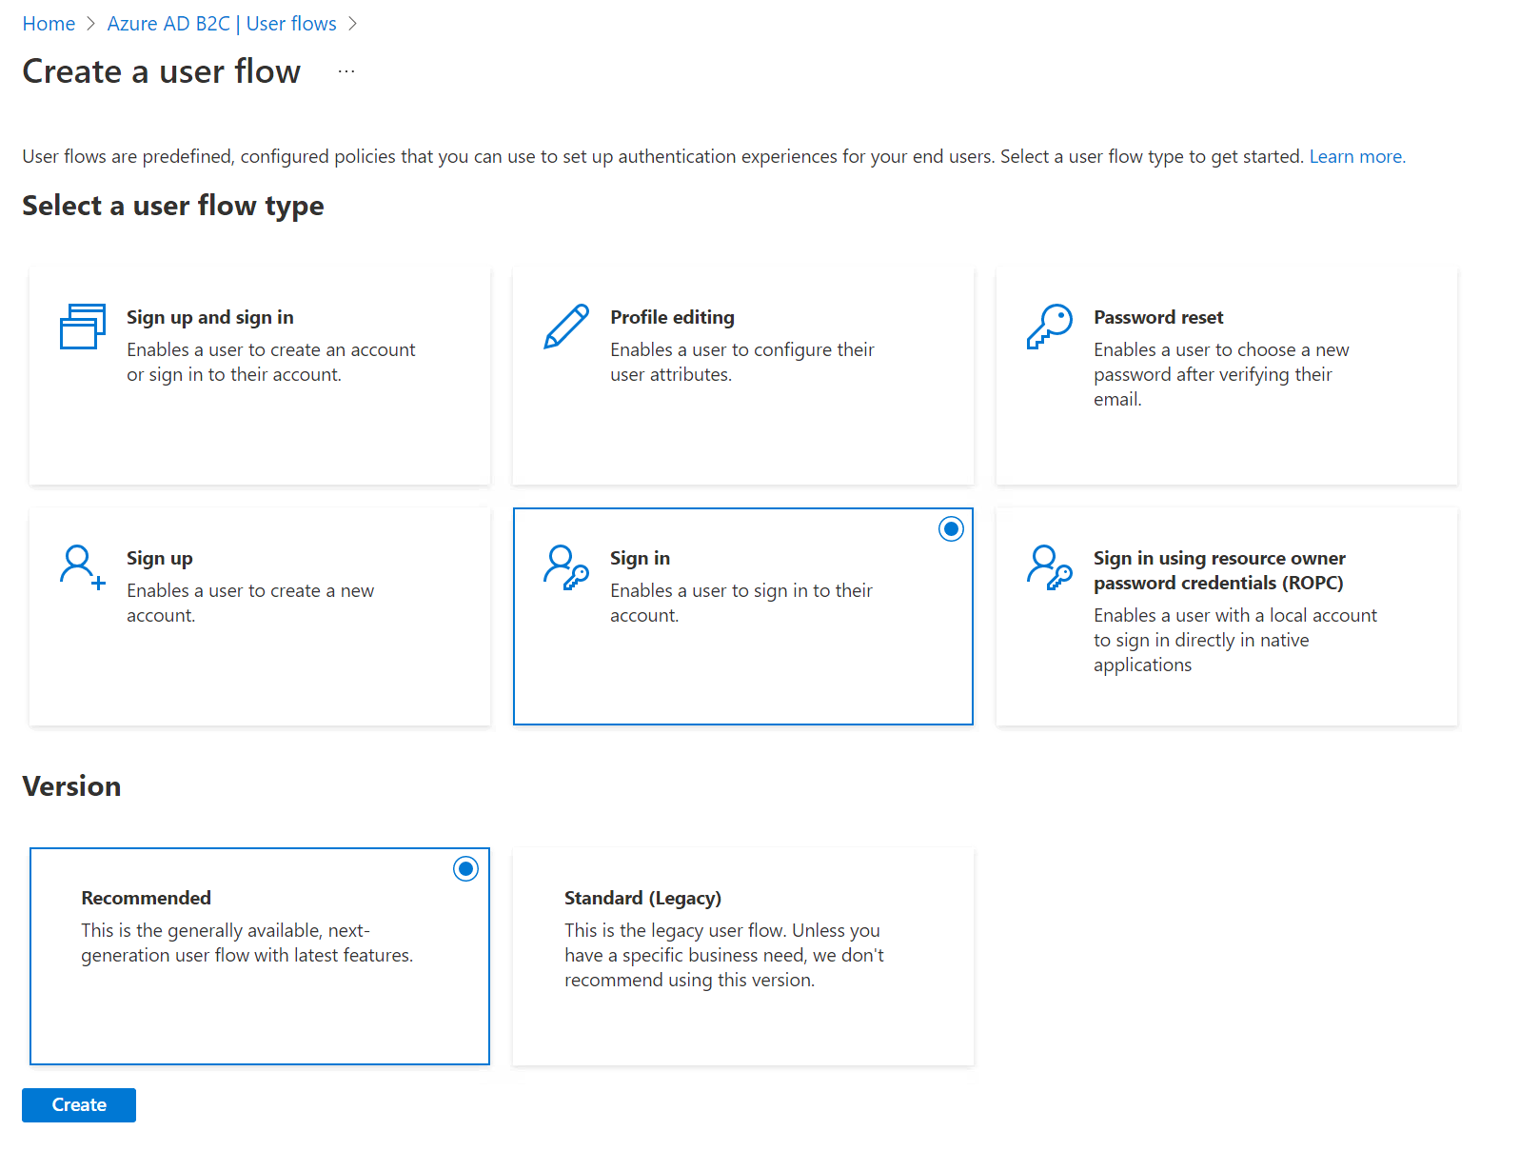
The flow is configured for sign in with local accounts, and MFA enforcements is set to Off. This flow is only used for password reset feature when an invitation is redeemed. Refer to the screen clipping below …

Deployment Pipelines and Repo
Include all details about source code locations and deployment information.

Repo
All source code for this solution can be located in Azure DevOps located here – [Paste link here]
The folders are shown in the screen clipping below:
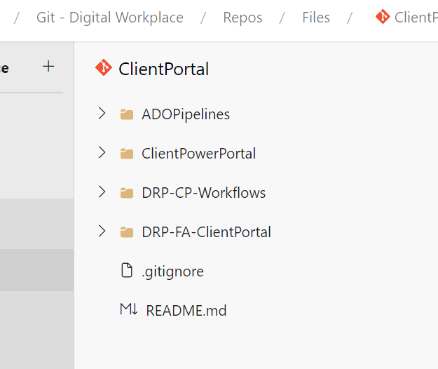
- ClientPowerPortal
This folder contains all of the Power Pages customisation. This includes HTML, JavaScript, Template, Image and other files required by the solution.
- DRP-CP-Workflows
This folder contains all of the source code related to plugins and custom workflow activities.
- DRP-FA-ClientPortal
This folder contains all of the source code related to the API’s which are deployed as function apps.
- B2C_Branding
This folder contains the language customisations and image files required to complete the steps in the B2C deployment section of this guide.

Deploy Power Apps Portal
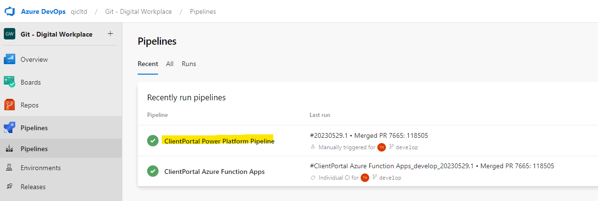

Main Pipeline Configuration - azure-pipelines.yml
This is the main configuration file for your CI/CD pipeline.
- `trigger: none` specifies that the pipeline will not be automatically triggered when changes are pushed to the repository.
- `pool: name: Default` defines the agent pool where the pipeline will be run. In this case, it's set to 'Default
- `extends:` is used to extend from another YAML template. This pipeline is extending the `build-deploy.yml` template with a parameter 'appName' set as 'ClientPortal'.

API Specification
API documentation should be presented as per the sample below.

Internal APIs

Environment URLs
Dev | [URL]
Sys | [URL]
Test | [URL]
Prod | [URL]

Sample API
Create a new Portal File. The API will generate metadata automatically based on the name of the file supplied. The file name should be in the format:
<Entity Name>+<Entity Code>+<Report Date>+<Report Code>.[Ext]

HTTP Request
POST /api/portalfile/createvalid

Request headers
Header | Value | Required
Authorization | Bearer {token} | Yes
X-Correlation-ID | {GUID} | Yes
Content-Type | application/json | Yes

Request Body
Parameter | Type | Description
name | String | Name of the file to be uploaded
file | Base64 String | The file to be uploaded

Example: Create a File
POST /api/portalfile/createvalid
Content-type: application/json
{
“name” : “part+part+part.ext”,
“File” : “base64”
}

Response - Success

HTTP/1.1 201 Created
Content-type: application/json
{
"id": "tracking id"
}

Response – Error

HTTP/1.1 400, 401, 403, 500, 503
{
"id": "tracking id",
"success": false,
"errors": [
{
"errorCode": "401/401/403/500/503",
"errorDescription": "Description"
}
]
}

Document Sign Off
Signed for and on behalf of  [Company]  Name: |  | Signed for and on behalf of  Enterprisecloud  Name:
Capacity: |  | Capacity:
Place: |  | Place:
Date: |  | Date:

