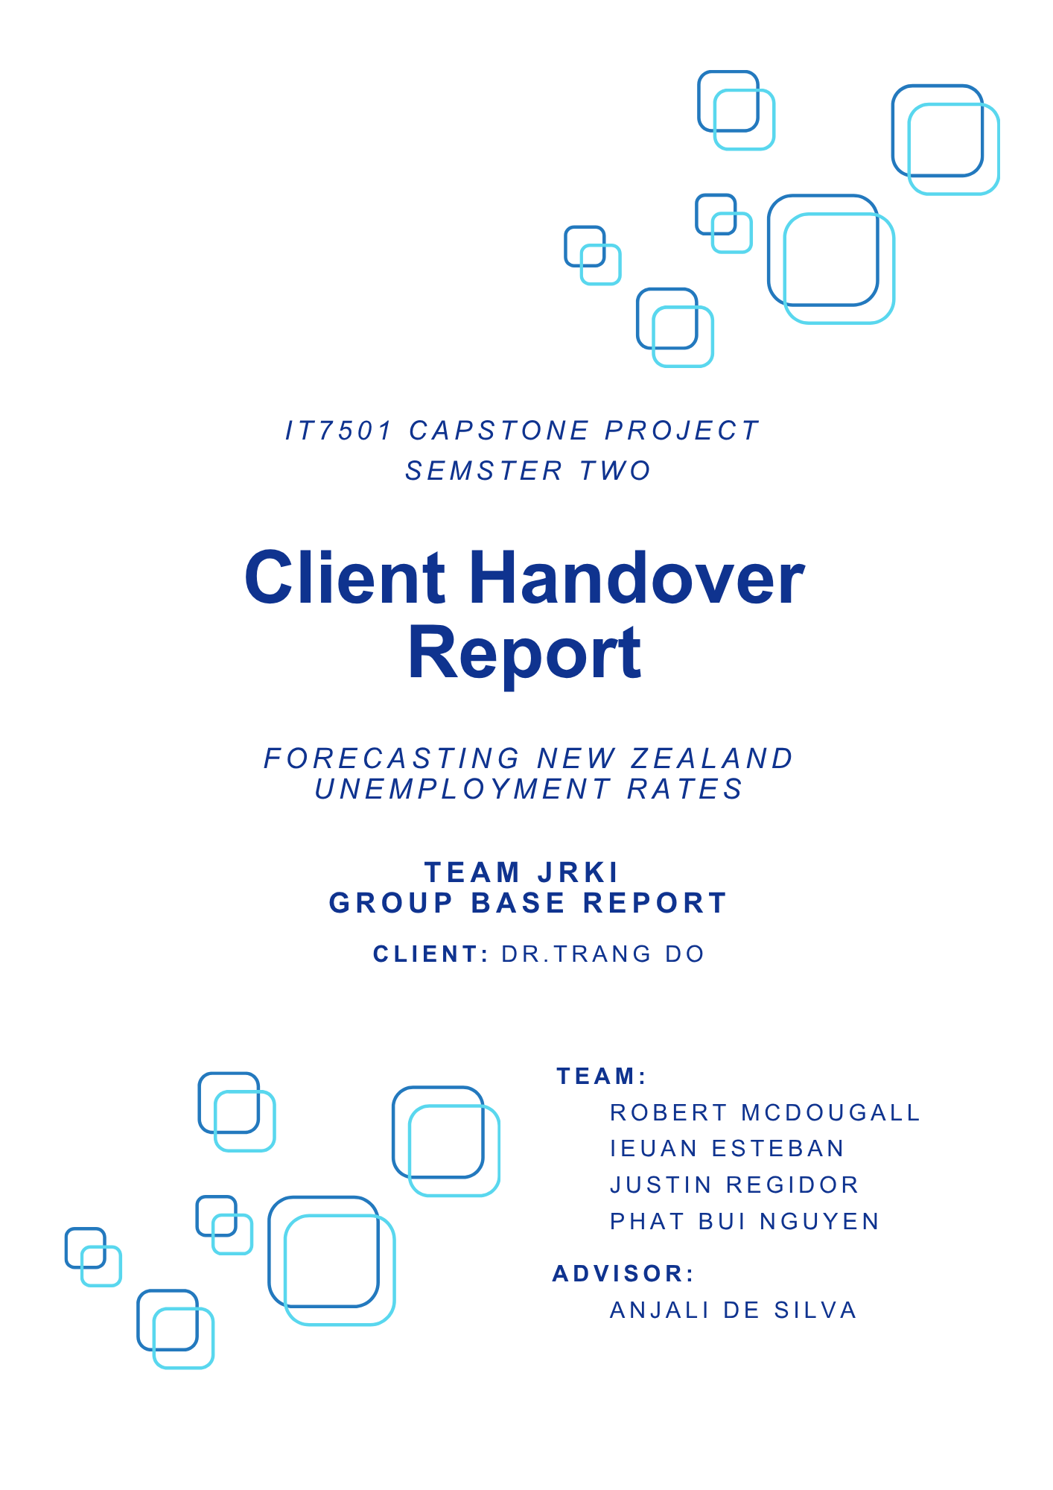
Rating Scale: 1 = Very Poor | 2 = Poor | 3 = Average| 4 = Good | 5 = Excellent
Please tick the box that best represents your experience.
Dashboard Usability Questions | 1 | 2 | 3 | 4 | 5
1. The dashboard was easy to navigate. | ☐ | ☐ | ☐ | ☐ | ☒
2. The key information was clear and accessible. | ☐ | ☐ | ☐ | ☐ | ☒
3. The visual layout and design supported understanding. | ☐ | ☐ | ☐ | ☐ | ☒
Functionality & Performance Questions | 1 | 2 | 3 | 4 | 5
4. The features (filters, buttons etc.) worked as expected. | ☐ | ☐ | ☐ | ☐ | ☒
5. The dashboard responded fast enough / performed smoothly. | ☐ | ☐ | ☐ | ☐ | ☒
Dashboard Information Questions | 1 | 2 | 3 | 4 | 5
6. The information provided was relevant and useful for decision-making. | ☐ | ☐ | ☐ | ☐ | ☒
7. The overall structure of the dashboard made it easy to find what I needed. | ☐ | ☐ | ☐ | ☐ | ☒
8. The level of detail in the information was appropriate (not too little or too much). | ☐ | ☐ | ☐ | ☐ | ☒
Dashboard Overall Satisfaction | 1 | 2 | 3 | 4 | 5
9. How satisfied are you with the dashboard overall? | ☐ | ☐ | ☐ | ☐ | ☒
Questionnaire

Open-ended feedback
Is there anything you would like to change, improve, or add to the dashboard?

No. Thanks the team for being patient as I am so busy with work. On the review date, we have an emergency, which led to the result that I was not able to review the whole work. However, I did recommend on the design of the main page and the team has changed accordingly. Wonderful effort from the team, especially the team lead/project manager!

Please sign and date after completing the review.
Name: Trang Do
Signature: Trang Do
Date: 3/11/2025

