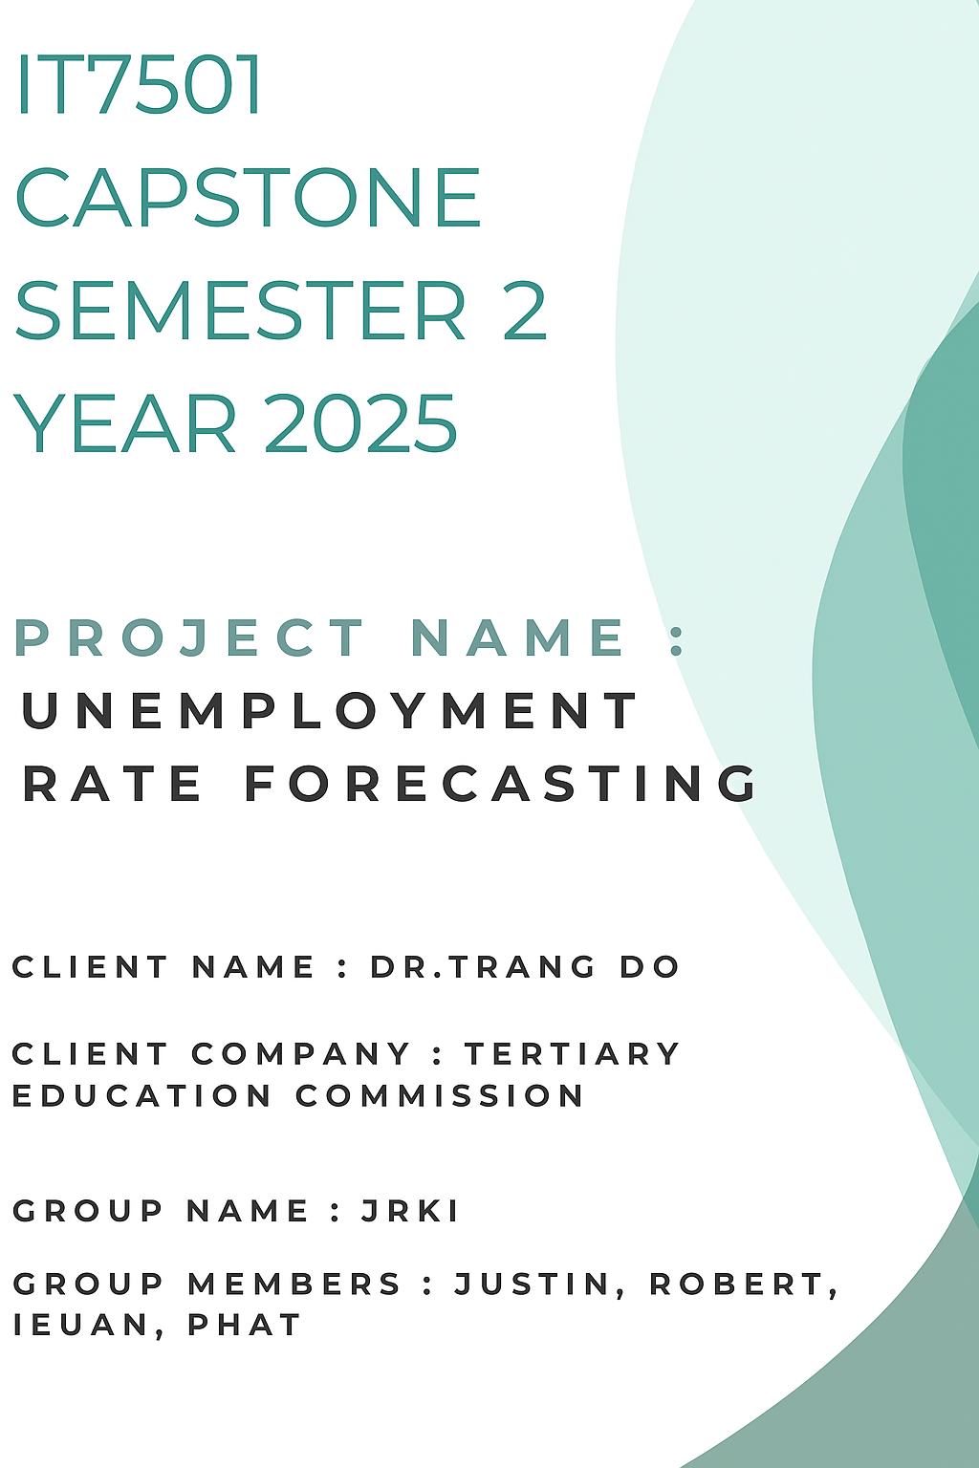

Table of Contents
Table of Contents 2
1.0 Project Objective 4
1.0.1 Introduction: 4
1.1 Background to the Client and Problem 5
1.2 Brief outline of deliverables and the problem 6
1.2.0 Client deliverables 6
1.2.1 Academic Capstone deliverables 6
1.3 Project Scope 7
1.3.0 In-Scope: 7
1.3.1 Out-Scope: 7
1.3.2 Assumption and Constraints: 7
2.0 Project Plan 8
2.1 Methodology 9
2.2 Technologies 10
2.2.0 Machine Learning Approaches 10
2.3 Project Budget 11
Table 1 Project Budget table 12
3.0 Project Personnel 13
3.1 Client Details 14
3.2 Group Members 15
3.3 Project Advisor 16
3.4 Communication Plan 17
Table 2 Communications plan table 17
3.5 Conflict of Interest Statement 18
3.5.0 Robert’s Statement 18
3.5.1 Justin’s Statement 18
3.5.2 Ieuan’s Statement 18
3.5.3 Phat Bui’s Statement 18
3.6 RACI assessment Matrix 19
Table 3 RACI assessment matrix table 19
3.6.0 Discussion 20
3.6.1 Role allocation 21
3.6.2 Collaboration 21
3.6.3 Balance and efficiency 21
3.7 Capstone Project Client Contract - Appendix B requirements 22
3.8 Client NDA and other intellectual property rights - Appendix C requirements 23
4.0 Project timeline and milestones 24
Table 4 Main milestones and deliverables dates 24
4.1 Gantt Chart 25
4.1.0 Discussion 25
4.1.1 Structure of the Timeline 25
4.1.2 Milestones 25
4.1.3 Team Coordination and Task Allocation 26
4.1.4 Flexibility and Contingency 26
4.1.5 Planning approach 26
5.0 Project Risk Analysis 27
Table 5 Risk Assessment Matrix 27
5.1.0 Risk Descriptions: 27
5.1.2 High Likelihood, High Impact: 27
5.1.3 Medium-High Risk: 28
5.1.4 Medium Risk: 28
5.1.5 Lower Risk: 28
Table 6 Risk Mitigation plan 29
Table 7 Risk Contingency Plan 35
6.0 References 41
7.0 Appendices 44
7.1 Appendix A: Gantt Chart 45
7.2 Appendix B: Capstone Project Client Contract 49
7.3 Appendix C: NDA or Client Statement for Option 4 51

1.0 Project Objective

1.0.1 Introduction:
The project client, Dr. Trang Do, has tasked our team JRKI to create a dashboard that can forecast unemployment rates. The expected deliverables by Dr. Trang Do for this project is a dashboard that contains visualization of the employment rates forecast and reasonably accurate forecasting.
The unemployment rate reflects the number of people actively seeking work but cannot find work giving an indication of the basic economic health as well as social outcomes. (Rea & Maloney, 2021) This information about the well-being of the workforce aids policy makers and businesses to make strategies based on this information. However the official unemployment statistics are released with time-lag limiting their usefulness for real-time policy making or business decisions. (Rea & Maloney, 2021)(Robinson, Culling, & Price, 2019)
An ability to forecast accurately would help elevate this time-lag by trying to predict the future labour market conditions ahead of official statistics release, giving quicker information to government and businesses allowing them to be better prepared in the shift within the labour market.(Rea & Maloney, 2021)

1.1 Background to the Client and Problem
The main problem is to accurately forecast the unemployment rate. Our project client, Dr. Trang Do has tasked us with producing an interactive main dashboard with accurate forecasting of official unemployment rates and visualisations of the forecast. This project is to produce an interactive main dashboard that can be updated live with these two features.
Dr. Trang Do is currently working for the Tertiary Education Commission and has extensive experience in previous roles at the Ministry of Business and Innovation (MBI). Dr. Trang Do was also a former Senior Lecturer at Weltec where she has developed papers related to data science such as Intelligent System Development and Business Intelligence and Big Data. Dr. Trang Do’s experience has shown her knowledge regarding data science and deep learning models which is related to the project at hand.
The problem presented to us by Dr. Trang Do focuses on the need for machine learning to help forecast unemployment rates accurately, alongside the ability to present this information into an understandable and clear visualisation. Since official statistics have a time-lag where creating strategies in responses to conditions are less effective, forecasting becomes a useful solution to this time-lag issue allowing for quicker responses and better preparation.(Rea & Maloney, 2021) So an interactive main dashboard that allows for up-to-date accurate forecasting with continuously inputting new data, alongside intuitive visualization suitable for stakeholders becomes the solution.
The project itself is an individual project by Dr. Trang Do, but there is a potential stakeholder involved with this project if it goes successful. Dr. Trang Do has informed us that if the project is well received it can have the potential to be presented to MBI with another presentation for review and approval since the ability to forecast accurately on a main dashboard is beneficial by allowing for better strategic planning on unemployment rates.

1.2 Brief outline of deliverables and the problem

1.2.0 Client deliverables
The project client, Dr. Trang Do expects a Main Dashboard using Power BI with the capability of live updates with new data inputs. These major deliverables can be split into two deliverables.
- The ability to forecast unemployment rates with high accuracy using comparative machine learning approaches. We expect to implement and evaluate multiple techniques including time series models (ARIMA/SARIMA), neural networks (LSTM), ensemble methods (Random Forest, Gradient Boosting), and regression techniques to determine the optimal forecasting approach - Python; Machine Learning
- To visualize the unemployment rate forecast using graphs - PowerBI
This interactive Main Dashboard is to help forecast unemployment rate through inputs of old official unemployment rates through previous years in an attempt to predict the future labour market. This project has the potential to expand beyond its scopes of forecasting unemployment as well as have the potential to be presented to another potential stakeholder, the Ministry of Business Innovation and Employment (MBIE).

1.2.1 Academic Capstone deliverables
The capstone paper requires us to also finish a set of deliverables in conjunction with the client deliverables to pass the course.
The expected deliverables are two video recordings for the midterm presentation and a client concluding review on Zoom. Documentations in the form of self management review, a client handover report, an academic handover report, individual closeout report, poster and one-pager. Then a final panel presentation detailing our project progress throughout the semseter.

1.3 Project Scope
The purpose of this project is to develop a forecasting application utilizing machine learning to predict unemployment rates in New Zealand based on official New Zealand unemployment statistics. This deliverable will be an interactive dashboard that visualizes forecast results to support decision-making for stakeholders.

1.3.0 In-Scope:
- Cleaning and preprocessing the dataset of New Zealand unemployment rates.
- Developing and training forecasting models using machine learning.
- Evaluate model accuracy.
- Build an interactive dashboard to display forecast results using PowerBI
- Implement the capabilities to support live updates of MBIE’s official data.
- Create a dashboard prototypes to explore different visualisation design
- Get client feedback on dashboard prototypes
- Mid-term presentation with client
- “One pager” poster
- Final Presentation

1.3.1 Out-Scope:
- International unemployment rates datasets.
- Capabilities of real-time (of any data) feeds.
- Economic indicators beyond what the client provides
- Any interactive dashboard outside of PowerBI

1.3.2 Assumption and Constraints:
- Our dataset will be given to us by our Project Client to work with.
- The scope is limited to a 17-week academic schedule.
- The interactive dashboard will be developed on PowerBI
- We have academic deliverables to complete on top of the project client’s deliverables. These two deliverables are assumed to be different from each other.

2.0 Project Plan
This project will develop an automated unemployment rate forecasting system with a live-updating dashboard for presentation to the Ministry of Business. The primary objectives are to create accurate unemployment predictions that inform policy decisions and recruitment strategies, while delivering visualizations that convey complex insights within five seconds.
The project will produce two main deliverables: a comprehensive forecasting model comparing multiple machine learning approaches, and an intuitive Power BI dashboard that automatically updates with new data. Development will follow an iterative approach with prototype reviews to ensure early feedback and alignment with stakeholder expectations.
The project timeline will be structured around fortnightly meetings with Dr. Trang, maintaining consistent progress while allowing flexibility for adjustments based on feedback. Communication will be conducted exclusively via email per the client's preference, with regular status updates between meetings.
The final deliverable will include a presentation to the Ministry of Business team, demonstrating both the technical capabilities of the forecasting system and its practical applications for policy making.

2.1 Methodology
Our project will employ Scrumban methodology, combining the structured framework of Scrum with the flexibility of Kanban to manage the development of the unemployment forecasting system. This hybrid approach aligns perfectly with Dr. Trang's requirements for iterative development with regular prototypes while maintaining the flexibility to adapt as we test multiple forecasting methods. The Scrumban framework will utilize two-week sprints aligned with our fortnightly client meetings, allowing us to demonstrate progress and gather feedback consistently. We'll maintain a Kanban board to visualize workflow and manage tasks flexibly, particularly important when comparing different machine learning approaches that may require varying development timeframes. The methodology emphasizes continuous delivery of working prototypes, enabling early validation of both the forecasting accuracy and dashboard usability against the five-second comprehension standard.
In contrast, a traditional Waterfall methodology would be poorly suited for this project due to its rigid sequential phases and limited flexibility for incorporating feedback. While Waterfall's comprehensive upfront planning might seem attractive for defining data requirements and model specifications, it would conflict with Dr. Trang's directive to "try every method and compare them" and the need for iterative prototype development. The Waterfall approach would delay client feedback until late in the project, risking significant rework if the dashboard design or forecasting accuracy doesn't meet expectations. Additionally, the evolving nature of unemployment data and potential scope adjustments from Ministry stakeholders requires the adaptability that Waterfall cannot provide.
The selection of Scrumban is justified by several project-specific factors. First, the fortnightly meeting schedule naturally aligns with sprint cycles while the Kanban elements accommodate the unpredictable nature of data cleaning and model comparison tasks. Second, the emphasis on visual project management through Kanban boards mirrors the project's focus on clear visualization, reinforcing team understanding of progress and bottlenecks. Third, the methodology's flexibility supports Dr. Trang's results-oriented approach, allowing the team to pivot between different forecasting methods based on performance rather than adhering to a rigid plan. Finally, Scrumban's continuous flow principle ensures steady progress toward the Ministry presentation while maintaining the ability to incorporate stakeholder feedback throughout development, critical for achieving both technical accuracy and policy-maker usability.

2.2 Technologies
The technical architecture centers on Power BI as the primary visualization and dashboard platform, leveraging its robust integration capabilities with Snowflake for data warehousing. This combination enables automated data updates and ensures scalability as new unemployment data becomes available.
Python will serve as the core development environment for data processing, cleaning, and model implementation, utilizing open-source libraries for machine learning and statistical analysis to minimize costs while maintaining flexibility.
Following the client's strong preference for free tools, we will maximize the use of open-source solutions wherever possible, with Power BI being the only approved paid platform. Databricks may be considered for advanced analytics if accessible through existing organizational infrastructure.
Critical to the implementation is strict data security protocols, with explicit instructions to avoid tools like ChatGPT for handling sensitive government data. The technical stack is designed to balance sophistication with cost-effectiveness while ensuring reliable automation and performance.

2.2.0 Machine Learning Approaches
While our final methodology will be determined through empirical testing and comparison as requested by Dr. Trang, we may expect to explore several forecasting techniques including:
- Time Series Methods: ARIMA/SARIMA models for capturing seasonal unemployment patterns and trend analysis
- Neural Networks: LSTM (Long Short-Term Memory) networks for sequential data modeling, particularly given the temporal nature of unemployment data
- Ensemble Methods: Random Forest and Gradient Boosting algorithms to combine multiple weak learners for improved accuracy
- Regression Techniques: Multiple linear regression, polynomial regression, and regularized methods (Ridge/Lasso) for baseline comparisons
- Advanced Time Series: Facebook Prophet for handling seasonality and holiday effects in unemployment data
- Support Vector Machines: For non-linear pattern recognition in economic indicators
The selection and implementation of these techniques will be guided by performance metrics, data characteristics, and the requirement to compare multiple approaches as specified by the client.

2.3 Project Budget
The project budget reflects Dr. Trang's emphasis on cost minimization through strategic use of free and open-source tools. Software expenses will be limited primarily to Power BI licensing, which represents the only approved paid platform for this project.
All machine learning model development, data processing, and analytical work will utilize open-source Python libraries, eliminating additional licensing costs while maintaining full analytical capabilities.
Infrastructure costs will be minimized by leveraging any existing Snowflake or Databricks access available through the organization.
Development efforts will focus on maximizing the capabilities of free tools, with budget allocation concentrated on ensuring robust Power BI implementation and any necessary data storage solutions. This lean budget approach aligns with the project's origins as a personal initiative while ensuring professional-grade deliverables suitable for Ministry presentation.

Table 1 Project Budget table
Item | Cost (NZD) | Justification
Power BI Desktop | $0 | Free desktop version for development
Snowflake (Free Trial) | $0 | 30-day trial sufficient for project
Python & Libraries | $0 | Open-source
Databricks Community Edition | $0 | Free tier if needed
JIRA (Academic License) | $0 | Free for students
MS Office | $0 | Free for students
MS Project | $0 | Free for students
Google Drive | $0 | Using team member's existing subscription
GitHub | $0 | Free for public repositories
VS Code / Jupyter | $0 | Open-source IDEs
Team Labour (4 × 300 hours) | $0 | Academic project
Client Consultation | $0 | Voluntary guidance from Dr. Trang Do
Advisor Consultation | $0 | Voluntary guidance from Anjali
Discord | $0 | Discord free
Zoom | $0 | Using team member’s existing subscription
Project Total | $0

3.0 Project Personnel
The JRKI team brings together four students with complementary skills that cover the technical requirements of this unemployment forecasting project. Robert handles project management and machine learning development, Justin focuses on data processing and statistical analysis, Ieuan leads the user interface design and documentation, while Phat supports coding and data preparation. We've structured our roles this way to make sure we can tackle both the technical challenges and user-facing aspects of building a dashboard for the Ministry of Business.
We plan to stay in close contact with Dr. Trang Do throughout the project, following her preference for fortnightly meetings and email communication. Since this is a real-world project that will eventually be presented to government stakeholders, we want to make sure we're building something that actually works for policy makers rather than just meeting academic requirements. We'll be showing prototypes along the way and adjusting based on her feedback to ensure the final forecasting system is both technically sound and practically useful.

3.1 Client Details
Dr. Trang Do, currently serving at the Tertiary Education Commission, brings extensive experience from previous roles at the Ministry of Business Innovation and Employment (MBIE) tourism team. As a former Senior Lecturer at WelTec who developed data science courses, Dr. Trang possesses both theoretical knowledge and practical understanding of data analytics applications. While this began as a personal project, it will ultimately serve the MBIE through formal presentation and potential implementation.
The primary stakeholder for review and approval is the MBIE, with policy makers serving as the main end users of the forecasting insights. Secondary beneficiaries include recruitment organizations and business entities, particularly in sectors like hospitality, who rely on unemployment data for strategic planning. It's important to note that Dr. Trang Do serves as the sole point of contact for this project, with no designated backup, requiring careful communication management throughout the engagement.

3.2 Group Members
Robert McDougall is the Project Manager and Machine Learning Engineer. He is responsible for algorithm development, workflow coordination, and quality control. Robert ensures the technical components are robust and the project remains on schedule.
Justin Regidor leads data processing and statistical modeling. He is in charge of building and maintaining the data pipeline, ensuring the accuracy and reliability of outputs. His analytical problem-solving skills are key in refining the models.
Ieuan Esteban specializes in user experience (UX) and interface design. He leads the development of user-facing components and documentation, ensuring the final product is intuitive, well-structured, and aligned with end-user needs.
Phat Bui supports coding, data wrangling. He plays an essential role in team integration, contributing to efficient code workflows and ensuring technical precision in support of the overall project vision.

3.3 Project Advisor
Anjali de Silva is a Data Science lecturer at Wellington Institute of Technology. She is working towards completing her PhD and has many years of research experience. She will be the official advisor for "The JRKI team" in the research project on unemployment forecasting. The team has already met with her and is confident that her support will provide valuable insights and ensure the research output meets the practical needs of the clients.

3.4 Communication Plan

Table 2 Communications plan table
Role | Name | Email address
Client name | Dr. Trang Do | dothutrang81@yahoo.com  trangdtt@gmail.com
Project advisor name | Anjali de Silva | anjali.desilva@weltec.ac.nz
Group project manager | Robert McDougall | rtmcdougall@yahoo.co.nz
Group member | Ieuan Esteban | ieuan.esteban@gmail.com
Group member | Justin Regidor | regidorjustin@gmail.com
Group member | Phat Bui Nguyen | buinguyenphat136@gmail.com

- Our primary contact with our client is via email as a phone number was not provided
- Team communication will happen via email and discord
- Communication with our advisor and course lead will be via email

3.5 Conflict of Interest Statement
This section provides the conflict of interest statement from each team regarding their relationship with the project client Dr. Trang Do.

3.5.0 Robert’s Statement
I had had no prior personal, professional, working or academic relationship to the project client Dr. Trang Do. This will be my first time working with Dr. Trang Do.

3.5.1 Justin’s Statement
This is the first time I will be working with Dr. Trang Do. I have no prior professional, academic, or personal relationship with the client or their organisation. I will maintain professional standards throughout the project and ensure all communication and deliverables meet academic and industry requirements.

3.5.2 Ieuan’s Statement
I, Ieuan Esteban confirm that I have no personal, academic or professional relationship with Dr. Trang Do or her organization. I commit to being professional and transparent during the duration of this project. If conflict was to arise, I will take immediate and appropriate action to ensure that it is managed responsibly, respectfully and ethically.

3.5.3 Phat Bui’s Statement
I’m genuinely excited to be working with Dr.Trang Do for the first time on this project. For full transparency, I confirm that I have no prior relationship with Dr.Trang Do or her organization. Together with my team, we will actively listen, support each other, and deliver the best possible value to our client.

3.6 RACI assessment Matrix
R - responsible
A- accountable
C - consulted
I - informed

Table 3 RACI assessment matrix table
Task | Robert | Ieuan | Justin | Phat Bui | Dr. Trang Do
PROJECT START
Identify stakeholders | R | A | R | C | I
Communication plan | C | I | R | A | I
Project timeline/milestones/Gantt chart | R | A | A | C | I
Risk assessment | A | R | C | C | I
Project scope/proposal
Define scope | R | C | A | C | I
Define methodology | A | C | R | C | I
Draft proposal | C | R | A | C | I
Submit proposal | R | A | A | A | I
Data collection/preparation
Gather data | A | C | R | R | R
Clean data | C | C | R | R | I
Handle outliers | A | C | R | R | I
Data documentation | C | R | A | A | I
Modelling/analysis/testing
Select type of machine learning algorithm | C | I | R | A | I
Train model | C | I | R | A | I
Tune models | C | I | A | R | I
Compare models | A | C | R | A | I
Visualization/Review
Create visualization | A | C | A | R | I
Data Preprocessing | A | C | R | A | I
Data Processing | A | C | R | A | I
Final report | C | R | A | A | I
Technical documentation | C | R | A | A | I
Delivery
Prototype presentation to client | R | R | R | R | A
Gather feedback | R | A | R | C | I
Review feedback | R | A | R | C | I
Deliver final presentation | R | R | R | R | I

3.6.0 Discussion
The RACI chart developed for this project plays an important role in defining clear responsibilities and ensuring clarity across the project life cycle. With a multidisciplinary team of Robert, Justin, Ieuan and Phat, supported by Anjali De Silva as our advisor, this chat will assist in establishing ownership of each task while promoting communication and accountability.

3.6.1 Role allocation
Each phase of the project is mapped with specific roles. An example of this would be Robert and Ieuan are very engaged in the project initiation and planning stages, handling stakeholders and setting timelines. Justin is positioned within the data preparation and modelling and taking the main responsibility of executing the technical aspect. Phat is accountable for tasks such as tuning, visualization and dashboard tasks.

3.6.2 Collaboration
There are multiple tasks that are handled collectively with all team members sharing the responsibility. This will ensure consistency and shared understanding of the outcomes. Tasks with ‘consulted’ allow for cross checking and peer review particularly during the modelling and documentation stages. Dr Trang Do (client) remains informed throughout the duration of the project ensuring that we are meeting client deliverables and expectations.

3.6.3 Balance and efficiency
This chart offers a well balanced team effort where not one team member is overloaded with tasks. ‘Responsible’ and ‘Consulted’ roles are rotated based on the nature of the task. This encourages participation from all team members and using their specific strengths. By identifying who leads and who supports/is kept informed will increase efficiency and reduce the likelihood of the same effort or miscommunication.

3.7 Capstone Project Client Contract - Appendix B requirements
Dr. Trang Do has expressed to us that the project can be used for personal use such that we can share it on our Job application for future use. She also expressed that we should be careful of the handling of the official dataset for security reasons. The ownership of the project itself, Dr. Trang Do has selected option 1 - Organisation Ownership. Refer to page 50 and 51 for the Project Client Contract.

3.8 Client NDA and other intellectual property rights - Appendix C requirements
This project does not involve the use or sharing of confidential or proprietary information. No Non-Disclosure Agreement (NDA) is required for this engagement.

4.0 Project timeline and milestones
Legends: Academic Deliverables _ Client Deliverables __

Table 4 Main milestones and deliverables dates
Requirement | Specific date OR academic week of semester
Submit Project Bid | Week 1
Submit Project Proposal | Week 5
Data collection/Cleaning | Week 6
Model Selected and designed | Week 7
First prototype generated | Week 8
Visualization/Documentation | Week 9
Midterm Presentation | Week 10
Dashboard prototype | Week 11
Final PowerBi dashboard complete | Week 12
Self Management Review | Week 13
Report and visuals complete | Week 14
Client Concluding Review | Week 15
Client Handover Report | Week 15
Academic Handover Report | Week 15
Individual Closeout Report | Week 15
Poster | Week 15
One-Pager | Week 15
Final panel presentation | Week 16

4.1 Gantt Chart

Gantt chart can be found in Appendix A on page 46-49

4.1.0 Discussion
The gantt chart presented in Appendix A provides a visual representation of the projects timeline, this sequence all tasks from the beginning of the course to the completion of the project. This plan has allowed our team to establish a clear roadmap, allocate responsibilities efficiently and to align the project deliverables with the expectations of the client.

4.1.1 Structure of the Timeline
The project has been broken down in seven phases:
- Initiation and Setup
- Proposal Development
- Data Collection and Cleaning
- Modelling and Testing
- Prototyping and Visualisation
- Dashboard Development
- Final Report and Submission

4.1.2 Milestones
Each major phase ends in a milestone which acts as a checkpoint for reviewing our progress and ensuring quality of work before proceeding to the next phase. Milestones include:
- Milestone 1: Submit Project Bid
- Milestone 2: Submit Proposal
- Milestone 3: Data Collection/Cleaning
- Milestone 4: Model Selected and Designed
- Milestone 5: First Prototype
- Milestone 6: Visualization and Documentation
- Milestone 7: Dashboard and Prototype Complete
- Milestone 8: Final Dashboard Complete
- Milestone 9: Report and Visuals Complete

4.1.3 Team Coordination and Task Allocation
The Gantt chart identifies who is responsible for each task. Roles are distributed across our four team members that ensures both accountability and collaboration. This distribution reflects each member’s strengths and supports efficient knowledge sharing across each phase.

4.1.4 Flexibility and Contingency
The timeline allows for flexibility by spacing between tasks and allows slack time towards the end of a major phase. This will allow our team to absorb minor delays without impacting the overall submission
Since our project is being managed using Scrumban principles, changes in the priorities within the deliverables can be incorporated iteratively, particularly during the modelling and dashboard phases.

4.1.5 Planning approach
By creating the Gantt chart early in our process, this has allowed our team to critically think about the project. It has helped us discover areas where bottlenecks may occur. Using Microsoft Project has allowed for dynamic tracking throughout, which means our progress can be updated weekly and can be communicated with both our client and our advisor.

5.0 Project Risk Analysis

Table 5 Risk Assessment Matrix
 | Severity
Likelihood | 1 | 2 | 3 | 4 | 5
5 |  |  | Data Quality Issues
4 |  | Integration Challenges | Single Point of Contact | Scope Creep
3 |  | Automation Reliability  Team Communication  Technology Failure | Accuracy Requirements  Key team member unavailable | Data Security Breach
2 | Budget Overrun |  | Stakeholder Misalignment | Ministry requirement change
1 |  |  |  |  | Project Cancellation

5.1.0 Risk Descriptions:

5.1.2 High Likelihood, High Impact:
- Data Quality Issues (5,3): Dr. Trang confirmed extensive data cleaning needed with potential missing data
- Scope Creep (4,4): Multiple interconnected factors and stakeholder requests could expand requirements
- Single Point of Contact (4,3): Only Dr. Trang available with no backup contact

5.1.3 Medium-High Risk:
- Data Security Breach (3,4): Handling sensitive government unemployment data
- Ministry Requirements Change (2,4): Potential changes from Ministry stakeholders during project

5.1.4 Medium Risk:
- Accuracy Requirements (3,3): Must meet performance standards across all demographics
- Key Team Member Unavailable (3,3): Risk of team member illness or unavailability
- Integration Challenges (4,2): Power BI and Snowflake integration complexity
- Stakeholder Misalignment (2,3): Balancing technical accuracy with policy-maker usability
- Technology Failure (2,3): System crashes or tool failures

5.1.5 Lower Risk:
- Automation Reliability (3,2): Dashboard auto-update mechanisms
- Team Communication Breakdown (3,2): Internal team coordination issues
- Budget Overrun (2,1): Low risk due to free tools preference
- Project Cancellation (1,5): Very unlikely but would have severe impact
This matrix reflects the client's emphasis on data challenges and the project's complexity while acknowledging the relatively stable budget situation due to the preference for free tools.

Table 6 Risk Mitigation plan
Risk ID | Risk | Mitigation Strategy
R001 | Data Quality Issues (5,3) | • Establish data validation protocols during initial data exploration  • Implement automated data quality checks using Python scripts  • Create data cleaning documentation and standard procedures  • Schedule early data assessment with Dr. Trang in Week 6  • Develop backup data sources identification plan  • Allocate 40% of project timeline specifically for data cleaning activities
R002 | Scope Creep (4,4) | • Document all requirements clearly in writing during initial meetings  • Establish formal change request process with Dr. Trang approval  • Create detailed project scope document for client sign-off  • Implement weekly scope review during team meeting  s• Set clear boundaries on demographics and economic factors to include  • Use fortnightly meetings to discuss and approve any scope changes
R003 | Single Point of Contact (4,3) | • Establish multiple communication channels with Dr. Trang (email + backup)  • Document all decisions and communications thoroughly  • Request emergency contact information for critical project decisions  • Create detailed meeting minutes and share immediately after each meeting  • Build buffer time into project timeline for potential communication delays  • Identify alternative contacts within Ministry of Business through Dr. Trang
R004 | Data Security Breach (3,4) | • Implement strict data handling protocols following government standards  • Use only approved tools (Power BI, Python, Snowflake)  • Avoid cloud-based AI tools like ChatGPT for sensitive data  • Create secure file sharing protocols using approved platforms only  • Establish data access controls and user permission levels  • Regular security compliance reviews and team training
R005 | Accuracy Requirements (3,3) | • Implement multiple ML algorithms and compare performance metrics  • Establish clear accuracy benchmarks with Dr. Trang early in project  • Create model validation framework using historical data  • Implement cross-validation and testing protocols  • Develop demographic-specific accuracy measures  • Plan for iterative model improvement based on prototype feedback
R006 | Integration Challenges (4,2) | • Conduct early technical feasibility testing for Power BI–Snowflake integration  • Create prototype integration in Week 6 to identify issues early  • Establish fallback integration methods using Python connectors  • Document all integration steps and dependencies  • Allocate dedicated time for integration testing and troubleshooting  • Identify alternative visualisation tools if Power BI integration fails
R007 | Stakeholder Misalignment (2,3) | • Create user personas for Ministry of Business policy makers  • Implement 5-second comprehension testing for dashboard design  • Regular prototype demonstrations to gather stakeholder feedback  • Establish clear success criteria with measurable outcomes  • Create documentation explaining technical decisions in business terms  • Schedule pre-presentation review with Dr. Trang before final delivery
R008 | Automation Reliability (3,2) | • Design robust error handling for automated data updates  • Create monitoring system for dashboard data refresh failures  • Implement data validation checks in automation pipeline  • Develop manual backup procedures for data updates  • Test automation reliability with simulated data scenarios  • Create user documentation for troubleshooting common issues
R009 | Budget Overrun (2,1) | • Maximise use of free tools as per client preference  • Identify free alternatives for all paid software requirements  • Monitor tool usage and costs throughout project lifecycle  • Negotiate academic discounts where applicable  • Create budget tracking system with weekly reviews  • Plan for tool substitution if costs exceed expectations
R010 | Project Cancellation (1,5) | • Maintain regular communication with Dr. Trang and Ministry stakeholders  • Deliver valuable prototypes early to demonstrate project value  • Document all project progress and maintain transparent reporting  • Ensure deliverables align with Ministry's strategic objectives  • Create contingency plan for partial deliverable completion  • Maintain professional relationships and project quality standards
R011 | Team Communication Breakdown (3,2) | • Establish clear communication protocols using Discord and email  • Implement weekly team sync meetings with documented outcomes  • Create shared project documentation using Google Drive  • Assign backup responsibilities for each team member's tasks  • Use RACI matrix to clarify roles and responsibilities  • Establish conflict resolution procedures and escalation paths
R012 | Technology Failure (2,3) | • Maintain multiple backup systems for all project files  • Use version control (GitHub) for all code and documentation  • Test all technology stacks early in project timeline  • Create alternative tool options for each technology component  • Implement regular backup schedules and recovery testing  • Document all technical configurations and dependencies
R013 | Key Team Member Unavailable (3,3) | • Cross-train team members on critical project components  • Maintain detailed documentation of all individual contributions  • Implement pair programming and knowledge sharing sessions  • Create shared access to all project resources and accounts  • Establish backup contact methods for all team members  • Develop task handover procedures and responsibility matrices  • Schedule regular check-ins to monitor team member availability  • Create critical path analysis to identify dependencies on specific members
R014 | Ministry Requirements Change (2,4) | • Establish clear requirements baseline with written confirmation from Dr. Trang  • Create flexible project architecture that can accommodate scope changes  • Build buffer time into project timeline for potential requirement adjustments  • Implement agile development methodology to adapt to changing needs  • Maintain regular communication with Dr. Trang about Ministry feedback  • Document all requirement changes with impact assessments  • Create modular dashboard design that allows for component modifications  • Establish change management process with formal approval workflows

Table 7 Risk Contingency Plan
Risk ID | Risk | Contingency Actions
R001 | Data Quality Issues (5,3) | • Immediately notify Dr. Trang of data quality problems and request alternative data sources  • Implement synthetic data generation for testing while seeking quality data  • Reduce project scope to focus on available high-quality data subsets  • Extend data cleaning timeline and reallocate team resources  • Schedule emergency meeting with project advisor for timeline adjustment  • Document data limitations and adjust accuracy expectations accordingly
R002 | Scope Creep (4,4) | • Hold immediate scope review meeting with Dr. Trang to prioritize requirements  • Document all new requests and create impact assessment on timeline/resources  • Negotiate trade-offs: accept new scope with extended timeline or maintain original scope  • Escalate to project advisor if scope changes threaten project viability  • Create revised project plan with new deliverables and timeline  • Communicate scope decisions to all stakeholders in writing
R003 | Single Point of Contact (4,3) | • Attempt multiple communication channels immediately (both email addresses)  • Contact Tertiary Education Commission to locate Dr. Trang  • Escalate to project advisor and course coordinator within 48 hours  • Continue project work based on last known requirements and decisions  • Document all assumptions made in absence of client contact  • Prepare project status report for when contact is re-established
R004 | Data Security Breach (3,4) | • Immediately isolate affected systems and stop all data processing  • Notify Dr. Trang and project advisor within 2 hours of breach discovery  • Document breach details, affected data, and potential impact  • Implement enhanced security measures before resuming work  • Review and revise all data handling procedures with team  • Consider legal implications and potential project suspension
R005 | Accuracy Requirements (3,3) | • Immediately review and adjust model parameters and feature selection  • Implement ensemble methods combining multiple algorithms  • Reduce forecast complexity or time horizon to improve accuracy  • Schedule urgent meeting with Dr. Trang to discuss acceptable accuracy levels  • Consider alternative modeling approaches (statistical vs. ML)  • Document accuracy limitations and provide confidence intervals
R006 | Integration Challenges (4,2) | • Switch to alternative integration method using Python data connectors  • Implement manual data transfer process as temporary solution  • Use Power BI's direct data import instead of live Snowflake connection  • Consider alternative visualization tools (Tableau, Python dashboards)  • Notify Dr. Trang of integration limitations and propose alternatives  • Adjust project timeline to accommodate integration rework
R007 | Stakeholder Misalignment (2,3) | • Schedule immediate clarification meeting with Dr. Trang  • Create multiple dashboard prototypes with different approaches  • Conduct user testing with proxy stakeholders (academic staff)  • Simplify dashboard design to focus on core requirements  • Prepare detailed explanation of technical limitations  • Offer multiple presentation formats for Ministry review
R008 | Automation Reliability (3,2) | • Implement manual data update procedures as backup  • Create monitoring dashboard to track automation failures  • Develop error notification system for immediate issue detection  • Provide detailed troubleshooting guide for end users  • Schedule regular maintenance windows for system updates  • Train Dr. Trang's team on manual override procedures
R009 | Budget Overrun (2,1) | • Immediately switch to free alternatives for all paid tools  • Negotiate with tool vendors for extended free trials  • Seek academic licensing through university connections  • Reduce tool functionality to stay within free tier limits  • Request budget approval from project advisor if critical tools needed  • Document all cost-saving measures implemented
R010 | Project Cancellation (1,5) | • Immediately contact Dr. Trang to understand cancellation reasons  • Prepare comprehensive project handover documentation  • Complete all work in progress to logical stopping points  • Deliver partial results and analysis completed to date  • Schedule final debrief with project advisor and course coordinator  • Transition to alternative capstone project if early in semester
R011 | Team Communication Breakdown (3,2) | • Call emergency team meeting within 24 hours to address issues  • Implement formal conflict resolution process with project advisor mediation  • Reassign tasks to functional team members to maintain progress  • Establish daily check-ins until communication issues resolved  • Document all decisions and progress to ensure continuity  • Consider team restructuring if conflicts cannot be resolved
R012 | Technology Failure (2,3) | • Activate backup systems and restore from most recent backups  • Switch to alternative tools (e.g., Excel instead of Power BI temporarily)  • Implement cloud-based alternatives with team member personal accounts  • Contact technical support for failed systems immediately  • Continue project work using available tools while fixing primary systems  • Document all system requirements for faster recovery
R013 | Key Team Member Unavailable (3,3) | • Redistribute critical tasks among remaining team members immediately  • Access unavailable member's work through shared repositories  • Schedule emergency team reorganization meeting  • Contact project advisor for guidance on timeline adjustments  • Implement pair programming/buddy system for knowledge transfer  • Consider scope reduction if team capacity significantly reduced
R014 | Ministry Requirements Change (2,4) | • Schedule immediate meeting with Dr. Trang to understand new requirements  • Assess impact of changes on current project timeline and deliverables  • Prepare multiple options: modify current approach vs. restart with new focus  • Negotiate timeline extension with academic supervisors if needed  • Document all requirement changes and get written approval  • Adjust project scope and methodology to align with new requirements

6.0 References

Asana. (2025, February 14). Scrumban: The best of two agile methodologies [2025]. Asana. https://asana.com/resources/scrumban
Atlassian. (2024). RACI chart: What is it & how to use. The Workstream. https://www.atlassian.com/work-management/project-management/raci-chart
Atlassian. (2025, April 24). Gantt charts explained [+ How to create one]. Atlassian. https://www.atlassian.com/agile/project-management/gantt-chart
CIO Executive Council. (2025, May 31). The RACI matrix: Your blueprint for project success. CIO. https://www.cio.com/article/287088/project-management-how-to-design-a-successful-raci-project-plan.html
DataCamp. (2024, January 12). Top 26 Python libraries for data science in 2025. DataCamp. https://www.datacamp.com/blog/top-python-libraries-for-data-science
Gantt.com. (2024). Gantt charts information resource. https://www.gantt.com/
Gleek. (2024). Gantt chart for a research project proposal: Step-by-step guide. Gleek Blog. https://www.gleek.io/blog/gantt-project-proposal
Harvard University. (2023). Machine Learning and AI with Python. Harvard Professional Learning. https://pll.harvard.edu/course/machine-learning-and-ai-python
Harvard University. (2024). Introduction to Data Science with Python. Harvard Professional Learning. https://pll.harvard.edu/course/introduction-data-science-python
Hyun, C.-T., Moon, H.-S., Cho, H., Hong, T., Lee, D.-E., Kang, H., & Park, S. (2021). Development of the RACI model for processes of the closure phase in construction programs. Sustainability, 13(4), 1806. https://doi.org/10.3390/su13041806
IBM. (2024). Python for Data Science, AI & Development. Coursera. https://www.coursera.org/learn/python-for-applied-data-science-ai
Kolomiiets, J. (2024). RACI matrix guide for 2024 [FREE template]. Noty AI Blog. https://noty.ai/blog/raci-matrix-guide-free-template-2024
Labguru. (2025, April 23). Master scientific project management with Gantt charts. Labguru Blog. https://www.labguru.com/blog/how-gantt-charts-help-you-manage-your-research
Maylor, H. (2001). Beyond the Gantt chart: Project management moving on. European Management Journal, 19(1), 92-100. https://doi.org/10.1016/S0263-2373(00)00074-8
Microsoft Corporation. (2024). Official Microsoft Power Platform documentation. Microsoft Learn. https://learn.microsoft.com/en-us/power-platform/
Microsoft Corporation. (2024). Power BI documentation. Microsoft Learn. https://learn.microsoft.com/en-us/power-bi/
Microsoft Corporation. (2024, October 15). Power BI October 2024 feature summary. Microsoft Power BI Blog. https://powerbi.microsoft.com/en-us/blog/power-bi-october-2024-feature-summary/
Microsoft Corporation. (2025, May). Power BI May 2025 feature summary. Microsoft Power BI Blog. https://powerbi.microsoft.com/en-us/blog/power-bi-may-2025-feature-summary/
Nicolas, R., Ahmed, S., & Kumar, P. (2024, June 21). The Gantt chart in modern project management: An empirical analysis from developing countries. ResearchGate. https://www.researchgate.net/publication/381604056_The_Gantt_Chart_in_Modern_Project_Management_An_Empirical_Analysis_from_Developing_Countries
Palacio-Aris, C., González-Pérez, B., Sánchez-Carracedo, F., Moreno-López, L., & Hernández-Leo, D. (2019). Adapting the scrum framework for agile project management in science: Case study of a distributed research initiative. Heliyon, 5(3), e01447. https://doi.org/10.1016/j.heliyon.2019.e01447
Project Review Insights. (2024, January 30). RACI matrix: Your guide to project clarity and collaboration. Project Review Insights. https://www.projinsights.com/raci-matrix-your-guide-to-project-clarity-and-collaboration/
Rea, D., & Maloney, T. (2021). Nowcasting the current rate of unemployment using administrative data. Centre for Social Data Analytics, Auckland University of Technology. https://csda.aut.ac.nz/__data/assets/pdf_file/0006/497715/Predicting-the-current-rate-of-unemploymentFORWEB_050521.pdf
Robinson, F., Culling, J., & Price, G. (2019). Evaluating indicators of labour market capacity in New Zealand (AN2019/09). Reserve Bank of New Zealand. https://www.rbnz.govt.nz/-/media/project/sites/rbnz/files/publications/analytical-notes/2019/an2019-09.pdf
SlideModel. (2024, April 24). 6 Gantt chart examples to understand project management. SlideModel Blog. https://slidemodel.com/gantt-chart-example/
Suhartono, H., Wibowo, F. A., & Suryadi, K. (2021). RACI matrix design for managing stakeholders in project case study of PT. XYZ. ResearchGate. https://www.researchgate.net/publication/354214293_RACI_Matrix_Design_for_Managing_Stakeholders_in_Project_Case_Study_of_PT_XYZ
TeamGantt. (2024). What is a RACI chart? Practical examples & project uses. TeamGantt Blog. https://www.teamgantt.com/blog/raci-chart-definition-tips-and-example
Testorelli, R., Tiso, A., & Verbano, C. (2024). Value creation with project risk management: A holistic framework. Sustainability, 16(2), 753. https://doi.org/10.3390/su16020753
VanderPlas, J. (2024). Python Data Science Handbook. GitHub Pages. https://jakevdp.github.io/PythonDataScienceHandbook/

7.0 Appendices

7.1 Appendix A: Gantt Chart

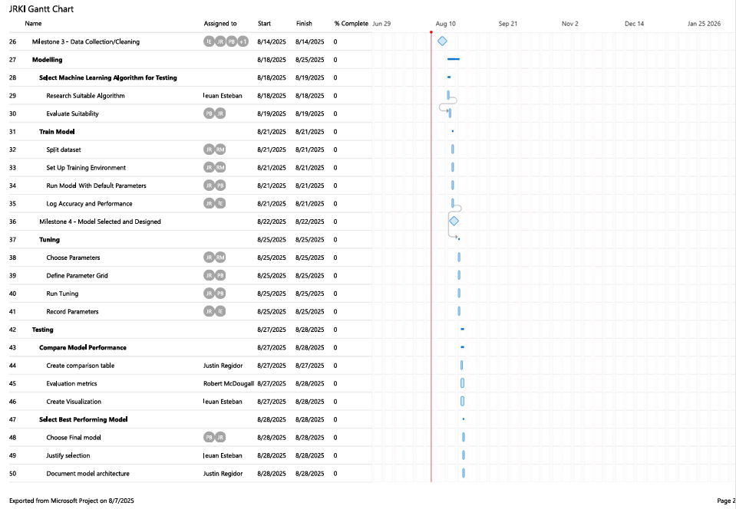
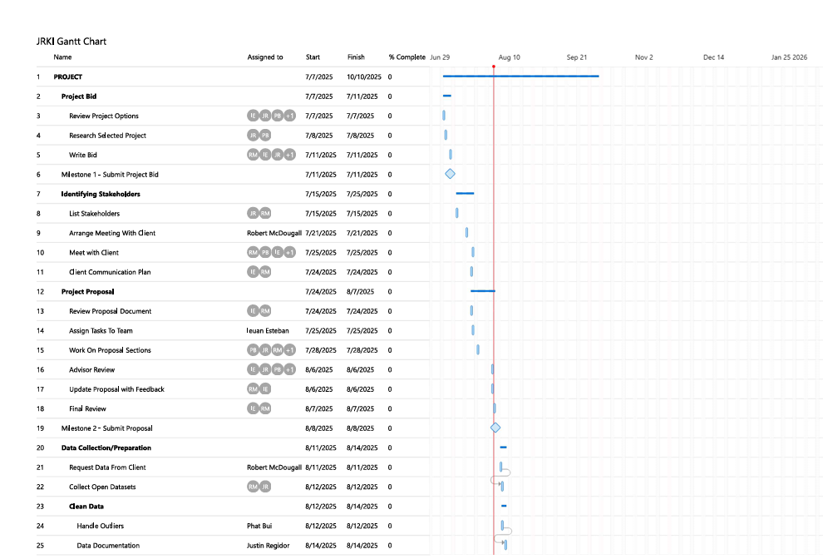
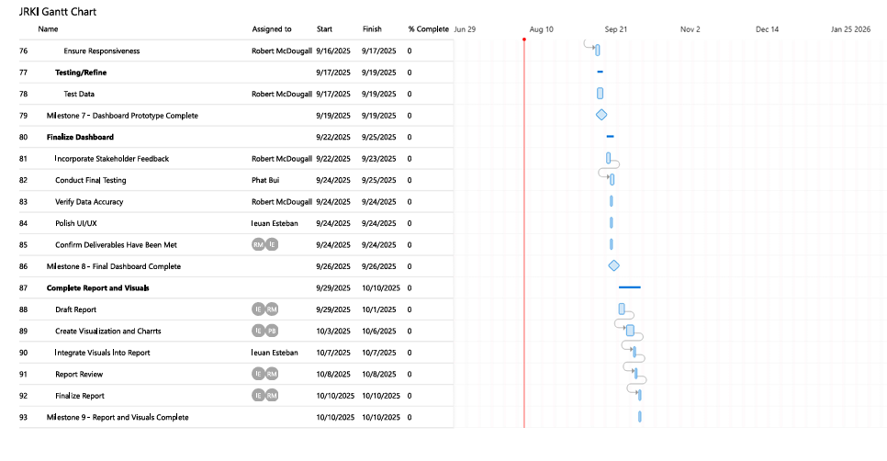
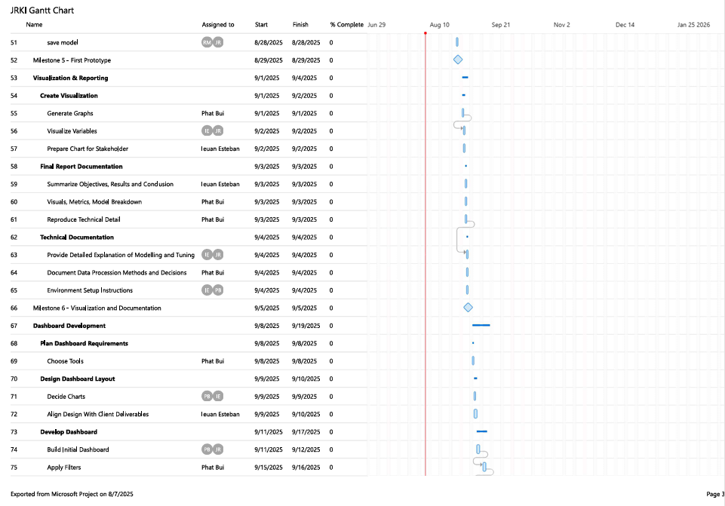

7.2 Appendix B: Capstone Project Client Contract
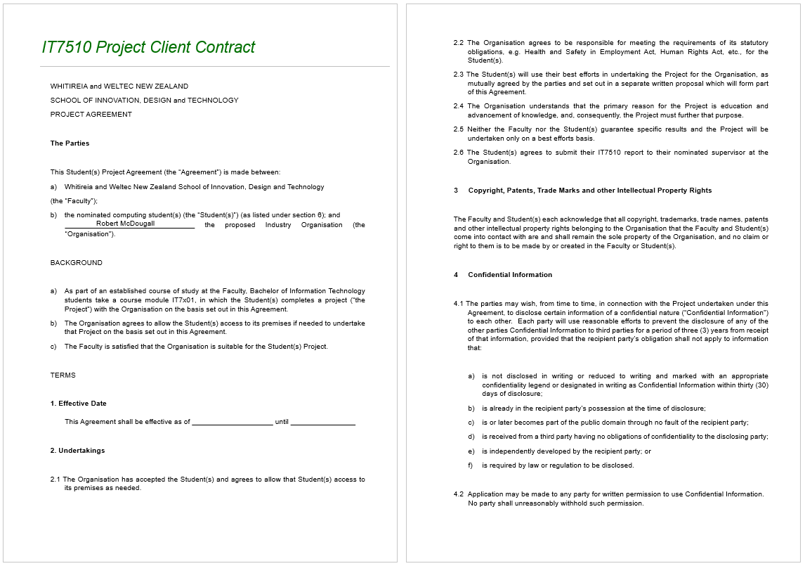

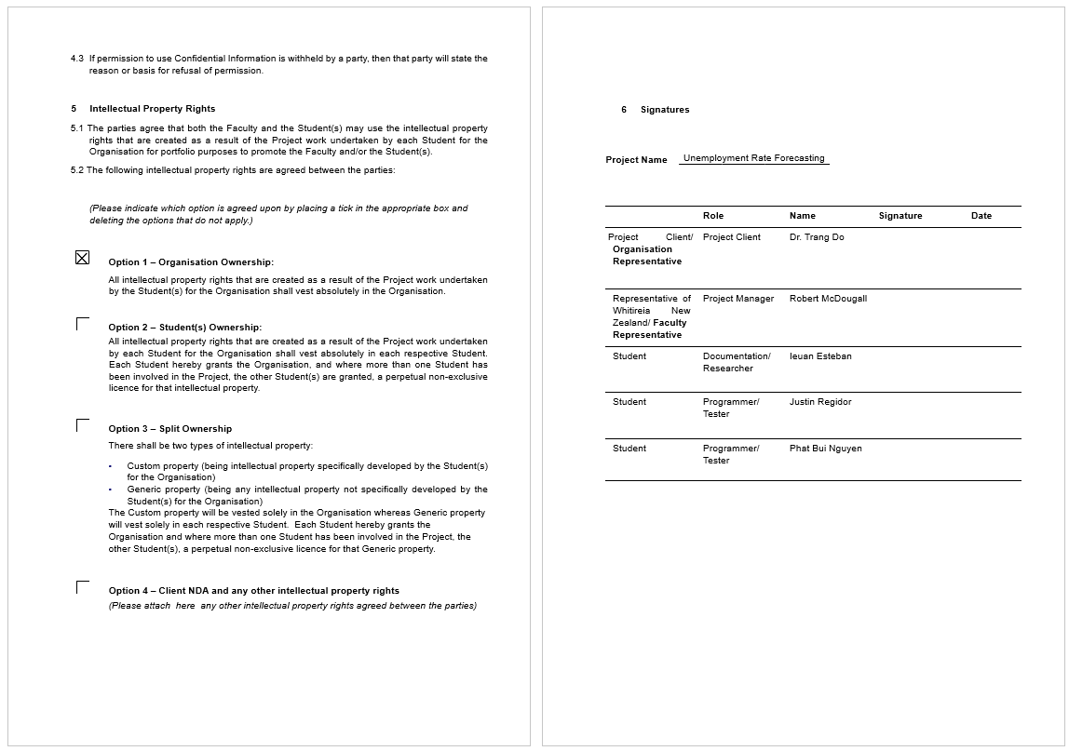

7.3 Appendix C: NDA or Client Statement for Option 4
Still waiting on her email statement

