Caleb  - Kornegay |  | 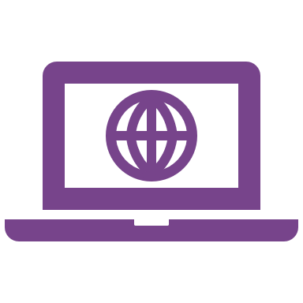  calebkornegay.github.io  (615) 924-4117  caleb.kornegay@gmail.com
 | Education

Bachelor of Computer Science | University of Tennessee, Knoxville | Graduated 5/2025
- 3.99 GPA, Summa Cum Laude, UTK eSports club (co-captain), and Lunabotics (controls team member)

Seymour High School | Graduated 5/2021 | 4.56 GPA, Valedictorian, 35 ACT, 1470 SAT

Experience

Electrical Research and Development Intern | Siemens Healthineers | 1/2024 – 8/2024

GUI development in Python using PySide6 and C# with WPF

Arduino distributed system for sensor data acquisition (hardware, wiring, soldering, and software)

CUDA/C++ research project to help scale processing speeds with data inflow

C RESTful API development on Zephyr RTOS along with React, Tailwind, and Typescript frontend

Teacher’s Assistant | University of Tennessee, Knoxville | 8/2022 – 12/2023

Responsible for hosting office hours, liaison between students and professors, proctoring exams, grading, and labs

TA for COSC101 (intro), COSC202 (DSA I) and COSC302 (DSA II)

Skills and awards
- C/C++ and C#  - Python and Bash scripting  - Outstanding CS Sophomore 2023  - AWS  - Computer networking and security | - Java and Kotlin  - TypeScript, CSS, React  - Golang  - SQL  - Rust

Projects

OpenTicket (Group Project) | 5/2025 | Golang, React Typescript), SQL, AWS CDK, Solidity
- Go backend that interfaces with Postgres Amazon RDS on a VPC using Lambda functions
- Solidity contract to handle ticketing and tracking
- React frontend using typescript with dynamic.xyz authentication provider and Coinbase API helpers for conversion

Rdiff (Personal Project) | 4/2025 | Rust
- Rust terminal user interface to show the differences between two files with syntax highlighting

Digital Dash (Personal Project) | 12/2024 | Golang and Kotlin
- Go backend that runs on a Raspberry Pi and serves up car sensor data across Bluetooth from the OBD-II port
- Android native app to receive and show data written in Kotlin

