Data is one of the most crucial factors in our world today. We are constantly surrounded by data in the physical world, from clocks, diagrams, maps, and even the orientation of the sun in the sky. We use this data to update our current thoughts, as we are more likely to go home when the sun goes down or to find a gas station when our car is low on gas. We do the same with data that can change our opinion, as we are likely to be mindful on what brand of car to buy when told that one brand has mechanical issues often. The digital realm only increases our exposure to data, as every pixel, every word, every google search, is new exposure to data that we may or may not have seen previously. This is why displaying data in a readable and approachable way is invaluable in the modern day. Most have exposure to data charts, as that is the most common way of displaying statistical data, which means people are often able to comprehend the data presented through that method. However, not all people have had such exposure, so when trying to create data visualization, it requires rethinking over what the data is, what message you are trying to portray, and how to explain it to your audience. In this lab, my partner and I have taken the Gen AI Misinformation Detection Data (2024–2025) dataset and will display it in four ways, three being created to target those who have exposure to data charts previously, and one being created for those who have not had exposure to data charts previous to this. We are approaching this design through the Five Design Sheets method.
Moving onto the sketches, sheet one (Figure 4 and Figure 5), I was essentially throwing ideas at the wall given the data we selected. Since the main audience is people that know how to read and analyze charts, I did not need to focus on making the data overly simplified, meaning all the charts sketched work on that premise. Focusing on the bar charts, my idea was to gauge the most common days of the week and times by showing the top three answers. I also sketched a bar chart that would compare the amount of data labeled misinformation and data that was determined to be misinformation, with the percentage of the posts being AI or human created being portrayed inside the bars. For the first bar chart idea, only showing the peak days that misinformation removes points of comparison that is given through seeing the other days of the week, making the data less credible as a result. The second bar chart shown also suffers from the same criticism above. The third does not suffer from this criticism, but this does not feel like the best portrayal of the data, as I believe it could, and will be later in the design process, into a percentage alongside another chart. The pie chart is a quickly observable chart that helps the reader understand the percentage of the items within, which in this case is the percentage between posts that are real and misinformation and who wrote the post, whether that be AI, a human, or undetermined. The scatter plot (Figure 5) is chaotic, but in combination with a trendline portrays if a correlation between post toxicity and source reliability exists, it portrays the message in an easily accessible way. The line chart that determines the rate of increasing and decreasing posts of misinformation is difficult to read and would need to be generalized more to provide useful data, as plotting every individual post and their time would make the lines so jagged that they are not useful.
Moving to sheet 2 (Figure 1), I expanded further into the pie chart concept, which would be targeted towards users that have experience with a chart before. It would feature two rows of pie charts, one for each unique platform listed in the data, and would be populated by the percentage of the writer’s posts being AI generated, human generated, or undetermined. The sections are filtered to only show percentages of posts being marked as true or misinformation and labeled appropriately. Underneath both of the pie chart sections, it contains the percentages of posts reported as misinformation and the percentage of posts marked as misinformation per platform. Testing revealed this is a bit difficult to read due to the amount of pie charts contained in the sketch, however this could be mitigated by providing further separation with outlines of these sections. No comments were provided for the reported and actual false section, although the labeling could use work.
Onto sheet 3 (Figure 2), this design is the most complicated and only interactive sketch that I created, which would be targeted towards users that have experience with a chart before. This sketch contains a bar measuring misinformation posts created per day of the week on individual platforms. This sketch also adds a trend line on each bar chart to further indicate the average movement of the bars. Clicking on an individual bar would take you further into that day of the week, showing the most likely times that misinformation was posted. It also features a modal at the top next to the title of the chart that would do the same functionality. Testing revealed that this modal is unnecessary, as it led to confusion on how it would interact with the days of the week and platform when focusing on times that misinformation posts would be created. No further criticism was provided on this sketch.
Moving to sheet 4 (Figure 3), the scatter plot stayed consistent with the previous explanation, with only minimal changing of labels to make it more approachable. This sketch is the only one I created that is targeted towards users that have not experienced a chart previously, as it is by far the simplest to take in. When focusing on the trend line, the data points can fade into the back of your mind, and the trend line can lead your understanding of the conclusion on the data portrayed. All other sketches require at least a baseline understanding on how to interpret the data, unlike this sketch, where the complexity is pushed to the background. The main criticism received in testing was the trend line being portrayed as multiple arrows to show motion and that it could be reduced to a singular line instead.
I created two sketches for sheet 5, which I will refer to as sketch 5.1 and 5.2 respectively. For sheet 5.1 (Figure 6), I recreated the scatter plot once again. There are no significant differences from the previous sketch, and no testing revealed further criticism. On sheet 5.2 (Figure 7), I further elaborated on the interactive design for the bar chart that explained the trends of misinformation posted weekly. The main page of this chart remained the same as previously described, with the removal of the trend line and re-shifting of the date window to match common calendars, to achieve the same effect that the trend line would provide. On the second page, this would be determined by which platform and day of the week you chose. Pressing on X (Formally Twitter)™’s Wednesday bar would change the day of the week inside the outlined box in page 2. The pie chart would be split into four sections, one for each six-hour period adding up to 24 hours. The posts created would be moved into their respective window of time. The second page also includes a back button to return to the previous page at the top right of the chart. Testing revealed confusion on the inclusion of all platform’s statistics for that day when the previous page has you selecting a specific platform. This was taken into consideration and fixed in subsequent implementations. Testing also revealed subtle confusion on the location of the back button, as it took a second to locate it, which can be rectified by placing it at the bottom right of the chart as well, where “continue” buttons are common, as the “back” action is essentially continuing to absorb the data in this context.
When sketching the graphs, the hypothesis of what the data will portray and what the data actually portrays often differs drastically. This was the case with for the sketch 4 (Figure 3), as I assumed it would actually contain a trend that would be easy to follow. After creation however, I believe labeling this as a “Clear” chart and labeling the chart in sheet 2 (Figure 1) as the finalized persuasive chart. Sheet 2 shows a quickly accessible story and data with little complication. This is due to the pie chart aspect and simplification to percentages, making it easier for a distracted viewer to understand the chart on first glance, without needing to necessarily know further axis meanings and then parse the meaning and result of the trend line. Sheet 4 (Figure 3), requires thought in analyzing the results and the meaning of the graph, regardless of how it is presented. It is for those reasons that the charts purposes were swapped between sketching and implementing.
The completed charts may not be pretty and have fancy colors like other designs, but they portray the data they collected in an efficient, (if sometimes confusing), way. Starting with the clear design (Figure 9), It stuck close to fifth design sheet part 1 (Figure 6). This design added two paragraphs to the top and bottom of the chart in a failed attempt to simplify the data presented. When adding these paragraphs, I believed it would patch the hole created by the confusing graph, which it did not manage to do. With the restrictions on what the persuasive user will do when viewing the graph, it revealed to me that regardless of what attempts I made to fix the complexity, it was not possible. The paragraphs help, but they require spending time reading the paragraphs, which our persuasive user will not be doing. It was at this point I relabeled it as the clear chart, as I believe it still works for a user that will read the paragraphs and not just glance at the graph.
For the newly named persuasive chart, it’s data presentation is still a bit chaotic at first glance, but after a few seconds it makes sense the story we are trying to tell through this chart (Figure 9). Depending on how long our persuasive user spends looking at the chart, different concepts are shown, starting with the easiest to understand at the bottom of the chart. These sections, labeled “Percentage of User Marked Posts as Misinformation” and “Percentage of Posts Actual Determined as Misinformation” respectively, tell the story of how effective the self-moderation of these platforms are at removing misinformation through percentages contrasted against each other. This chart also tells the story on what the likelihood (based on percentage) that misinformation and true information is written by a human, a Large Language Model (LLM), or unknown in the form of pie charts. While this portion is harder to understand at a quick glance, if you have slightly more time to analyze the section, you can pull out the percentages of what posts were written by humans that are both real and misinformation. I believe that section will lead to the most confusion, as it does require a bit of thought to make the connection, but even if that section is ignored at first glance, the secondary percentages can take the lead and portray their story instead.
These charts and sketches are crucial to learning the process of creating readable and approachable data, especially in sets like ours that has 31 columns and 500 entries throughout, which is practically impossible to sift through without a visualization of some sort. While I acknowledge there is room for improvement on the final designs, I believe they accomplish the goals given for them in a valid way. I believe all of our charts followed alongside the principles stemmed from the reading, as we our data did not purposely start at arbitrary points that mislead the viewer, it does not portray the data in a way that negates or hides specific points of focus from view. However, it does suffer from a small sample size, making the data statistically unreliable, and their conclusions unreliable as well. For the clear chart (Figure 9), I specifically ignored the advice inside the “SHOW, DON’T TELL” section in the reading “The Good, The Bad, and The Biased”, as I believe the data is simply too complicated without the explanation. While this reflects a flaw in the design, I believe with more data, the current visualization would function the way it was intended, even if it does not with the data currently.

Figures
Figure 1: Five design sheet page 2, a sketch portraying the accuracy of fact checking alongside the percentage of truthful posts alongside untruthful posts by percentage of human, ai, and unknown writers.
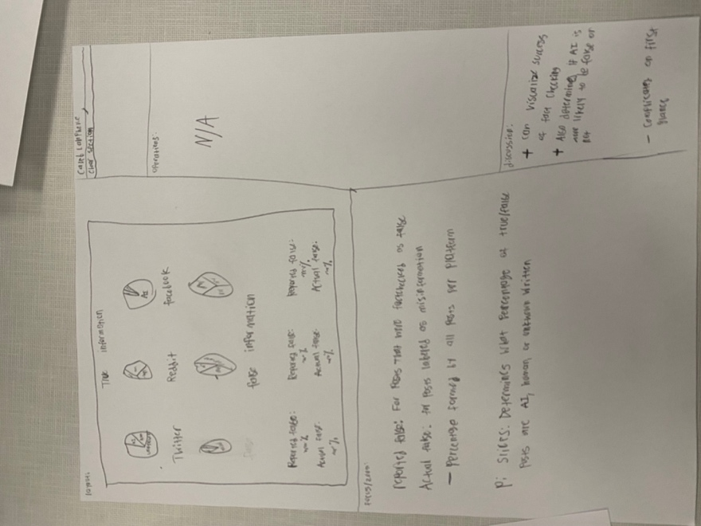
Figure 2: Five design sheet page 3, a sketch for an interactive chart that shows posts per day that are inaccurate per platform.
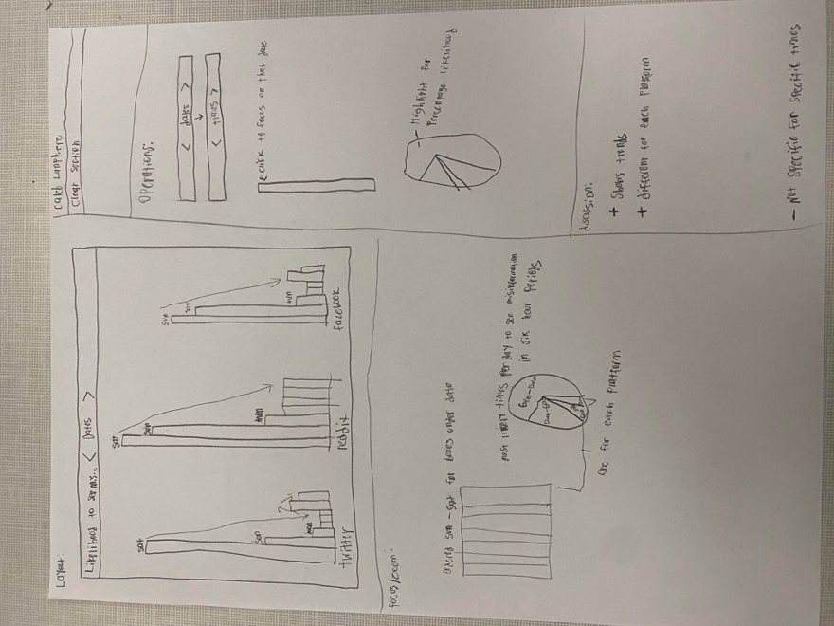
Figure 3: Five design sheet page 4, a scatter plot that plots the authority of sources against the toxicity of the posts writing
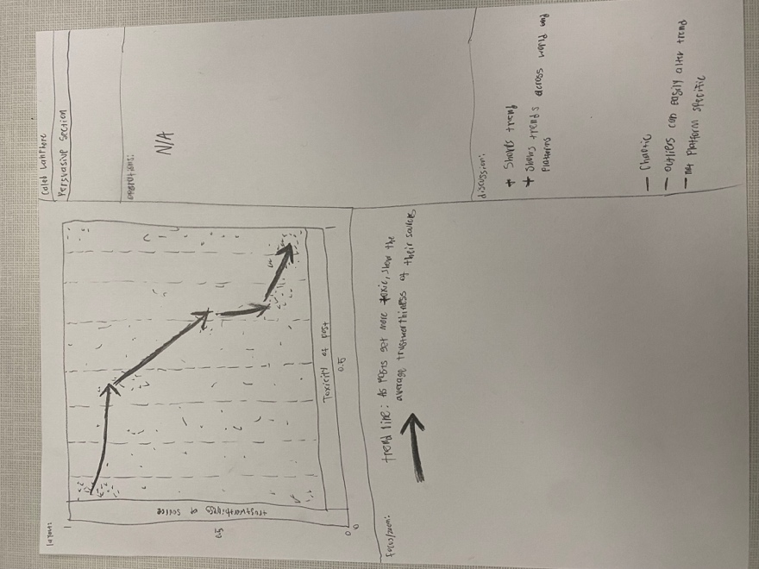
Figure 4: Five Design sheet page 1, displaying some ideas and other more finalized designs
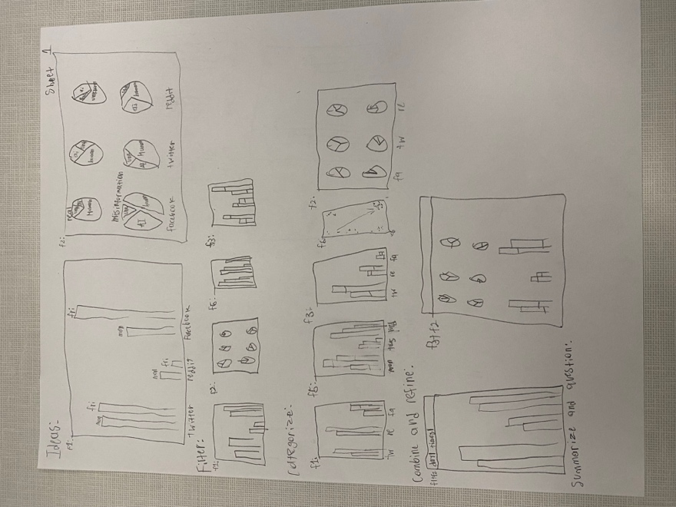
Figure 5: Five design sheet 1 back page, displaying more ideas
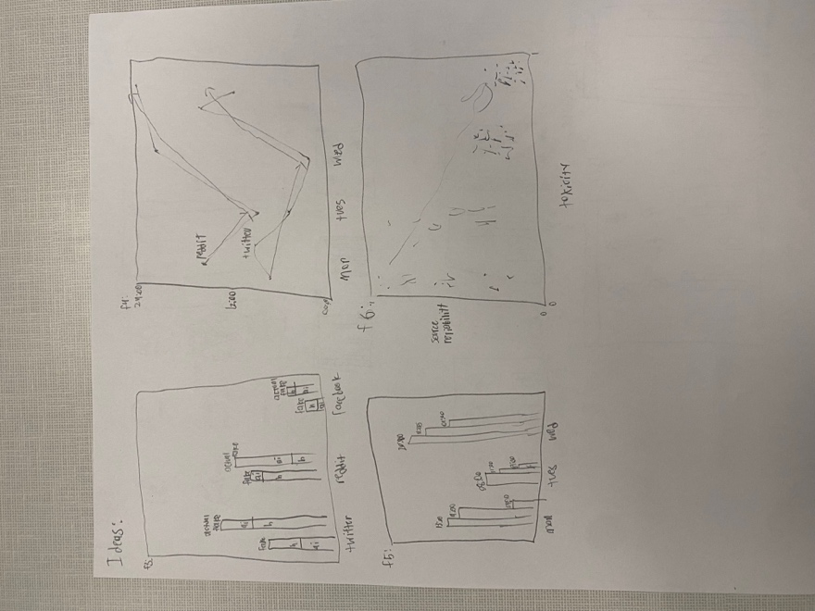
Figure 6: Five design sheet 5.1, portraying the scatter chart displaying the trend between post toxicity and trustworthiness of the sources used
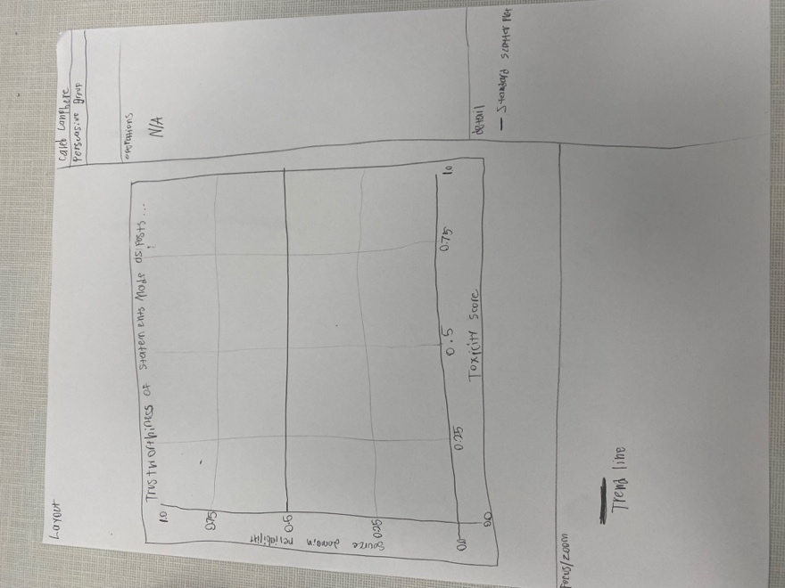
Figure 7: Five design sheet 5.2, portraying the interactive chart showing daily and hourly trends of misinformation being posted by platform
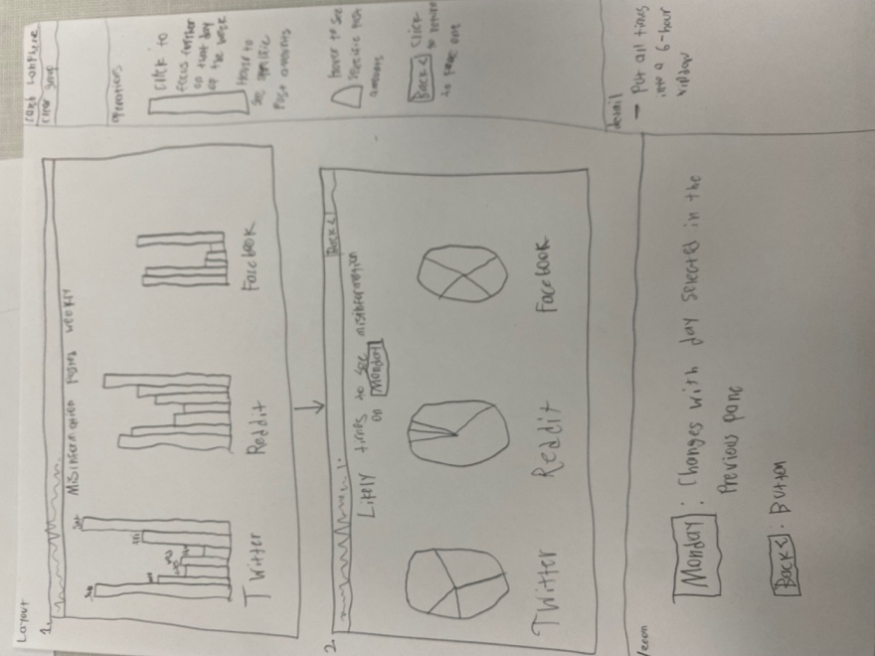
Figure 8: Finalized design of the Persuasive chart
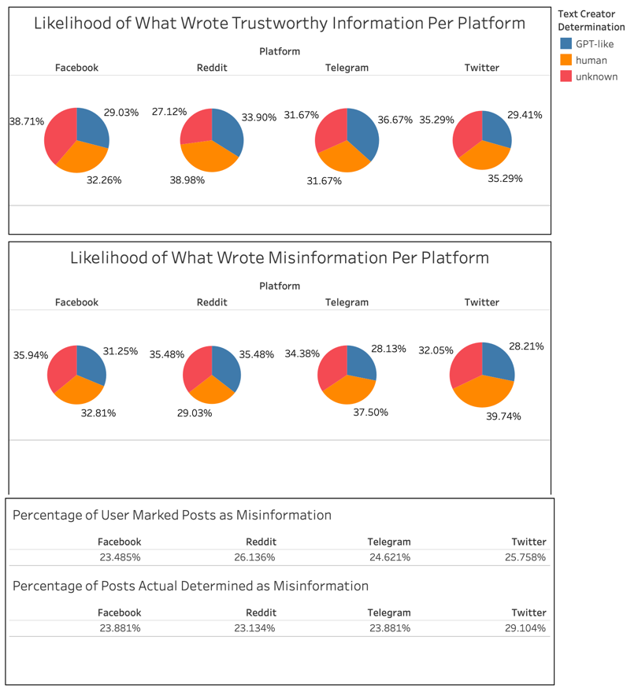
Figure 9: Finalized design of the Clear Chart
