Throughout the interviews I conducted, one glaring issue was prevalent, shining through a handful of questions and a variety of responses, being the accuracy of information online. This, at first glance seems like a complex issue, especially with the scale of websites and likelihood for pages to slip away from maintainers minds. However, I believe I have theorized a solution that could be both easy to implement, easy to maintain, and help the ever-growing issue of online misinformation. I will briefly talk about the concept and theorize a backend implementation before considering the UI design that was brainstormed inside our lab session, as they are critical to the understanding of the solution to this problem.
This system uses a system based on expiration to encourage accuracy in systems and websites. The individual implementation of the expiration system would remain up to the developers of the page. I foresee this being incredibly helpful for dates, news stories, and general modification of data that is relevant only for a specific or after a specific time. Every time a user went to a website that implemented this system, it would check against the expiration date of the data. Depending on if the data is expired or not, the site owner can portray different ideas. Let’s imagine a municipal site has this system implemented for dates of local events. Commonly, these are released close to the event, then left abandoned and inaccurate on their page until the next time it comes around. Our system would make that date invalidate itself after the expiration date passes. The site developer could change the date to state “TBD” (Figure 1)when the data expires or removes the date entirely (Figure 7). In another scenario, lets imagine a news website is covering breaking news that has not been able to be verified through official sources yet. They could implement this system to keep the article or addendum up until the expiry date passes, making sure that data that could be inaccurate does not linger and possibly mislead people accidently. The system could also be implemented to notify the user that the article or addendum has not been verified after a period of time, making the user aware that the information may be incorrect.
The backend would be critical to a system of this scale. It would need to reliably scale, with high concurrency and fast reads across the globe. Writes to the database are the most important in this design, as if one entry gets dropped, sites that implement that entry will break, especially if they are not designed to handle no data being received. This system would need to utilize a CDN (Content Delivery Network) of some kind in order to allow rapid reads from across the globe, so users are not stuck waiting for a server across the world to respond to their request. It would also need a system that splits the expiration data across databases and tables to keep the search time down. Adding an in-memory cache database would help this goal as well. While this implementation factor is not critical to this lab, it is important to understand how it is designed to get further insight into some factors of the UI designs that were sketched.
Beginning with the web interface shown in Figure 1, I wanted to take inspiration from systems that are similar to mine and also have the majority of the implementations take place in the back end. I decided to follow a similar approach to a software interface for MySQL databases called phpMyAdmin (Figure 8). This software uses a column and row approach to display the contents of the database. This is a common and easy way to portray information, as the understanding of its function is commonly understood by most, especially those in the environments working with this software. Next to each entry is a button for managing that individual entry (Figure 2). This is to make the management of each entry equally as fast as finding it in the table, as it appears like another column. I can see this causing difficulty when trying to modify the data in mass, as it only accounts for modification of one entry at a time. This concern was noted and rectified in Figure 5, which uses a “selection” basis to determine which to modify. The latter is a common approach, which is also used in phpMyAdmin as shown in Figure 8. The left-hand side contains the different navigation options, which would contain the user controls, management settings, and information to help implement the system into websites, applications, and the data entry requirements into backend systems. These were not sketched but would follow a similar design to the sketched figures. On the bottom left is the API Token and the log-out button (Figure 2). With further thought, the API token should be hidden in a submenu, even with the visibility button that is present that hides the API token by default. Since this is a sensitive string, having it accessible at all times creates security risks. The log-out button also has a confirmation window, which would be centered on the screen. This is to prevent accidental logouts. The last major focus of this design is the large “New” buttons located at the bottom center and upper right end of the UI. These were placed in two positions to reduce the required amount of time to find the button for a new entry. For time-sensitive applications, like breaking news stories that want to implement this service, every second counts to get the news out, so every second added while trying to create the entry will lead to people not using it or adding it afterwards, making someone need to fix the site and making the entire purpose of this system redundant. Figure 5 shows the same implementation but designed in a more approachable manner that matches modern sites. This follows a modern approach to minimalism for administration panels, where Figure 2 follows an older iteration of this approach.
For creating a new data entry, I wanted to keep it simple and clear for anybody using the system. As shown in Figure 3, the design is mainly text fields and drop-down menus. The fields are placed in the same order that they would be implemented in the database schema, as it makes it allows users to quickly go down the page and enter the data in a consistent manner. All fields are labeled above, which in the sketch, hold a placeholder for design purposes. The names would need to be clearer for actual users, as the existing terms are at a higher level of abstraction that will create confusion. For the data-type drop-down menu, it is important for the person implementing the data received to understand exactly what the data is and how to accurately display it. You wouldn’t want to implement a date the same way you would a calendar event. While this adds complexity for the user adding entries, it is a necessary evil to try to make the implementation across the board easier for all users. The checkbox underneath the expiry date labeled “Does not expire” does exactly as labeled, making the data entry not expire at any time, likely by setting an incredibly long time like Xbox 360 permanent account bans (Figure 9) That feature allows for data to be kept online unless manually removed, which can be useful for case laws or scholarly articles. They would not be automatically removed from a page after a certain date unless the person managing this data decided to remove them, which is faster than removing the entire page or sections of a page that reference it. The last component that needs explanation is the “Data Region” drop-down, which determines the region of data center the data will be replicated (Figure 3). As described previously, the backend implementation would include a CDN network, which is important for sites of scale that need to be accessed quickly across the globe. However, for smaller projects or local sites for municipalities that do not need the data to be replicated across the globe, they can pick a specific region for the data to be stored. This keeps the main region the data will be accessed at fast and places that are not likely to use the information slower. This is a niche feature that would likely be ignored by most users, as it would be set to “all” by default, but if our system was designed as a plug-in for WordPress or as a containerized (Docker) image, this saves time and money for those implementing it if they do not want to use the connected CDN, likely at a cost.
The login system illustrated in Figure 4 is designed to reach a common-sense part for logging in. The design follows the standard design for login pages on most modern sites. It also accounts for OAuth 2.0 implementation, which this service would benefit from, as Single Sign-on (SSO) technology is getting more common place in businesses and organizations.
The mobile design follows the same principles explained in detail above, as it is an extension of the web portal (Figure 6) However, it follows standard approaches in mobile applications, like moving the extra options into a “Hamburger” menu on the right-hand side and moving the main buttons to the bottom center of the application. The creation menu follows the same approach as the web portal, with little alteration (Figure 7) In retrospect, this would be a frustrating design for a mobile device, as it requires a lot of different screen presses across the length of the screen. It would be better to use a screen-by-screen design, where one field is on one page, with a back and next button on the bottom of the display. This allows for a header that names the field, a short description for complicated fields that could be expanded on the top center of the display, and only one field to modify located in the middle of the display. This does create a lot of dead space, but feels better in the hand, especially when typing a lot of information on the mobile keyboard. It also leaves the field that receives data in line with the keyboard, making it fast to see the information typed. The final screen in this pattern would need to contain a summary of the inputted information, with a quick-access jump button to their respective fields or a way to modify that field quickly, a create button placed in the bottom right side of the screen, as this is the common location for confirmation buttons, and a discard button on the bottom left side of the screen, where the cancel button is commonly located. While the proposed design slows down the creation of data entries, it is more approachable on mobile devices, which cannot use standard web interfaces with ease.
If given unlimited resources and time to continue this design, my first step would to be interview both frontend and backend developers to get greater insight in the complexity to implement such a system and how much time it could save or add to existing workflows. Then I would follow that up with extensive interviews with everyday users across fields to determine if a userbase would benefit from this system in some form that makes the development worthwhile. After the interviews, the actual design work would start with creating standard implementations for the data received and testing them with contextual inquiries and eye trackers to determine where the users first glance after at the box and which information receives a positive effect. Only after this step is completed after dozens of inquiries, would we move forward with a design for managing this data, as the visible part to all users is more important than the system administrator end on all fronts. It would follow the same contextual inquiry approach for with experienced and new system administrators and developers, with the use of eye trackers during a series of tasks to provide areas they look first to optimize button and data placement. Every inquiry would be followed by a brief interview to recount the events and get feedback. This would also be repeated dozens of times, in order to provide substantial data to finalize a design.
Systems of this design do not appear to exist for the described use cases. It does exist mainly for reminder apps for contracts and administrative purposes. This is a shame, as I can envision this helping restore legitimacy of news articles and provide assurance to readers that data they see are accurate and not based on outdated information. The designs provided in this document solve the problem for our persona in the previous lab, as now she can confirm that the data is likely correct at first glance, with a reassuring tag that tells the user “We guarantee this data is accurate as inputted”. Now she can go to the event seen online, with a slim chance of having her time wasted and day potentially ruined. While this trust could and likely would be undermined by improper data implementation or incorrect information being provided, it allows a quick way to remedy this information. The design documented in this document is created in a way that makes it as easy for all interacting with it. From backend and frontend developers in a large organization to a solo developer adding it to their site to add authenticity to their events.

Figures:
Figure 1: A paper sketch showing possible implementations of the system
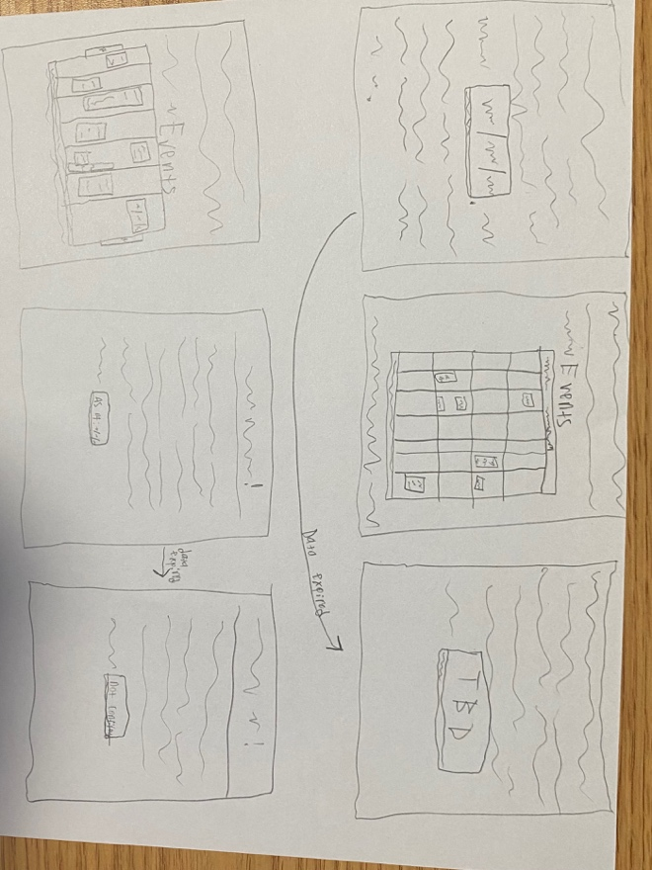
Figure 2: A paper with the sketch for a usable UI for adding and modifying the data entered into the service
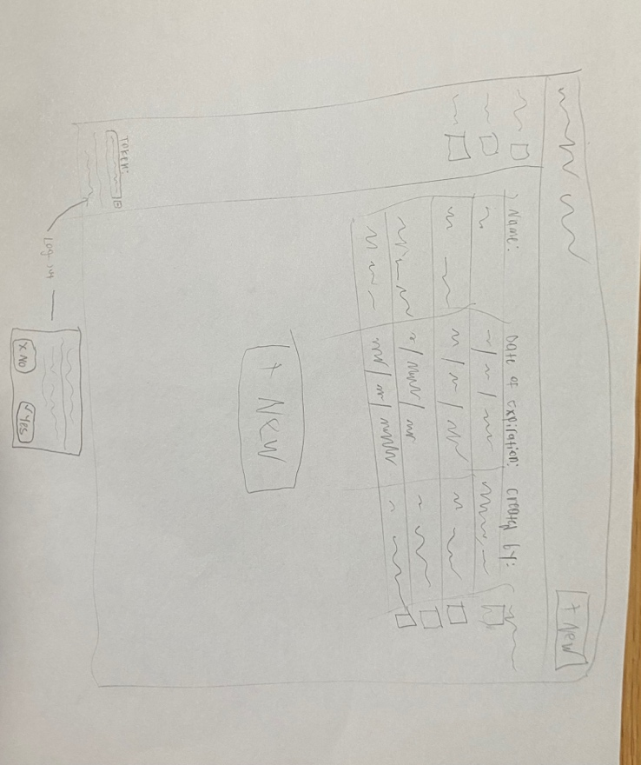
Figure 3: A paper showing the web UI sketch for adding a new data entry
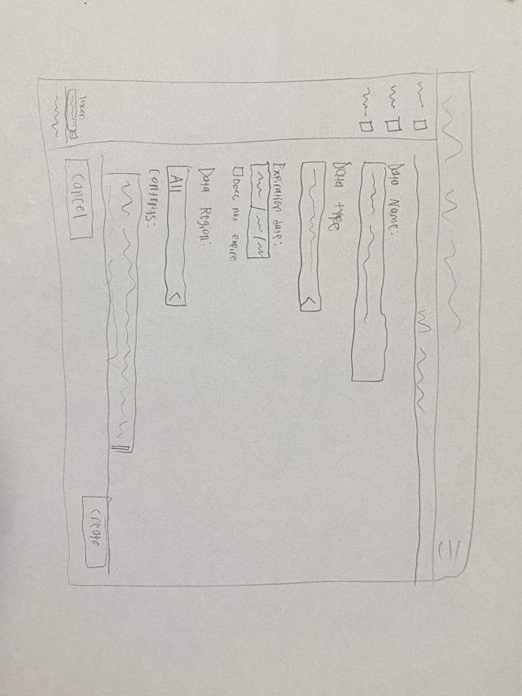
Figure 4: A paper UI sketch of the web login screen; Adaptable to mobile devices
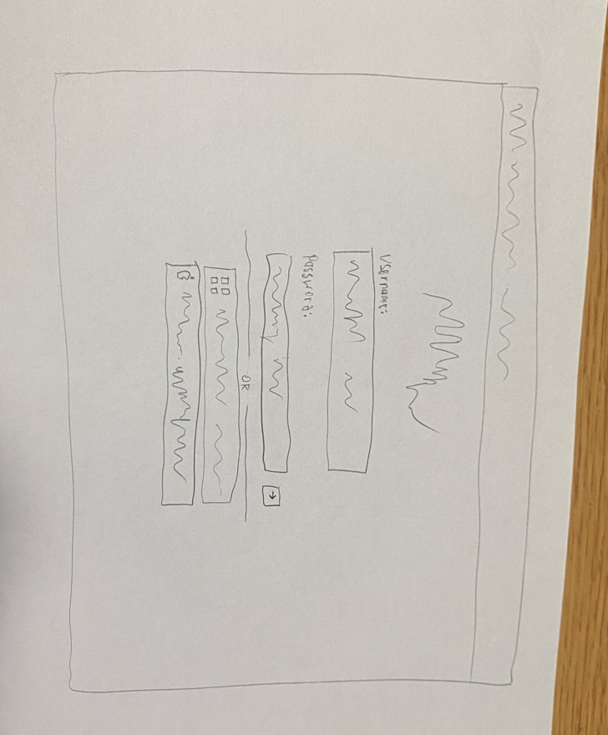
Figure 5: A paper sketch showing an alternative UI web layout to Figure 2 & Figure 3
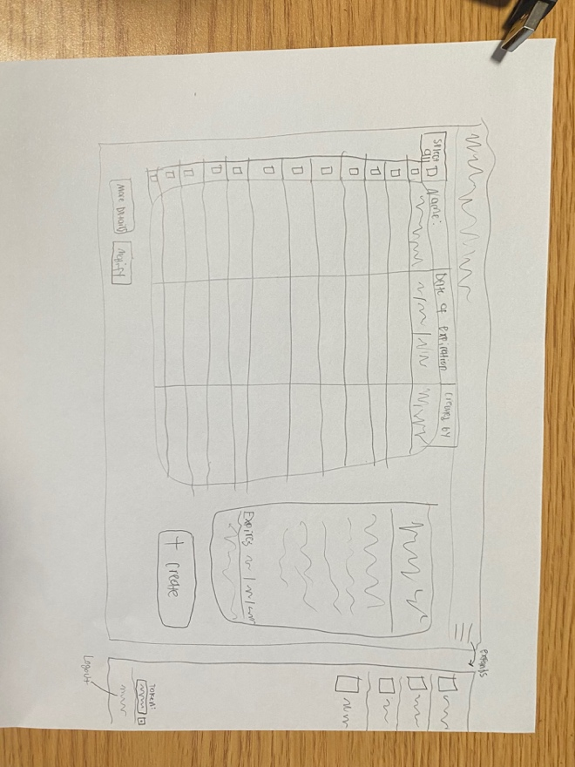
Figure 6: A paper mobile design sketch as a companion to the web design sketches
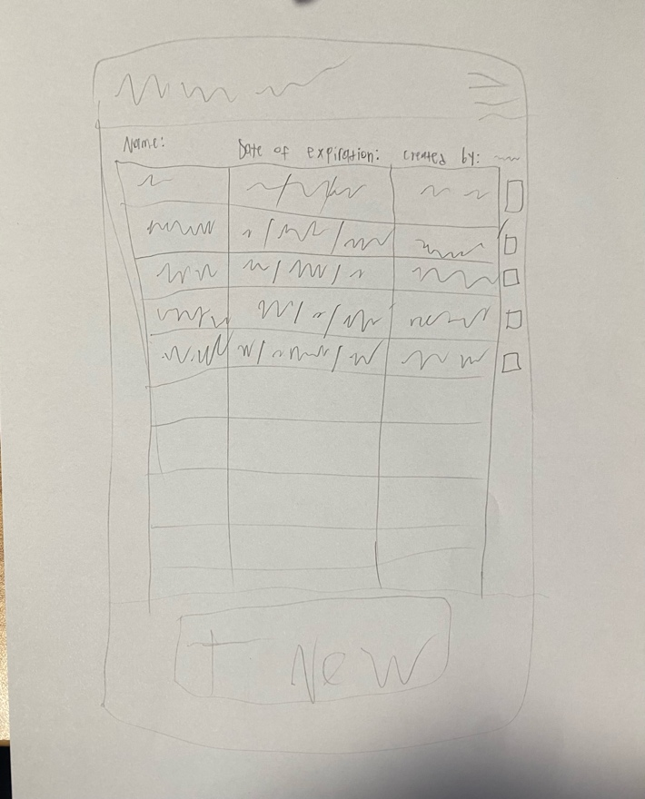
Figure 7: A paper sketch showing the mobile creation of data entries for the service (right) and more possible uses (left)
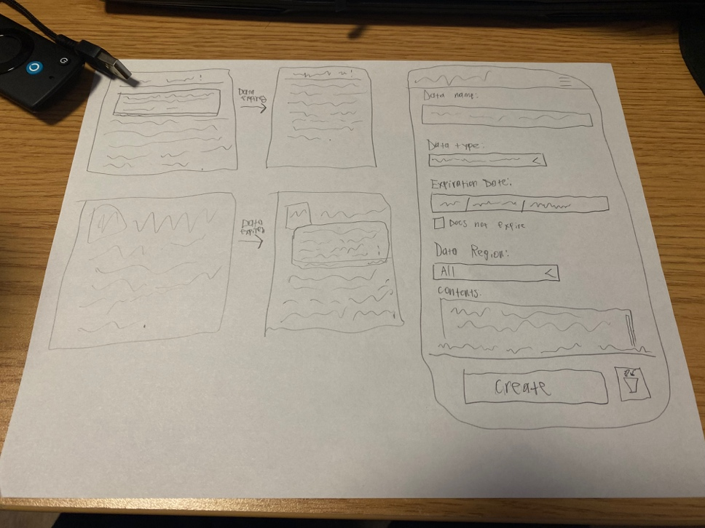
Figure 8: A screenshot of the phpMyAdmin interface
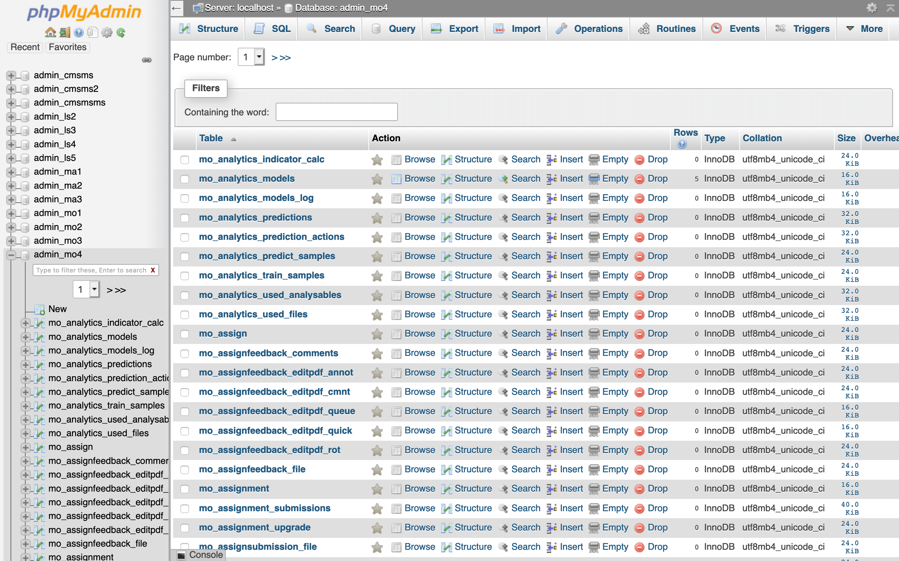
Figure 9: A permanently banned Xbox Live account on the Xbox 360 console
