Design is an iterative endeavor that takes years of practice to have any innate skill, especially when following human centered approaches to your designs. Iterating previous designs allow for a person to address any number of flaws in their designs, ranging from a non-functional layout to changing the size and position of buttons to better reflect actions that could be taken by a user. Throughout the semester, I have learned a significant amount more about human centered design philosophy, how to test designs, how to develop successful sketches and prototypes, and how to critically evaluate advice from testers and myself. Looking back, I believe my first Figma prototype, created in the lab titled Design for Dimensions, deserves a redesign, as I believe it could use an expansion on its design following the new principles I have learned throughout the course. In this document, I will critique the current design using standard heuristics, sketch fixes or total redesigns to solve these problems, and recreate a new Figma prototype that reflects these changes following similar guidelines to the original lab.
The Design for Dimensions lab was rushed by the end, due to mistakes on my part on understanding the requirements stated. While I believe the designs that were produced appear fine, they likely contain flaws that I was not aware of when originally completing the prototype. To find these flaws, I will be using ten heuristics style detailed by Jakob Nielson (Nielsen, Jakob) and analyzing through all of these concepts throughout the application, then identify and elaborate on any page that violates most of these concepts the most. For the entire prototype, it tends to follow the second, fifth, and eighth heuristic goal. The prototype ignores the rest heuristic goals, whether it be on purpose or on accident. The prototype on average is clear and concise. It does not show unnecessary information by default, as shown in Figure 3. This hides unnecessary information to reading the content behind a button. All pages also hide the navigation components behind the “hamburger menu”, which is common on some mobile applications and on screens of smaller size. It also helps prevent errors, as it compartmentalizes everything, meaning that it breaks things into sections. This helps catching errors, as these sections can be tested more thoroughly than an entire application, making it less likely to encounter errors throughout the application.
For the heuristic goals that were not followed, goal number one on system status was purposely ignored. Prototypes can account for system status, but for mobile applications, the only system status you can show tends to be loading, which prototypes attempts to avoid. It is for that reason that this heuristic was ignored at the time. The third heuristic on user control and freedom was not thought about when designing this application. I did not recognize the possible need to quickly navigate out of a section, especially when viewing a piece of content that might benefit from an escape route (Figure 3). Heuristic goal number four explaining consistency was not achieved throughout this prototype, as it uses words like “Go” in Figure 1 for searching, which is inconsistent mapping to other platforms and can cause confusion upon first glance. Heuristic seven on efficiency of use was not considered throughout the prototype, as no special features allow for faster navigation of the pages. Heuristics nine and ten on error messages and documentation were also ignored purposely, as we can include error messages and documentation in a prototype, but this removes the ability to focus on other, more crucial components of a prototype.
After analyzing the prototype with these heuristic guidelines, I felt the need to modify multiple parts, some being minimal changes and other requiring major redesign of specific components. One part that needs modification is “main” page, as currently is it an extension of the advanced search page. With the current design, I believe it is redundant and removes spots for company information and updates. The content viewer also needs a back button and confirmation that your place in the content viewed is saved in order to further heuristic goals one, three, and five. The content viewer can also benefit from a better method to view the contents additional information like the name, size, and tags. As shown in Figure 5, it is inconsistent with placement of buttons and does not follow expected mappings. The blog page needs to be recreated, as it stands out from the rest of the application, breaking heuristic number four. The navigation component can also use a redesign, as the bar with a “hamburger menu” is valid and perfectly fine in this implementation, furthering heuristic number two can be accomplished by making it from scratch to match other implementations for other applications. The search page needs a changing from checkboxes to another selection method to further heuristic goal number four.
Starting with the second sketch portrayed in Figure 7, I wanted to follow modern mobile navigation component standards with the navigation icons being located at the bottom of the screen rather than the top. This is helpful when holding the phone, as we tend to hold the phone at the bottom, so placing navigation components at the bottom allows for the easier pressing of these navigation components. I created multiple ideas from different platforms but ended up going with the Facebook style of navigation modal, as the Instagram model feels older due to its blocky nature and the Tik Tok style put unneeded emphasis on the search icon, which is already given focus for being placed in the middle of the component.
With sketch three portrayed in Figure 8, I recreated a design for the news page, which leans towards the design of the rest of the application. Since the news articles are preexisting in the main archive site, the search function was reduced to its bare essentials, as if you need to find an article based on factors like description or collection, the main search can be used. The sketch contains a two by infinity grid for all the posts, however for consistency and better use of screen space, the grid must be one by infinity.
For sketch four portrayed in Figure 9, I wanted to add components that help accomplish more heuristic goals. The screen had a back button placed at the top left of the screen, that when pressing hides the content being viewed. The information modal also changed from a popup with improperly action buttons to a distinct page with a back button and a citation generator, as the user we are designing for is using the application for research, and this simplifies the citation creation.
For sketch five portrayed in Figure 10, I needed to rethink how to handle checkboxes on mobile devices. The mobile screen is not keen to precise presses that checkboxes require due to its design. However, no great alternative exists that is intuitive for mobile devices, as they require mappings that do not exist in the real world or commonly on web interfaces. This is why I went with a Gmail approach to get the simplification of checkboxes by having the swiping from one side to the other map to a sorting criterion. The sketch has swiping from the right to the left negate the text entered and swiping from the left to the right changes the search term from containing the text to an absolute match. I acknowledge that this can be seen as a flawed design as it is not intuitive to new users and is only useful for advanced users that understand the features existence. This is why a help button was placed across the row from the “add custom search field” button, as it allows users of all skill levels to have the same chance to use the applications search to its fullest extent.
The main page needed a bit more work to it after further thought. While it could be kept as a pseudo page alone, I feel that it is better served as an information page that contains information about the Internet Archive and their mission rather than an extension of the search page. In sketch seven portrayed in Figure 11, I attempted to redefine this page to further the above goal. It still retains the search component, as it’s the first page that appears when you enter the app and most want to find the content by search, so retaining this feature makes the transition faster with the side effect of a transition to the advanced search page. As portrayed in both Figure 11 and Figure 6, the search component would compact itself on scroll, so the screen space can be allocated to other content like news articles, mission statements, contact information, and extra links that are not relevant to our user.
Sketch six portrayed in Figure 12 shows the design for the accounts page. This page, as in most other applications, is a mix of account settings and application settings, with the account settings being first and application settings being placed below. It breaks each settings section into its own page, which will include a back button to reduce the overwhelming feeling of having a bunch of text fields and buttons in a mobile design that are sometimes difficult to dodge when scrolling past. For each setting that can be changed and has an effect on the users experience or appearance on the platform, it contains the save/discard buttons shown in Figure 12 at the bottom, which will be associated with a popup to confirm discarding of the content. This is to avoid accidental presses of the discard button destroying work. For settings that have no significant effect on the users experience or appearance on the platform, no save/discard will be present, as confirming all actions can be tedious and cause frustration when changing simple settings like disabling notifications.
The Figma design stayed close to the sketches, so I will not go into great detail about every page. This project has managed to find a deficit in Figma, mainly in the limiting defined interactions. Since it does not natively have an “on scroll” interaction, I had to create a pseudo one, by dragging the page in any direction to permanently shrink the search bar (Figure 13, Figure 14). Despite this annoyance, the screen is designed the same as in the prototype. This page has an information bar about each collection, which expands to explain the name and description of the collection (Figure 15). While not necessary for all, users can use it to help identify the purpose of each collection which collection is likely to store the information that they are searching for. This helps push the main page to satisfy heuristic goals number 2, 4, 5, and 10. This is because the page has matching mappings, creates and forwards consistent language, helps steer users towards certain pages to avoid errors, and holds links to documentation on the page for those who need the help.
The advanced search page remained relatively untouched at first glance. The content is in the same spot and the same general layout, while missing the check boxes as previously stated (Figure 16). As stated previously, the feature of the checkboxes was removed and replaced with the swiping from one side of the component to the other, as shown in Figure 17. These actions were color coded to red and green, which the background of the search term will change to reflect the successful change of the effect on the search. Since it is not clear that this is a feature, I added the “Help with Search?” button, which redirects the user to the search help page, which dictates these features. The rest of the page remained untouched. This helps satisfy heuristic goals 1, 7, 8, and 10, as we show the visibility of the state of those components, provide shortcuts for advanced users but do not degrade the experience for novice users, remove extra options from view, and provide further documentation to the page. This design does break heuristic goal 6, as we remove the recognition portion of the interface that existed in the previous interface, which is a downside of this design.
The viewer page, similar to the previous page discussed, received tweaks rather than a redevelopment. As shown in Figure 19, the screen now features a back button, satisfying heuristic goal 3 and 4, as we now have the “emergency exit” that heuristic goal 3 describes and consistency is added through the usage of the back button in all pages that are submenus. Figure 18 and Figure 20 show the introduction of a loader screen and a confirmation when exiting the viewer page. This helps accomplish heuristic goal 1, as it now notifies the user of the state of the application, so they do not believe the application is frozen. It also furthers heuristic goal six by making the saving of the user’s position in a text explicit, saving them the worry of it not doing so. The viewer information page shown in Figure 21 received similar treatment, as it received a back button for heuristic goal three, had the download button changed to a citation copying button, furthering heuristic goals five and eight by making it less confusing and mapping the options properly.
For the news page as shown in Figure 22, now meshes with the rest of the application seamlessly. The page has the inclusion of a “Load more articles” button, which furthers heuristic goal eight by hiding older news articles by default. For the individual news articles as described in Figure 23, it features the back button, the text, all comments, and a box to add comments. The back button furthers heuristic goals three and four.
For the favorites page portrayed in Figure 24 and Figure 25, I added collapsable menus that will store the favorites for each collection of data. This helps further heuristic goal three, five, and eight, as it allows the user to pick which collections to view, prevents the user from clicking unintended content links, and hides unneeded content, like empty fields and user chosen fields by default. This incidentally also furthers heuristic goal four, as it provides further consistency by following heuristic goal four.
The settings page shown in Figure 26 followed the work established in the previous pages, with the simplification of the screen for heuristic goal eight. Further work is needed with wording to further heuristic goal four. In the subpage shown in Figure 27, it furthers heuristic goals three, four, five, and eight. Goal three is furthered with the inclusion of a back button and goal four is furthered with the inclusion of the back button and collapsible menu. Goal five is furthered with the hiding of the deactivate and delete account options shown in Figure 28 and goal eight by hiding those components to simplify the screen. When clicking the delete or deactivate button, it will ask for a confirmation from the user portrayed in Figure 29, which furthers heuristic goal five, six, and nine. Goal five is furthered as it prevents accidental clicks from deleting a user’s account, goal six by explaining what will happen with their account with the confirmation, and goal nine by confirming with a user for them to use the description provided to guide their next action.
The help page in Figure 30 also globally furthers heuristic goals three, four, five, seven, eight, nine, and ten. It furthers goals three by giving the emergency exit through the back button and goal four by having the back button. It furthers goal five by having specific options for the user to pick with clear and concise language and goal seven by having the “Frequently Asked Questions” present, which can speed up users getting help for specific tasks. It furthers goal eight by simplifying the screen into sections and subpages for subsections to avoid overcomplication of the page and goal nine and ten by aiding with errors the user may encounter and troubles with the features of the application. Going further into the help pages to the search help page specifically, portrayed in Figure 31 and Figure 32, shows the approach for assisting users that helps further those heuristic goals. By default, only the explanation of the feature is expanded, which helps further heuristic eight. When expanding to get further assistance for specific features, it gives all approaches to accomplish the goal, with the recommended options at the top and less recommended options further down. As shown in Figure 32, the recommended option is always broken down into steps with visuals to assist the user in completing the goal. It both tells the user what to do and what the user should see to understand the success of the action. This furthers heuristic goals one, five, nine, and ten. Goal one is furthered by providing understanding into what the system provides for the user to understand the state of the system. Goal five and goal nine are furthered, as this approach helps users avoid errors by understanding what to do and what to look for if something does go wrong. Goal ten is furthered because this is documentation written in a clear and user-friendly way, preventing confusion that can arise by using overly technical terms that the user may not be privy to.
The new design has furthered all previously recognized diversions from the heuristics as noted by Nielsen. While it diverges in new ways, the strict following of a guideline will never replace actual interviews and testing by users. However, when designing an application without the ability to test with users of the application, this approach can go a long way. Even without users testing my new design, I can recognize where issues can arise based on these heuristic guidelines and further the compliance with them before spending time testing with real users.

Works Cited
Nielsen, Jakob. “10 Usability Heuristics for User Interface Design.” NNGroup, 30 Jan. 2025, https://www.nngroup.com/articles/ten-usability-heuristics/. Accessed 18 Nov. 2025.
Figma Design Link: https://www.figma.com/design/V4rlLkj3UYNjYr67AaZfkf/Internet-Archive-Redesign-Redesign?node-id=0-1&t=3xDyVo8GBGSiRW76-1

Figures
Figure 1: Screenshot of the old Figma design of the main page
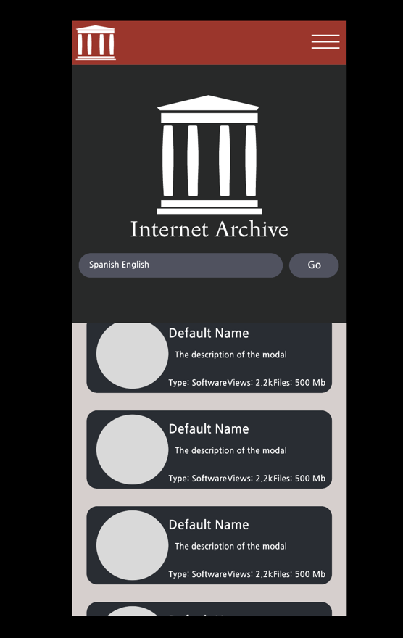
Figure 2: Screenshot of the old Figma design of the advanced search page
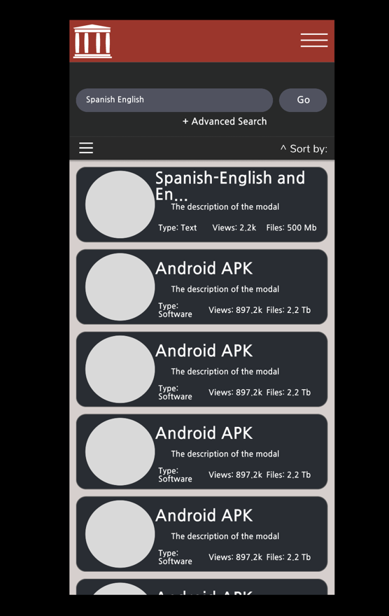
Figure 3: Screenshot of the old Figma design of the viewer page
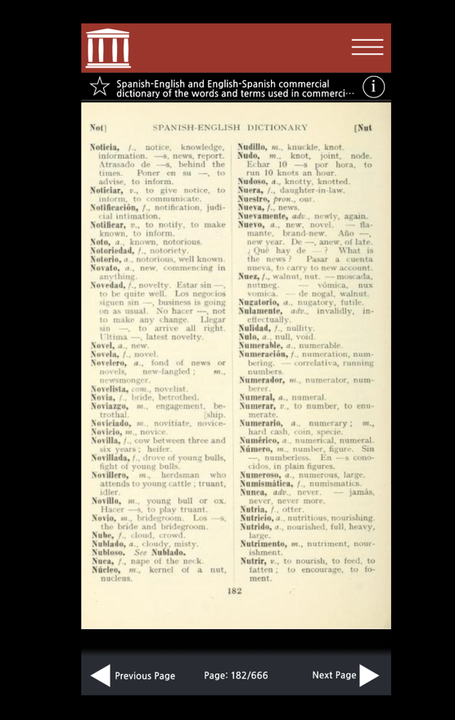
Figure 4: Screenshot of the old Figma design of the blog page
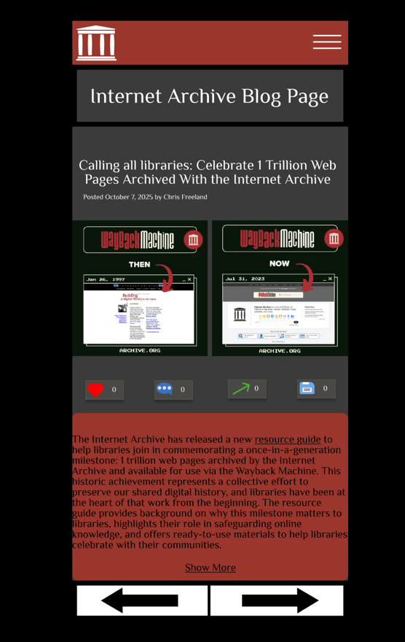
Figure 5: A screenshot of the old design with the additional information modal on the viewer page visible
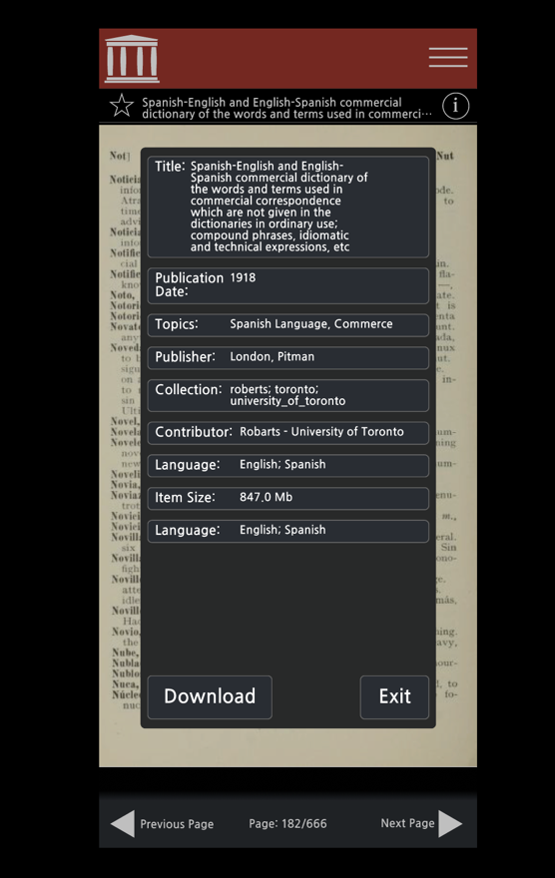
Figure 6: Sketch of shrinking search bar for search/home page
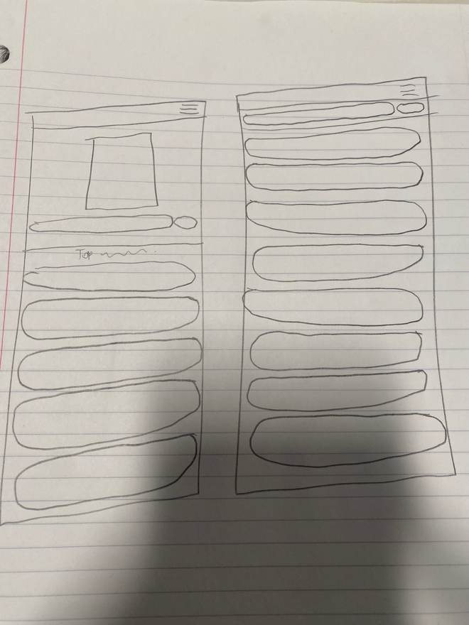
Figure 7: Sketch of navigation bars
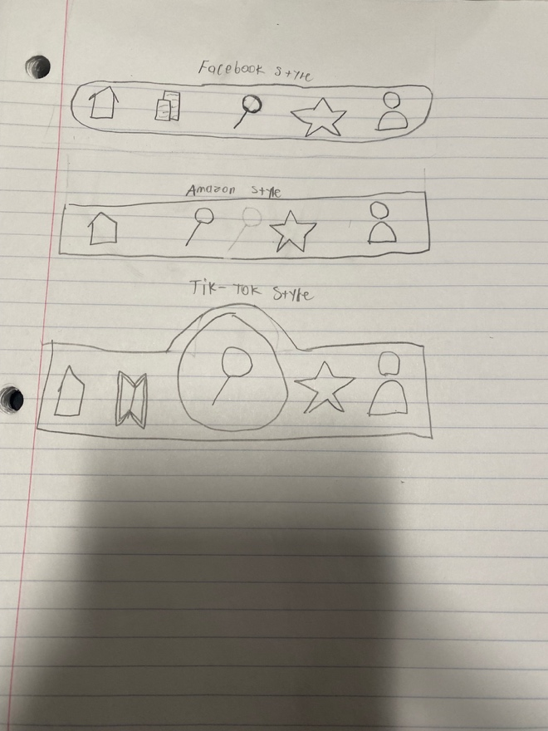
Figure 8: Sketch for news page replacement
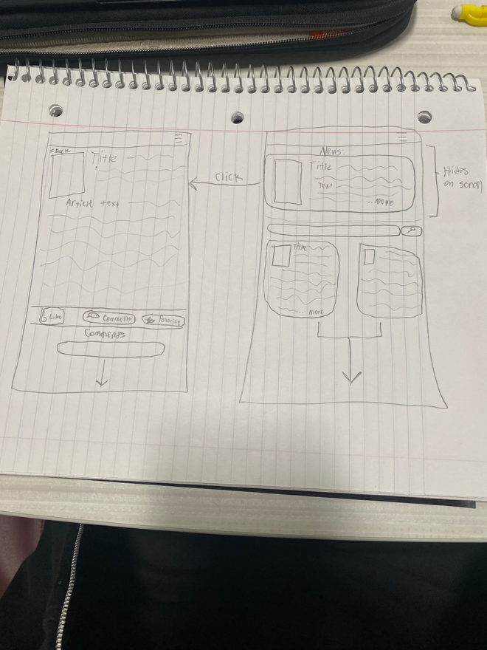
Figure 9: Sketch to fix viewer page
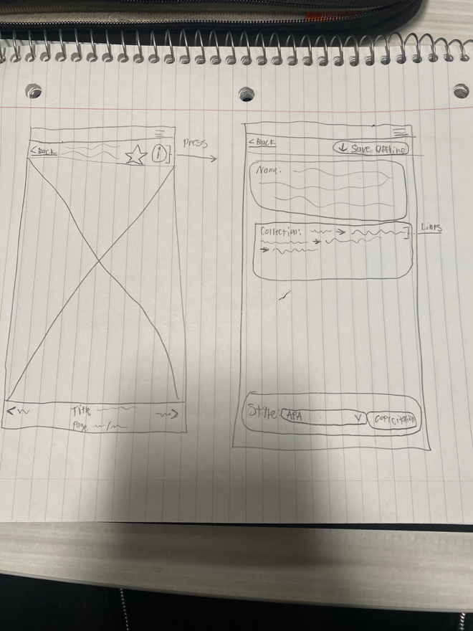
Figure 10: Sketch for replacing checkboxes
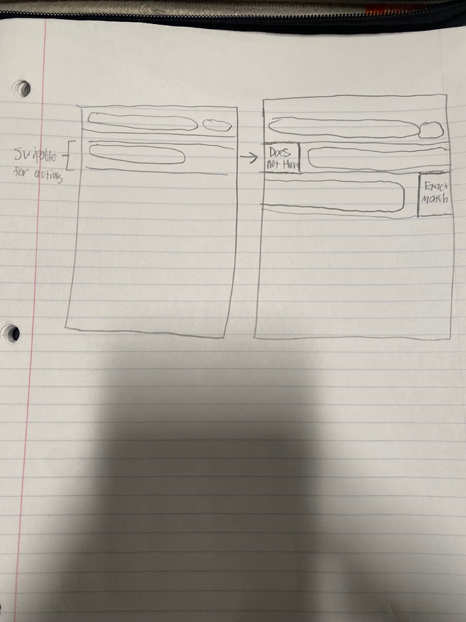
Figure 11: Another sketch of the main page
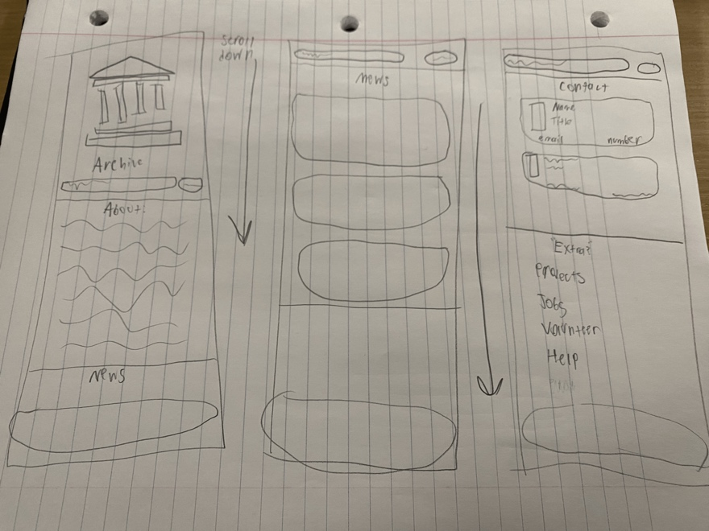
Figure 12: A sketch of the accounts page
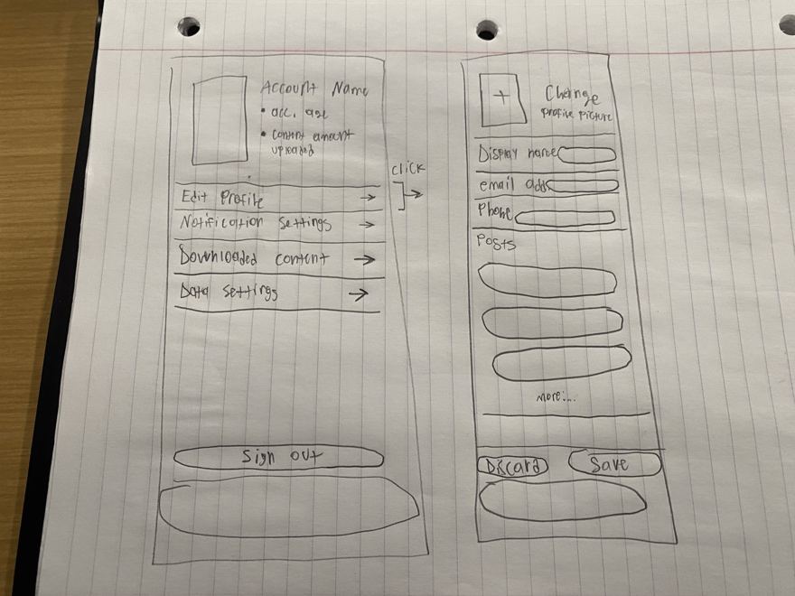
Figure 13: Figma design home page with search expanded
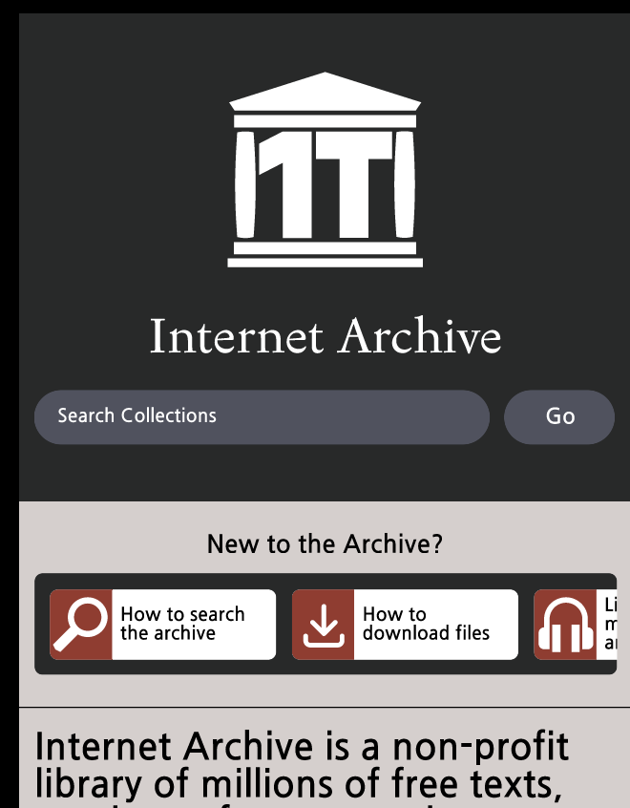
Figure 14: Figma design home page with search minimized
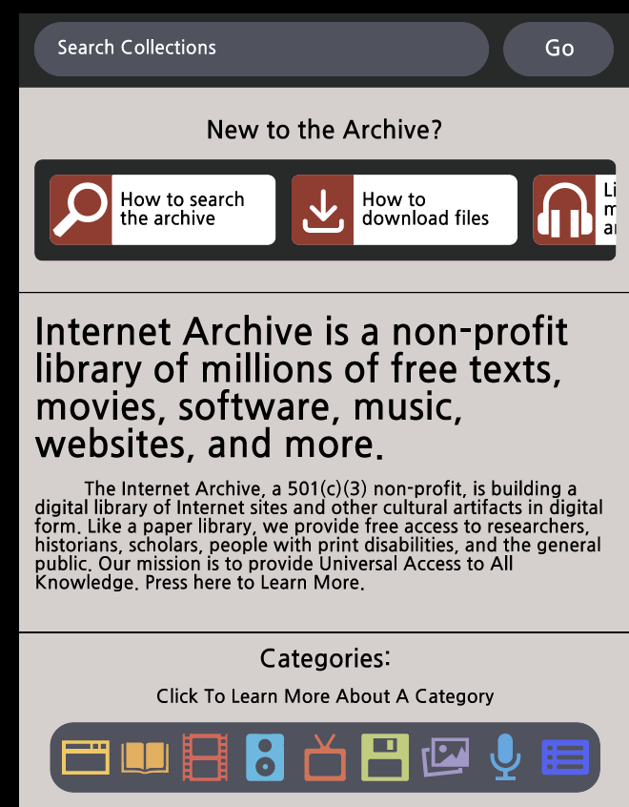
Figure 15: Figma design of the categories dropdown
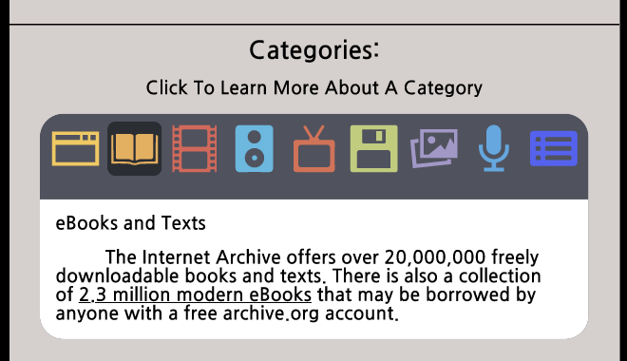
Figure 16: A screenshot of the advanced search page without any search terms modified
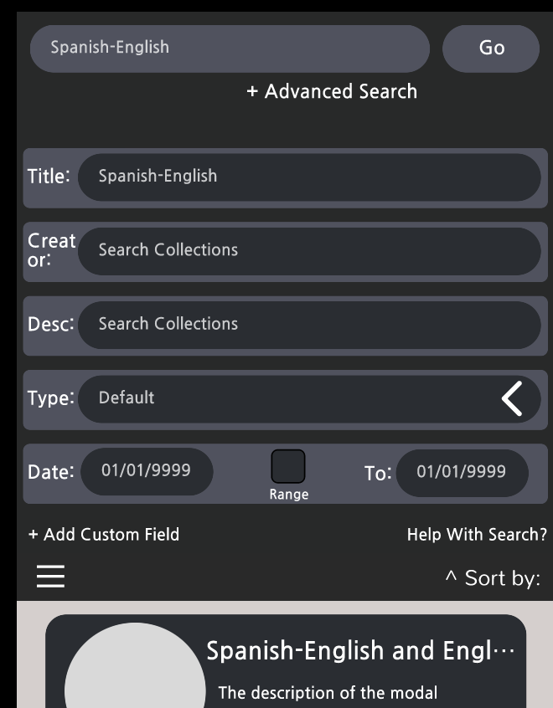
Figure 17: A screenshot of the advanced search page with search terms modified, indicated by color
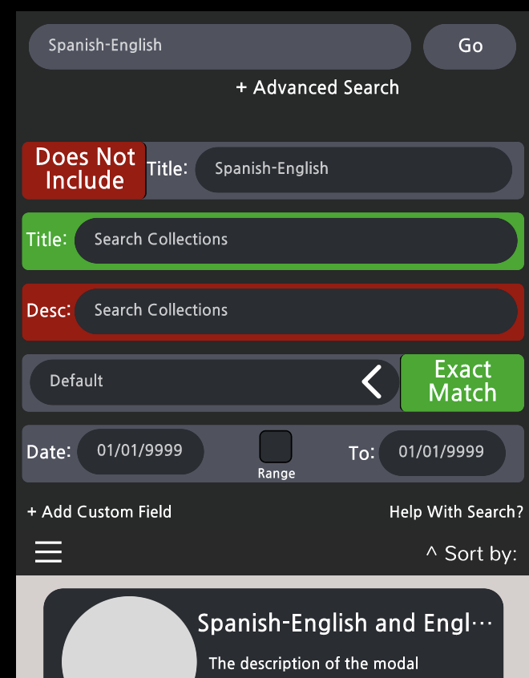
Figure 18: Screenshot of the viewer page, displaying the loading effect
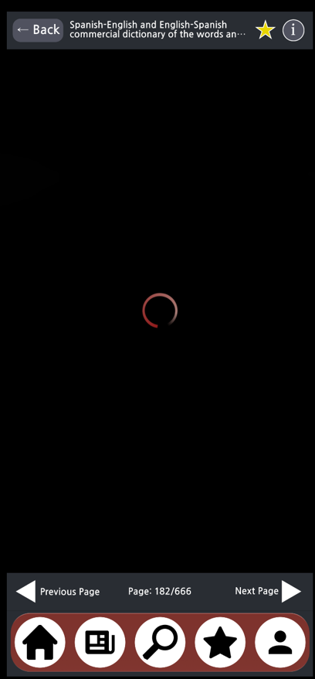
Figure 19: Screenshot of the viewer page
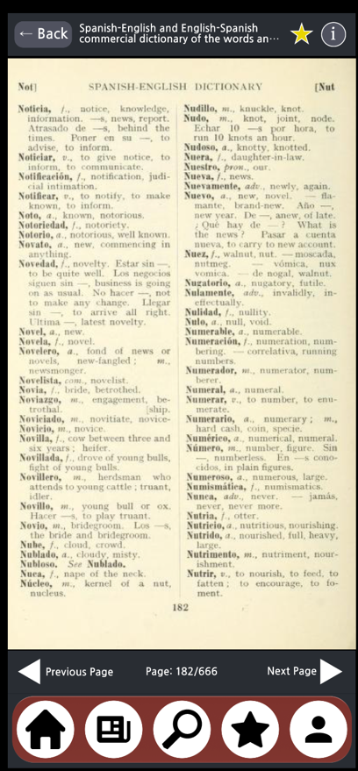
Figure 20: Screenshot of the viewer page with the position saved confirmation popup
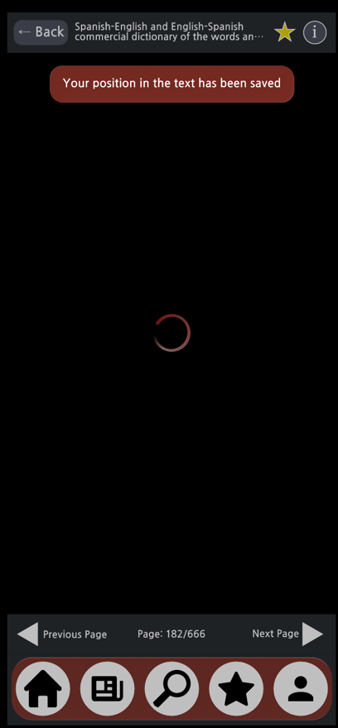
Figure 21: Screenshot of the viewer information page
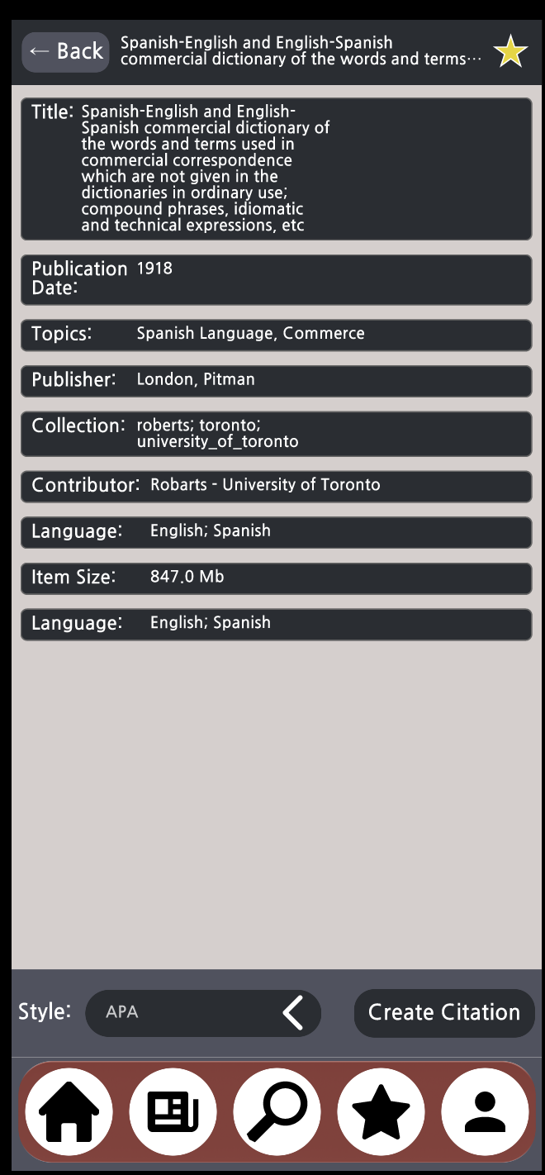
Figure 22: Screenshot of the blog/news page
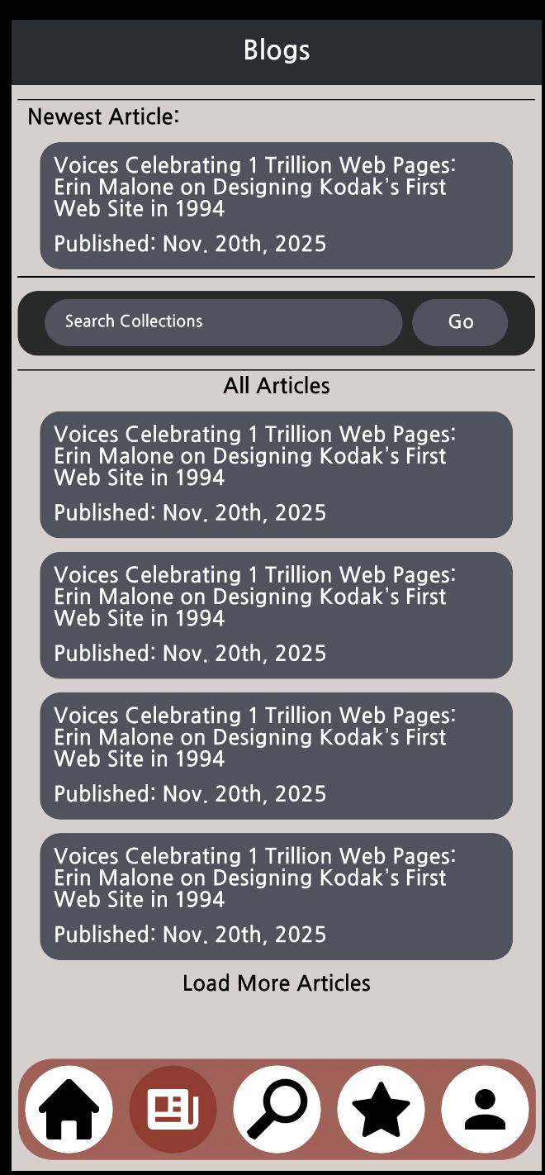
Figure 23: Screenshot of an individual article
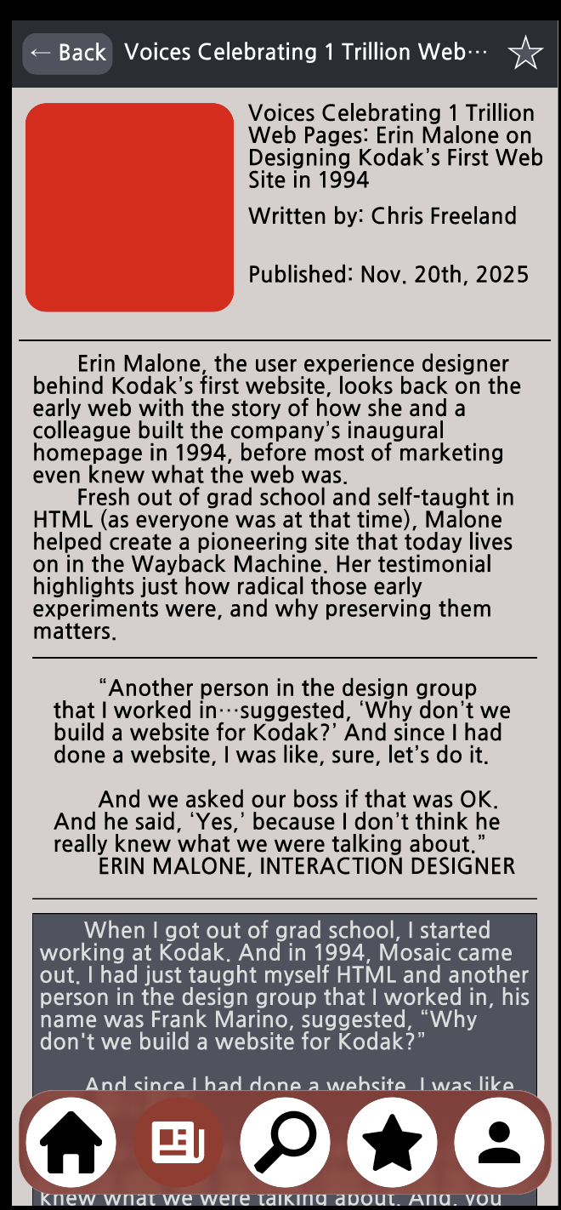
Figure 24: A screenshot of the favorites page in its default state
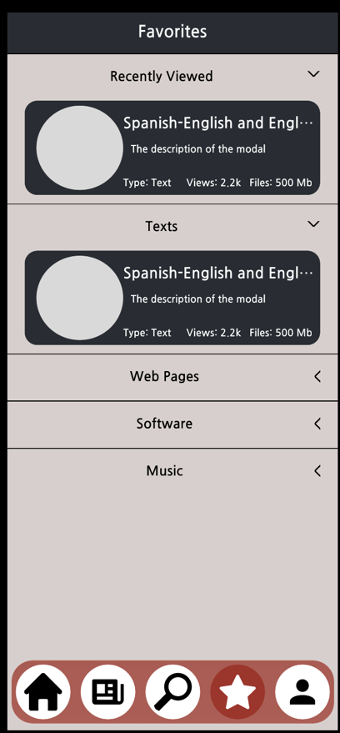
Figure 25: A screenshot of the favorites page with boxes expanded and collapsed
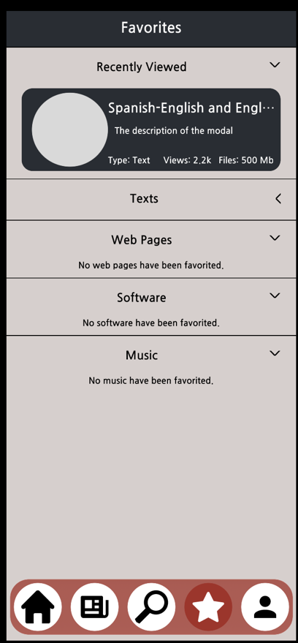
Figure 26: A screenshot of the settings page
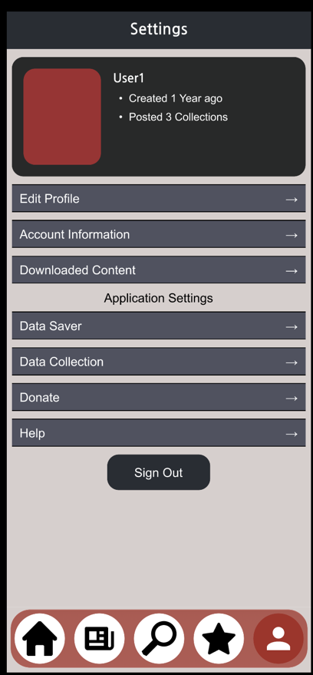
Figure 27: A screenshot of the submenu “Edit Profile” in the settings page in its default state
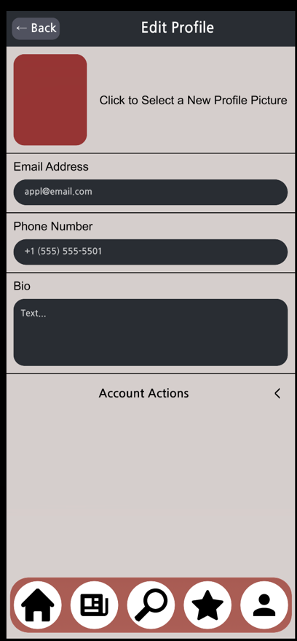
Figure 28: A screenshot of the submenu “Edit Profile” in the settings page with the “Account Actions” expanded
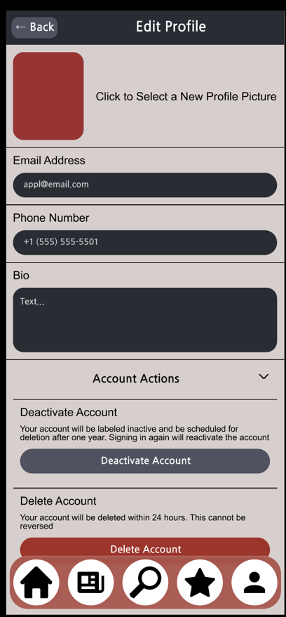
Figure 29: A screenshot of the “Delete Account” confirmation window
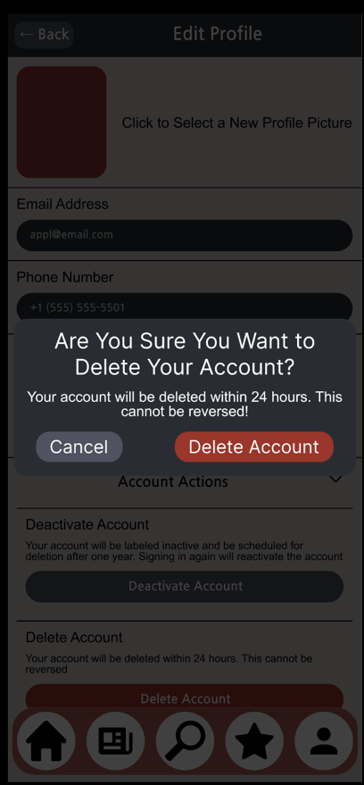
Figure 30: A screenshot of the main help page
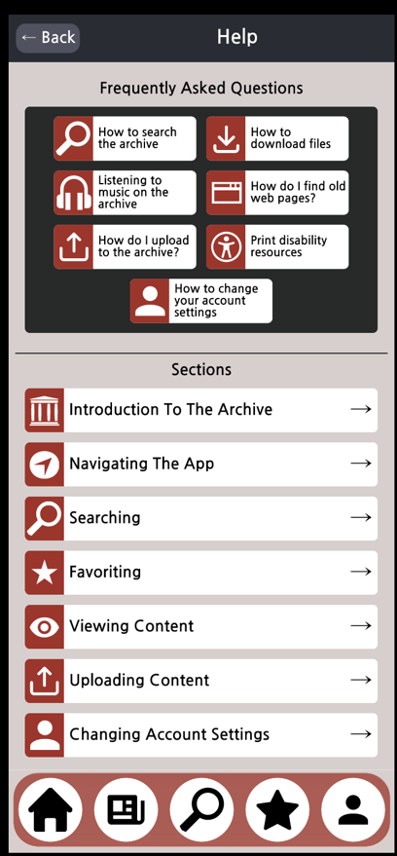
Figure 31: A screenshot of the Search Help page in its default state
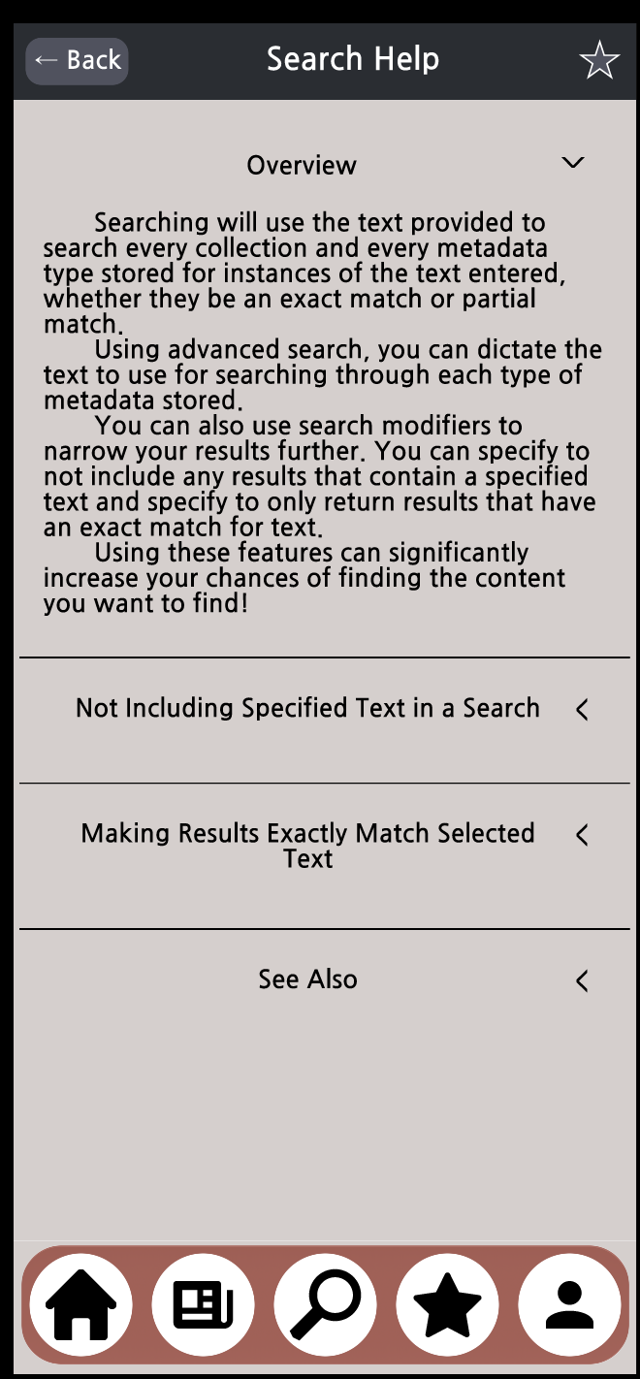
Figure 32: A screenshot of the Search Help page with fields expanded
