Collaboration in large systems is an incredibly complex graph of asynchronous and synchronous actions spread across various parts of a system, all combining together to provide some value to a user. This varies depending on the purpose of the platform, as a large-scale messaging application has different interaction points than a music streaming application. This is what this lab is structured to provide us, to think critically about a large-scale system with users interacting with the platform alongside others based on a set of guidelines provided. We were privy to a design meeting with members of the campus radio station WSBU 88.3FM The Buzz, who laid out their wants and requirements for the application in effort to receive a final product someday down the line. This meeting gave a list of desires, not necessary in order or feasible in reality. Throughout this lab, we will parse the data received by the radio station for their wants, categorize it into requirements, wants, and the priority of each, complete multiple sketches and test them against possible users, create a prototype to demonstrate for the radio station, and briefly discuss some practical implementations for components of our design.
Starting off with parsing the data received during the meeting with the radio station, they went a bit of everywhere with their wants, but they made compelling arguments and guidelines that we must follow. For mandatory requirements, they require the prototype have the features to play live music, show written articles, show schedules, comments, DJ profiles, comment moderation tools, and breaking news articles. While not necessarily mandatory, they also want features for showing song metadata (name, album, artist, etc.), feedback sections, push notifications, links to external platforms for playing songs on demand, a place for calling into the show, and an ability to see listeners that are currently watching. For features they would like but can be negated if time falls short, they would like a live chat that can only be seen by the active DJ, analytic pages to show listener count, average traffic times, etc., interactivity for the show schedule, archival functionality for podcasts and articles, descriptions for podcasts and shows that are hosted, and dedicated web portal and app for the entire application. These all have to be under one master site, as a main concern with their current implementation is the separation of their pages, making the pages harder to cross-navigate. Their main user base is active students, followed by staff and alumni, with a minimal number of outside users. This should not affect the way the site is designed significantly but can influence certain decisions down the line.
These are a lot of requests, which can seem important and not important depending on the designer. Properly placing priorities will greatly speed along the design process, as it gives the required parts the time they need and the less-required parts time to marinate and have further thought into them if they can be implemented into the design. For the mandatory parts, the first designed needs to be the radio functionality, second, news articles functionality, third is comments and comment moderation tools, fourth is show times, and the fifth being DJ profiles. For the most important level of wants, first is song metadata, second is external links to platforms hosting music on demand, third is feedback segments, fourth is a visible phone number for calling into shows, and the fifth being a live count of active listeners. For all other wants, they are equally as important as each other and I will not list them for this reason.
Moving onto the sketches, since there is a significant amount of them, I will talk about specific features from the sketches, but not necessarily every sketch for time’s sake. The sets of sketches are split into two sections, which I will call the user section and the management section respectively, as they serve those general purposes for the application. I will also briefly go over explanations for features and design decisions if they are not understandable based on first glance for the same reason as before.
Starting with the “user” section’s interface, I based it on the interfaces like Spotify™ and Apple Music™, which main focus is the music player. These platforms have the music player bar that constantly stays at the bottom as shown in Figure 1. Behind this is where those platforms place all other functions that are irrelevant to the current song playing. I followed this approach by putting the articles, favorite DJs, upcoming shows, account settings, showlists, and access to the management section behind this widget. This widget can be full screened, as like previous examples, which is shown in Figure 2, which shows the information regarding the current show/song, comments on the show, links to other platforms for songs, liking and favoriting shows, alongside the information of the show like the name, hosts, and description. This is also where the live chat with the DJ is located and the phone number of the station is located. This design places the radio portion as the main component of this site, as I believe it should be the main component of their site, as a site for a radio station would, understandably, play what is on their radio station. This widget always remains at the bottom of the page while inside the “user” section, regardless of what page you navigate to, in order to keep the station playing in the background, as other music players accomplish.
Continuing with the “user” section, news articles would be placed behind in the main section, with a spot that can be added and removed for breaking news segments, like sport scores or time-sensitive articles (Figure 1). This also has a sort and search bar combined into one modal. On the left side I placed the upcoming shows and the favorite DJs modals, as platforms like Spotify™ place favorited playlists and artists in the same spot, giving a consistent mapping of favorites being in a similar position, even if they function differently. Feedback is also placed here but could be moved to the right-side modal to keep the favorites mapping semi-consistent. The right side keeps the navigation links to moving to the show lists, the searchable list of all DJs, access to an about page so the club can explain their purpose and contributors, and the sign-in buttons.
The show list described in Figure 3 would be semi-interactive, as poorly shown. By pressing on a show listed, it would expand to show its hosts, full name, time of the show, and the show description. This sketch follows calendars similar to Microsoft™ calendar built into Outlook, by having the entire week shown and split it into a column that shows events, or in our case radio shows, as blocks of time in the column. This could be expanded to have the window shrink or grow based on user preference.
Figure 4 shows the implementation of their articles, which would remain similar to reading any online article, including the comments per article, liking the article, and a share button to quickly share the article. For this component, I believe changing it too drastically will make it harder to read as it ruins the natural mapping we have built from sites that are dedicated for news, so keeping it the same is both convenient, but also beneficial.
The DJ search and explore function shown in Figure 5 I went with a standard grid approach, which can be separated by the type of content they produce, or level in the club, etc. It contains a search function, as to be expected with areas with large amounts of data to sift through. Each element would contain a picture of the DJ, their name, their position, and the shows they host/cohost. When clicking an entry, it creates a sidebar of sorts that contains the previously mentioned fields alongside a biography of the DJ and their major. This component could be reused at any point you can interact with a DJ name, like under the hosts list in Figure 2. This can also be expanded or shrunk to show different data. It also contains a like and favorite button. While it is not sketched, I believe an implementation for searching through shows would function similarly to this.
Signing into the site as shown in Figure 6 and Figure 7 are the inverse of common website logins, where they have their own implementation of logins on top then Single Sign On (SSO) links below. Since the main audience of this application is Saint Bonaventure University (SBU) students and alumni, I vested to use the opposite pattern. Since SBU uses SSO as their main login method and avoid using standard login practices, I believe using this pattern would help those audiences map the login requirements from other SBU sites to this app. However, since other users outside of the university may interact, it must take this into consideration and have a standard way for creating an account outside of the SSO approach. The sign in for the management portal applies the same premise. The management portal login still has a standard login approach available in case they have an account that many users would share within the recording booth, as creating and paying for a Microsoft Office™ license for one account extra can add extra cost that is unnecessary.
Moving into the management section, the design is premised on the main page sketched in Figure 8, being the main screen that the DJs would interact with for the digital stream of the station. For this reason, it contains a graph of current listeners for the last hour and the live chat. It also contains toggles for both these components, in the chance that the DJ does not want people to interact with him or do not want to see the listener chart. Below that is the currently playing channel/stream, then an options panel that contains settings for moderation of the live chat and other options that the DJ may want to control can be placed there as well. The sketch shows the feature that these controls could be overridden elsewhere by management, in the case they want less or more restrictions for the DJs. It also contains the time remaining for the allotted show segment at a glance, based on the already created schedule, and a master pause switch for the stream, in case the stream must be paused to remove an expletive from the stream. This is a dangerous feature to have in this position, as some users could click it and not realize the effect, but for regulation purposes, having it is important. Other regulation settings are set elsewhere.
Creating show times, as shown in Figure 9 would follow a similar approach to creating an event in Microsoft Outlook™, with the ability to either specifically type in the times or drag on the schedule to get a segment of time allotted for a show. When dates and times are selected or highlighted, it would place a semi-transparent block over those sections that would update in real time to reflect changes. It would also be movable in this semi-transparent form and update the associated times and dates as well.
Figure 10 shows the sketched analytics page, which would contain analytics collected from users of the app for a given year. This would change based on the requested fields. Highlighting two useful features is the “Print Report” button and the “Archived Reports” button. These buttons would, as described, create a printable report of the analytics and allow the seeing of archived reports up to a specified date. This is useful for meetings with leadership and record keeping in general.
Figure 11 shows the settings page, which as described, keeps all settings, keeps all digital stream settings alongside the controls that can be used on the main page of the management section. It contains settings for the stream delay, for the same regulation purposes as for radio transmissions, news archiving settings, comment settings, and other associated settings.
Figure 12 sketched a page for approving comments and deleting already approved comments. As other yes or no button placements, the yes is on the right side and the no is on the left side, similar to confirm or cancel buttons are elsewhere in the application and on the greater web.
Figure 13 is the final sketch showing the account control segment. This section specifically controls DJ and management account profiles, not general user profiles. While they could be controlled, I figure with the inability to post anything other than comments, such drastic moderation tools to ban users or delete their accounts is redundant, as comment deletion is already present and that is the only way you can cause deviance inside the application. At the top, it shows default settings per domain setting, for controlling the default settings for accounts that are created for the management portion of the application. This reduces the effort for IT personnel. It also has the ability to manipulate individual accounts, for changing permissions on a per-user basis.
Testing on the sketches revealed little complaints. A question was brought up during testing, which was the inclusion of the audio player in the login screen. They argued that it’s a part of the site that would not benefit from its inclusion.
The Figma design is incredibly large in scale compared to previous labs with an extra focus on functionality. Most buttons can be clicked, which allows us to get a better sense of how the layout would functionally work, as clicking around actually takes us where it should lead. As shown in Figure 1, the document is ridiculously sized and complicated. Since most decisions that differ from sketches to the Figma document is minimal, I will only talk about new features that were changed or designed while developing the Figma prototype before points that are of lesser importance. The general idea sketched throughout was changed to better blend with my partners sketch ideas, as I sketched with the assumptions of a singular, reactive page, and he sketched with the understanding of separate pages. This is why a difference exists between some sketches and implementations in the prototype. Figure 15 is by far the most important idea added into the prototype that was not sketched, as it shows how articles would be added. I decided having two options, one for adding from a PDF file, and another for doing it from scratch would be a nice quality of life feature. A design decision I feel is needed to bring up is the navigation bar shown in Figure 16. Since the prototype has multiple pages that users can navigate, having each one linked directly in the navbar would clutter the page and make it harder to find the page you want to visit. By shoving it into a “hamburger menu”, it allows for more pages with little added confusion. Incidentally, this also allows for easier porting to mobile devices, as the “hamburger menu” is commonly found on mobile devices for the same reason as stated for our decision. Colors are where I could not discover a good schema, as I wanted to lean towards the university’s colors, which are, in my opinion, difficult to work with. This makes the “Management” sections flood with yellow in the current design, as I believed grey would blend into the other grey components that exist on the pages. This is a part that could be reworked if given more time to manipulate the page colors.
The testing of this Figma design did not reveal any major red flags, although it did mention the colors being unfriendly to the eyes and revealed that some features were not used by the user, as they did not notice its existence.
Overall, I am proud of the layout I have created, as it follows most heuristic guidelines, like following familiar mappings and implementing confirmations for actions like discarding a draft or triggering a digital stream pause. If given the chance to further this lab, I would lean further into giving it a distinct visual identity. As of now, the lab has consistent colors, but no visual identity besides the university colors being scattered across the platform. With extra time, I would generate a ascetic for the prototype and reincorporate that ascetic across all pages.

Figures
Figure 1: Main screen sketch
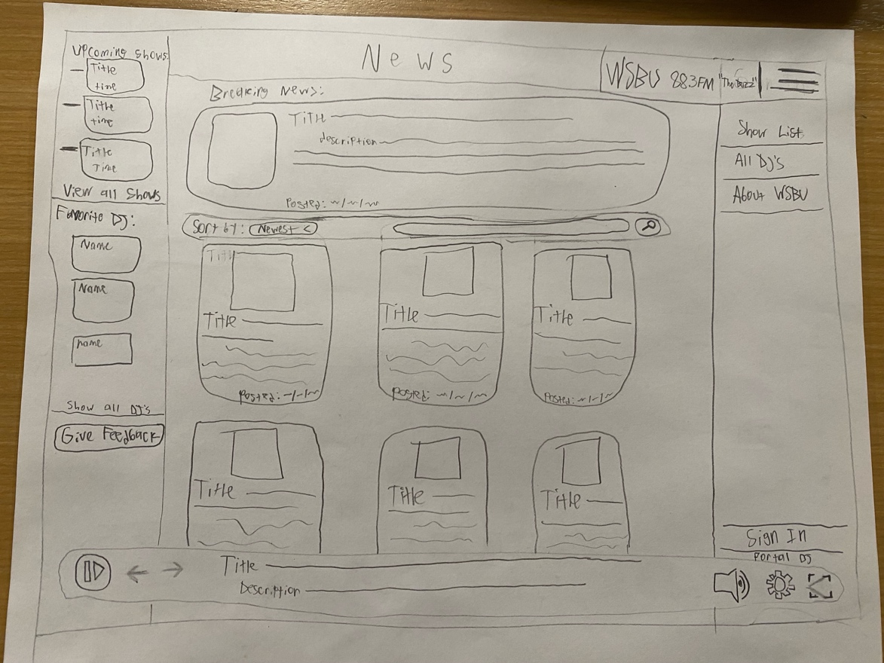
Figure 2: Main screen sketch with the music player full screened
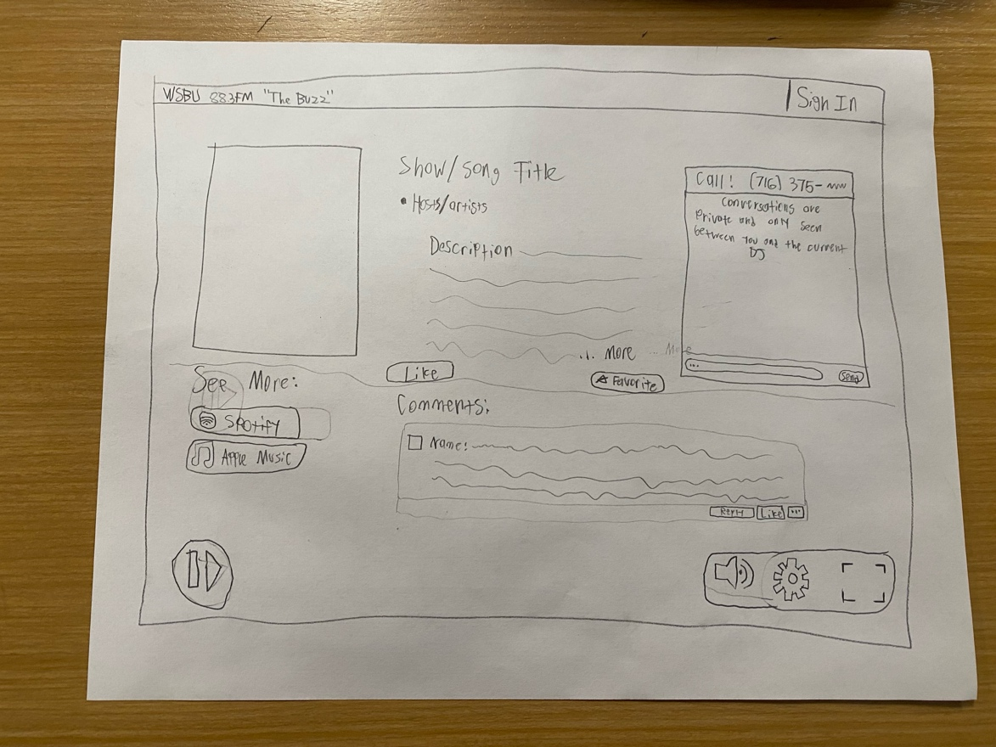
Figure 3: Show times interactive sketch
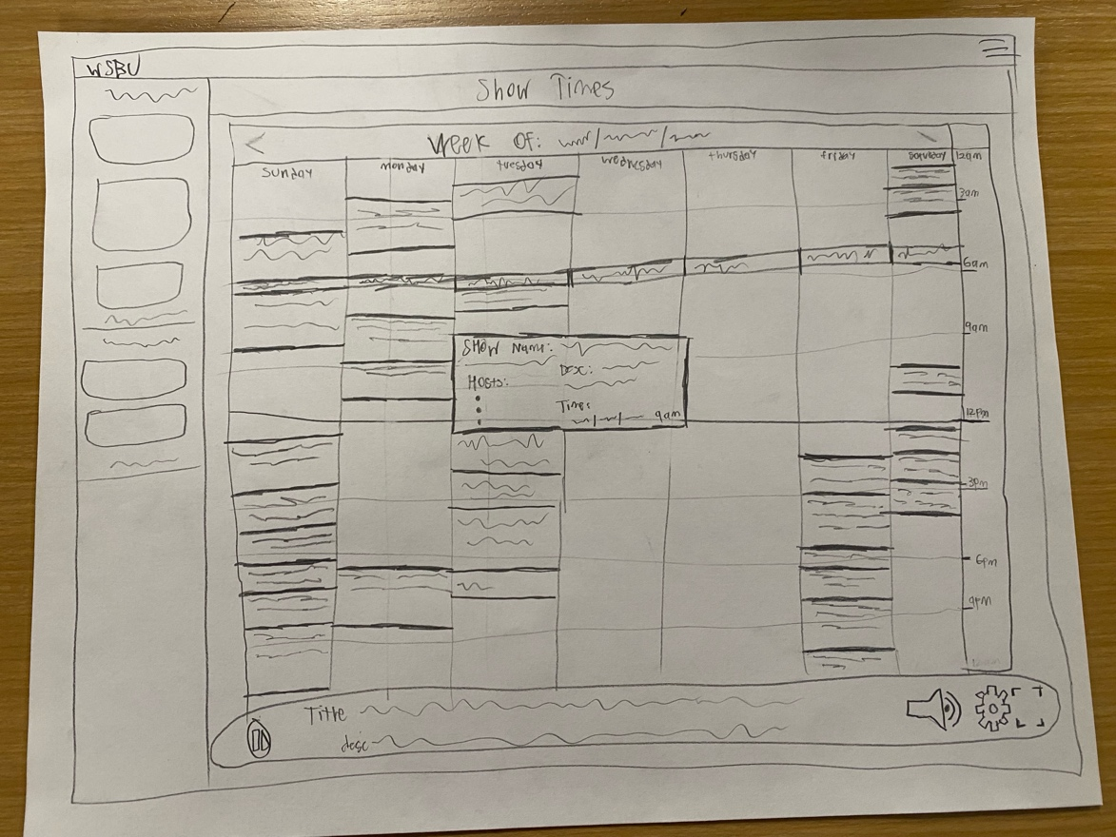
Figure 4: Article reading sketch
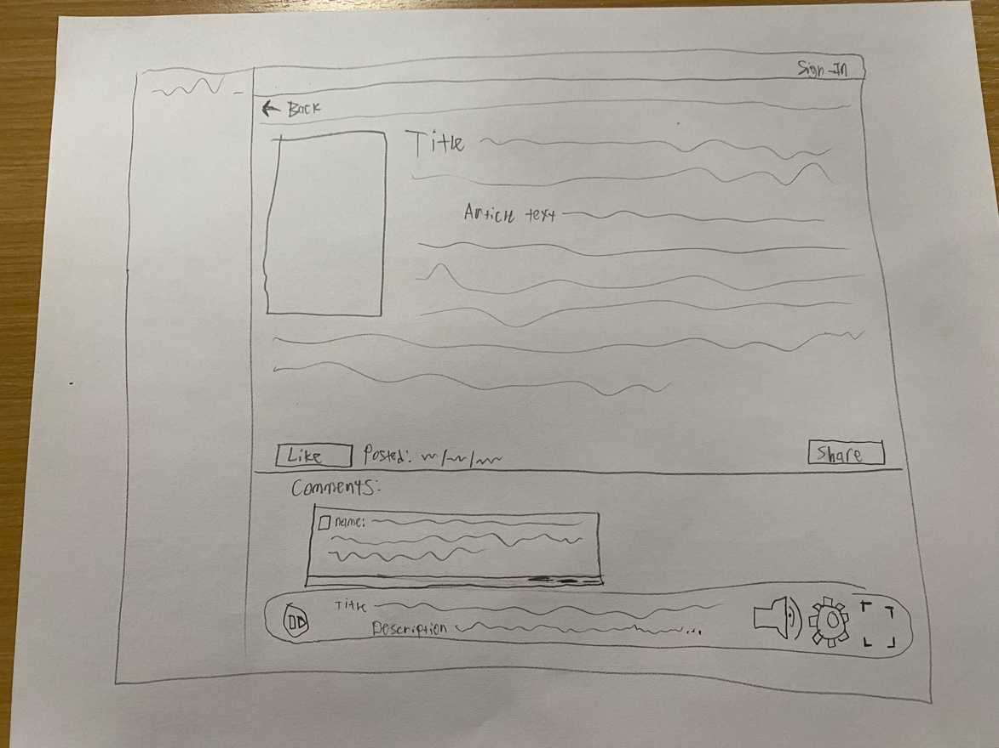
Figure 5: DJ Biography sketch
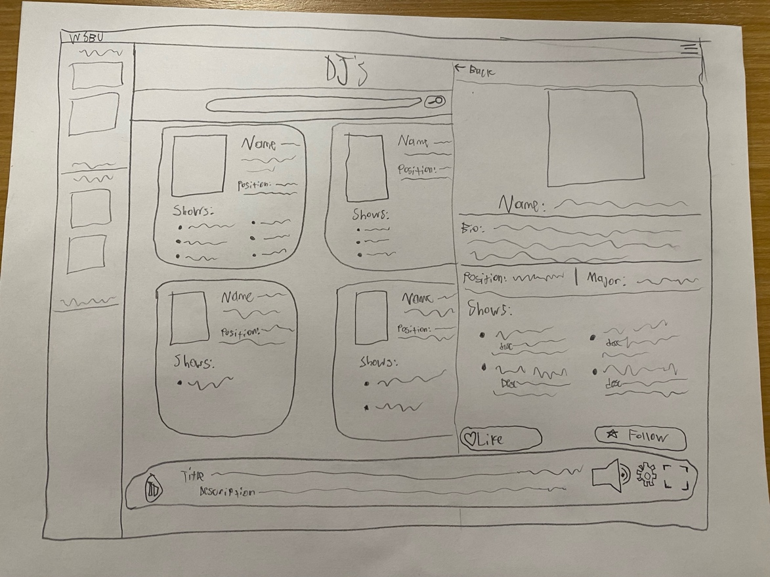
Figure 6: Staff login portal sketch
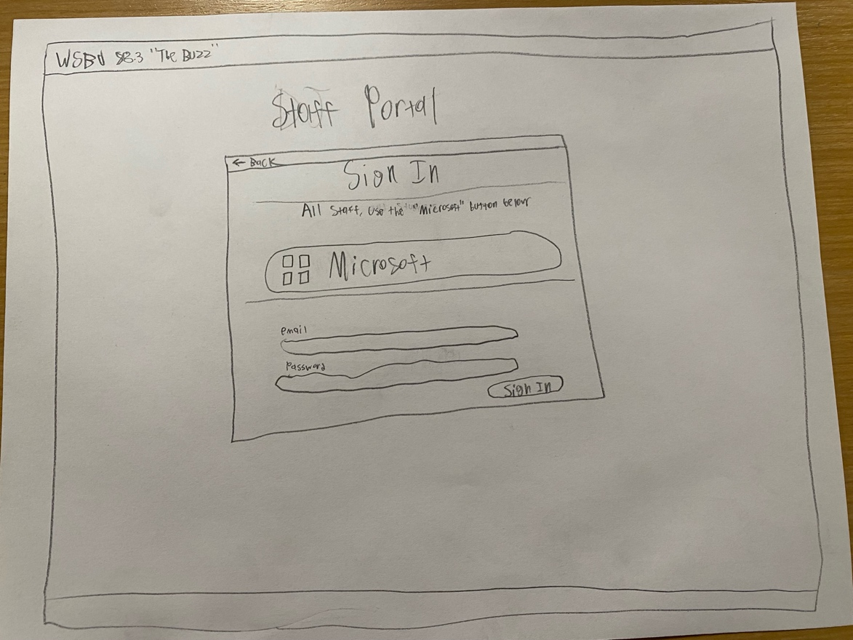
Figure 7: User login sketch
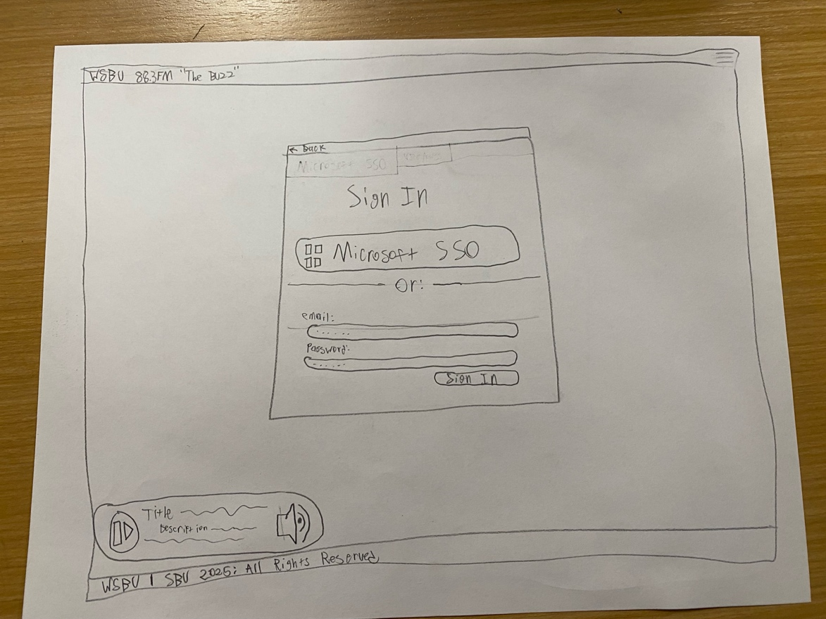
Figure 8: Staff Portal main page sketch
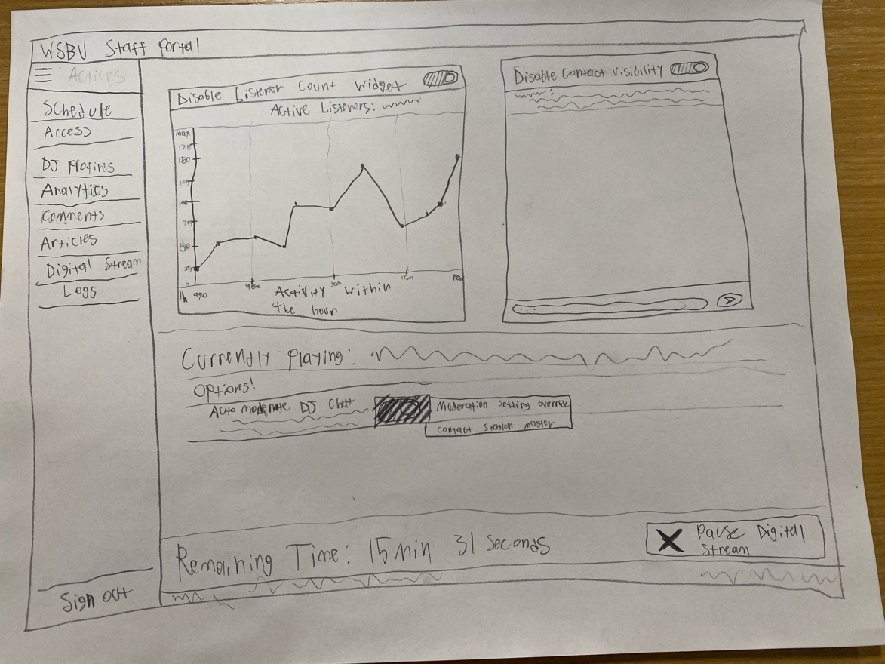
Figure 9: Show schedule creating sketch
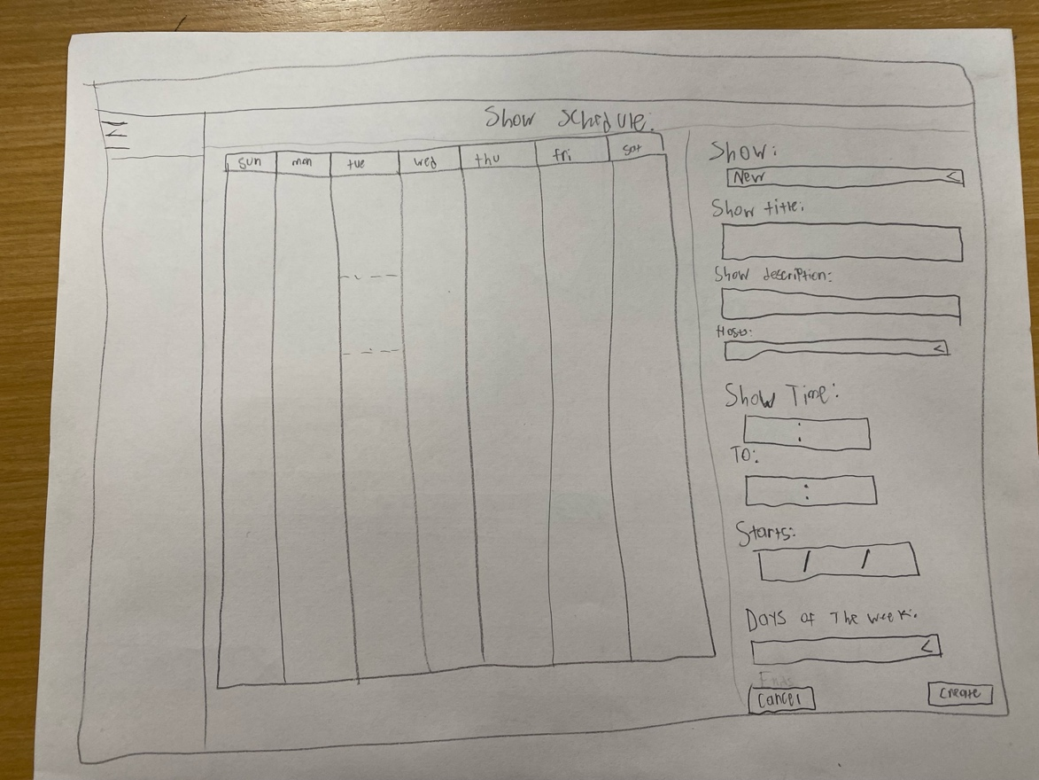
Figure 10: Analytics page sketch
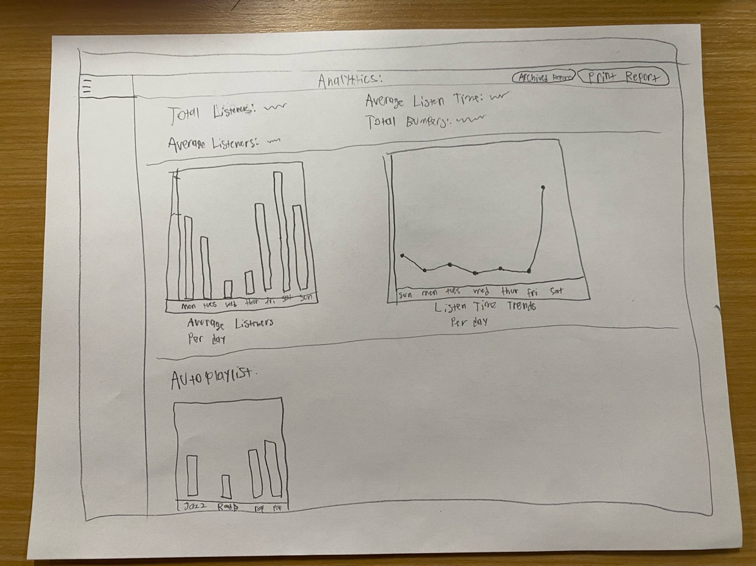
Figure 11: Digital Stream settings page sketch
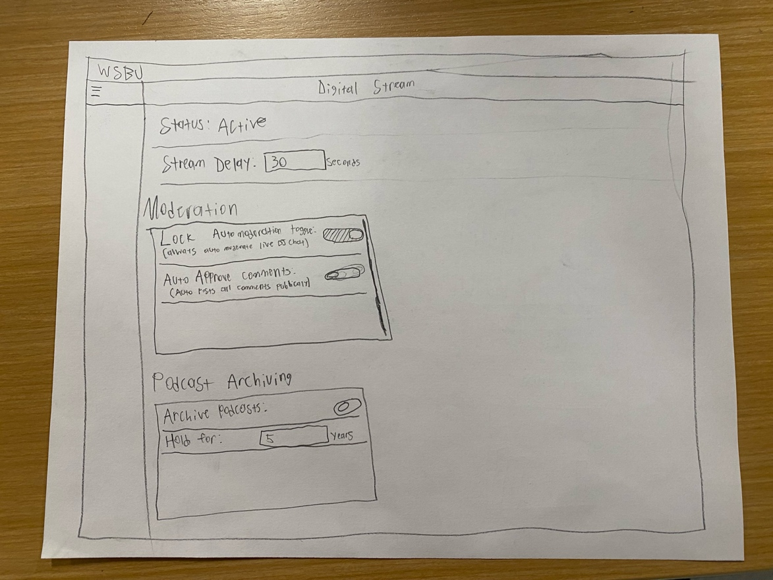
Figure 12: Comments page sketch
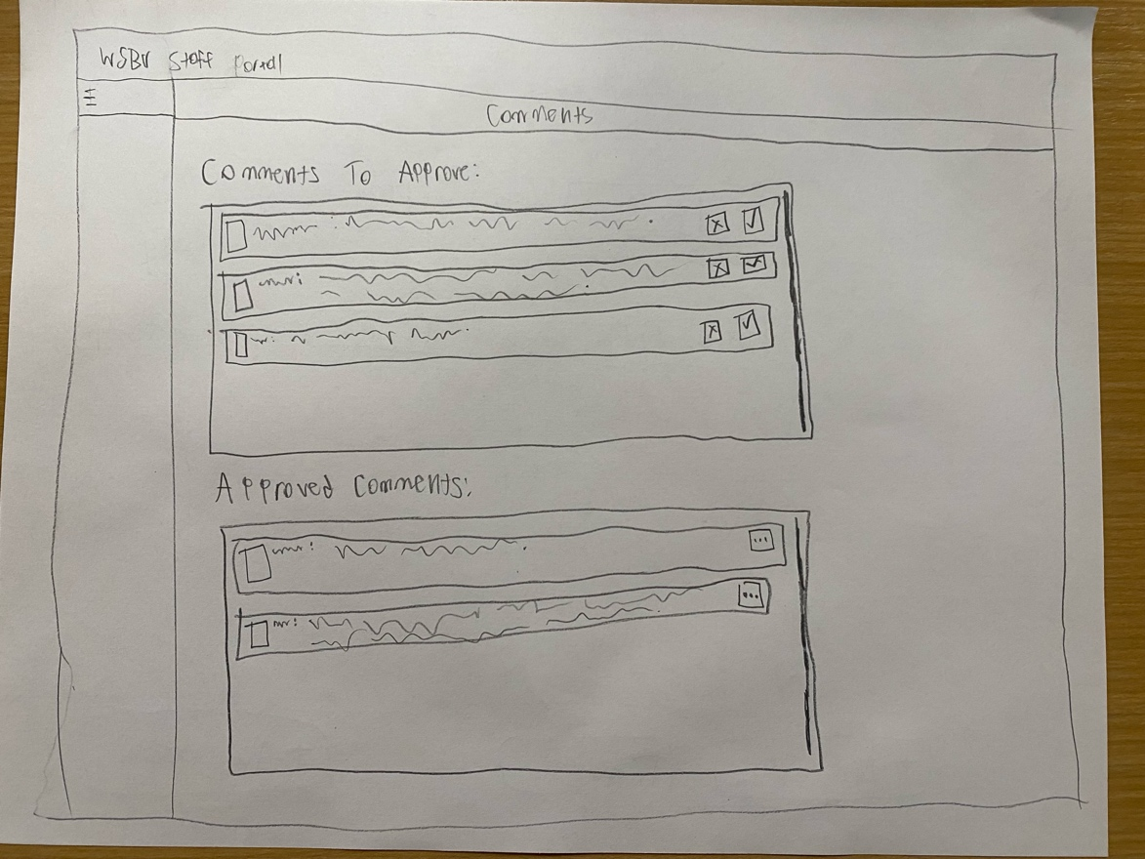
Figure 13: Account Access page sketch
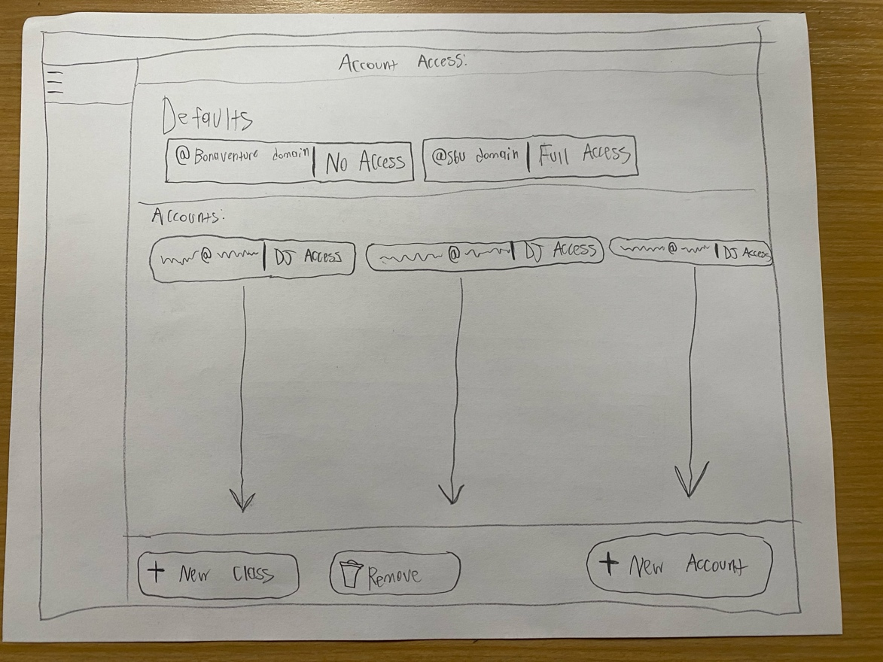
Figure 14: Figma design document as of 11/14/2025
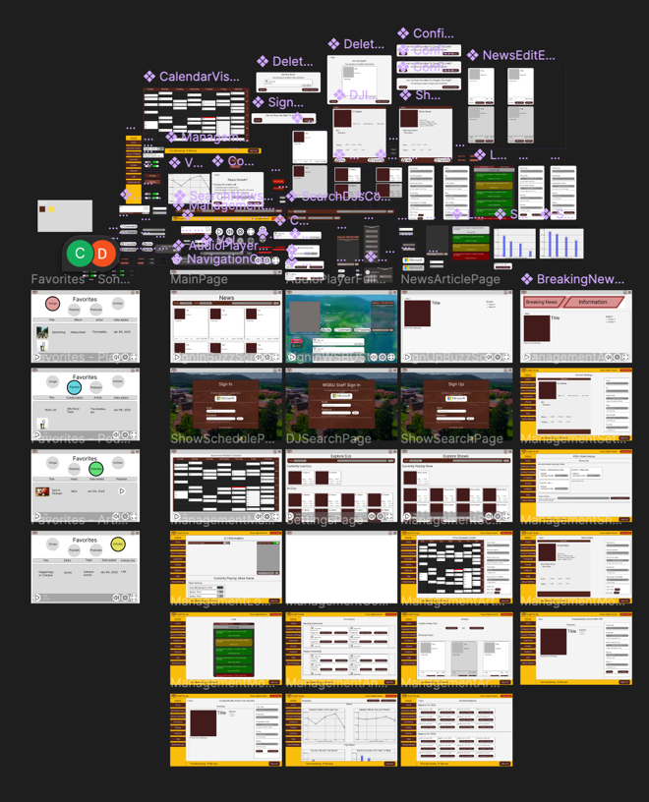
Figure 15: Screenshot of the “ManagementArticlesPage”
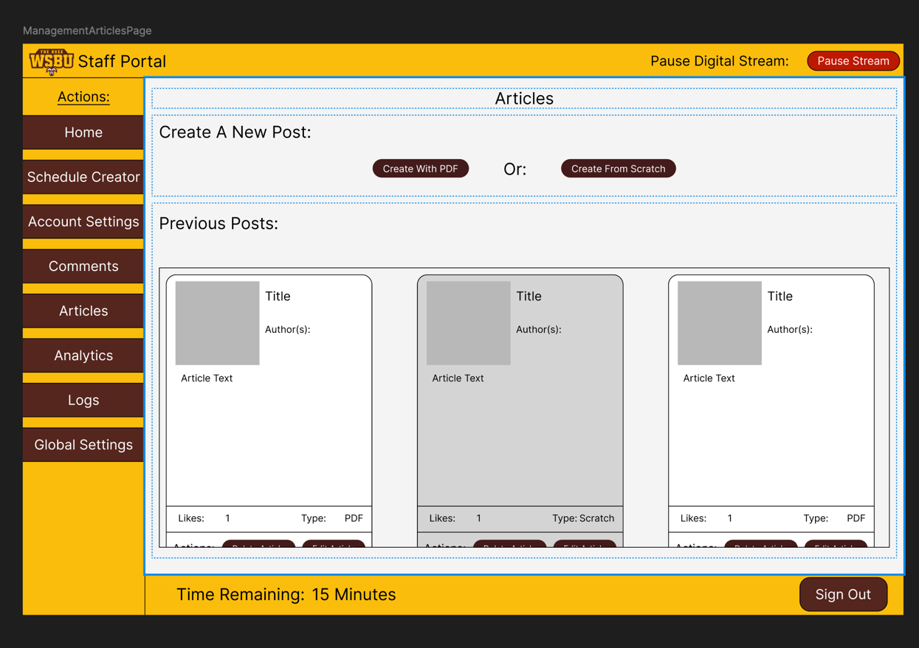
Figure 16: A screenshot of the “AudioPlayerFullScreenModal” page, with the navigation bar visible
