Since its introduction to North America, the EAB has spread rapidly across the U.S. and parts of Canada, killing millions of ash trees in the process. North America’s ash trees are far more susceptible to this foreign pest because it lacks the natural enemies and defensive traits of their Asian counterparts (Rebek et al. 2008). Efforts to control this problem have been very expensive for government and environmental agencies alike. To further complicate things, *A. planipennis* movement is very difficult to track because most of the insect’s lifecycle takes place in the inner tissue of ash trees. This makes the larvae more evasive, providing a means of unintentional human aided dispersal through ash wood product transportation (Cappaert et al. 2005).

### **Biology and Life Cycle**

The EAB was first discovered in North America near Detroit, MI and Windsor, Ontario in 2002 (Anulewicz et. al 2008, Poland and McCullough 2006). Several specimens were brought to the Department of Entomology at Michigan State University that were collected from dying ash trees in the greater Detroit area. The Entomology Department determined that the specimens were likely the genus *Agrilus*, and were later positively identified as *Agrilus planipennis* by Dr. Eduard Jendek of Slovoka. This marked the first time it was identified outside of its native host range in Asia (Poland and McCullough 2006).

At the time of EAB’S discovery in North America, very little was known about the beetle. In fact, prior to 2003, even in its native range in Asia few studies were documented on the biology and ecology of *A. planipennis* because it there were insufficient areas where it was causing significant damage (Siegert et al. 2010; Wang et al. 2010). It was because of the more recent and severe ash mortality rates of *Fraxinus velutina* (velvet ash) in Tianjin, China that necessitated the need for a better understanding of this beetle (Wang et al. 2010). The native range of the EAB is China, Japan, Korea, Mongolia, eastern Russia, and Taiwan, but studies have shown that they generally only attack stressed trees in these areas because the Asian ash are more resilient as a result of coevolution with the beetle (Anulewicz et. al 2008).

The EAB is a member of the order Coleoptera and is in the Buprestidae family, which are the wood boring beetles. The life cycle of *A. planipennis* spans from one to two years, depending upon the temperatures of the infested region. The two-year lifecycle tends to occur in the northern parts of the U.S and Canada where there are harsher winters. The larvae will spend a second winter season to mature, feeding on the phloem and cambium in a pre-pupae state through four instar stages (Marshall et al. 2010). The adult form of *A. planipennis* is small, usually less than ten millimeters long and approximately two millimeters wide. Their bodies are elongated in the shape of a bullet with bronze to gold coloring on their abdomen with metallic emerald colored wing covers.

The adult beetles do not cause significant damage to ash trees as they usually feed on the leaves and mate on the bark of the trees. Instead, it is the larvae that effectively girdle the trees during the winter months, essentially cutting of the nutrient supply from the roots to the crown of the tree. During the mating season, females lay their eggs on the bark and in between crevasses on the outer surface of trees. Oviposition, or the process of laying eggs typically occurs in mid-May in the native range of the EAB and in June to early July in North America (Poland and McCullough 2006; Wang et al. 2010). The females will lay eggs under the bark or in cracks and the larvae will usually hatch within two weeks and start boring into the phloem of the tree (Anulewicz et. al 2008). Each female will typically lay between 50-90 eggs during her lifecycle (Poland and McCullough 2006). Research has shown that some females will lay eggs on trees other than ash but the larvae will often not survive in non-ash trees (Anulewicz et. al 2008; Rebek et al. 2008).

When the eggs hatch, the larvae emerge as a creamy white wormlike organism and begin chewing through the inner tissue right away. In the first few months, the instars in their pre-pupae state will form shallow serpentine tunnels in the phloem and cambium of the trees leaving behind a trail of frass, which is a brown woody excrement. The larvae mature through four instars in their pre-pupae form by feeding on phloem during the fall, and then move deeper into the sapwood to form overwintering chambers. In the early spring, the larvae will transform into sexually mature adults and emerge from the trees leaving D-shaped exit wounds.

### **Ash Trees and Economic Impacts**

Since the EAB arrived in North America in 2002, millions of ash trees have fallen victim to this invasive species. In fact, by 2006, it was estimated that over 100 million ash trees had been attacked or killed by *A. planipennis*, with over 20 million ash fatalities in Michigan alone (Anulewicz et al. 2007). Once an ash tree is attacked, it will usually die within two to four years depending on the larval density. This process is known as slow ash mortality (SLAM, McCullough and Mercader 2012). By the time the tree has dense a larval population, the tree will already have visible signs of declining health (Wang et al. 2010). Other more obvious visual cues of an EAB attack are crown dieback, epicormic shoots, and bark flaking.

Ash trees are a hardwood species that are very common in North America, Canada, and China. They are a member of the genus *Fraxinus* in the order *Lamiales* and the family *Oleacea*. The trees most commonly attacked in North America are white ash *(F. americana*), green ash (*F. pennsylvanica*), blue ash (*F. quadrangulata*), black ash (*F. nigra*), and pumpkin ash. (*F. profunda,* Anulewicz et. al 2008; BenDor et al. 2006). They are medium sized trees with average heights reaching 50-80 feet at the top of the crown and tend to colonize gaps in older hardwood forests. Ash trees are also very common ornamental shade trees in urban settings because they are fast growing woodland trees that are used to line streets (Poland and McCullough 2006). Ash trees are especially abundant in urban settings in Michigan, Chicago, and New York comprising approximately 15-20% of all urban tree species (BenDor et al. 2006).

Future ash tree perseverance in forest stands that have been heavily infested with the EAB will depend on the potential for regeneration (Klooster et al. 2013). This can be problematic for ash tree survival because the beetles will feed on trees as small as 2.5 cm (McCullough et al. 2008; Rebek et al. 2008; Klooster et al. 2013) and some ash species take up to 60 years before they are mature enough to produce seeds (Kurmis and Kim, 1989; Klooster et al. 2013). The regeneration of ash trees in forested areas is unlikely when ash mortality is high in the aftermath of an EAB invasion and will depend on the resilience and reproduction of an “orphaned cohort” of the ash seedlings and saplings that had previously occupied the area. Michigan has experienced this seemingly irreversible ash mortality according to this theory. By 2007, ash mortality topped 90% from the rapid spread of *A. planipennis* in Michigan, which nearly decimated the ash seed bank. Within the next two years, a small number freshly germinated ash seedlings remained and only the earlier established ash seedlings and saplings survived in Michigan’s forests as ash mortality rates soared to over 99% (Klooster et al. 2013).

With the high rates of ash mortality as a result of the EAB invasion in North America, there is bound to be significant economic impacts in urban settings. Sydnor et al. (2007) attempted to quantify the economic impacts of the EAB threat to the state of Ohio’s urban ash resource. Based on a study of 200 Ohio communities, they estimated that median based losses in landscape value from urban ash mortality was $0.8 billion and the mean based loss at $3.4 billion. This assumes the complete loss of ash trees within the city limits and includes costs associated with ash treatment and replacement. They also determined that a more cost effective solution would be removing the infested trees without replacing them which would result in losses of $0.7 billion and $2.9 billion for the median and mean losses in all cities.

### **EAB Spread in Minnesota**

The first confirmed EAB sighting in Minnesota was discovered in the Saint Anthony’s Park area of St Paul in May of 2009. Since then, it has spread to a total of 10 counties mostly within the metro area, but also into sites in the southeastern portion of the state along the Mississippi River. It is likely the EAB is in other portions of the state, but have not yet been discovered. This beetle threatens the ash tree resource in Minnesota as its dense populations are susceptible to high levels of ash mortality, and tree removal can be very expensive in urban settings where ash is a common monoculture (Minnesota Department of Agriculture, 2016).

The City of Saint Paul has seen significant increases in the amount of infested ash trees in recent years. In 2015 alone, it was estimated that the EAB had spread across 75% of the city, as opposed to 55% in the beginning of the year. These numbers are quite high compared to 2010, when only about 3.5% of the city had known infestations. There are an estimated 26,000 ash trees in the Right of Way (ROW) on street boulevards, and tens of thousands more in public parks and open land areas. These numbers do not include ash trees on private lands, which the responsibility of the well being of the trees fall on the landowner. These dead and dying trees present many hazards within the urban landscape because the branches become weak and break off easily, causing damage to property (city of Saint Paul, Minnesota, 2015).

Tree removal has already been a burden on the city of Saint Paul. Since the EAB Management Program began in 2009, thousands of trees on public property have been removed and or treated with insecticides. The city currently uses a “Structured Removal” system that removes all publically owned ash trees within an infested area rather than just the infested ones. Between the years of 2009-2015, a total of 6,190 trees have been removed from public ROW. The city has also began using insecticide treatments to help trees last until they are scheduled for structured removal. As of 2015, the total amount of publically owned ROW trees that have undergone treatment reached 1,922, while the total number of treated city park trees reached 179 (city of Saint Paul, Minnesota, 2015).

For every removed ash tree, the city hopes to replace it with a different species. Unfortunately, the city faces budget challenges as their annual $150,000 budget has not increased to compensate for the mounting costs of tree stock and installation. Since 2010, prices have gone up significantly as the price to purchase and install 2-inch caliper Hackberry skyrocketed from $155 to $285 in 2015. To make matters worse, the city has also been unable to add any additional staff to keep up with the demand for tree replacement due to budget constraints (city of Saint Paul, Minnesota, 2015). City residents are also seeing the negative impacts of the EAB because they are responsible for removing any hazardous trees on their property. According to [www.treeremoval.com](http://www.treeremoval.com), on average tree removal can cost the landowner $459 to $651 depending on the size and distance to power lines in the Minneapolis area (2016).

### **Searching for New Infestations in Minnesota**

The lifecycle of the EAB presents an interesting mitigation challenge for agencies like the DNR and MDA. Because the trees often do not show signs of stress until it is too late and the larvae spend so much time under the bark, finding new infestations does not come easy. The MDA has several methods for searching for EAB infestations in new areas. Thousands of purple prism traps have been placed around the state (**Figure 2**) to capture and detect adult beetles. In addition to periodically checking the traps, field crews are also sent to perform branch sampling in high risk areas. The MDA uses a risk area map to estimate where new infestations may be so traps can be effectively placed (**Figure 3**).

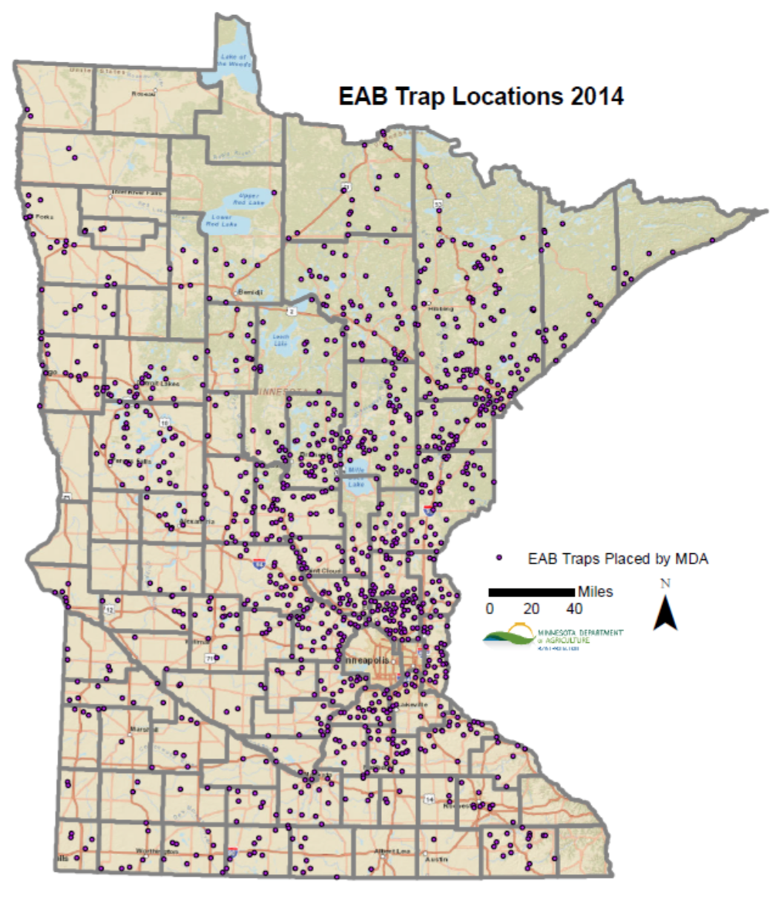**Figure 2. Map of EAB traps placed by MDA (MDA 2015)**

**Figure 3. EAB Risk Map (MDA 2006)**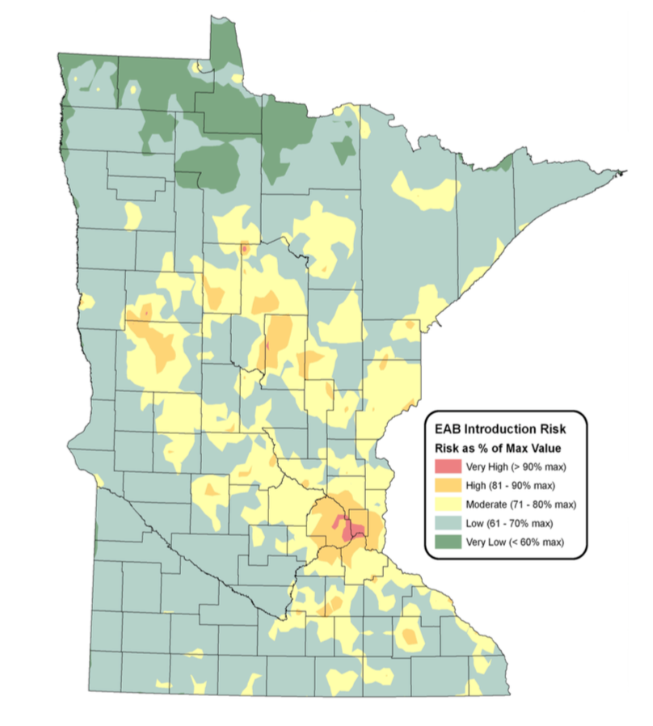

The EAB Risk Model was developed by the MDA in 2006 using Geographic Information Systems (GIS). They combined seven datasets representing factors believed pose the highest risk to introduce the EAB in Minnesota:

* Campgrounds
* Seasonal Homes
* Urban Areas
* Sawmills
* Firewood
* Nurseries
* Accessibility to Highways and Major Cities

The risk map provides a guideline as to where the EAB is likely to be, and therefore are the areas where the MDA concentrates their efforts to find new sightings (Minnesota Department of Agriculture, 2006). One important factor working against the EAB that is not accounted for in risk map are the northern parts of Minnesota where winter cold snaps can cause high mortality rates of EAB larvae, particularly in the USDA Plant Hardiness Zones 3a and 3b (**Figure 4**). When a tree’s inner core reaches extreme temperatures between -20° F and -30° F, EAB larval mortality can be estimated to be around 50%. EAB larval mortality can exceed 90% when the tree’s core dips below -30 F for an extended period of time. It is important, however, to note that wind chill reaching this temperature does not affect the larvae (Venette et al., 2014).

**Figure 4. Map of EAB traps placed by MDA (MDA 2015)**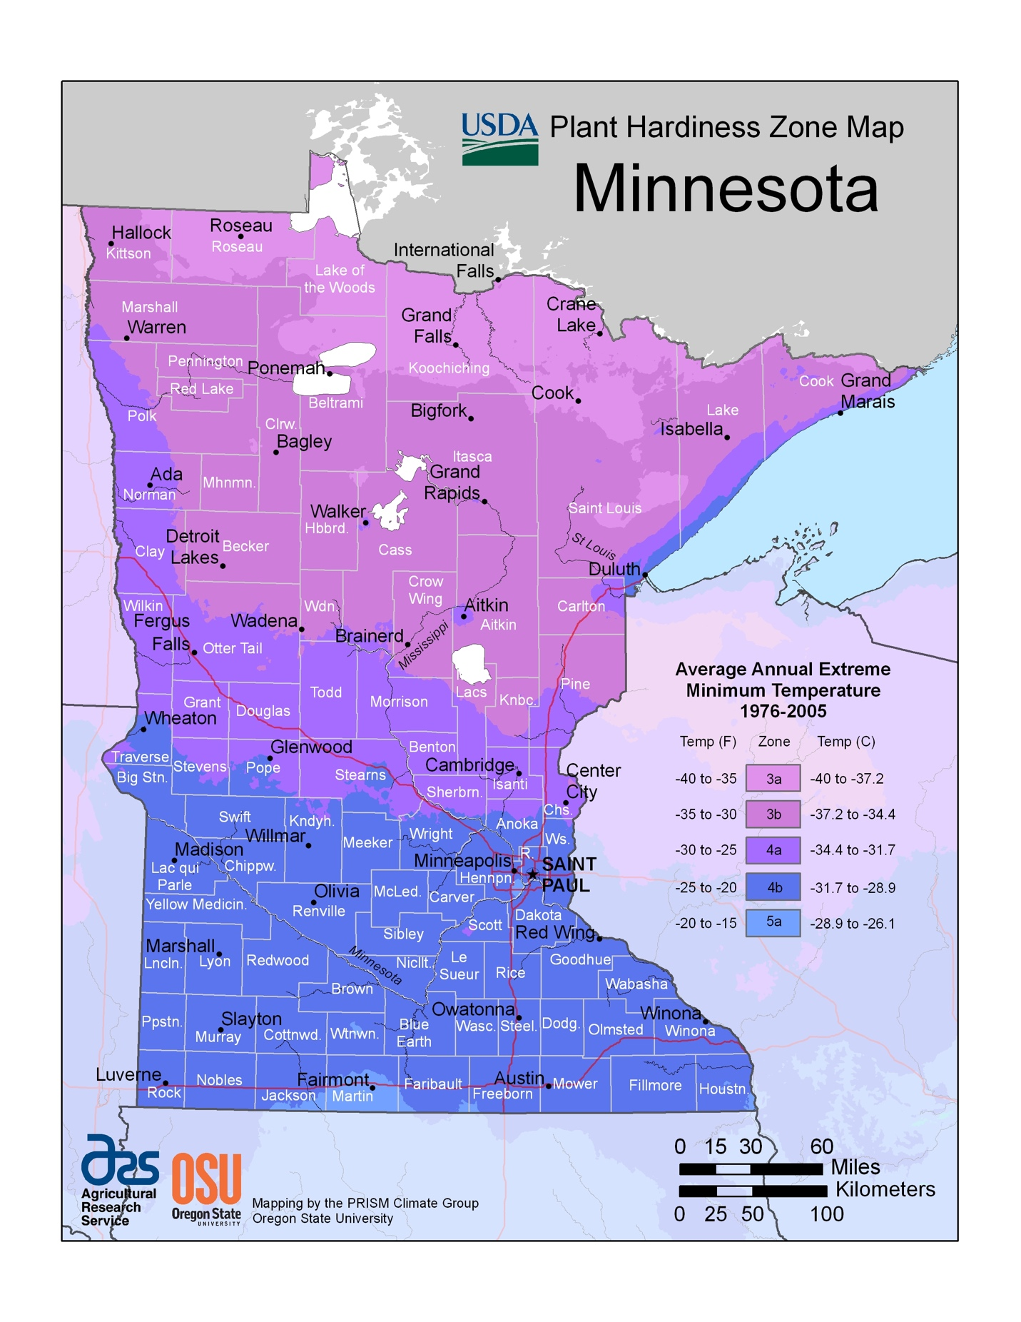

The MDA staff rely on visual cues such as crown dieback, epicormic shoots, bark splits, D-shaped exit holes, and blonding or flecking as a result of woodpecker feeding. The woodpecker damage can be a sign of a dense infestation within a tree, as woodpeckers will damage the bark looking for larvae (P. Walrath, personal communication, February 17, 2016). When there are visual cues in an area indicative of a new EAB infestation, staff from the MDA will perform branch sampling. Staff collects a minimum of 35 branches within a forest stand and peel back the bark to search for larval galleries. There are several wood boring beetles that can be found in Minnesota, but the EAB create distinct S-shaped galleries. Purple prism traps are also set and visited by MDA staff. These traps use lures such as manuka oil that mimic a stressed ash tree and sticky paper is used to trap adult beetles (P. Walrath, personal communication, February 17, 2016).

### **Quarantines and Biocontrols**

In order to slow and prevent the spread of wood boring pests, the USDA APHIS Plant Protection and Quarantine (PPQ) institutes an emergency quarantine when a pest is found in a new area. What this means is that there are strict regulations put in place to prevent wood products from being moved or sold outside of the quarantined area. Wood products are defined as: 1) logs and green lumber; 2) nursery stock, scion and bud wood; 3) chips and mulch, either composted or uncomposted; 4) stumps, roots, and branches. In order to avoid having the entire state of Minnesota being part of the federal quarantine, the MDA has agreed to enforce the USDA APHIS quarantine within the state, usually at the county level. By the Minnesota Statues Section 18G.06 (2008), the Commissioner of the MDA has the authority to declare that a county is under quarantine (Minnesota Department of Agriculture, 2016).

Some infested wood can be moved under the quarantine laws if it has been heat treated first. There are two different types of wood that can be moved legally in Minnesota. The first type is the DNR approved firewood. This wood may not be pest-free and therefore cannot be moved outside of a quarantine. This wood is allowed on any DNR administered lands or within 50 miles of the harvest location as long as it does not go outside of a quarantine. By far the safest wood to move is the MDA/USDA approved firewood which can be moved outside of quarantine boundaries within the state. This wood has been heat treated in a USDA APHIS approved dry kiln facility where the core of the wood is required to maintain an internal temperature of at least 60° C (140° F) for a period of at least 60 minutes. Also required when moving MDA/USDA certified wood out of a quarantined area is a signed Compliance Agreement (CA) with the MDA for interstate movements, or with both the MDA and USDA APHIS PPQ for transporting outside of the state. The CA requires the business or individual to comply with the methods, conditions, and procedures for handling ash wood, pursuant to the quarantine laws. Any violation related to transporting untreated wood outside of a quarantine can result in daily fines up to $7,500 (Minnesota Department of Agriculture, 2016). If you are moving your own untreated wood, you are encouraged to burn it near where it was found.

Slowing the EAB in known infested areas is a high priority task to protect Minnesota’s ash trees. In recent years, the MDA has been introducing biocontrols to prey on EAB. The USDA APHIS suggested to bring in two different species of parasitoid wasps to prey on the EAB, with careful consideration not to disturb other native species. The Encyrtid Wasp (*Obius agrili*) are very tiny wasps less than a millimeter in length who feed on EAB eggs. Adult female Encyrtid Wasps actually lay their eggs inside of EAB eggs and allow them to overwinter. With two generations emerging as adults in the spring and summer, these wasps are able to achieve parasitism rates of up to 60% because each female can lay approximately 62 eggs. Another introduced wasp is the Eulophid Wasp (*Tetrastichus planipennisi*). Similar to the Encyrtid Wasp, the *T. planipennisi* also target EAB eggs and the larvae overwinter after their active period, which is spent consuming the EAB larvae and are able to reach parasitism rates of up to 65%. The adult Eulophid Wasps are a little larger than the Encyrtid Wasp, usually reaching lengths around 1.6 mm (Minnesota Department of Agriculture, 2016).

### **Engaging the Public**

The MDA is currently trying to educate as many citizens as possible to assist in identifying and reporting EAB sightings in new locations. Workshops are held at various locations to train citizens to become volunteers to engage in the hunt for new infestation sites. The MDA staff show citizens how to spot signs of an EAB attack on live ash trees, paying particular attention the most helpful visual cues such as woodpecker damage. They also show attendees how to properly identify an EAB in both the larval and adult stages as well as some of the common look-a-like insects that are often mistaken for an EAB. One thing that is stressed at these workshops is that the MDA truly needs the help from public volunteers (P. Walrath, personal communication, February 17, 2016).

The MDA does not have enough staff to patrol the entire state and are therefore asking the public to keep an eye out and report new sightings through their “Arrest the Pest” website (<http://www.mda.state.mn.us/arrestthepest)>. They ask that if you see an EAB, you should take a picture and try to describe exactly where it was spotted and get a sample if possible. If you are able to provide the MDA with a sample or photograph of the sighting, it can help them determine if the sighting presents a legitimate EAB threat, and therefore an inspection crew can be sent to the site for verification.

### **Technology**

### **Web GIS**

The backbone of web GIS will always be maps and the data behind them. However, as technology is evolving, the mapping process is moving away from traditional desktop applications and hard copy maps to more dynamic and lightweight web mapping applications. This means that the end users do not need to have any software installed on their computers and can access the maps and data through a web browser and maps can even be accessed from mobile devices. This allows geospatial information to be deployed and consumed more rapidly than ever.

## **Web GIS as a Decision Making Tool**

Web GIS presents a new way of thinking and promotes collaboration between decision makers and stakeholders in the planning and management process. It takes traditional static maps and transforms them into dynamic maps to allow users to interact with spatial data and even provides the ability query the data by attributes or spatial relationships. The three major advantages of using web GIS are improvements in spatial data access and distribution, spatial data examination and geovisualization, and the ability to perform geospatial analysis through the web without needing any software installed on the client side (Dragićević 2004). Moreover, the maps can be shared to the general public through nothing more than a web browser, which can be extremely powerful in the event of an emergency. Real time data such as election results and vehicle fleet tracking can also be displayed through web GIS.

In a study by Dragićević and Balram in 2004, they assessed the ability of web GIS to aid in the communication of ideas for natural resource management by allowing them to draw geometries and annotate base maps. They found that utilizing the web maps as a visual communication tool allowed stakeholders to be more involved in the planning process and were able to communicate more efficiently. Other advantages included cutting down on costs associated with travel for face to face meetings as communication through maps was more effective than traditional emails and phone calls.

## **Architecture**

Web GIS platforms typically use a server-client architecture, often over a distributed network (Figure X). Each mapping service is processed and published from a web server and therefore can support collaboration from disparate sources (Dragićević and Balram 2004). As a client interacts with the map service through a web application or as an HTTP request, the server handles the request by querying information from the spatial database in a round trip and returns the results to the client (Alesheikh, Helai, and Behroz 2002; Bauer 2012). The web server pushes the data to the World Wide Web via Microsoft Internet Information Services (IIS), Apache, or similar, and the client queries the data by passing in parameters through the URL. The data transfer formats and service configurations are usually stored as eXtensible Markup Language (XML) or Geography Markup Language (GML), and the query results can be retrieved in a variety of formats such as JavaScript Object Notation (JSON) (Alesheikh, Helai, and Behroz 2002; Bauer 2012).

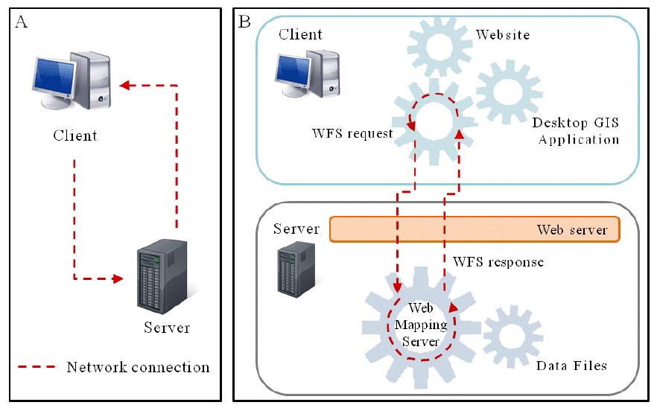

**Figure 1**. Client-Server Architecture (Bauer 2012)

The SOA design coupled with advances in cloud computing can facilitate crowd-source analysis capabilities as robust servers can handle more and more requests. Cloud services such as Amazon Elastic Cloud (Amazon EC2) and Microsoft Azure can provide Software as a Service (SaaS), Platform as a Service (PaaS), and Infrastructure as a Service (IaaS), meaning that the web servers no longer have to be managed in house, which can alleviate IT headaches and increase web service up time (Zhao, Forester, and Yue 2012). By taking advantage of these cloud services, the web servers become scalable so that when there are high volumes of users running analysis through crowd-sourcing, new server instances can be spun up to handle the increase in HTTP requests.

### **Types of Web Services**

Most web GIS platforms adhere to the standards proposed by the Open Geospatial Consortium (OGC). The OGC has laid out many different types of web GIS services with the main three being the web mapping service (WMS), web feature service (WFS), and web coverage service (WCS). The WMS offers map image requesting capabilities with exports available in standard formats such as JPEG and GIF based on a bounding box request from the client. The WFS offers more advanced functionalities beyond just standard map image exports such as the ability to perform queries and even data manipulation (Dragićević 2004, Frehner and Brandli 2006, Reed 2011).

For the WFS, the basic requests suggested by the OGC WFS standards are get capabilities, describe feature type, and get features (Reed 2011; Bauer 2012). Each type of requests tells the server how to handle the WFS information and what to send back to the client. A get request sends the WFS XML document back to the client that outlines the service capabilities, while a describe request will give detailed descriptions of the service capabilities and properties, such as the spatial reference of the service. The request features operation will actually return the attribute and geometry information from the spatial database in a variety of formats. Similar to the WFS, the WCS allows for pixel or vector based queries and map image exports, supporting a variety of formats such as GeoTIFF and NetCDF (Bauer 2012). Other services such as GeoData allow for users to extract spatial data in popular GIS formats and even allow for GIS analysis through the web in a geoprocessing service.

## **Early Web GIS Platforms**

A study done by Dragićević and Balram in 2004 was performed in order to see if using a distributed Web GIS system could help overcome some of the inefficacies involved in the planning process of decision makers in a dispersed network. At that time there were not a lot of options, but among the first Web GIS platforms was the Environmental Science Research Institute’s (ESRI) ArcIMS. Other notable web GIS options were Autodesk’s MapGuide, University of Minnesota’s MapServer, and the Xerox Company’s Map Viewer (Dragićević 2004). Even in these early days, configuring a Web GIS environment with ArcIMS was difficult for GIS professionals. The development of a functional web application required both server and client side scripting. The infrastructure used by Dragićević and Balram was common at the time where the Internet Mapping Services (IMS) were housed on an Apache server. All server side scripting was handled through Microsoft’s ASP.NET server side scripting language, and dynamic links to data sources and communication to the client were handled through Hypertext Markup Language (HTML) and JavaScript. All communication between the client and web server is exchanged through a web browser through Hypertext Transfer Protocol (HTTP) requests. Achieving a basic set up in this type of integrated Web GIS framework was not overly challenging. However, configuring the web applications for optimum performance and introducing more client side functionality can present a steep learning curve as traditional Geographers and GIS professionals are not typically trained for these types of tasks.

## **Modern Web GIS Platforms**

As the Web has made significant technological advances, so to have web GIS applications. There are a wide variety of both open source and proprietary web GIS frameworks to choose from. The proprietary market is dominated by ESRI’s ArcGIS Server which offers multiple Application Program Interfaces (API’s) and custom service types such as Network, Geoprocessing, and Geocoding services. ArcGIS Server utilizes a Representational State Transfer (REST) framework for communication between the client and server (ESRI 2015). Open source options include MapServer, GeoServer, MapGuide, and Mapnik. Each has its own pros and cons and each platform should be chosen based on budget constraints and by the nature of the applications that need to be developed.

## **ArcGIS Online**

## **ArcGIS Runtime SDKs**

The ArcGIS Runtime is based on a small, high performance C++ Runtime Core, which has its own geometry engine. The ArcGIS Runtime allows for a faster display via GPU Acceleration with OpenGL or DirectX, depending on which platform is being used. ESRI provides Runtime SDKs to support many platforms in the desktop and mobile environments, and each Application Programming Interface (API) has its own bindings to the Runtime Core (ESRI 2015).

## **Android**

The most popular mobile operating system (OS) available today is Android, which is provided by Google. Android applications are written in the Java programming language. The Android software stack can be broken down into 4 different categories. At the lowest level is the Linux Kernel, which creates a layer of abstraction for the device hardware. The next level contains all the Linux libraries for the Kernel and the Android Runtime, which runs in a Dalvik virtual machine (VM) and has its own set of core libraries. The Dalvik virtual machine is multithreaded and optimized to be memory efficient on mobile devices and differs from the typical Java VM. This is where the ArcGIS Runtime Core interfaces with and Android operating system. The third level is that of the application framework, which are the controls for instantiating different activities in an application, managing different view screens, resource manager, and notifications manager. The highest level is the application level, which is where the EAB Tracker app is compiled and ran from the device.