Integrating Crowdsourcing and GIS to Slow the Spread of the Emerald Ash Borer in Minnesota

By Caleb Mackey

Minnesota State University - Mankato

**Abstract**

The emerald ash borer (EAB), *Agrilus planipennis* Fairemaire (Coleoptra: Buprestidae), is an invasive species that has killed millions of ash trees (Fraxinus spp.) in North America since it was discovered here in 2002. Because these beetles spend most of their life as larvae feeding on the inner vascular tissue of ash trees, most of their movement can be attributed to unintentional human transportation of infested wood. As Minnesota has large number of urban ash trees, the best defense against slowing the spread of EAB in the state may be early detection and quarantine (preventing the ash wood to be moved across county lines if not first treated to kill larvae inside). Field visual surveys and traps are currently used by the Minnesota Department of Agriculture (MDA) to monitor ash trees for new infestations. However, the MDA does not have enough staff to monitor the thousands of EAB traps around the state. Therefore, a crowdsourcing method is proposed to gather EAB information effectively. For this purpose, a real-time mobile GIS application was developed that allows any person, especially the online community, to photograph and report an EAB sighting along with locational information. Once the sighting is reported, concerned authorities can then check the gathered information to verify a legitimate sighting and institute a county quarantine to slow and prevent further spread. The developed method and application could provide the MDA and other relevant agencies a highly cost effective way for EAB monitoring and management.

## **Introduction**

The emerald ash borer (EAB), *Agrilus planipennis* Fairemaire (Coleoptra: Buprestidae), is an invasive species that has killed hundreds of millions of ash trees (*Fraxinus* spp.) since it was first detected in North America in 2002; although it had likely been present since the late 1990’s (Anulewicz et al., 2008; Poland & McCullough, 2006). Because these beetles spend most of their life as larvae under the bark of ash trees, most of their movement can be attributed to unintentional human transportation of infested wood. As a result, it is difficult to predict where the EAB will move, making early detection nearly impossible. The effort to slow the spread of this pest is headed up at a federal level by the US Department of Agriculture (USDA) Animal Plant Health Inspection Service (APHIS) and typically by the individual state agencies at the state level. The Minnesota Department of Agriculture (MDA) is the lead agency in Minnesota.

#### **Biology and Lifecycle**

The EAB is a member of the Buprestidae family, which are the wood boring beetles. The majority of the lifecycle of the EAB is spent inside of trees where the larvae feed to mature in a pre-pupae state through four instars into their adult form. This occurs in a one to two-year cycle, where the two-year cycle is more common in colder regions (Marshall et al., 2010). There are certain temperature thresholds where the winter is too cold for the EAB larvae to survive. When a tree’s inner core reaches extreme temperatures between -20° F and -30° F, EAB larval mortality can be estimated to be around 50%. EAB larval mortality can exceed 90% when the tree’s core dips below -30 F for an extended period of time. However, it is important to note that wind chill reaching this temperature does not affect the larvae (Venette et al., 2014).

The adult form of the EAB is small, usually around ten millimeters long and approximately two millimeters wide. Their bodies are elongated in the shape of a bullet with a bronze abdomen and metallic emerald wing covers (**Figure 1**). In their adult form, the beetles do not cause significant damage to ash trees as they usually feed on the leaves. Instead, it is the larvae that effectively girdle the trees during the winter months, cutting of the nutrient supply from the roots to the crown of the tree eventually resulting in the death of the tree. During the mating season, females lay their eggs on the bark and in between crevasses on the outer surface of trees. On average, each female will lay between 50-90 eggs during her lifecycle (Poland & McCullough, 2006).

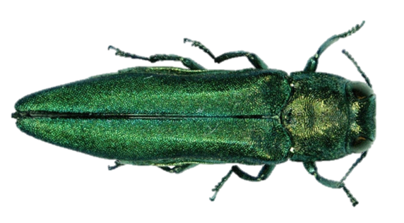

**Figure 1. Adult EAB**

**Tracking the EAB in Minnesota**

The first confirmed EAB sighting in Minnesota was discovered in the Saint Anthony’s Park area of St Paul in May of 2009. Since then, it has spread to a total of 14 counties in the metro area and from Winona all the way up to Duluth along the eastern side of the state. It is likely the EAB is in other portions of the state, but have not yet been discovered. This beetle threatens the ash tree resource in Minnesota where dense populations can result in high levels of ash mortality. In urban settings, tree removal can be very expensive where ash is a common monoculture (MDA, 2016).

The lifecycle of the EAB presents an interesting mitigation challenge for the MDA. Trees often do not show signs of stress until it is too late because most of the damage occurs under the bark. The MDA has several methods for searching for EAB infestations in new areas. Thousands of purple prism traps baited with oils that mimic the smell of stressed ash trees have been placed around the state to capture and detect adult beetles. In addition to periodically checking the traps, field crews are also sent to perform branch sampling in high risk areas.

The MDA uses a risk area map based on criteria such as ash population densities, campgrounds, and sawmills to 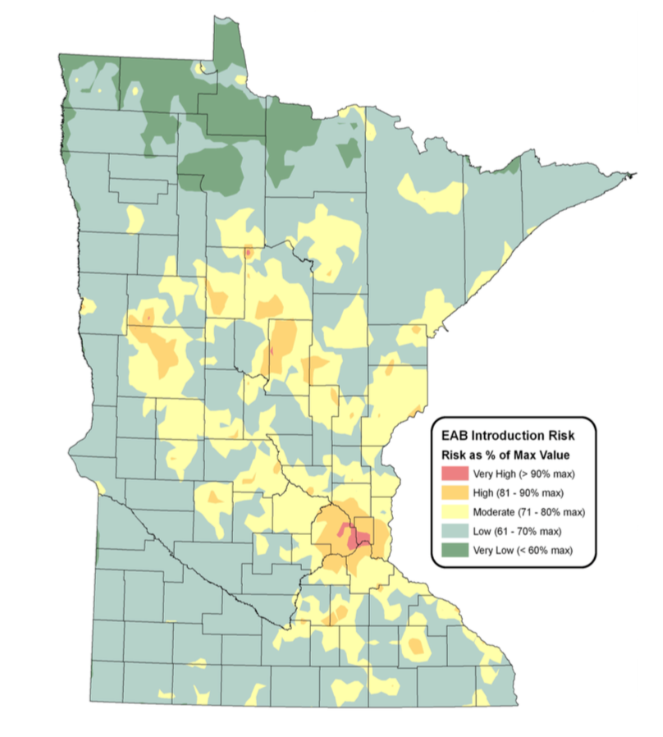estimate where new infestations may be so traps can be effectively placed (MDA, 2006; **Figure 2**).

**Figure 2. EAB Risk Map (MDA, 2006)**

The MDA staff rely on visual cues such as crown dieback, epicormic shoots, bark splits, D-shaped exit holes, and flecking as a result of woodpecker feeding (also known as blonding) in high risk areas. The woodpecker damage can be a sign of a dense infestation within a tree because they peel back the bark while looking for larvae. If these signs are present, they will perform branch sampling by collecting at least 35 branches within a forest stand and checking under the bark to search for larval galleries. There are several wood boring beetles that can be found in Minnesota, but the EAB create distinct S-shaped galleries (P. Walrath, personal communication, February 17, 2016).

### **Quarantines, Firewood Regulations and Mitigation**

In order to slow and prevent the spread of wood boring pests, the MDA institutes an emergency quarantine when EAB are found in a new area as an extension of the USDA APHIS Plant Protection and Quarantine (PPQ). This puts strict regulations put in place to prevent wood products from being moved or sold outside of the quarantined area. The MDA defines wood products as: 1) logs and green lumber; 2) nursery stock, scion and bud wood; 3) chips and mulch, either composted or uncomposted; 4) stumps, roots, and branches. In order to avoid having the entire state of Minnesota being part of the federal quarantine, the MDA has agreed to enforce the USDA APHIS quarantine within the state, usually at the county level. By the Minnesota Statues Section 18G.06 (2008), the Commissioner of the MDA has the authority to declare that a county is under quarantine. Any violation related to transporting untreated wood outside of a quarantine can result in daily fines up to $7,500 (MDA, 2016).

Once a quarantine has been put in place, the MDA will begin mitigation strategies. In recent years, the MDA has been introducing biocontrols to prey on EAB. The USDA APHIS suggested to bring in two different species of parasitoid wasps to prey on the EAB, with careful consideration not to disturb other native species. The Encyrtid Wasp (*Obius agrili*) are very tiny wasps less than a millimeter in length who feed on EAB eggs. Adult female Encyrtid Wasps actually lay their eggs inside of EAB eggs and allow them to overwinter. With two generations emerging as adults in the spring and summer, these wasps are able to achieve parasitism rates of up to 60% because each female can lay approximately 62 eggs. Another introduced wasp is the Eulophid Wasp (*Tetrastichus planipennisi*). Similar to the Encyrtid Wasp, the *T. planipennisi* also target EAB eggs and the larvae overwinter after their active period, which is spent consuming the EAB larvae and are able to reach parasitism rates of up to 65%. The adult Eulophid Wasps are a little larger than the Encyrtid Wasp, usually reaching lengths around 1.6 mm (MDA, 2016).

### **Web GIS and VGI**

Early detection of EAB in new areas is extremely valuable to the MDA because the sooner they take action against an EAB population, the better their chances for slowing it down. This presents a perfect scenario where volunteered geographic information (VGI) can be leveraged to use “humans as sensors”. VGI was defined by Michael Goodchild as using technology to “create, assemble, and disseminate geographic information provided voluntarily by individuals” (2007). VGI is extremely useful in early warning systems and post catastrophic events as people familiar with the area are able to provide accurate geographic observations in real time. The main catalyst that made VGI possible was evolution of the Web 2.0 and its potential only grows with easy access to smart phones. Citizens become sensors themselves as they are each “an intelligent synthesizer and interpreter of local information” (Goodchild, 2007).

Web GIS is a huge part of what makes VGI a viable option for collecting large amounts of geographic data through client to server interaction. Countless GIS databases are made accessible through web services and can be shown in the context of rich basemaps available from different sources. These datasets often have full editing capabilities allowing the user to create, update, or delete data. Once this data is exposed as a web service, it can be consumed by any client that can make HTTP requests, often without the end user needing to install any additional software.

### **Engaging the public**

In the spirit of VGI, the MDA is currently trying to educate as many citizens as possible to assist in identifying and reporting EAB sightings in new locations. Workshops are held to train citizens how to spot signs of an EAB attack on live ash trees, paying particular attention the most helpful visual cues such as woodpecker damage. They also show attendees how to properly identify an EAB in both the larval and adult stages as well as some of the common look-a-like insects that are often mistaken for an EAB. One thing that is stressed at these workshops is that the MDA truly needs the help from public volunteers (P. Walrath, personal communication, February 17, 2016).

The MDA does not have enough staff to patrol the entire state and therefore welcome the public to report new sightings through their “Arrest the Pest” website (<http://www.mda.state.mn.us/arrestthepest)>. They ask that if you see an EAB, you should take a picture and try to describe exactly where it was spotted and get a sample if possible. If you are able to provide the MDA with a sample or photograph of the sighting, it can help them determine if the sighting presents a legitimate EAB threat, and therefore an inspection crew can be sent to the site for verification.

One way to facilitate reporting EAB sightings in Minnesota through VGI is to develop a mobile application that can collect information in real time. With nearly every adult resident owning a smart phone, a mobile application is a great way to empower the public to accurately report new sightings. Mobile applications can be web based or native. A web based mobile app is just a web application that has been tailored to have a responsive user interface (UI) for mobile devices based on the screen size and orientation. Native mobile apps are designed for a specific platform (i.e. Android or iOS) using their specific Software Development Kits (SDKs) and required programming languages. The advantages of native apps are faster performance, they are more responsive, and the developer has access to the full capabilities of the device’s hardware (if user grants permissions) and operating system (Saccomani, 2016). The EAB Tracker has been developed natively from the ground up for both iOS and Android.

In order to leverage ArcGIS technology in native mobile applications, the ArcGIS Runtime SDKs must be used. The ArcGIS Runtime was developed by the Environmental Science and Research Institution (ESRI) and is based on a small, cross platform high performance C++ Runtime Core with its own geometry engine and built in GPU Acceleration for fast display of graphics. ESRI provides Runtime SDKs to support virtually all platforms in the desktop and mobile environments, and each Application Programming Interface (API) has its own bindings to the Runtime Core (Cameron et al., 2015). The EAB Tracker app is currently under development using the ArcGIS Runtime SDK for iOS and ArcGIS Runtime SDK for Android. The Android and iOS platforms were chosen because collectively they make up 93.95% of the mobile market share as of June 2016, with Android taking 70.85% and iOS taking 23.1% (Epstein, 2016).

**Study Area and Data**

This study will focus on Minnesota, particularly in the predicted risk areas where there have been no prior EAB infestations discovered, however, any EAB sightings in the state will be useful. **Figure 3** shows the web map hosted by the MDA showing the areas currently quarantined. A county boundary shapefile was downloaded from the Minnesota GeoCommons website, which will be used to help track existing quarantines as well as counties that could have infestations based on data collected by citizens. Other data sources used for the app are those provided by the MDA from their ArcGIS Online services. This data includes MDA confirmed EAB sightings, biological control sites, and general infested areas. The biological control sites represent areas where the MDA has released different wasps and woodpeckers to pray on the EAB.

../images/maps/eab_mn_10_2016.pdf

**Figure 3. Map Generated from the MDA’s ArcGIS Online Map Viewer**

**Methods**

### **GIS Data Preparation**

A file geodatabase was set up with a point feature class to track individual sightings and a polygon feature class to track counties with their respected quarantine status and was published to ArcGIS Online as a hosted feature service. Attribute domains were created with helpful description aliases so that even users unfamiliar with the EAB can record detailed information about the sighting. The attribute domains allow the user to describe the type of sighting such as adult beetle, visible larvae, D-shaped exit holes, and S-shaped larval galleries. Another field tracks information about any visible tree stress such as crown dieback, epicormic shoots, and bark splitting. For purposes of checking data integrity and reliability of the user, another field was added to get a sense of the user’s knowledge level of the EAB with options such as that user being a biologist or entomologist, environmental scientist or similar, or not having much knowledge of the beetle. Other information the user can add are site descriptions, comments, as well as their name and email.

The county polygons are much simpler with the only important attribute other than the county name being the current quarantine status. There are three options for the application: currently quarantined, no positive sightings, and needs to be considered for quarantine. The sighting points and county data were published to ArcGIS Online as a hosted Feature Service with editing capabilities.

A web map was also created in ArcGIS Online with all the data to store some configurations for the mobile applications. The MDA data was added to the map by referencing the Representational State Transfer (REST) endpoints to the MDA services. It is advantageous to reference a web map in an ArcGIS Runtime app because the web map specification contains popup attributes and layer definitions for the ArcGIS web services and can be transferred into the app. This is very convenient because the web map specification is represented in JavaScript Object Notation (JSON) which is queried by the web app ID when the app is loaded to get all the layer and popup information, meaning that the application’s source code does not need to be modified when additional layers are added, changed, or removed. When an ArcGIS online web map is not used, the programmer is responsible for initializing all layers and popups programmatically in the source code. It is important to note that because the ArcGIS Runtime has its own display engine, the layers from the web app are not viewed through a web browser, but are instead rendered on the device natively.

#### **Mobile Phone Applications**

Despite the application being developed for two different platforms, the capabilities and functionality will accomplish the same goals: 1) incorporate a map view where new sightings of EAB can be reported, 2) allow users to identify/view sightings and Web GIS Services provided by the MDA for traps, biocontrols, and confirmed sightings, 3) provide the user with information on how to identify Ash trees and the EAB, 4) send an email to the the MDA when a new sighting has been logged, 5) send out push notifications to everyone who has the app when a new sighting has been logged, and 6) send out an email to the MDA’s “Arrest the Pest” email account. When new sightings are reported through the app, the device GPS can be used to log the location while the camera allows the user to provide photographic evidence so the MDA can determine whether or not the site needs to be visited for field verification. Additional attribute information can also be collected from the user through a form with drop-down domain values and text boxes feeding into a cloud based GIS database.

#### **iOS Application Setup**

The iOS application was developed using Apple’s Swift programming language. All iOS development was done within the Xcode Integrated Development Environment (IDE). The first step in this application was to enable the ArcGIS functionality required for the app. Because the ArcGIS Runtime SDK for iOS is a third party library provided by ESRI, it needed to be referenced in the app as a dependency. This was added to the EAB Tracker app by using CocoaPods, which is a dependency manager for Swift and Objective-C projects. A “podfile” was set up and used to install the ArcGIS API version 10.2.5 locally within the project so it could be compiled with the application’s source code (Figure X).

There are also some application security settings that needed to be managed within the project as well. Because this application will be working with ArcGIS Web Services, the device will need to have appropriate permissions set to make web requests. Exception domains for accessing ArcGIS Online and the Google Maps Geocoding API were added to the application’s information properly list. Also stored in the information property list is the prompt to ask the user if they will allow this application to have access to their location services. The final permission necessary for the application is the use of the device camera, which the prompt text was set in the app source code.

**Android Application Setup**

The Android application was developed using the Java programming language and the Android Studio IDE, and the permissions set up was similar to iOS. The ArcGIS Runtime SDK (version 10.2.7) for Android was added to the project as a dependency by using Gradle, which can be used to install third party libraries for Java/Android (Figure X). All user permissions were set within the “AndroidManifest.xml” file, which included internet access, camera, and GPS location. One additional permission that had to be explicitly set in the Android application was the use of the OpenGL graphics library, which is what the ArcGIS Runtime Core uses to display 2D and 3D graphics.

**Building the Applications**

The main layout for each app will be in the style of a tabbed view application with the tabs being on top in Android, and at the bottom in iOS. The app will always launch into the map view first as the default screen and will use the device’s GPS to zoom to the current location (**Figure 4**). The map scene will also allow the user to view data from the MDA’s EAB information map service. Popups have been configured for each layer in the map so the user can select a feature to view its attributes. When the user chooses to report a new sighting, the first thing the app will do is ask the user to take a photograph of the sighting or choose a photo from their media library. Once a photo is added, the user will be asked to choose the type of sighting based on a visual cue (adult beetle present, larval gallery, D-shaped exit hole, etc.). Once a visual cue is chosen, the user will be brought to a form where they can fill out additional attribute information such as comments, sight description, their name and contact info.

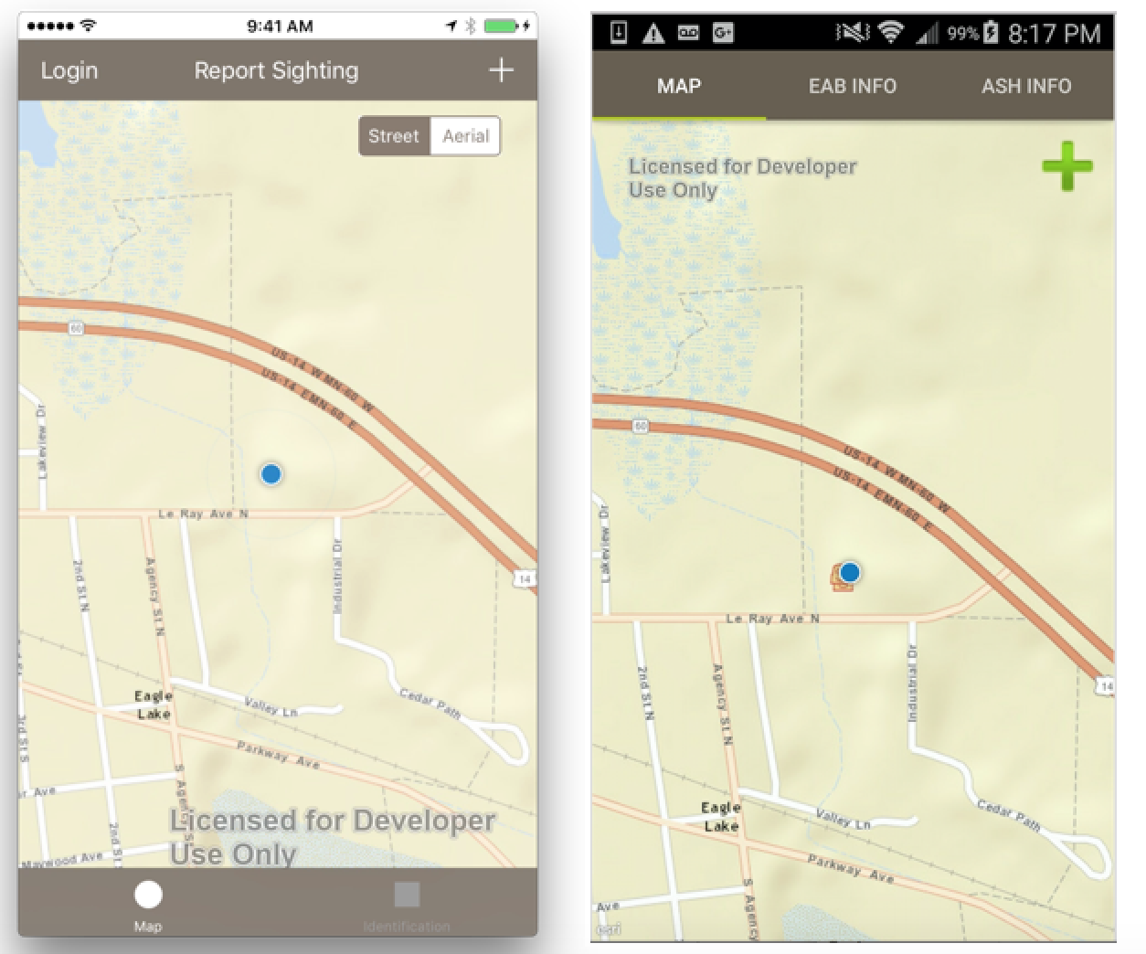

**Figure 4. Map View for iOS (left) and Android (right)**

A few attributes are automatically populated such as the latitude and longitude from the device’s GPS, as well as an address for their current location. The address is obtained by performing a reverse geocode against the Google Maps API by providing latitude and longitude values. The address can be overwritten by the end user from the form. When a user reports a sighting, the app will also query the county in which the new sighting has been reported to check the quarantine status. If there is no quarantine and no reported sightings in the county, its status will be changed to “Possible EAB Present – needs to be considered for quarantine”. This will change the county polygon’s fill color to orange so it is easy to see from the map view. While the county query and re-symbolization happens on a background thread, a default email will pop up from the user’s personal email account to the MDA’s “Arrest the Pest” account to automatically report the sighting to them. The user has the option to cancel the email (**Figure 5**).

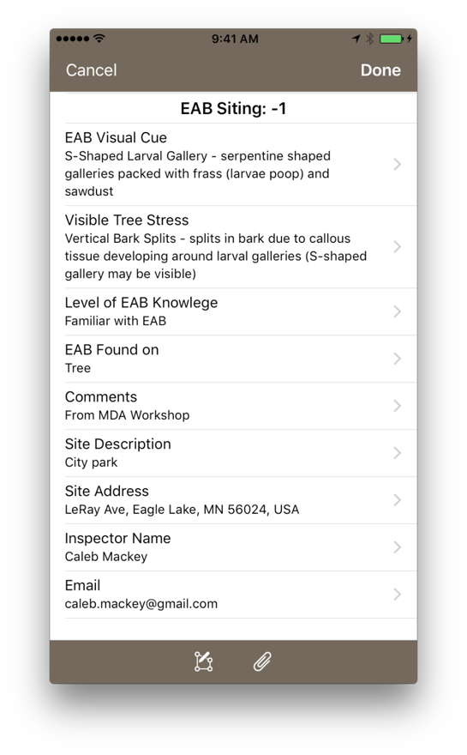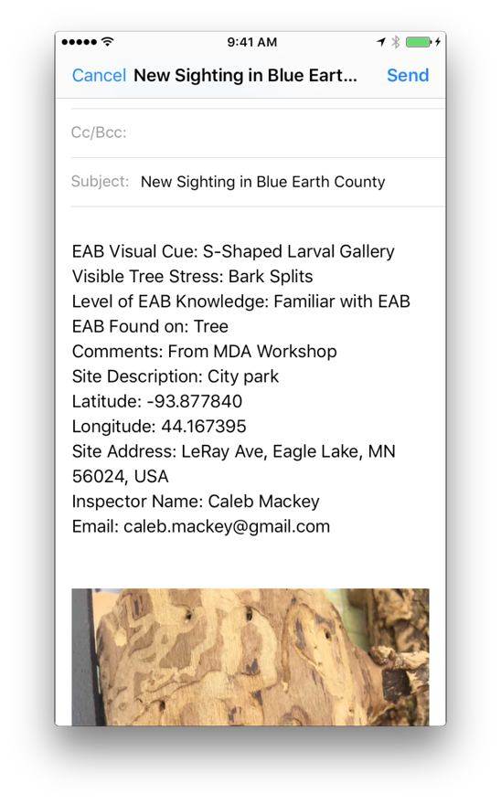

**Figure 5. When the sighting is reported (left) an email is formatted for the MDA (right)**

Another valuable feature of the app is the information on how to identify the EAB as well ash ash trees. For the EAB identification tab, photographs of the EAB in its different lifecycle stages are included with detailed descriptions. Similar information is displayed in the ash information tab to help the user identify an ash tree. Also included in the ash tab, are photos of the visual cues with descriptions that are similar to the domain values from the sightings layer. This will give the user an example of what to look for when looking for crown dieback, epicormic sprouting, larval galleries, bark splits, and D-shaped exit holes (**Figures 6 and 7**).

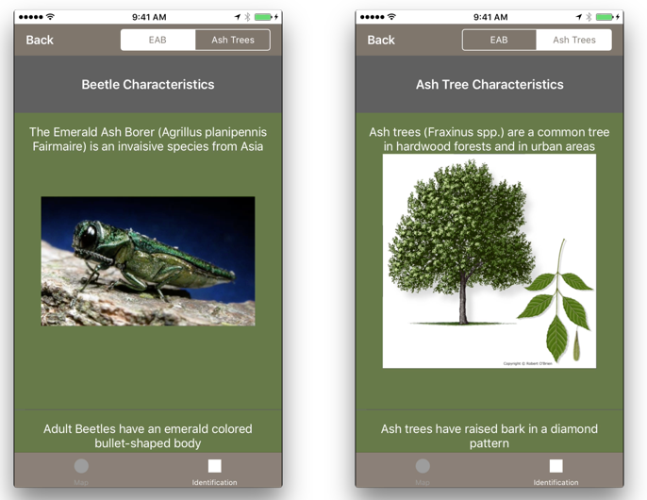

**Figure 6. The Identification Tabs on the iOS App**

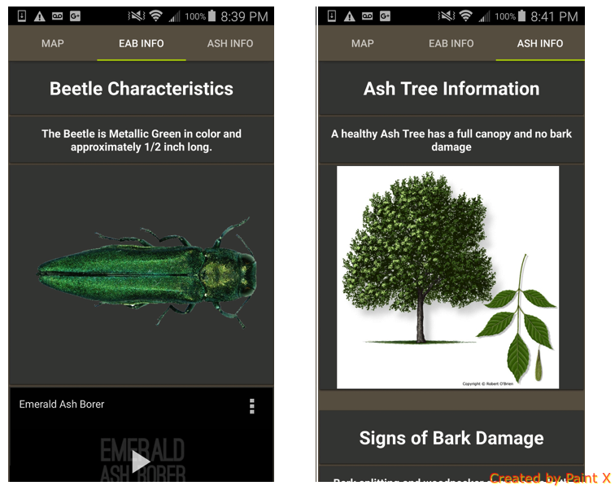

**Figure 7. Identification Tabs in Android App**

The app will also provide editing capabilities for privileged users such as the MDA staff. This will allow these special users to verify sightings and delete any that are not valid. The user will also have the ability to change the quarantine status. Because the feature service that drives the sightings and counties is public, the authentication model is not using authentication for an ArcGIS Online Organization, but is instead just a named user I have provided with the application. For the iOS app, in addition to signing in with the named user account, the ability to also sign in using the “Touch ID” feature of iOS, which can authenticate the user via their registered fingerprints. Touch ID is only active when the device has this feature turned on and signs in for the first time with the admin account. This works by saving the password to the device “Keychain” after a successful login and can be retrieved from the keychain with Touch ID. This feature is currently not available in Android. Screenshots of the app can be viewed in **Figure 8**.

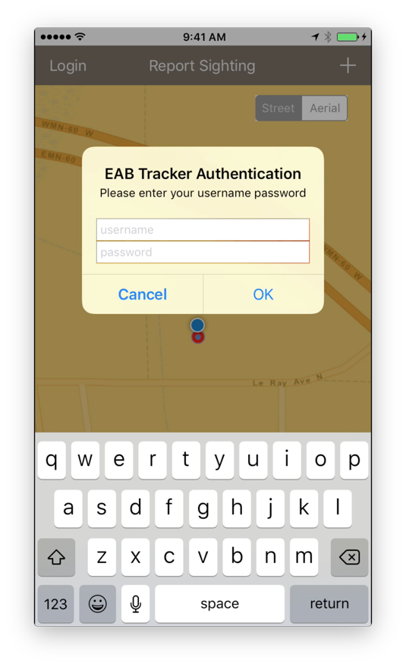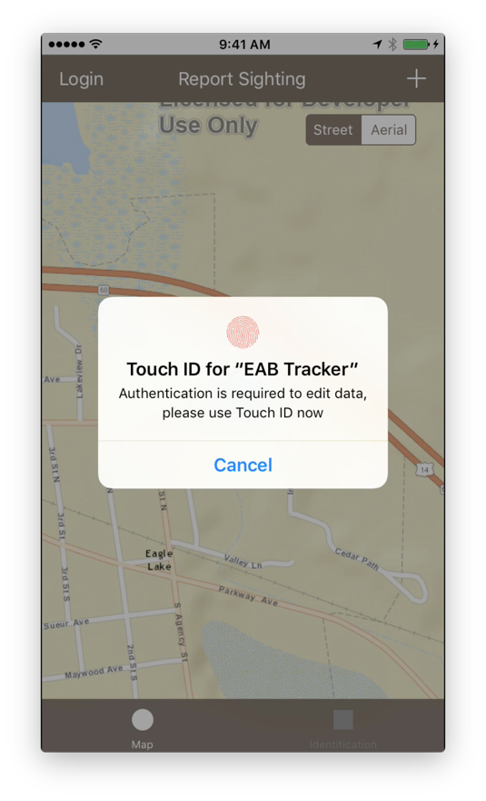

**Figure 8. Logging in by typing username and password or using Touch ID**

**Expected Results and Future Work**

The result of this study is a fully functional mobile application that will successfully store the geographic location of new sightings as well as the photos. This functionality is valuable as it can promote early detection of new infestations. When the MDA hosts future workshops, this mobile application could serve as a complimentary tool that would allow attendees to report their sightings in a consistent manner. Because the app will be using push notifications in the future, MDA staff who use the app will be notified immediately when a new sighting is reported, and can hopefully promptly visit the site to validate and take any necessary actions.

The most difficult task will be engaging the public and getting volunteers to submit new sightings. One major challenge is letting people know that the app exists in the first place. Social media could be used for advertising, but picking the best venues to distribute this information will take careful consideration. Another important aspect is to ensure that the app is designed in a way that is visually appealing, intuitive, and easy to use. A poorly designed app will likely not get much use or provide any tangible value to aid in early detection of the EAB.

As mentioned earlier, the apps are not yet complete. The goal is to have both apps finished by early 2017, so they are available in the Apple Store and Google Play Store prior to the EAB flight season that begins in May. There are still many features that need to be added to the apps such as push notifications, a table of contents that shows the map layers and their symbology, and give the user the ability to manually draw a point or use a photo’s GPS data if they are working offline in the field.

**Conclusion**

I believe that this tool could make a difference in early detection and swift mitigation strategies if enough people use the app. If successful, this app does not have to stop at collecting data for the EAB. There are numerous invasive species in Minnesota alone that could also benefit from having a mobile app such as this one. This Framework could easily be applied to other species or to provide a means for another crowd-sourced data collection on almost any type of geographic data.

## **References**

Anulewicz, A. C., Mccullough, D. G., Cappaert, D. L., & Poland, T. M. (2008). Host Range of the Emerald Ash Borer (*Agrilus planipennis* Fairmaire) ( Coleoptera : Buprestidae ) in North America : Results of Multiple-Choice Field. *Environmental Etomology*, *37*(1), 230–241.

Cameron, E., Crick, W., Cardella, D. Getting started with the ArcGIS Runtime. Retrieved from <http://video.esri.com/watch/4266/getting-started-with-the-arcgis-runtime>

Epstein, Z. (2016, June 2). *Apple’s mobile market share sees big drop in May as Android Skyrockets*. Retrieved from <http://bgr.com/2016/06/02/apples-mobile-market-share-sees-big-drop-in-may-as-android-skyrockets/>

Goodchild, M. F. (2007). Citizens as sensors: The world of volunteered geography. *GeoJournal*, *69*(4), 211–221. http://doi.org/10.1007/s10708-007-9111-y

Marshall, J. M., Storer, a. J., Fraser, I., & Mastro, V. C. (2010). Efficacy of trap and lure types for detection of *Agrilus planipennis* (Col., Buprestidae) at low density. *Journal of Applied Entomology*, *134*(4), 296–302. doi:10.1111/j.1439-0418.2009.01455.x

Minnesota Department of Agriculture.(2006)*. Emerald Ash Borer Introduction Risk Model for Minnesota*. (2006). Retrieved from <http://www.mda.state.mn.us/Global/MDADocs/pestsplants/eab/riskmodel.aspx>

Minnesota Department of Agriculture. (2015). Emerald Ash Borer Early Detection & Rapid Response. Retrieved January 5, 2016, from http://www.mda.state.mn.us/plants/pestmanagement/eab

Poland, T. M., & McCullough, D. G. (2006). Emerald ash borer: Invasion of the urban forest and the threat to North America’s ash resource. *Journal of Forestry*, *104*(3), 118–124. doi://000237540400003

Saccomani, P. (2016, September 26). Native, Web or Hybrid Apps? What’s the Difference? Retrieved from <https://www.mobiloud.com/blog/native-web-or-hybrid-apps/>

Venette, R., Christianson, L., Abrahamson, M. (2014). Cold Snap is no Snow Day for Emerald Ash Borer Management. Biological and Environmental Influences on Forest Health and Productivity.

Walrath. P. (2016, February 17). Personal Interview.