*Firewood Regulations, Quarantines, and Early Detection of the Emerald Ash Borer in Minnesota*

Caleb Mackey

Minnesota State University

Geography 681

# Introduction

The emerald ash borer (EAB), *Agrilus planipennis* Fairemaire (Coleoptra: Buprestidae) is an invasive species that has killed millions of ash trees (Fraxinus spp.) since it was first discovered in United States and Canada in 2002, and is spreading rapidly in Minnesota. Because this pest is particularly hard to track and predict where it will move due to unintentional human transportation through wood products, early detection of new infestations is a difficult task.

The EAB was first found in the US in the greater Detroit, MI area in 2002, but it had likely been here since the late 1990’s (Anulewicz et al., 2008; Poland & McCullough, 2006). It is believed that they traveled from eastern Asia in wood shipping pallets. Since its induction to the US, this invasive beetle has quickly spread across the Midwest and eastern states where the ash resource is the most plentiful (**Figure 1**). They have been able to thrive here due to the lack of natural predators and the abundance and vulnerability of ash trees. Because ash trees were able to coevolve with the EAB in their native range in Asia, they have developed a chemical resistance to the EAB, and typically only very stressed trees are attacked. Due to the ash resistance combined with the presence of natural predators, the EAB does not cause significant damage in its native range (Rebek et al., 2008).

The EAB is a member of the order Coleoptera (beetles) and is in the Buprestidae family, which are the wood boring beetles. The life cycle of *A. planipennis* spans from one to two years, depending upon the temperatures of the infested region. The two-year life cycle is likely in Minnesota, where the larvae will spend a second winter season to mature to feed on the phloem and cambium in a pre-pupae state through four instar stages (Marshall et al., 2010). The adult form of *A. planipennis* is small, usually less than ten millimeters long and approximately two millimeters wide. Their bodies are elongated in the shape of a bullet with a bronze abdomen and metallic emerald colored wing covers.

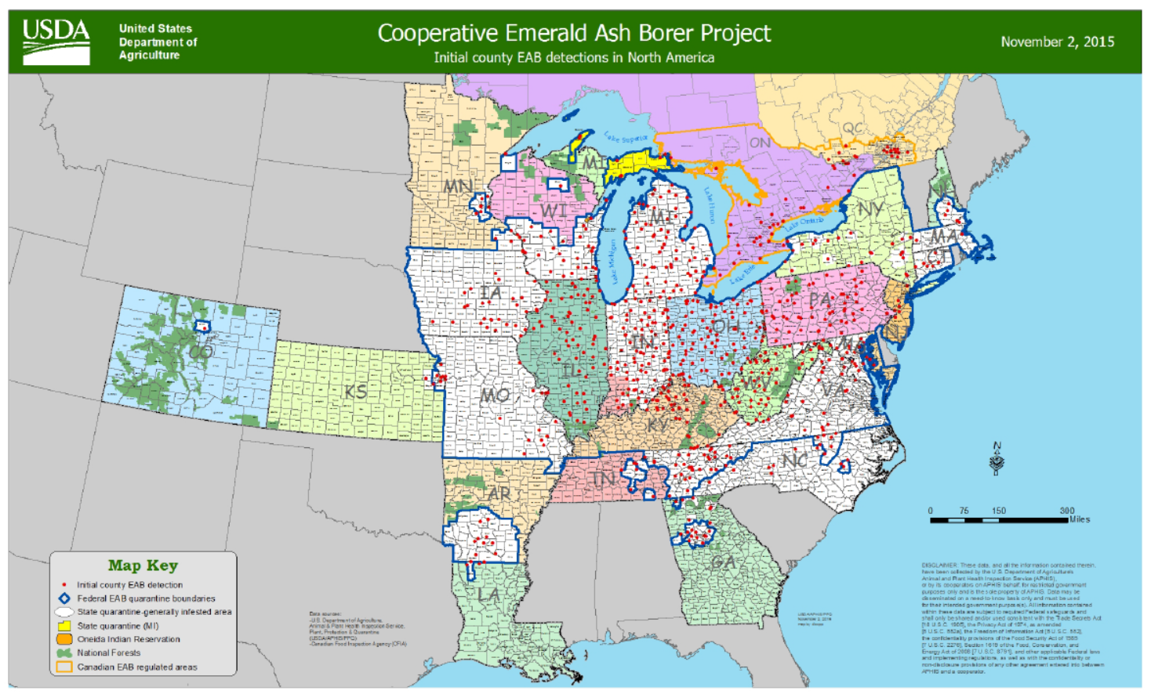 **Figure 1. Current EAB Distribution (USDA 2015)**

The adult beetles do not cause significant damage to ash trees as they usually feed on the leaves and mate on the bark of the trees. Instead, it is the larvae that effectively girdle the trees during the winter months, essentially cutting of the nutrient supply from the roots to the crown of the tree, resulting in ash mortality. During the mating season, females lay their eggs on the bark and in between crevasses on the outer surface of trees. The females will lay eggs under the bark or in cracks and the larvae will usually hatch within two weeks and start boring into the phloem of the tree (Anulewicz et al., 2008). On average, ach female will lay between 50-90 eggs during her lifecycle (Poland & McCullough, 2006).

When the eggs hatch, the larvae emerge as a creamy white wormlike organism and begin feeding right away. In the first few months, the instars in their pre-pupae state will form shallow serpentine tunnels in the phloem and cambium of the trees leaving behind a trail of frass, which is a brown woody excrement. The larvae mature through four instars in their pre-pupae form by feeding on phloem during the fall, and then move deeper into the sapwood to form overwintering chambers. In the early spring, the larvae will transform into sexually mature adults and emerge from the trees leaving D-shaped exit wounds (Poland & McCullough, 2006).

Ash are a very common hardwood forest tree and are especially prevalent in urban settings in major cities like Detroit, Chicago, and New York City; comprising approximately 15-20% of all urban tree species (BenDor et al., 2006). Their spread has been extremely difficult to track because the adults lay eggs on the bark of the tree, allowing the larvae to bore into the vascular tissue of the tree, where they will feed for one to two years (Marshall et al., 2010). This kills the tree because the larval galleries disrupt the nutrient flow from the roots to the crown of the tree. Because the larvae live in the tree for so long, the infested wood is often transported long distances by humans without their knowledge.

Depending on the intensity of the infestation, EAB larvae can typically kill an Ash tree within 2-4 years. Populations tend to be strong in areas with dense Ash populations because they do not have any natural predators in the U.S., they have been very effective in damaging Ash stands. Forests near Detroit have experienced ash mortality rates exceeding 99% (Klooster et al., 2013). They have also had significant impacts in urban areas. Damages in cities for removal/replanting of heavily infested and dying ash trees in Ohio communities is estimated in to be in the billions (Syndor et al., 2007).

### EAB Spread in Minnesota

The first confirmed EAB sighting in Minnesota was discovered in the Saint Anthony’s Park area of St Paul in May of 2009. Since then, it has spread to a total of 10 counties mostly within the metro area, but also into sites in the southeastern portion of the state along the Mississippi River. It is likely the EAB is in other portions of the state, but have not yet been discovered. This beetle threatens the ash tree resource in Minnesota as its dense populations are susceptible to high levels of ash mortality, and tree removal can be very expensive in urban settings where ash is a common monoculture (Minnesota Department of Agriculture, 2016).

The City of Saint Paul has seen significant increases in the amount of infested ash trees in recent years. In 2015 alone, it was estimated that the EAB had spread across 75% of the city, when it was closer to 55% in the beginning of the year. These numbers are quite high compared to 2010, when only about 3.5% of the city had known infestations. There are an estimated 26,000 ash trees in the Right of Way (ROW) on street boulevards, and tens of thousands more in public parks and open land areas. These numbers do not include ash trees on private lands, which the responsibility of the well being of the trees fall on the landowner. These dead and dying trees present many hazards within the urban landscape because the branches become weak and break off easily, causing damage to property (city of Saint Paul, Minnesota, 2015).

Tree removal has already been a burden on the city of Saint Paul. Since the EAB Management Program began in 2009, thousands of trees on public property have been removed and or treated with insecticides. The city currently uses a “Structured Removal” system that removes all publically owned ash trees within an infested area rather than just the infested ones. Between the years of 2009-2015, a total of 6,190 trees have been removed from public ROW. The city has also began using insecticide treatments to help trees last until they are scheduled for structured removal. As of 2015, the total amount of publically owned ROW trees that have undergone treatment reached 1,922, while the total number of treated city park trees reached 179 (city of Saint Paul, Minnesota, 2015).

For every removed ash tree, the city hopes to replace it with a different species. Unfortunately, the city faces budget challenges as their annual $150,000 budget has not increased to compensate for the mounting costs of tree stock and installation. Since 2010, prices have gone up significantly as the price to purchase and install 2-inch caliper Hackberry skyrocketed from $155 to $285 in 2015. To make matters worse, the city has also been unable to add any additional staff to keep up with the demand for tree replacement due to budget constraints (city of Saint Paul, Minnesota, 2015). City residents are also seeing the negative impacts of the EAB because they are responsible for removing any hazardous trees on their property. According to [www.treeremoval.com](http://www.treeremoval.com), on average tree removal can cost the landowner $459 to $651 depending on the size and distance to power lines in the Minneapolis area (2016).

### Searching for New Infestations in Minnesota

The lifecycle of the EAB presents an interesting mitigation challenge for agencies like the DNR and MDA. Because the trees often do not show signs of stress until it is too late and the larvae spend so much time under the bark, finding new infestations does not come easy. The MDA is the lead agency and have several methods for searching for EAB infestations in new areas. Thousands of purple prism traps have been placed around the state (**Figure 2**) to capture and detect adult beetles and crews are sent to perform branch sampling. The MDA uses a risk area map to estimate where new infestations may be so traps can be effectively placed (**Figure 3**).

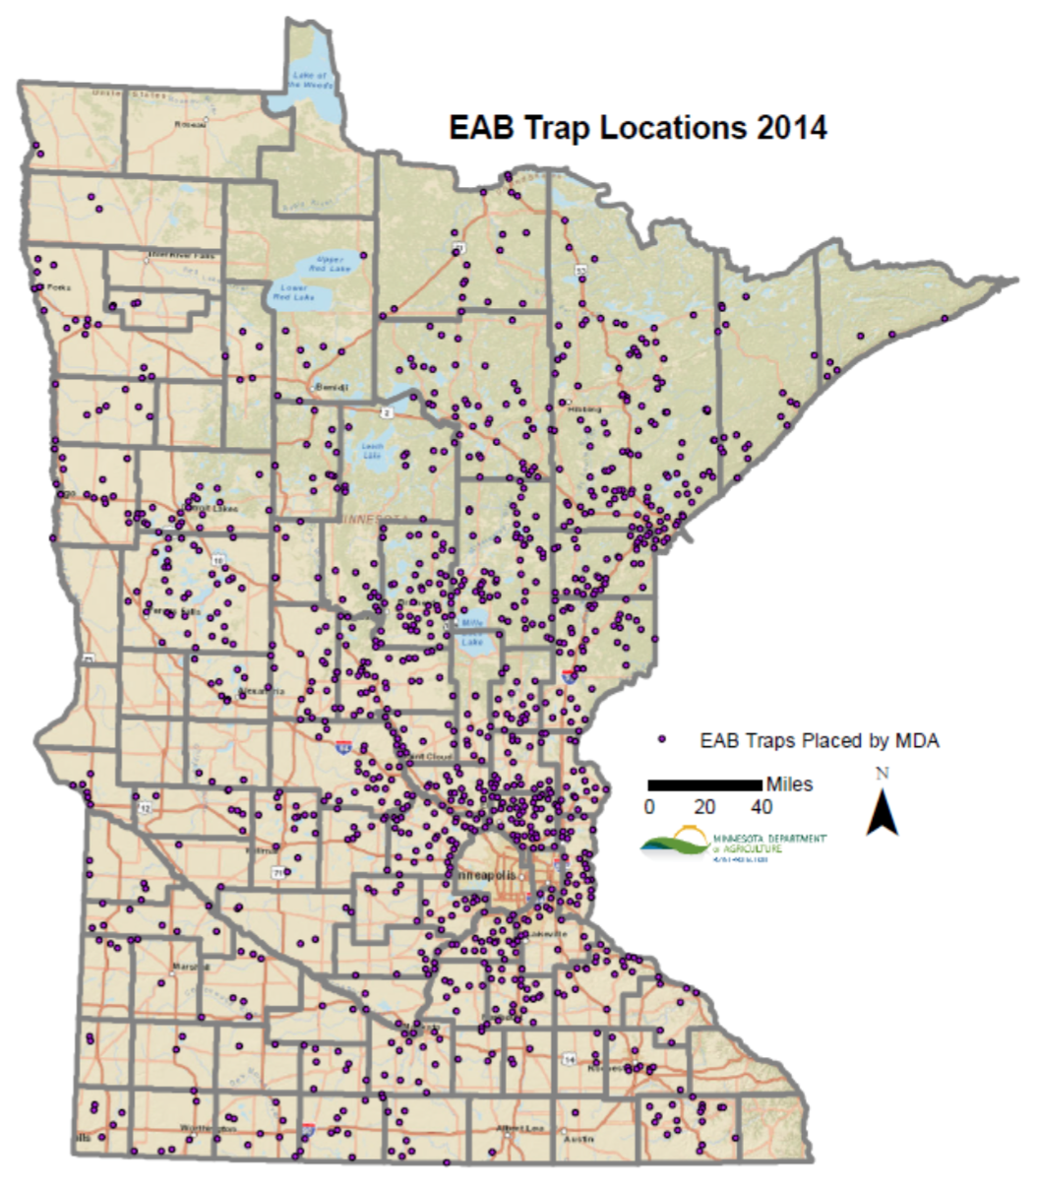**Figure 2. Map of EAB traps placed by MDA (MDA 2015)**

**Figure 3. EAB Risk Map (MDA 2006)**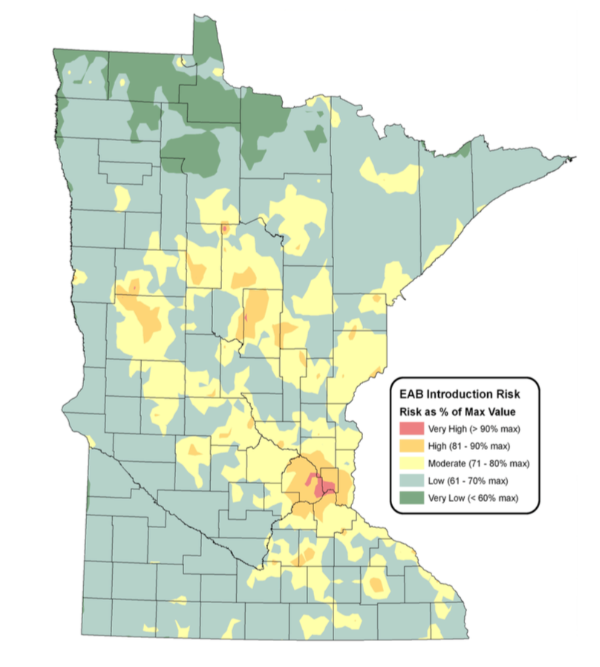

The EAB Risk Model was developed by the MDA in 2006 using Geographic Information Systems (GIS). They combined seven datasets representing factors believed pose the highest risk to introduce the EAB in Minnesota:

* Campgrounds
* Seasonal Homes
* Urban Areas
* Sawmills
* Firewood
* Nurseries
* Accessibility to Highways and Major Cities (Chicago)

The risk map provides a guideline as to where the EAB is likely to be, and therefore are the areas where the MDA concentrates their efforts to find new sightings (Minnesota Department of Agriculture, 2006). One important factor working against the EAB that is not accounted for in risk map are the northern parts of Minnesota where winter cold snaps can cause high mortality rates of EAB larvae, particularly in the USDA Plant Hardiness Zones 3a and 3b (**Figure 4**). When a tree’s inner core reaches extreme temperatures between -20° F and -30° F, EAB larval mortality can be estimated to be around 50%. EAB larval mortality can exceed 90% when the tree’s core dips below -30 F for an extended period of time. It is important, however, to note that wind chill reaching this temperature does not affect the larvae (Venette et al., 2014).

**Figure 4. Map of EAB traps placed by MDA (MDA 2015)**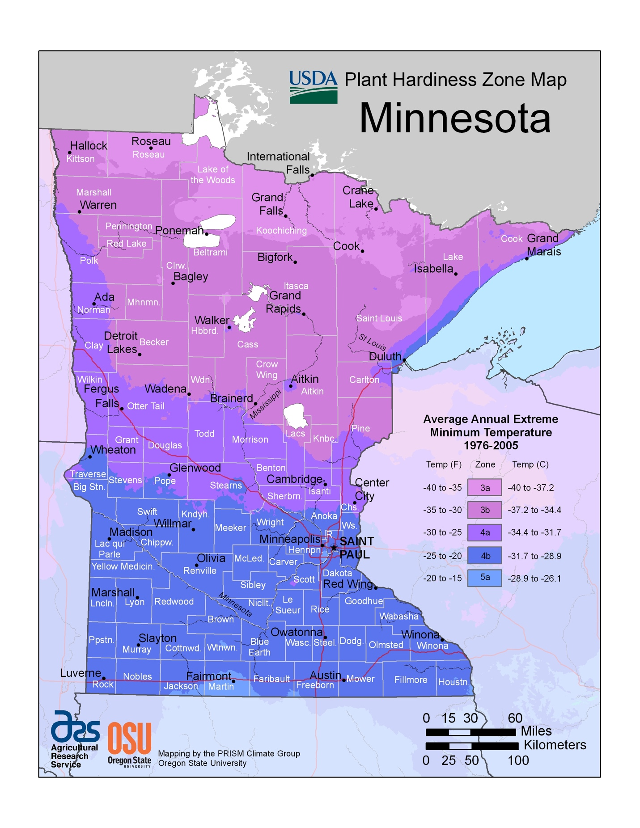

The MDA staff rely on visual cues such as crown dieback, epicormic shoots, bark splits, D-shaped exit holes, and blonding or flecking as a result of woodpecker feeding. The woodpecker damage can be a sign of a dense infestation within a tree, as woodpeckers will damage the bark looking for larvae (P. Walrath, personal communication, February 17, 2016). When there are visual cues in an area indicative of a new EAB infestation, staff from the MDA will perform branch sampling. Staff collects a minimum of 35 branches within a forest stand and peel back the bark to search for larval galleries. There are several wood boring beetles that can be found in Minnesota, but the EAB create distinct S-shaped galleries. Purple prism traps are also set and visited by MDA staff. These traps use lures such as manuka oil that mimic a stressed ash tree and sticky paper is used to trap adult beetles (P. Walrath, personal communication, February 17, 2016).

### Quarantines and Biocontrols

In order to slow and prevent the spread of wood boring pests, the United States Department of Agriculture (USDA) Animal and Plant Health Inspection Service (APHIS) Plant Protection and Quarantine (PPQ) institutes an emergency quarantine when a pest is found in a new area. What this means is that there are strict regulations put in place to prevent wood products from being moved or sold outside of the quarantined area. Wood products are defined as: 1) logs and green lumber; 2) nursery stock, scion and bud wood; 3) chips and mulch, either composted or uncomposted; 4) stumps, roots, and branches. In order to avoid having the entire state of Minnesota being part of the federal quarantine, the MDA has agreed to enforce the USDA APHIS quarantine within the state, usually at the county level. By the Minnesota Statues Section 18G.06 (2008), the Commissioner of the MDA has the authority to declare that a county is under quarantine (Minnesota Department of Agriculture, 2016).

Some infested wood can be moved under the quarantine laws if it has been heat treated first. There are two different types of wood that can be moved legally in Minnesota. The first type is the DNR approved firewood. This wood may not be pest-free and therefore cannot be moved outside of a quarantine. This wood is allowed on any DNR administered lands or within 50 miles of the harvest location as long as it does not go outside of a quarantine. By far the safest wood to move is the MDA/USDA approved firewood which can be moved outside of quarantine boundaries within the state. This wood has been heat treated in a USDA APHIS approved dry kiln facility where the core of the wood is required to maintain an internal temperature of at least 60° C (140° F) for a period of at least 60 minutes. Also required when moving MDA/USDA certified wood out of a quarantined area is a signed Compliance Agreement (CA) with the MDA for interstate movements, or with both the MDA and USDA APHIS PPQ for transporting outside of the state. The CA requires the business or individual to comply with the methods, conditions, and procedures for handling ash wood, pursuant to the quarantine laws. Any violation related to transporting untreated wood outside of a quarantine can result in daily fines up to $7,500 (Minnesota Department of Agriculture, 2016). If you are moving your own untreated wood, you are encouraged to burn it near where it was found.

Slowing the EAB in known infested areas is a high priority task to protect Minnesota’s ash trees. In recent years, the MDA has been introducing biocontrols to prey on EAB. The USDA APHIS suggested to bring in two different species of parasitoid wasps to prey on the EAB, with careful consideration not to disturb other native species. The Encyrtid Wasp (*Obius agrili*) are very tiny wasps less than a millimeter in length who feed on EAB eggs. Adult female Encyrtid Wasps actually lay their eggs inside of EAB eggs and allow them to overwinter. With two generations emerging as adults in the spring and summer, these wasps are able to achieve parasitism rates of up to 60% because each female can lay approximately 62 eggs. Another introduced wasp is the Eulophid Wasp (*Tetrastichus planipennisi*). Similar to the Encyrtid Wasp, the *T. planipennisi* also target EAB eggs and the larvae overwinter after their active period, which is spent consuming the EAB larvae and are able to reach parasitism rates of up to 65%. The adult Eulophid Wasps are a little larger than the Encyrtid Wasp, usually reaching lengths around 1.6 mm (Minnesota Department of Agriculture, 2016).

### Engaging the Public

The MDA is currently trying to educate as many citizens as possible to assist in identifying and reporting EAB sightings in new locations. Workshops are held at various locations to train citizens to become volunteers to engage in the hunt for new infestation sites. The MDA staff show citizens how to spot signs of an EAB attack on live ash trees, paying particular attention the most helpful visual cues such as woodpecker damage. They also show attendees how to properly identify an EAB in both the larval and adult stages as well as some of the common look-a-like insects that are often mistaken for an EAB. One thing that is stressed at these workshops is that the MDA truly needs the help from public volunteers (P. Walrath, personal communication, February 17, 2016).

The MDA does not have enough staff to patrol the entire state and are therefore asking the public to keep an eye out and report new sightings through their “Arrest the Pest” website (<http://www.mda.state.mn.us/arrestthepest)>. They ask that if you see an EAB, you should take a picture and try to describe exactly where it was spotted and get a sample if possible. If you are able to provide the MDA with a sample or photograph of the sighting, it can help them determine if the sighting presents a legitimate EAB threat, and therefore an inspection crew can be sent to the site for verification.

### Conclusion

As the Emerald Ash Borer is making its way through Minnesota, early detection through public engagement and volunteer efforts may be the most effective and economically viable plan of attack. When new sightings are discovered in new counties, it is imperative to institute a quarantine as quickly as possible so the MDA has the authority to prevent firewood from spreading to new locations. If the MDA is able to prevent infested wood from leaving a quarantined area, it may provide enough time to introduce biocontrols to eradicate the local populations of EAB.

References

Anulewicz, A. C., Mccullough, D. G., Cappaert, D. L., & Poland, T. M. (2008). Host Range of the Emerald Ash Borer (*Agrilus planipennis* Fairmaire ) ( Coleoptera : Buprestidae ) in North America : Results of Multiple-Choice Field. *Environmental Etomology*, *37*(1), 230–241.

BenDor, T. K., Metcalf, S. S., Fontenot, L. E., Sangunett, B., & Hannon, B. (2006). Modeling the spread of the Emerald Ash Borer. *Ecological Modelling*, *197*(1-2), 221–236. doi:10.1016/j.ecolmodel.2006.03.003

City of Saint Paul, Minnesota. (2016). *Emerald Ash Borer Management Program 2015 Annual Report*. Retrieved from https://www.stpaul.gov/sites/default/files/Media Root/Parks %26 Recreation/Emerald Ash Borer Annual Report.pdf

Klooster, W. S., Herms, D. a., Knight, K. S., Herms, C. P., McCullough, D. G., Smith, A., Cardina, J. (2013). Ash (*Fraxinus* spp.) Mortality, Regeneration, and Seed Bank Dynamics in Mixed Hardwood Forests Following Invasion by Emerald Ash Borer (*Agrilus planipennis*). *Biological Invasions*, *16*(4), 859–873. doi:10.1007/s10530-013-0543-7

Marshall, J. M., Storer, a. J., Fraser, I., & Mastro, V. C. (2010). Efficacy of trap and lure types for detection of *Agrilus planipennis* (Col., Buprestidae) at low density. *Journal of Applied Entomology*, *134*(4), 296–302. doi:10.1111/j.1439-0418.2009.01455.x

Minneapolis Tree Removal & Stump Removal Services | Minneapolis, MN. (n.d.). Retrieved April 30, 2016, from http://www.treeremoval.com/us/minneapolis/

Minnesota Department of Agriculture.(2006)*. Emerald Ash Borer Introduction Risk Model for Minnesota*. (2006). Retrieved from <http://www.mda.state.mn.us/Global/MDADocs/pestsplants/eab/riskmodel.aspx>

Minnesota Department of Agriculture. (2015). Emerald Ash Borer Early Detection & Rapid Response. Retrieved January 5, 2016, from http://www.mda.state.mn.us/plants/pestmanagement/eab

Poland, T. M., & McCullough, D. G. (2006). Emerald ash borer: Invasion of the urban forest and the threat to North America’s ash resource. *Journal of Forestry*, *104*(3), 118–124. doi://000237540400003

Rebek, E. J., Herms, D. a, & Smitley, D. R. (2008). Interspecific variation in resistance to emerald ash borer (Coleoptera: Buprestidae) among North American and Asian ash (*Fraxinus* spp.). *Environmental Entomology*, *37*(1), 242–6. Retrieved from http://www.ncbi.nlm.nih.gov/pubmed/18348816

Sydnor, T. D., Bumgardner, M., & Todd, A. (2007). The Potential Economic Impacts of Emerald Ash Borer (*Agrilus planipennis* ) on Ohio, U.S., Communities. *Agriculture & Urban Forestry*, *33*(1), 48–54.

Venette, R., Christianson, L., Abrahamson, M. (2014). Cold Snap is no Snow Day for Emerald Ash Borer Management. Biological and Environmental Influences on Forest Health and Productivity.

Walrath. P. (2016, February 17). Personal Interview.