Web GIS: Services, Architecture, and Challenges

Caleb Mackey

Geography 670

4/29/2015

## **Introduction**

Advances in technology over the last decade have made accessing maps and geospatial data more convenient than ever in the advent of web GIS. By allowing geospatial information to be exchanged over the World Wide Web, it has never been easier to share data with GIS professionals and the general public alike by integrating information from multiple sources. Geospatial data is no longer confined to static maps as web GIS applications allow users to interact with the data directly and even perform their own analysis.

The backbone of web GIS will always be maps and the data behind them. However, as technology is evolving, the mapping process is moving away from traditional desktop applications and hard copy maps to more dynamic and lightweight web mapping applications. This means that the end users do not need to have any software installed on their computers and can access the maps and data through a web browser and maps can even be accessed from mobile devices. This allows geospatial information to be deployed and consumed more rapidly than ever. However, with the rapid changes to technology, this presents a new challenge to GIS professionals to keep up with the new technologies and retain the necessary skillsets. This paper will examine the evolution of web GIS and the challenges related utilizing the technology.

## **Web GIS as a Decision Making Tool**

Web GIS presents a new way of thinking and promotes collaboration between decision makers and stakeholders in the planning and management process. It takes traditional static maps and transforms them into dynamic maps that allow users to interact with the spatial data and even provides the ability query the data by attributes or spatial relationships. The three major advantages of using web GIS are improvements in spatial data access and distribution, spatial data examination and geovisualization, and the ability to perform geospatial analysis through the web without needing any software installed on the client side (Dragićević 2004). Moreover, the maps can be shared to the general public through nothing more than a web browser, which can be extremely powerful in the event of an emergency. Real time data such as election results and vehicle fleet tracking can also be displayed through web GIS.

In a study by Dragićević and Balram in 2004, they assessed the ability of web GIS to aid in the communication of ideas for natural resource management by allowing them to draw geometries and annotate base maps. They found that utilizing the web maps as a visual communication tool allowed stakeholders to be more involved in the planning process and were able to communicate more efficiently. Other advantages included cutting down on costs associated with travel for face to face meetings as communication through maps was more effective than traditional emails and phone calls.

## **Architecture**

Web GIS platforms typically use a server-client architecture, often over a distributed network (Figure 1). Each mapping service is processed and published from a web server and therefore can support collaboration from disparate sources (Dragićević and Balram 2004). As a client interacts with the map service through a web application or HTTP request, the server handles the request by querying information from the spatial database in a round trip and returns the results to the client (Alesheikh, Helai, and Behroz 2002; Bauer 2012). The web server pushes the data to the World Wide Web via Microsoft Information Services (IIS), Apache, or similar, and the client queries the data by passing in parameters through the URL. The data transfer formats and service configurations are usually stored as eXtensible Markup Langauge (XML) or Geography Markup Language (GML), and the query results can be retrieved in a variety of formats such as JavaScript Object Notation (JSON) (Alesheikh, Helai, and Behroz 2002; Bauer 2012).

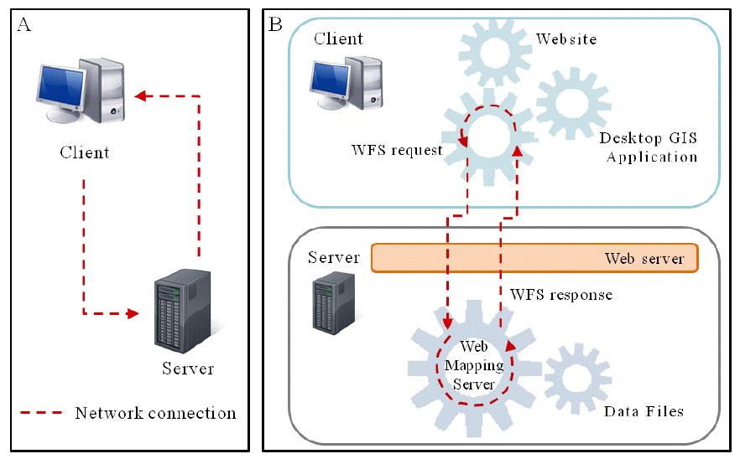

**Figure 1**. Client-Server Architecture (Bauer 2012)

### **Types of Web Services**

Most web GIS platforms adhere to the standards proposed by the Open Geospatial Consortium (OGC). The OGC has laid out many different types of web GIS services with the main three being the web mapping service (WMS), web feature service (WFS), and web coverage service (WCS). The WMS offers map image requesting capabilities with exports available in standard formats such as JPEG and GIF based on a bounding box request from the client. The WFS offers more advanced functionalities beyond just standard map image exports such as the ability to perform queries and even data manipulation (Dragićević 2004, Frehner and Brandli 2006, Reed 2011).

For the WFS, the basic requests suggested by the OGC WFS standards are get capabilities, describe feature type, and get features (Reed 2011; Bauer 2012). Each type of requests tells the server how to handle the WFS information and what to send back to the client. A get request sends the WFS XML document back to the client that outlines the service capabilities, whiel a describe request will give detailed descriptions of the service capabilities and properties, such as the spatial reference of the service. The request features operation will actually return the attribute and geometry information from the spatial database in a variety of formats. Similar to the WFS, the WCS allows for pixel or vector based queries and map image exports, supporting a variety of formats such as GeoTIFF and NetCDF (Bauer 2012). Other services such as GeoData allow for users to extract spatial data in popular GIS formats and even allow for GIS analysis through the web in a geoprocessing service.

The geoprocessing service, henceforth referred to as the geoprocessing web has emerged in recent years as a very powerful tool to perform geospatial analysis over the web. This type of analysis used to only be possible in traditional desktop GIS software, where now the software only needs to be accessible by the web server. Aside from not needing any additional software installed on the client side, the geoprocessing web has many benefits such as taking advantage of crowd-sourcing to perform analysis and mapping, enabling real-time GIS data processing, and facilitates collaborative analysis between disparate sources (Zhao, Forester, and Yue 2012). The Service-Oriented Architecture (SOA) has become a popular framework for deploying geoprocessing services with the ability to create complex workflows that execute on both the server and client side. (Yue et al. 2011; Zhao Forester, and Yue 2012).

The SOA design coupled with advances in cloud computing can facilitate crowd-source analysis capabilities as robust servers can handle more and more requests. Cloud services such as Amazon Elastic Cloud (Amazon EC2) and Microsoft Azure can provide Software as a Service (SaaS), Platform as a Service (PaaS), and Infrastructure as a Service (IaaS), meaning that the web servers no longer have to be managed in house, which can alleviate IT headaches and increase web service up time (Zhao, Forester, and Yue 2012). By taking advantage of these cloud services, the web servers become scalable so that when there are high volumes of users running analysis through crowd-sourcing, new server instances can be spun up to handle the increase in HTTP requests.

## **Early Web GIS Platforms**

A study done by Dragićević and Balram in 2004 was performed in order to see if using a distributed Web GIS system could help overcome some of the inefficacies involved in the planning process of decision makers in a dispersed network. At that time there were not a lot of options, but among the first Web GIS platforms was the Environmental Science Research Institute’s (ESRI) ArcIMS. Other notable web GIS options were Autodesk’s MapGuide, University of Minnesota’s MapServer, and the Xerox Company’s Map Viewer (Dragićević 2004). Even in these early days, configuring a Web GIS environment with ArcIMS was difficult for GIS professionals. The development of a functional web application required both server and client side scripting. The infrastructure used by Dragićević and Balram was common at the time where the Internet Mapping Services (IMS) were housed on an Apache server. All server side scripting was handled through Microsoft’s ASP.NET server side scripting language, and dynamic links to data sources and communication to the client were handled through Hypertext Markup Language (HTML) and JavaScript. All communication between the client and web server is exchanged through a web browser through Hypertext Transfer Protocol (HTTP) requests. Achieving a basic set up in this type of integrated Web GIS framework was not overly challenging. However, configuring the web applications for optimum performance and introducing more client side functionality can present a steep learning curve as traditional Geographers and GIS professionals are not typically trained for these types of tasks.

## **Modern Web GIS Platforms**

As the Web has made significant technological advances, so to have web GIS applications. There are a wide variety of both open source and proprietary web GIS frameworks to choose from. The proprietary market is dominated by ESRI’s ArcGIS Server which offers multiple Application Program Interfaces (API’s) and custom service types such as Network, Geoprocessing, and Geocoding services. ArcGIS Server utilizes a Representational State Transfer (REST) framework for communication between the client and server (ESRI 2015). Open source options include MapServer, GeoServer, MapGuide, and Mapnik. Each has its own pros and cons and each platform should be chosen based on budget constraints and by the nature of the applications that need to be developed.

Jennifer Bauer did a study in 2012 to compare web GIS platforms for coastal mapping applications with respect to performance and functionality. The three web GIS platforms compared were ArcGIS Server, GeoServer, and MapServer. The purpose of this study was not only to find the most robust web GIS framework, but also to examine avenues that facilitate the most optimal means to allow for collaboration for ecological decision makers from disparate locations, different disciplines, and different agencies to aid in the planning and coastal management process. Web GIS provides a visual medium with real time spatial data as an effective means of communication and offers a nice way to share potential management strategies through WFS services and mark up tools. The ability to print maps and export images also delivers a more concise form of communication than traditional emails and phone calls. With these things in mind, Bauer wanted to find the most performant web GIS framework for exchanging ideas and geospatial data in the context of coastal web applications.

In order test the performance of three web GIS frameworks side-by-side, spatial and attribute queries through HTTP requests against WFS layers were executed and timed using Python, a popular open source scripting language. Each of the three web mapping servers support similar operating systems, database types, and web services. Because each web mapping server produces its own flavor of the WFS, the design affects the performance of the service. Therefore, a WFS containing the same spatial data which included land parcels for four counties in Wisconsin was published from each web server for comparison. Parcels were chosen because they provide information on the economic values of coastal properties which are essential in the management process. A Python script was used over a high speed network of 100 Mbps to make all three request operations (get, describe, get features) against each of the four parcel datasets. The request time and file size of the data returned back to the client was logged for evaluation with a total of 30 observations for each request type and parcel data set.

The results of Bauer’s study showed that all three frameworks were effective in handling client queries against each WFS service and produced accurate results. In most cases, both MapServer and GeoServer outperformed ArcGIS Server in terms of download speeds which could be due in part to ArcGIS Server creating larger WFS. The open source options are more lightweight, but may not offer as much functionality as ArcGIS Server. Across the board, GeoServer was faster in all categories. One thing to note is that her study examined ArcGIS Server version 10.0, which was completely redesigned at version 10.1 to produce a more efficient framework.

## **Challenges for the GIS Professional**

With rapidly changing technologies comes the need for more technical knowledge as an essential skill for today’s GIS Professional. To administer web GIS servers and create web mapping applications, some knowledge of server architecture and HTTP protocols are necessary. To further complicate things, the development web applications requires understanding of web programming languages such as ActiveX, Adobe Flash, Microsoft Silverlight, or JavaScript and HTML (Batty et al. 2010). Security is yet another concern when dealing with sensitive geospatial data in web services.

### **Designing Functional Web Applications**

Aside from these technical challenges associated with building web GIS applications, the user interface (UI) and user experience (UX) needs to be taken into account (Figure 2). In order to provide an easy and comfortable experience for the end users, special considerations need to be made to ensure that the application is actually meeting the client’s needs. This can require considerable planning and client interactions before the application goes into the development stage. In order to help with the UI design aspects of a web application, a user-centered design (UCD) framework can be employed as a five stage process to assess the effectiveness of the map and tool interface (Tsou and Curran 2008). Map functionality and content (e.g. layers) also need to be carefully considered.

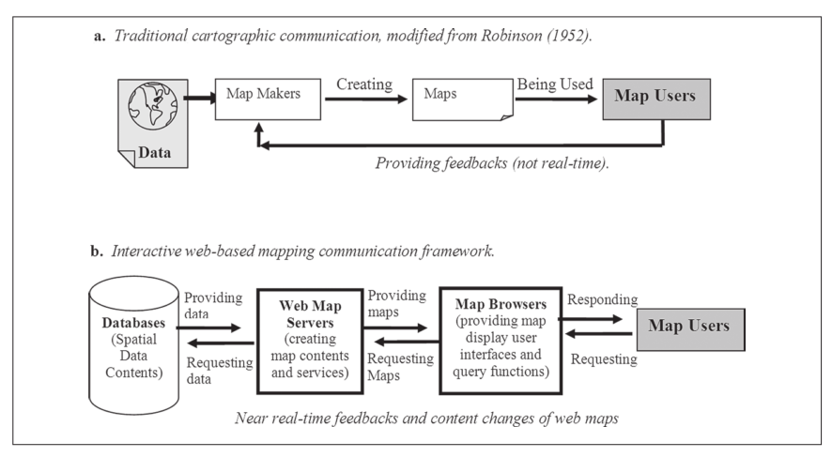

**Figure 2**. The web mapping user experience (Tsou and Curran 2008)

The UCD framework has five major design components that affect the development and client side of the web application: strategy, scope, structure, skeleton, and surface (Figure 3). The purpose of the strategy phase is to narrow down the specific needs of the end user and what they want to get out of the application. The strategy phase identifies what specific features need to be included in the site for the end user to carry out the tasks they need to perform. The web mapping service scope needs to be identified next with a focus on two components: the site functionality (query tasks, geoprocessing, map printing, etc.) and content requirements (layers, cartographic display, map hyperlinks, etc.). The structure phase is a critical phase in the process where the developer needs to determine how the different components and functions of the site will fit together and complement each other. This is the phase where the actual map functionality is developed in the context of the application to make sure the requirements are as indicated in the scope phase. The skeleton phase involves putting the pieces together to enable users to use the site to handle user events and build logic into the application. This also organizes the layers and functionality into appropriate themes that are intuitive to the application. The final phase is the surface stage, where everything is brought together as a fully functional application and deployed to the end users. This includes the final design and display of buttons, symbols, text, and finalizing the cartographic design for the application (Tsou and Curran 2008). During this final step, the strategy needs to be reviewed again to make sure that the application will meet the original needs of the end users.

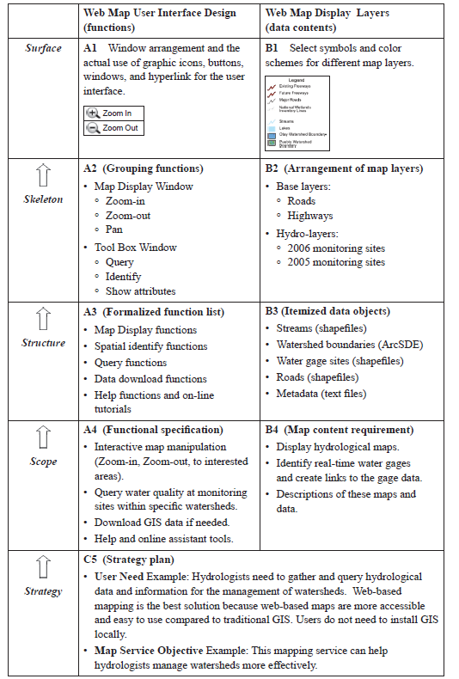

Figure 3. UCD in the application development process (Tsou and Curran 2008)

Other considerations when implementing a web GIS involve infrastructure needs and performance of the services and web applications. Processing power and the ability to handle simultaneous client requests dictate the internal infrastructure needs in terms of what kind of machines are needed. For applications that are available to the general public and those that will experience high volumes of client requests, resources to handle those requests need to be allocated accordingly. This may mean that additional servers need to be added to accommodate higher web traffic volumes (Zhao, Forester, and Yue 2012). Cloud services are an excellent way to overcome these problems and alleviate stress because the infrastructure does not need to be managed internally and a certain uptime is guaranteed by the vendor. Uptime is especially important in services that contain sensitive data or emergency response services.

### **The Role of Cartography in Web GIS**

While the framework of mapping is changing rapidly to be more geared to the web, GIS Professionals and Geographers can still wrap their minds around cartographic design and geovisualization as they were trained to do. This, along with the data behind the maps will always be the foundation of a web based GIS platform. Creating maps that communicate well, synthesize trends in phenomena, and summarize the results of geographic analysis are all aspects of good geovisualization (Kraak 2004). According to Kraak, good geovisualization techniques and cartographic design visually stimulate the end user to think spatially about patterns, trends, and relationships in the data. Maps also evolve from static representations of geographic data to dynamic and interactive applications where the end user can draw their own conclusions from the data as the ability to query the spatial databases behind the maps is at their fingertips (Kraak 2004, Dragićević 2004).

## **Conclusion**

Web GIS provides many advantages over traditional Desktop GIS applications. It has never been easier to get geospatial data out to the general public for easy access with no client-side software installs necessary. Web GIS promotes collaboration between decision makers and managers by creating a visual medium that serves as an excellent form of communication of proposed management strategies. Most users of web mapping applications do not have any formal GIS or cartography training, but are still able to utilize the maps as any Geographer would. That is the beauty of web GIS in that it is easy to use and empowers non-geographers to perform their own analysis through a web browser. It can even allow for collaborative, crowd-sourcing efforts to perform geospatial analysis and mapping.

The biggest challenges at this time seem to revolve around infrastructure, rapid changes to technology, and developing and designing meaningful web applications. All these things require GIS professionals to learn new skills that do not align with traditional Geography curriculums. A new type of hybrid Geographer is being born that possesses knowledge of geography, spatial analysis and place theory, coupled with computer technology skills to create smart maps that reach out to everyone. However, with these challenges and new demand for computer programming skills, are there enough GIS professionals who have these skills to match up with the number of new jobs that are asking for web development experience? Is Web GIS something that needs to be incorporated into the GIS curriculum at universities?

Alesheikh, A., Helali, H., & Behroz, H. (2002). Web GIS: technologies and its applications. *Symposium on Geospatial Theory*. Retrieved from <http://www.isprs.org/proceedings/xxxiv/part4/pdfpapers/422.pdf>

ArcGIS for Server 10.3. 2015. Esri, Redlands, CA.

Bauer, J. R. (2012). *Assessing the Robustness of Web Feature Services Necessary to Satisfy the Requirements of Coastal Management Applications*. Oregon State University.

Dragićević, S. (2004). The potential of Web-based GIS. *Journal of Geographical Systems*, *6*(2), 79–81. http://doi.org/10.1007/s10109-004-0133-4

Dragićević, S., & Balram, S. (2004). A Web GIS collaborative framework to structure and manage distributed planning processes. *Journal of Geographical Systems*, *6*(2), 133–153. http://doi.org/10.1007/s10109-004-0130-7

Frehner, M., & Brandli, M. (2006). Virtual database: Spatial analysis in a Web-based data management system for distributed ecological data. *Environmental Modelling & Software*, *21*(11), 1544–1554. http://doi.org/10.1016/j.envsoft.2006.05.012

Kraak, M.-J. (2004). The role of the map in a Web-GIS environment. *Journal of Geographical Systems*, *6*(2), 83–93. <http://doi.org/10.1007/s10109-004-0127-2>

Reed, C. N. "The open geospatial consortium and web services standards." *Geospatial Web Services: Advances in Information Interoperability* (2011): 1-16.

Tsou, M., & Curran, J. M. (n.d.). User-Centered Design Approaches for Web Mapping Applications : A Case Study with USGS Hydrological Data in the United States.

Yue, P., Wei, Y., Di, L., He, L., Gong, J., & Zhang, L. (2011). Sharing geospatial provenance in a service-oriented environment. *Computers, Environment and Urban Systems*, *35*(4), 333–343. http://doi.org/10.1016/j.compenvurbsys.2011.02.006

Zhao, P., Foerster, T., & Yue, P. (2012). The Geoprocessing Web. *Computers & Geosciences*, *47*, 3–12. http://doi.org/10.1016/j.cageo.2012.04.021