Div – NAV burger style

Business logo

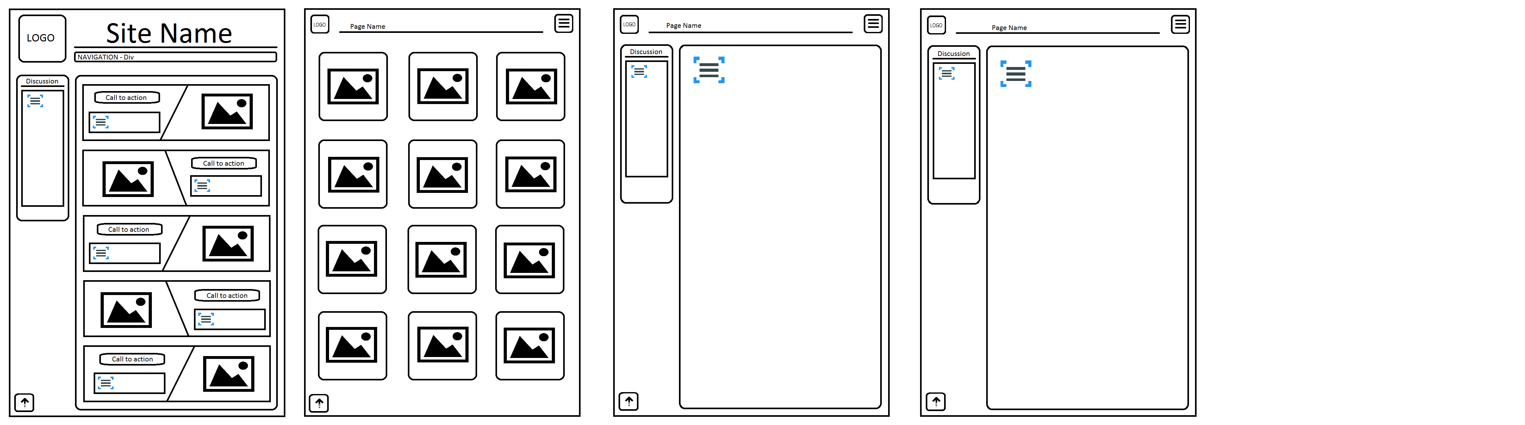

Back to top

Images

