Caleb McManus

7/13/2025

CS 330

2-3 Milestone One

My image:

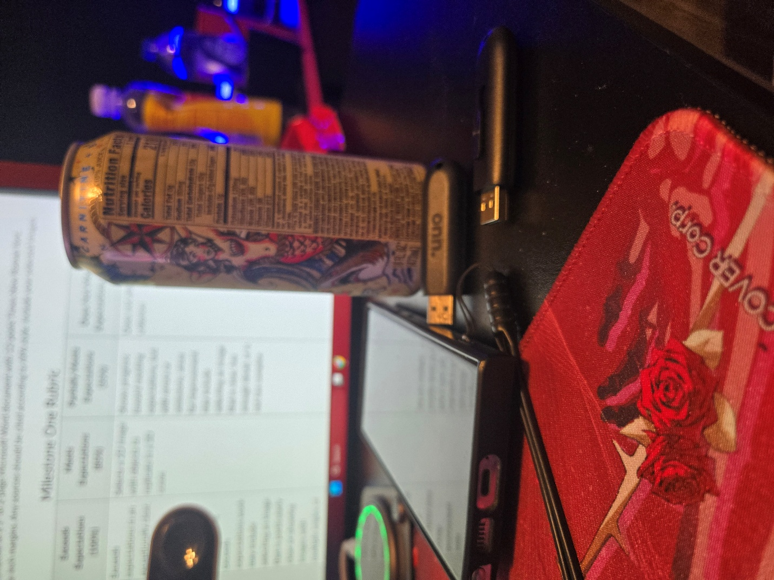

Theres a phone, 2 usb at different angles, and a can of monster in the background. I’ve chosen these items as I feel that it gives me a good mix of simple objects like a simple phone rectangle and cylinder can, while also giving me the ability to try out and make complex shapes with the different square, rectangle, and curved end of the usb. As mentioned before, the phone would be a long and thin box in 3d space, but I can easily use a simple 2d white rectangle on top to mimic a reflection to give definition of a screen. The can of monster is ultimately mostly just a cylinder, but I could always add at least the tab at the top that would be used to open the drink. The two usb are at different angles, but both would have a thin cube to represent the male port. After which, it would go into a thin and long rectangle than will transition into a half sphere to end off the grip portion of the stick.