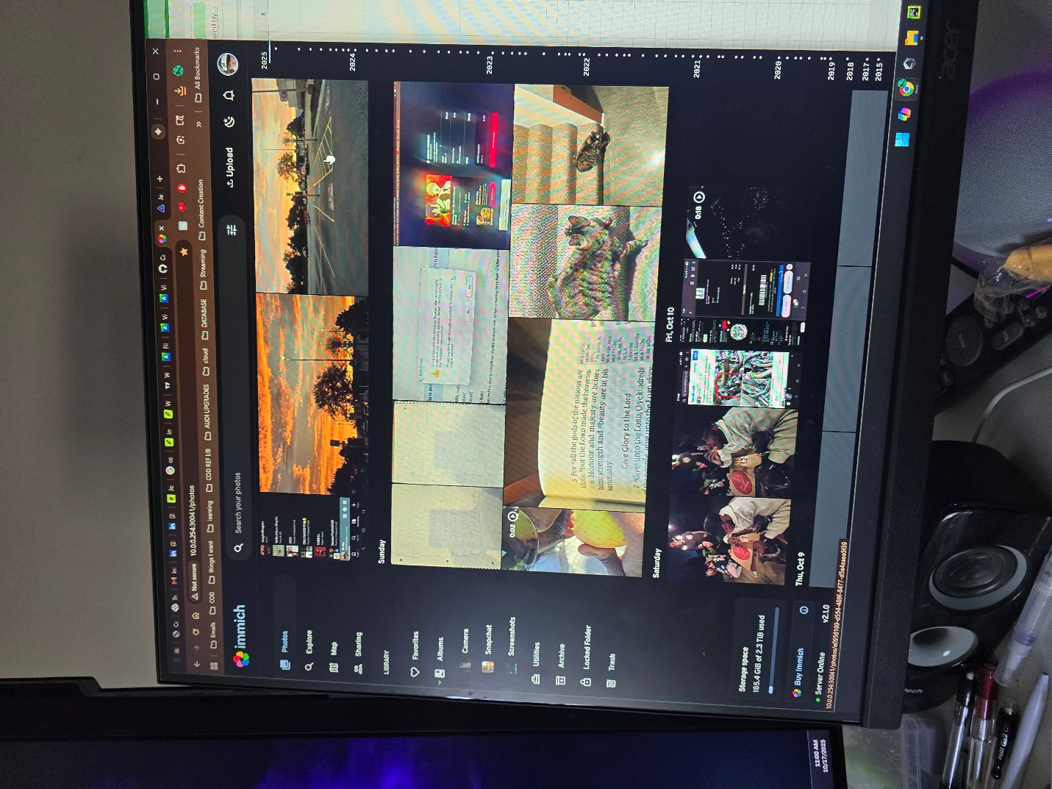This part was pretty easy. I Just configure the storage in the NAS with TrueNas. First step was to allocate storage to mirror the data between my 2 3tb drives. Then I set up security for the server and data on it with enceryption ect. Then I made a storage pool and this is accessable on the home network as a storage device.