Delayed Discounting Data Extraction Instructions

1. Make a folder on your desktop to copy data into.
2. Copy data from the server into a folder on your computer.
   1. STUDIES/Accommodation/Data
   2. If this is the first time you’re extracting data, you’ll need to copy the scripts into this folder as well.
      1. STUDIES/Accommodation/MATERIALS/ITCTask/SCRIPTS
3. Open the data output spreadsheet on the server
   1. The file is called ‘Accom_DelDiscount_AllSs_output.xlsx’
   2. STUDIES/Accommodation/Data/ Accom_DelDiscount_AllSs_output.xlsx’
4. Open MATLab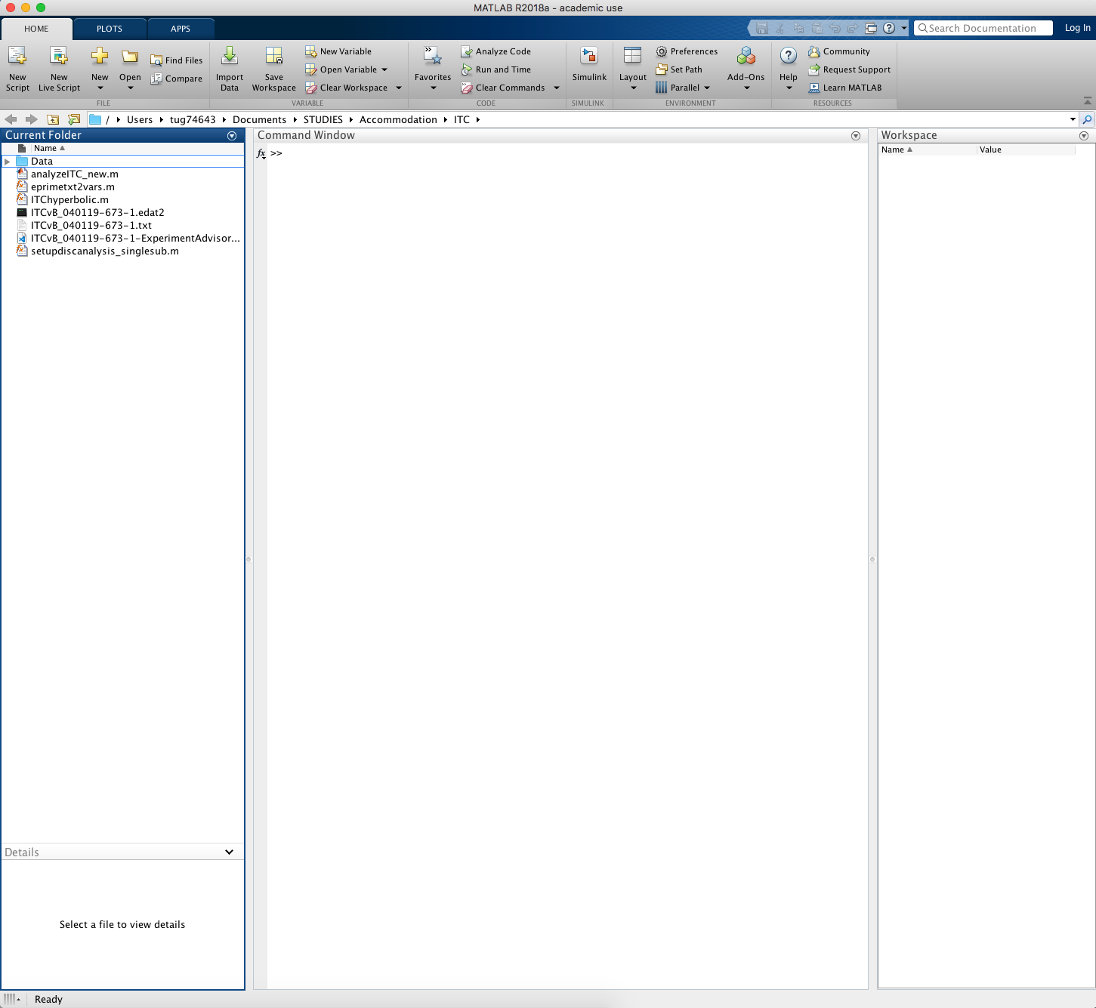
5. You’ll see the folder you made on the left-hand side under ‘Current Folder’
   1. 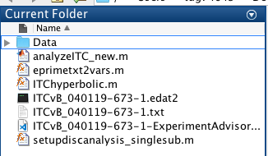
      1. This is where the data you copied into your folder lives
      2. This is also where the scripts to export the data live
   2. If you’re unable to open the folder, right click and select ‘Add to Path’
6. Run the data extraction script by dragging it from the left-hand column to the command window
   1. The script is called setupdiscanalysis_singlesub
   2. 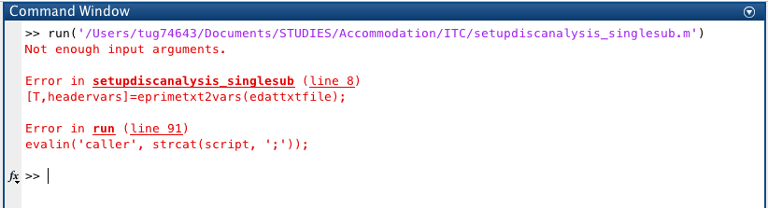
   3. When you drop the script in the command window, you’ll see this error message.
      1. This just means that you haven’t given the script any data to work with.
7. **To extract the data**:
   1. Open one of the data files in the ‘Current Folder’ panel on the left-hand side
   2. Drag the .txt file to the command window
      1. 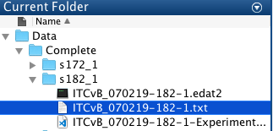
      2. 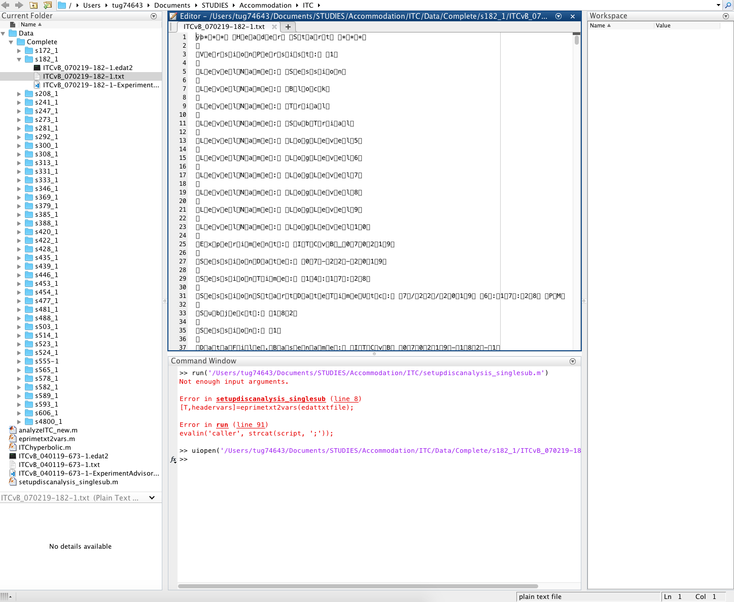
         1. This is the screen that will come up. You’ll still be working with the command window. Don’t worry about the new box above that.
   3. **To run the script**, type ‘setupdiscanalysis_singlesub(‘ ‘ in the command window
      1. 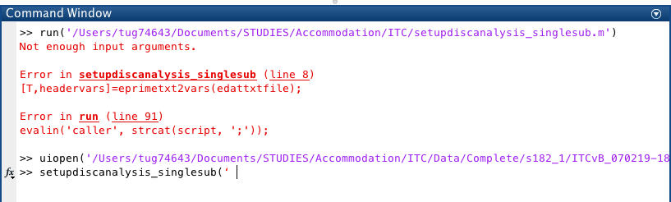
   4. Copy the ITCvB_070219-SUB##-1.txt’ that is in purple and copy it next to the script
      1. 
      2. 
         1. If the name of the data .txt file is red, it means something is entered incorrectly. Make sure there aren’t any extra spaces, and make sure there are parentheses and apostrophes at the beginning and end of the file name.
   5. Hit ‘enter’ on your keyboard
      1. 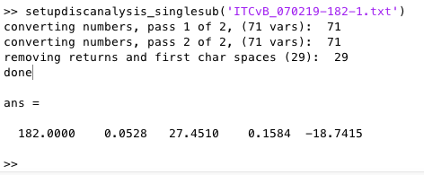
   6. After a few seconds, these five numbers will be generated by the script.
      1. This is what you need to copy into the Accom_DelDiscount_AllSs_output spreadsheet.
      2. 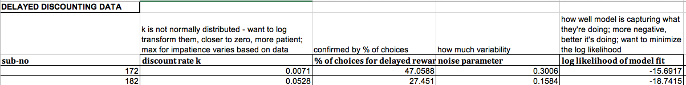
      3. Each number should be copied into its respective column.
   7. Repeat this for all subjects
   8. Save the spreadsheet before closing the server