Rover External Specification

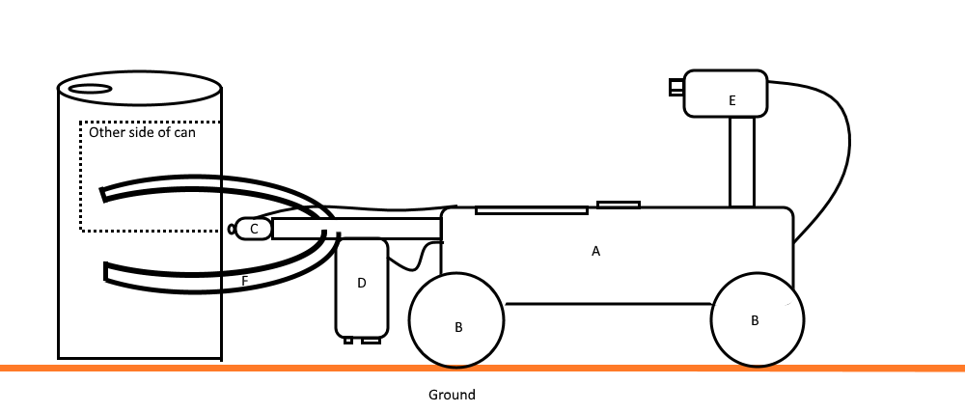

List of interactions

|  |  |  |
| --- | --- | --- |
| Id | Part | Interactions Description |
| A | Chassis | Interacts with sensors and wheels. Produce noise based on function. Plays sound controls logic for the bot.  The chassis plays a tone at a High pitch while wheels are turning counterclockwise. |
| B | Wheel | Interacts with ground and chassis. Attached to the chassis the wheels allow the bot to move on any surface. The chassis plays a tone at a High pitch while wheels are turning counterclockwise. |
| C | Push sensor | Interacts with can and chassis. When its pressed due to pushing a can the chassis will play a Medium pitch tone. The push sensor begins the timing and distance tracking of the can removal; this is handled by the chassis. |
| D | Light sensor | Interacts with ground, light and chassis. It gets the light value at the current position by checking the grounds light value. Communicates to the chassis to determine movement. |
| E | Sonar sensor | Interacts with the environment and chassis. The sensor pulses to find cans. Communicates to the chassis to determine direction of cans. |
| F | Claw | Interacts with can, used to remove can. |

1. The chassis
2. The wheels
3. The push sensor
4. Light sensor
5. Sonar sensor
6. The claw