Flying Squirrel

My game is called Flying Squirrel. The object of the game is, you are a flying squirrel who is trying to recover diamonds from the evil creatures of the woods. Your objective is to get the most amount of diamonds possible without dying and to make it to your home in the tree to store the diamonds. Some features of the game include a fully functional home menu that will allow you to play the game, see instructions for how to play , and quit.

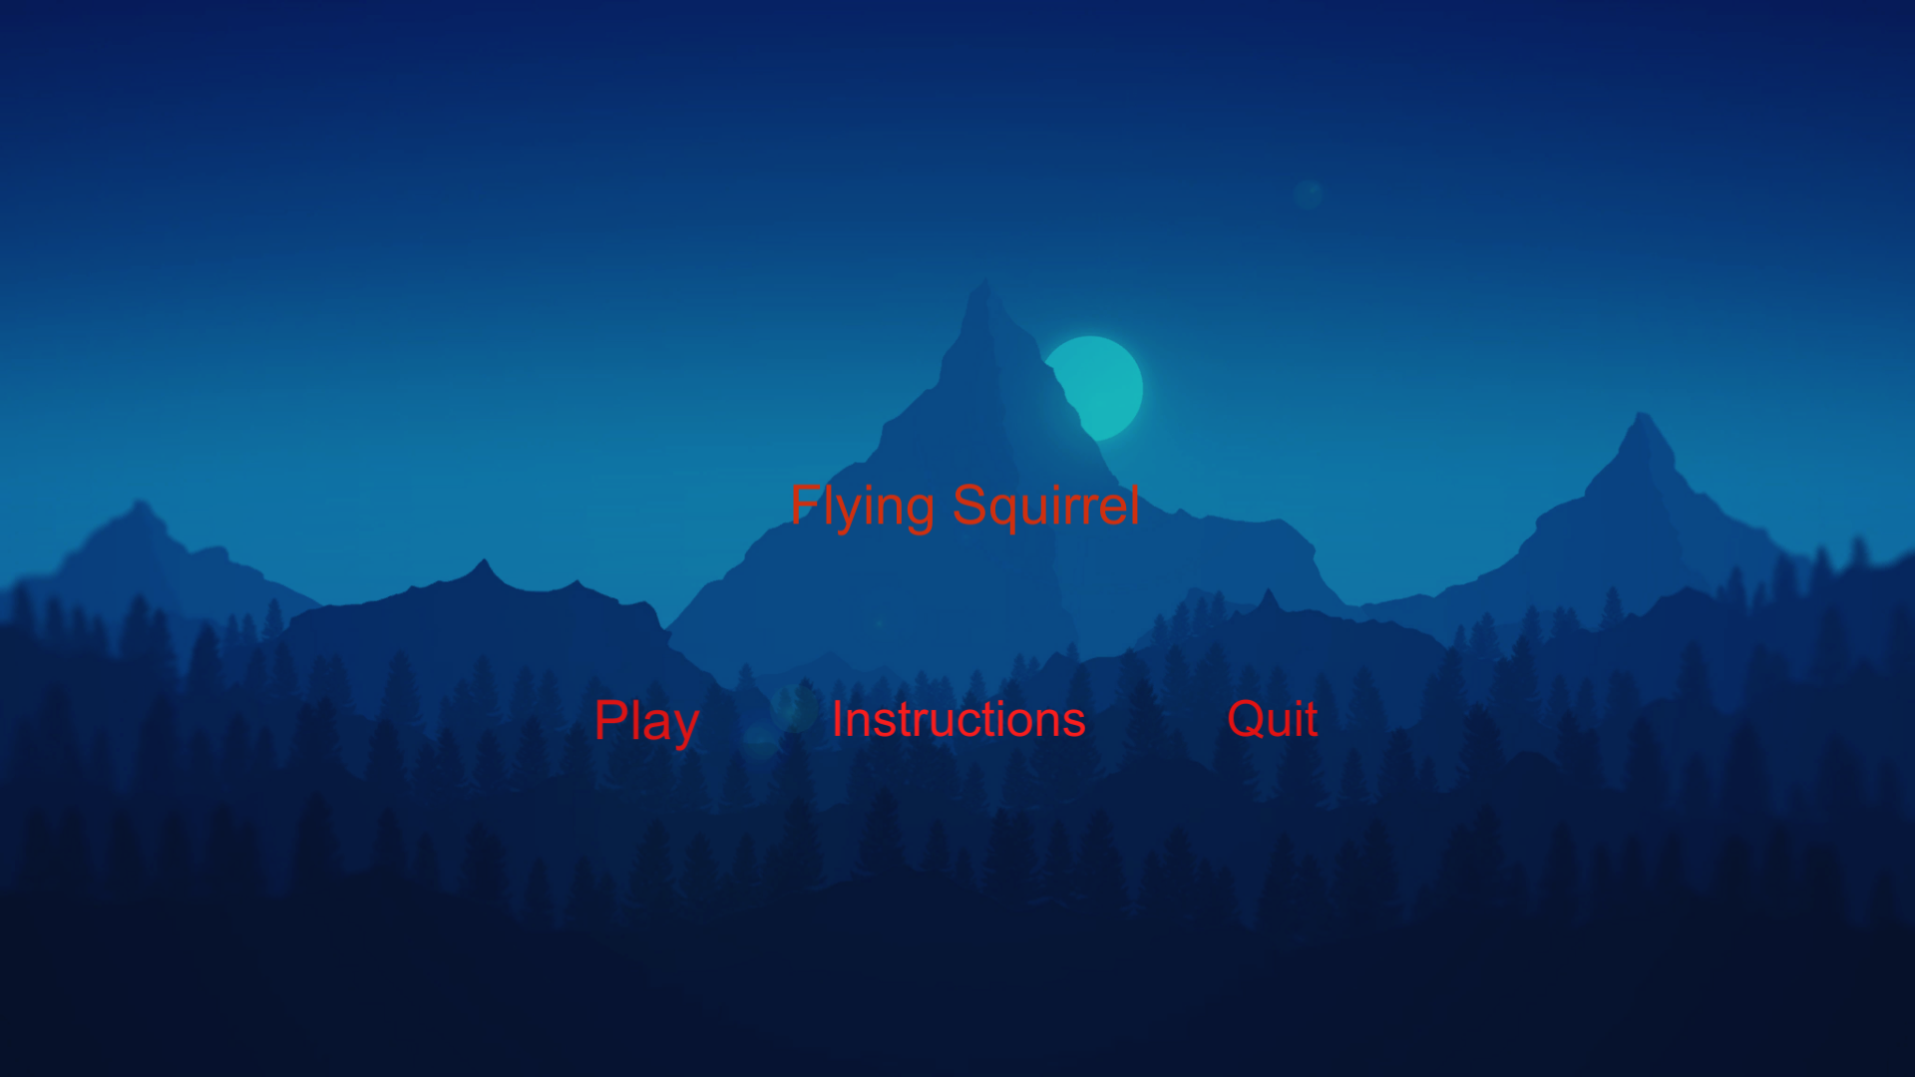

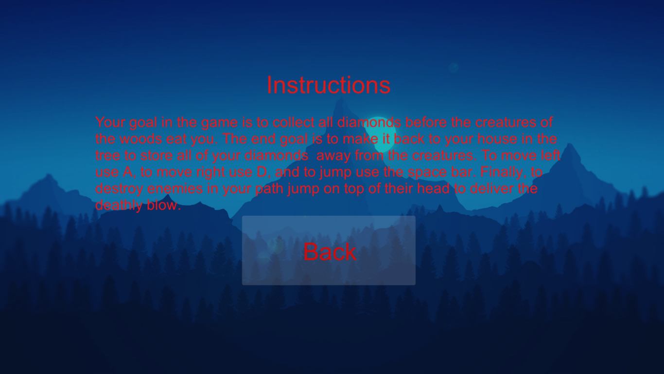

Once the user clicks play, the game will start. The user starts with 3 lives and 0 diamonds. As seen in the picture of the GUI below.

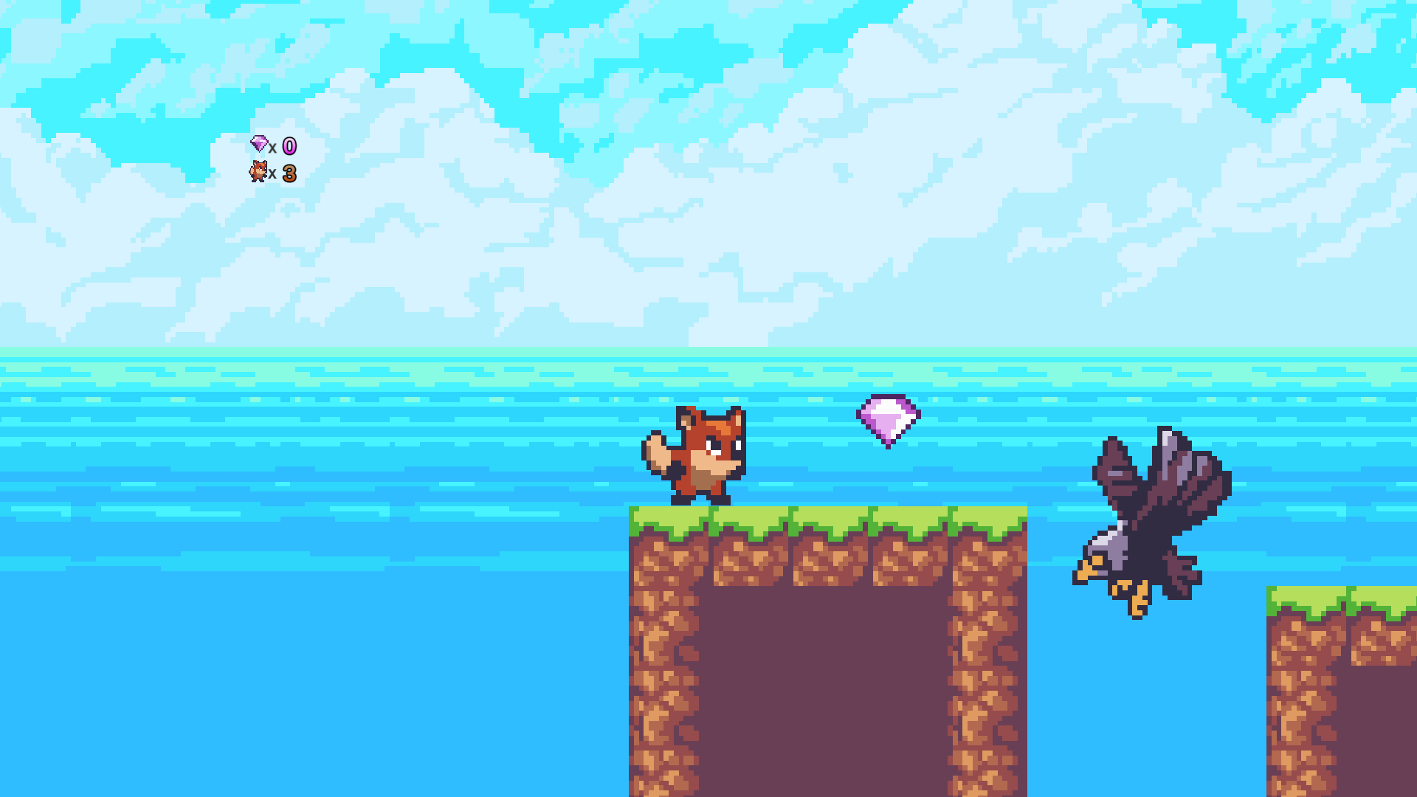

The user will press A to move left, D to move right, and Space bar to jump. When the user falls off the world they will immediately lose all lives and be sent back to the beginning of the game and diamonds will be reset to 0 as well. However, if the user runs into an enemy they will lose one life. When the user loses all of their lives, they will be sent back to the start of the game with new lives and diamonds will be reset to 0. As you can see below, when the user gets hurt the life count goes down. Also, as diamonds are collected the counter for diamonds goes up as well.

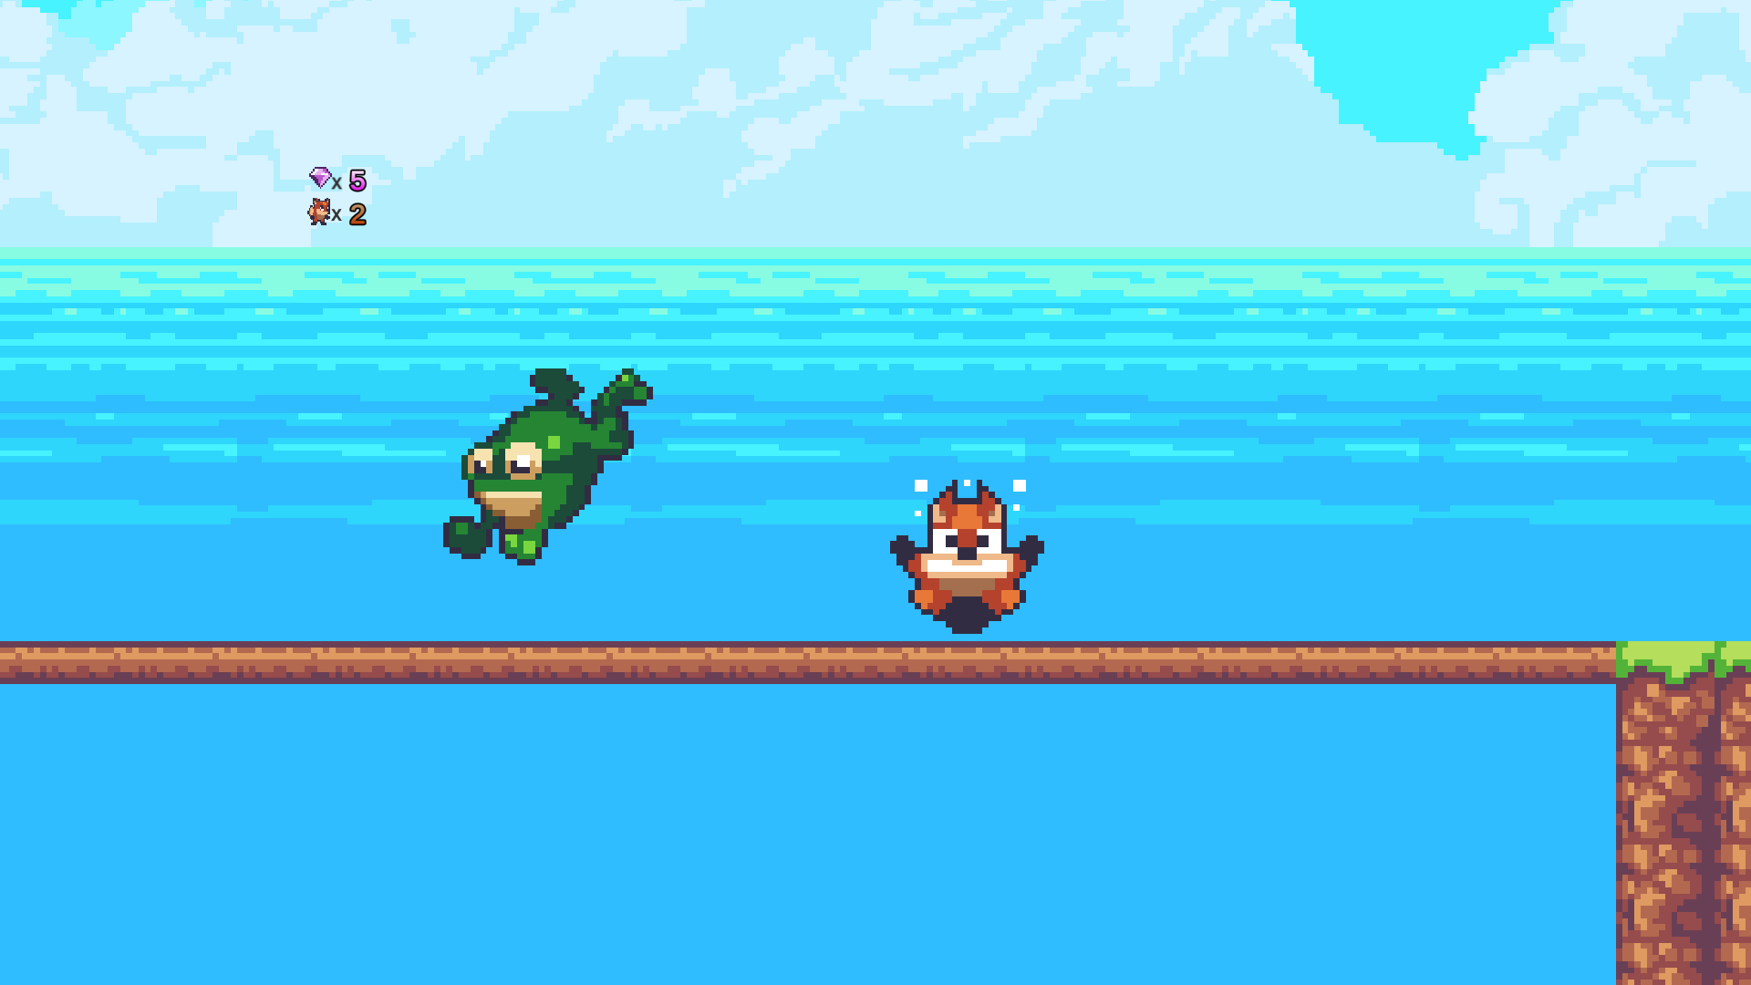

Another neat feature of the game is, as diamonds are collected it will make a collection noise when collectiong diamonds. Also, as enemies are destroyed it will make an explosion sound when destorying them. Also, when an enemy is destoryed it will, along with the sound, show the explosion of the enemy(as seen below). The user will be able to destroy enemies by jumping only on top of their head. If the user tries to destroy the enemy by running into them, they will be hurt and the life count will go down.

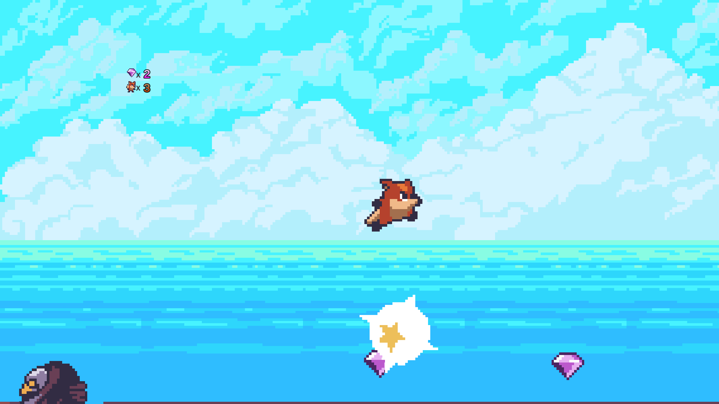

When the user gets as many diamonds as possible and makes it to the tree the game will end and the user will have won. When the user makes it to the tree the game will enter into the end game scene and will display a screen with a replay, instructions, and quit option. These options are also fully functional. When the user clicks replay the user will be sent to the beginning of the game, when the user presses instructions they will see the instructions menu, and when the user presses on quit it will end the game.

