Mighty Mouse Documentation

Caleb Enright

Most Comfortable – Least Comfortable

Lenovo – Microsoft – Amazon – Apple

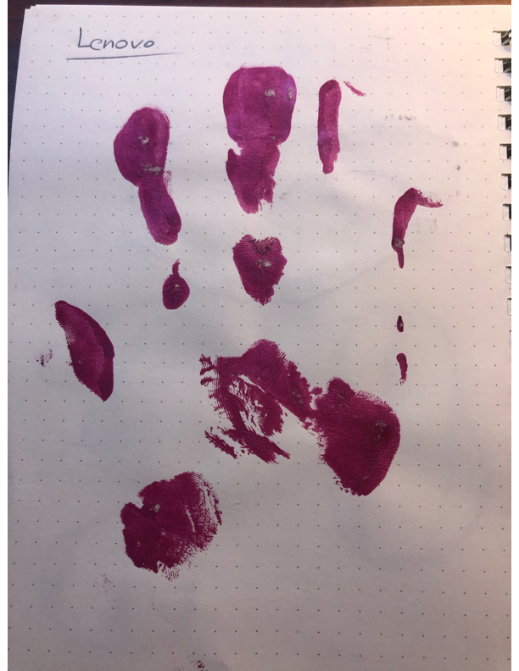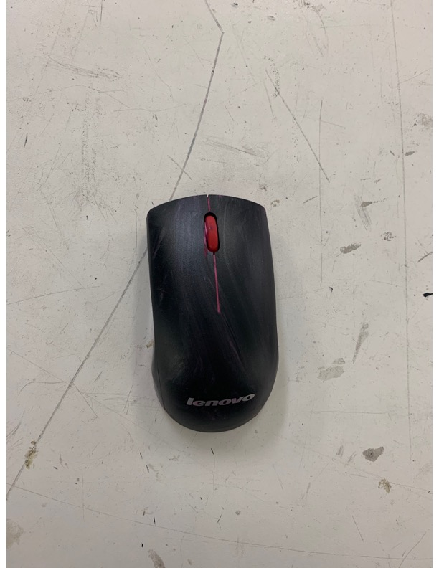

Lenovo felt the best mostly due to its taller “hump” or “bridge”. I thought it hit A3 and B3 much better than any of the other mice.

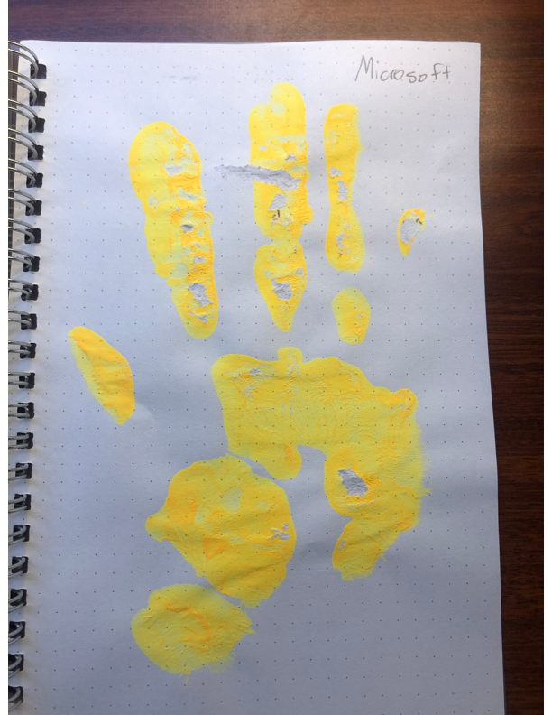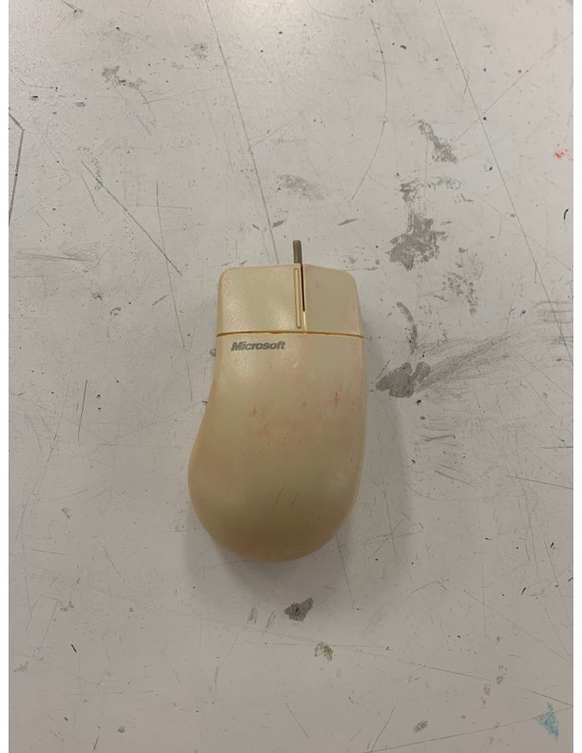

Microsoft was second due to the fact that most of my hand was supported. However, it wasn’t supported in the best way. The design was flat and long and forced my hand in an uncomfortable position. I really hated how there was nowhere to put my pinky. You can see there was basically 0 support in D1, D2, and D3.

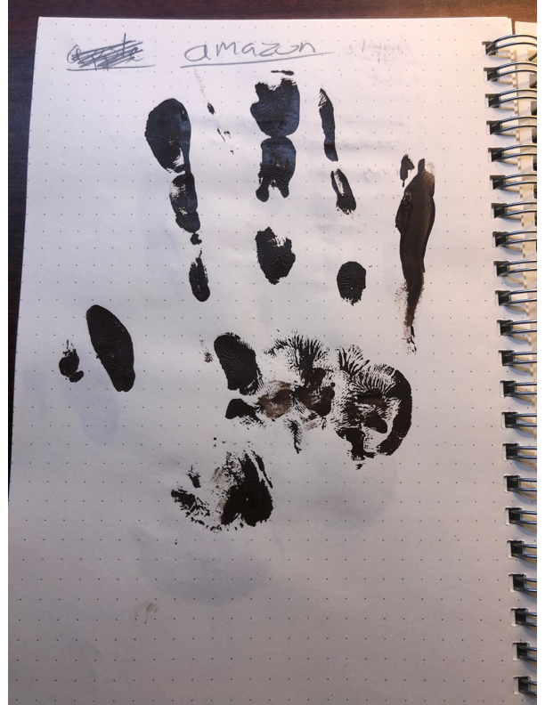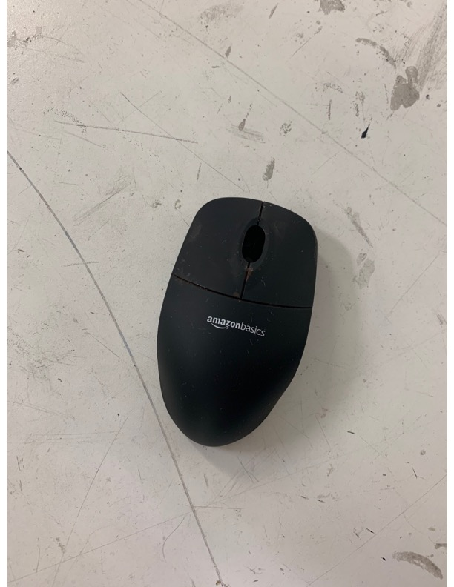

Amazon was way to small. There was barely contact in F2, F3, and F4. I also felt like it hit A3, B3, and C3, weird. My hand just did not feel supported.

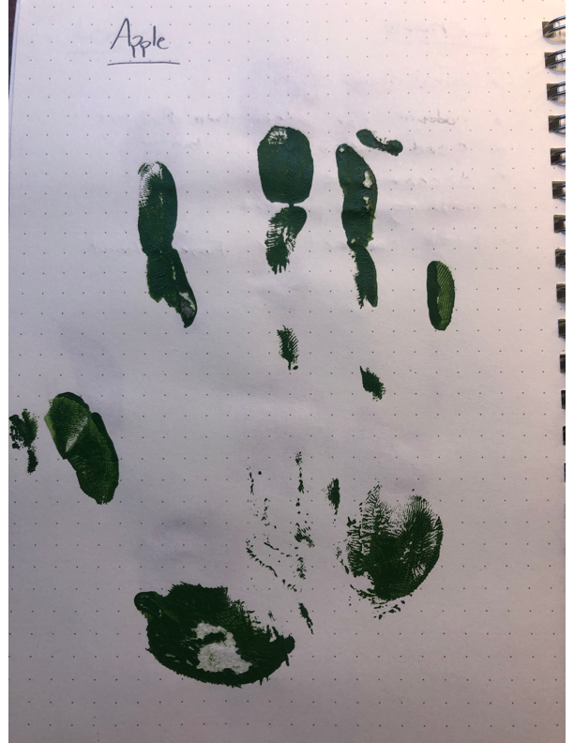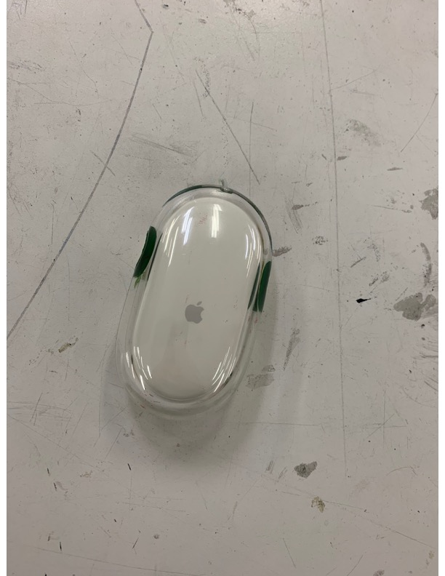

Apple was by far the worst. Little to no contact in A2, B2, C2, A3, B3, C3, D3, F1, and F2. It was very flat. It was overall an uncomfortable mouse.