Regulation and Player Odds: A Case Study of Offshore iGaming (GemBet)
Final Project Report

1. Introduction
This project investigates whether gambling regulation meaningfully affects player protection and disclosed fairness, using GemBet, an offshore sportsbook and casino operator, as a central case study. The central question: do players in tightly regulated markets such as the UK and US receive materially stronger protections and fairer disclosed terms than players on offshore platforms licensed in low-oversight jurisdictions, and if so, how large is that gap in practice?

2. Thesis
In jurisdictions like the UK (UK Gambling Commission) and the US (state-level gaming boards), operators are legally required to disclose minimum RTP (Return to Player) figures, submit games for independent testing, and maintain named dispute-resolution channels. Operators licensed in low-barrier offshore jurisdictions such as Anjouan or Curacao face little to no equivalent requirement. This project treats that difference as structural rather than incidental, and tests it empirically across seven real operators.

3. Methodology
Seven betting/casino operators were selected -- three regulated (Bet365, DraftKings, William Hill) and four offshore (GemBet, Stake, Rollbit, BC.Game). For each operator, public information was manually collected from official site footers/terms pages and cross-checked where possible against third-party sources (e.g. Slot Tracker, regulator public registers, industry news). Data collected per operator included:
- Licensing jurisdiction and regulating body
- License number(s)
- Whether RTP (Return to Player) is publicly disclosed
- Whether an independent audit or fairness certification is used
- Whether a named, external dispute-resolution mechanism exists
- Target markets and payment processing structure
From this dataset, a simple regulatory strength score (0-3) was calculated in Python for each operator, based on three equally-weighted binary/partial checks: RTP disclosure (1 point), independent audit (1 point, 0.5 for partial/crypto-based fairness systems), and a named dispute mechanism (1 point). Full scoring logic is included in the accompanying analyze.py script.

4. Results
Operator | Category | RTP Disclosed | Independent Audit | Dispute Mechanism | Total Score (/3)
Bet365 | Regulated | 1 | 1.0 | 1 | 3.0
DraftKings | Regulated | 0 | 1.0 | 1 | 2.0
William Hill | Regulated | 0 | 1.0 | 1 | 2.0
Stake | Offshore | 0 | 0.5 | 1 | 1.5
Rollbit | Offshore | 0 | 0.5 | 1 | 1.5
GemBet | Offshore | 0 | 0.0 | 0 | 0.0
BC.Game | Offshore | 0 | 0.0 | 0 | 0.0

Average regulatory strength score: Regulated operators = 2.33 / 3. Offshore operators = 0.75 / 3.
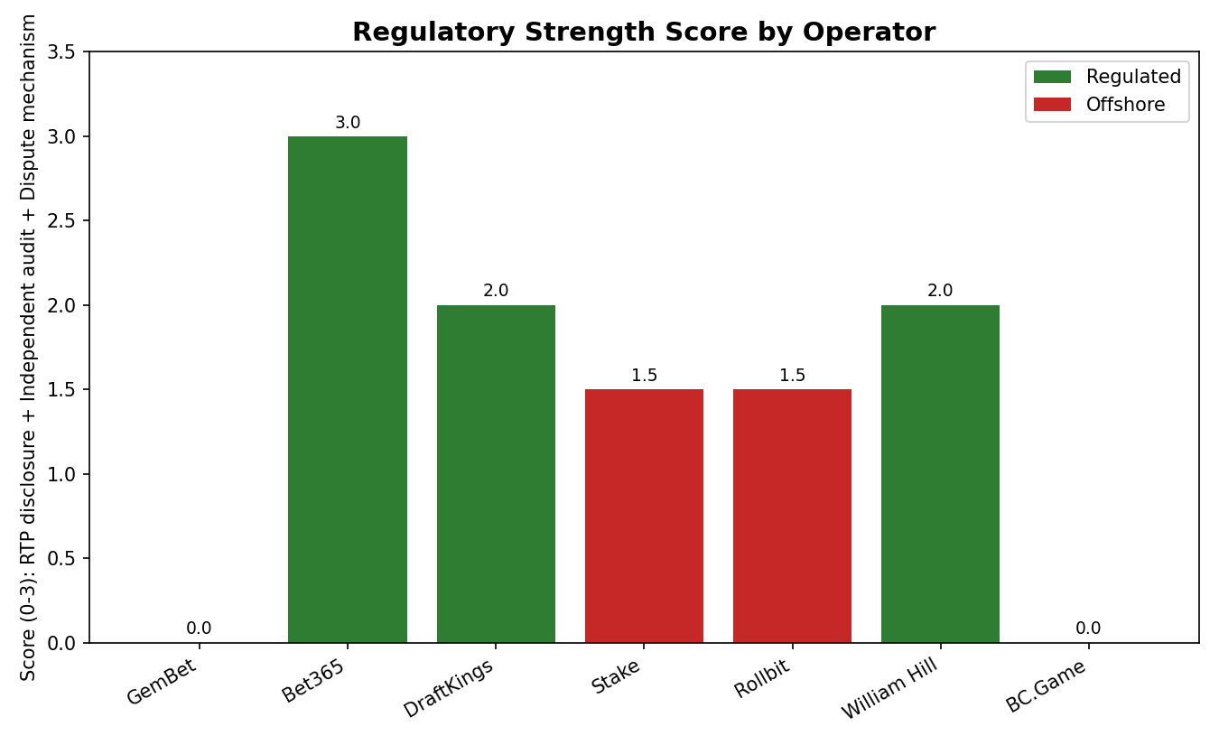

5. Case Study: GemBet
GemBet is operated through Grand Complications N.V. (Curacao), licensed by the Government of the Autonomous Island of Anjouan (License No. ALSI-122405027-FI2), with payments processed via a separate Cyprus subsidiary, Rockman Enterprises Limited. GemBet's own site footer claims it is 'authorized to offer gaming and wagering services across multiple jurisdictions worldwide,' while placing the burden of legal compliance on the player ('make sure you check your local laws'). No independently published RTP figures were found; a third-party tracker (Slot Tracker) reported community-sourced statistics from 22,501 spins but gated the actual RTP figure behind a sign-up wall. No named dispute-resolution mechanism was found. GemBet scored 0.0 out of 3 on the regulatory strength scale used in this project.

6. Case Study: BC.Game (Regulatory Failure in Practice)
BC.Game illustrates the practical consequence of weak offshore oversight. The operator lost its original Curacao license following bankruptcy proceedings tied to more than $2.5 million in unresolved player claims, including one individual claim exceeding $1 million. It subsequently obtained a license from Anjouan, which was later found to have been issued by a fictitious regulatory body, invalidating that license as well. The operating entity has changed three times (BlockDance B.V., then Small House B.V./Rabidi N.V., then Twocent Technology Limited, currently licensed in Belize), with each move landing in a jurisdiction offering less oversight than the last. This is a documented, real-world example of the 'no recourse for players' failure mode central to this project's thesis.

7. Discussion
The results support the thesis: regulated operators (UK Gambling Commission, Gibraltar Gambling Commissioner, US state gaming boards) consistently scored higher across all three measured dimensions, and in Bet365's case, achieved a perfect score by combining public RTP disclosure, named independent auditing (eCOGRA), and an external dispute body (eCOGRA ADR). Offshore operators licensed in Curacao, Anjouan, or similar jurisdictions consistently lacked at least one, and often all three, of these protections. Notably, even offshore operators that adopted partial protections (Stake and Rollbit's 'Provably Fair' cryptographic systems) did so through self-implemented technical mechanisms rather than third-party oversight, and neither publicly disclosed a formal dispute-resolution channel.
One notable exception worth highlighting: Rollbit maintains a separate UK Gambling Commission-licensed entity (Rollbit.co.uk), created specifically because the English Premier League requires proper licensing for sponsorship deals. This suggests that offshore operators can and do seek stronger regulation when a commercial partner requires it -- indicating the gap is driven by incentives and enforcement, not technical inability to comply.

8. Limitations
- The regulatory strength score is a simplified, unweighted model based on three equally-weighted binary/partial checks; a more rigorous model might weight RTP disclosure, auditing, and dispute mechanisms differently.
- The sample includes only seven operators; a larger sample would strengthen statistical confidence in the category averages.
- Data was collected manually from public-facing site content and news sources rather than pulled systematically from regulator databases, introducing some risk of human error or omission.
- RTP disclosure and payment processor jurisdiction were not fully verified for all operators (e.g. DraftKings, Stake, Rollbit, William Hill) due to geo-blocking or access limitations from Singapore.

9. Conclusion
The perceived 'better odds' associated with UK- and US-regulated betting operators are not a matter of chance, but the product of enforced transparency requirements backed by regulators with real enforcement power. Offshore operators such as GemBet and BC.Game operate with minimal comparable oversight, and in BC.Game's case, this absence of oversight has already produced documented, unresolved financial harm to players. The regulatory arbitrage this project set out to examine is not merely a business-model curiosity -- it has measurable consequences for player protection.

Appendix: Repository Contents
- GemBet_Operator_Dataset_CLEANED.xlsx -- full operator dataset with sources and notes
- analyze.py -- Python script used to calculate regulatory strength scores and generate the chart
- regulatory_strength_chart.png -- output chart comparing all seven operators
- GemBet_Project_Structure.docx -- original project proposal and structure

