Link for read me, project, videos, everything.
https://github.com/Calebthe51773/GroupOneMovieStoreAppFinal

Direct link to the FINAL VERSION of our app:
https://github.com/Calebthe51773/GroupOneMovieStoreAppFinal/tree/master/GroupOneMovieStoreAppFinal121325_1

Code Screenshot:

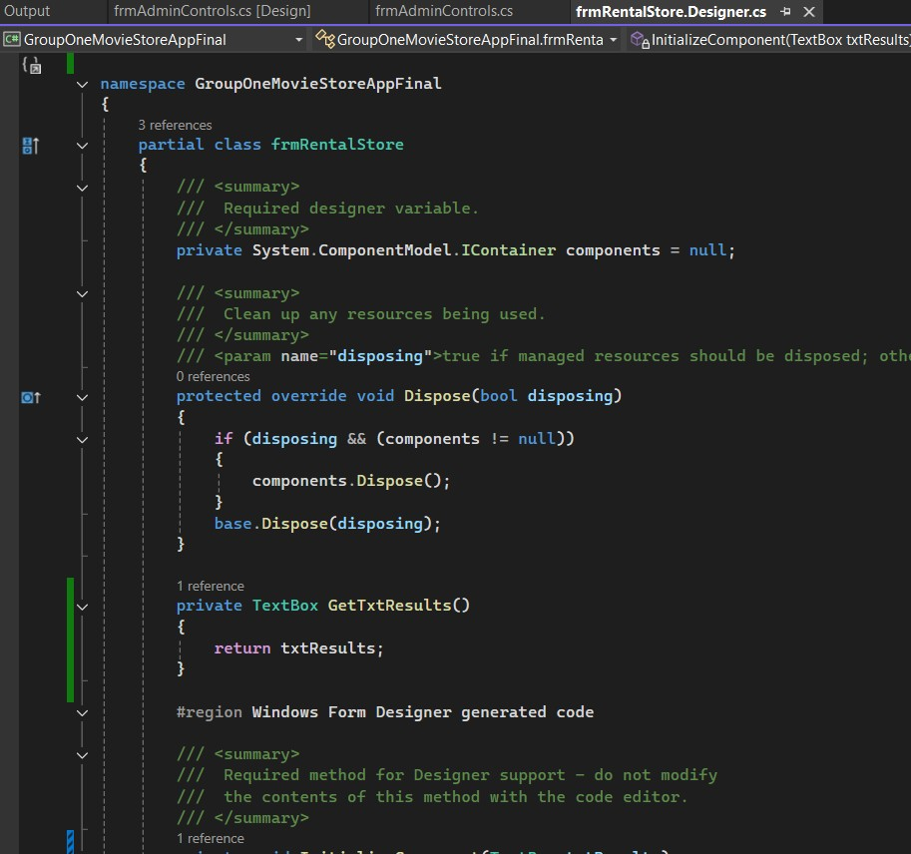
Output screenshot:

