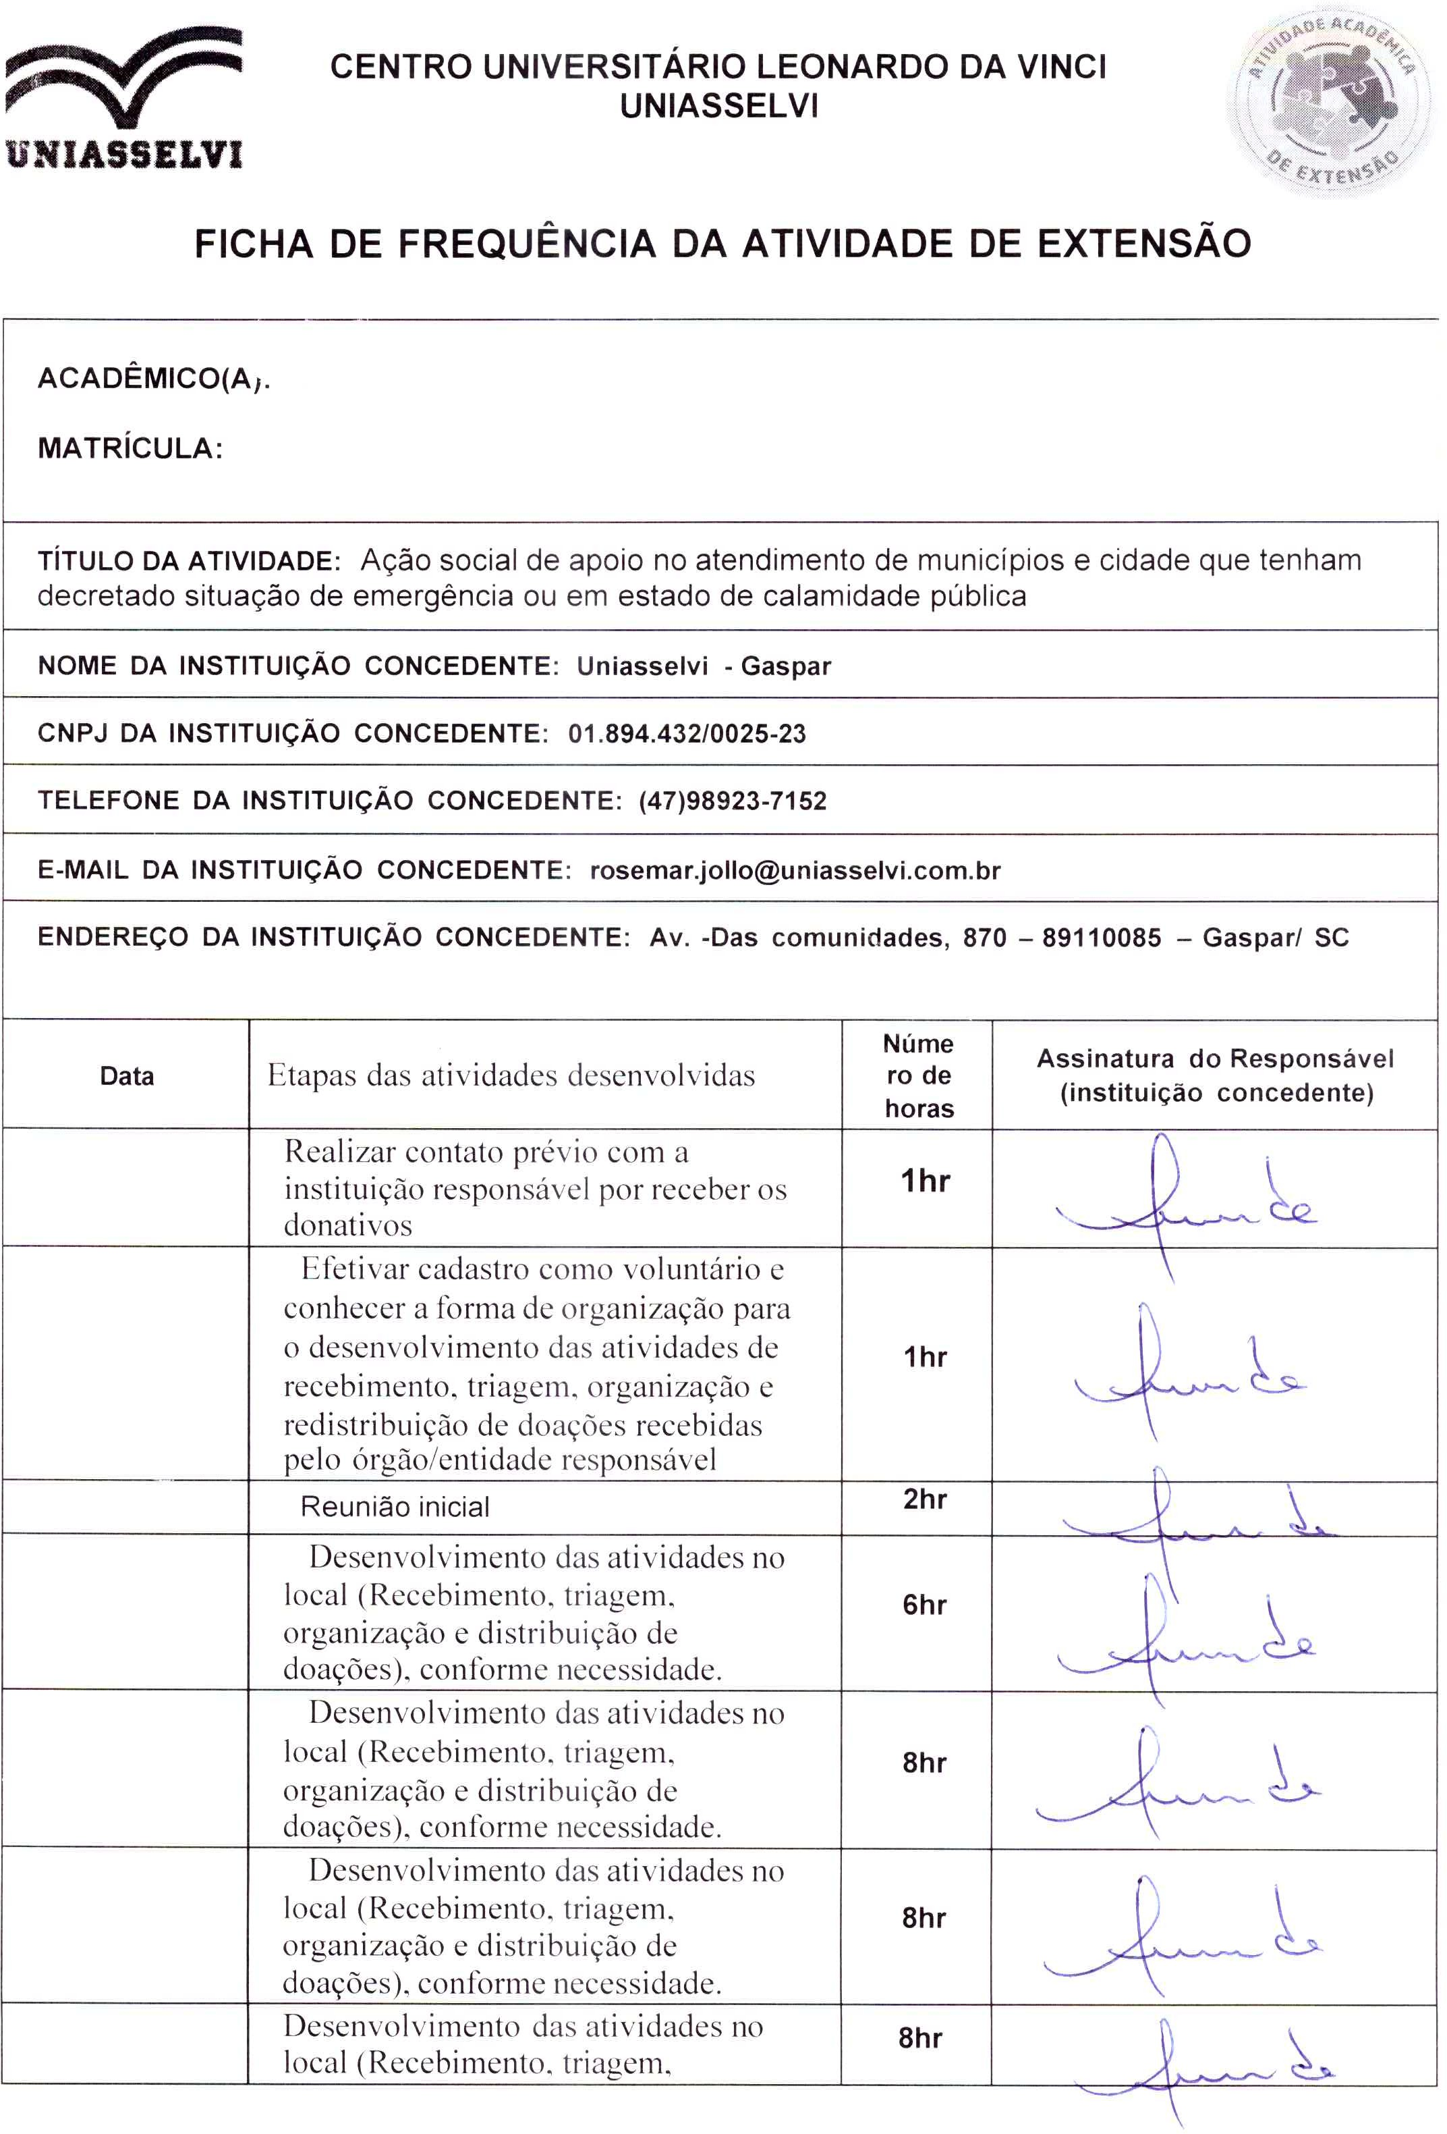
{{DATA_4}}
{{DATA_3}}
{{DATA_1}}
{{DATA_5}}
{{DATA_2}}
{{NOME_ALUNO}}
{{DATA_7}}
{{DATA_6}}
{{MATRICULA}}

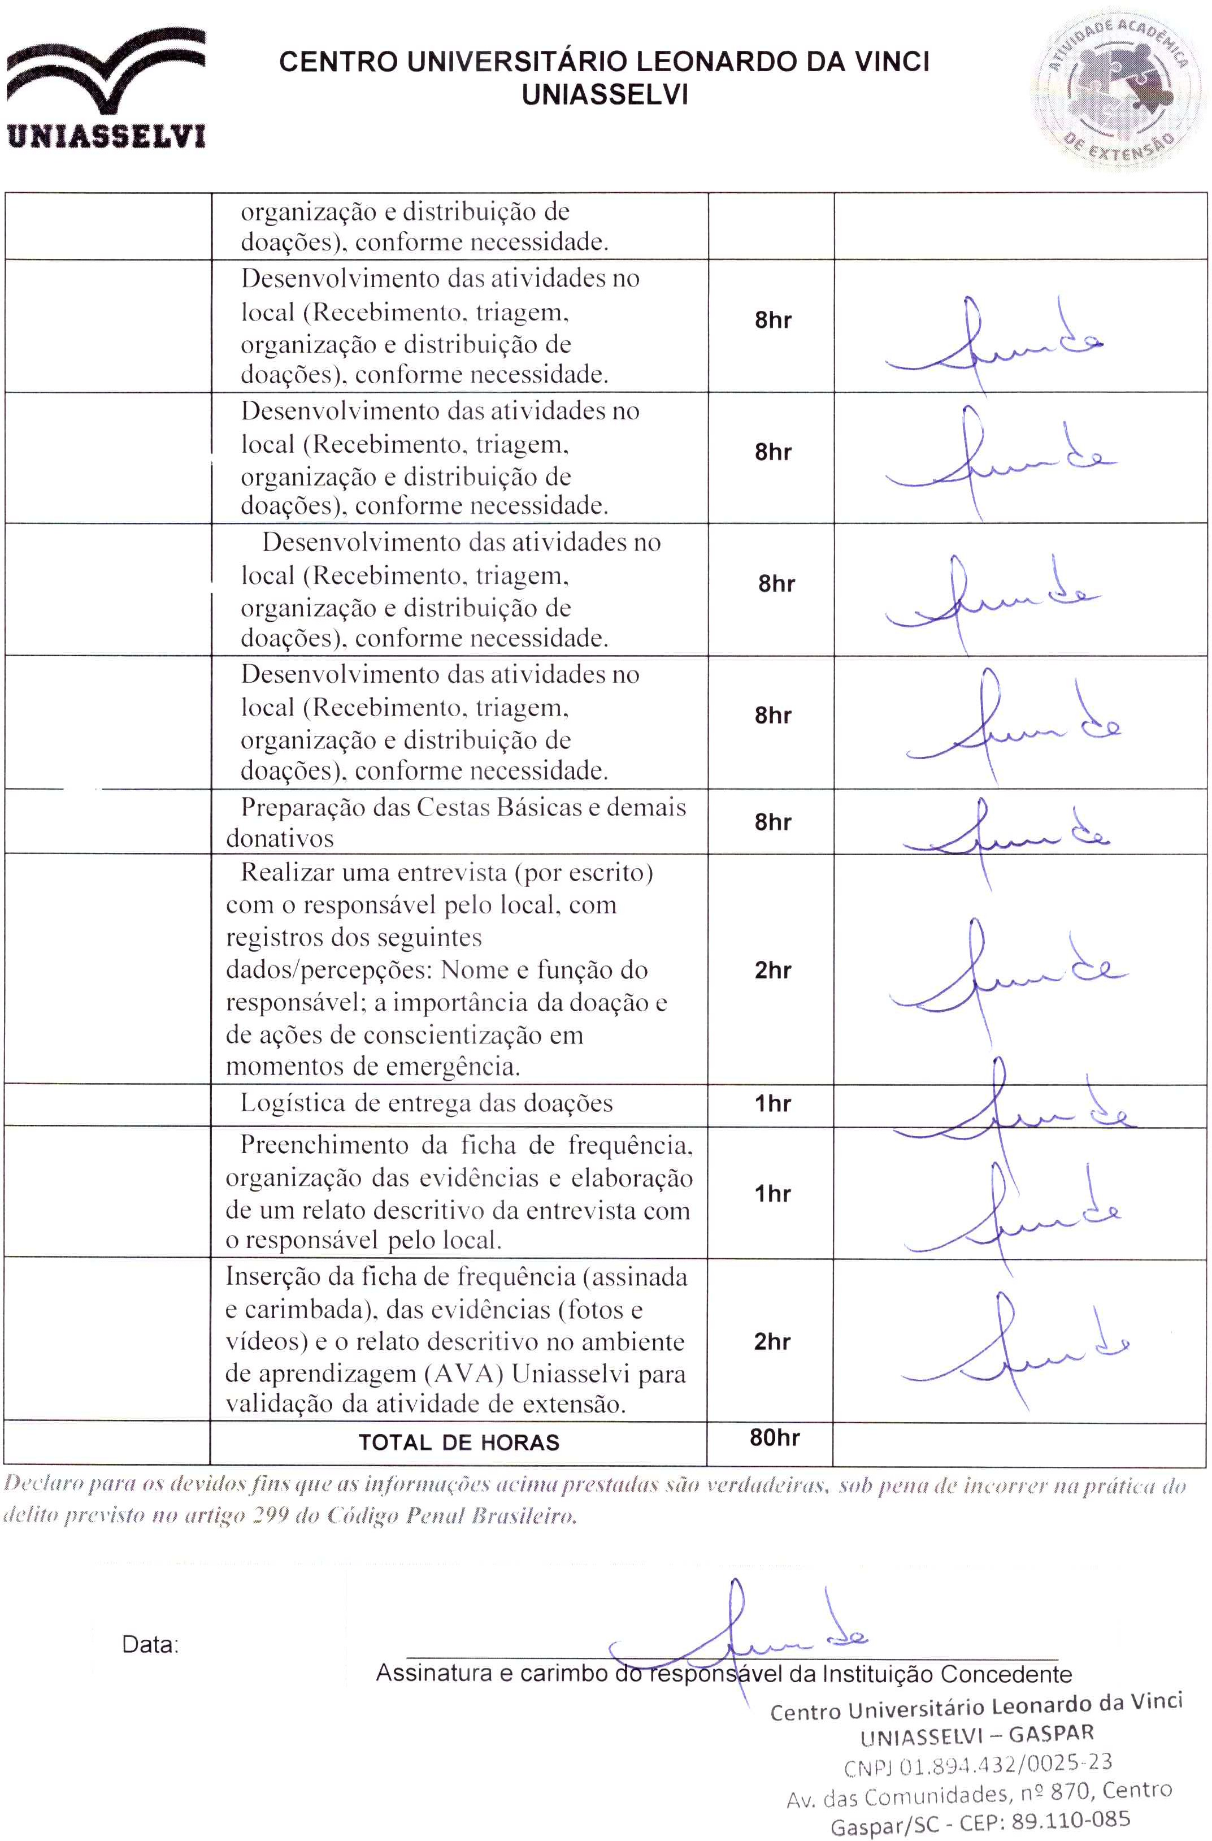
{{DATA_15}}
{{DATA_18}}
{{DATA_17}}
{{DATA_16}}
{{DATA_14}}
{{DATA_13}}
{{DATA_12}}
{{DATA_11}}
{{DATA_10}}
{{DATA_9}}
{{DATA_8}}

