# Setup on ODBC Data Source on application Client

Install the PostreSQL ODBC via psqlodbc_x86.msi (in MemorialGander\setup\)

Then start the C:\Windows\SysWOW64\odbcad32.exe (ODBC Data Source Admin)

In “System DNS” add a new Connection as shown below.

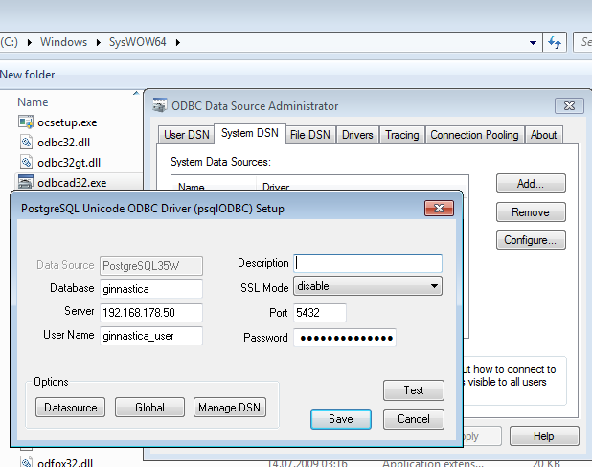

The client applicaton will the use only the data source “PostgreSQL35W” as a DB. User/IP/Port are already defined here.

# Setup on ODBC Data Source on Server

Add or edit the following line in your postgresql.conf :

**listen_addresses = '*'**

Add the following line as the first line of pg_hba.conf. It allows access to all databases for all users with an encrypted password:

# TYPE DATABASE USER CIDR-ADDRESS METHOD

**host all all 0.0.0.0/0 md5**

The restart the Postres Service in order to take the changes

## Firewall

Add a new rule to allow the port 5432

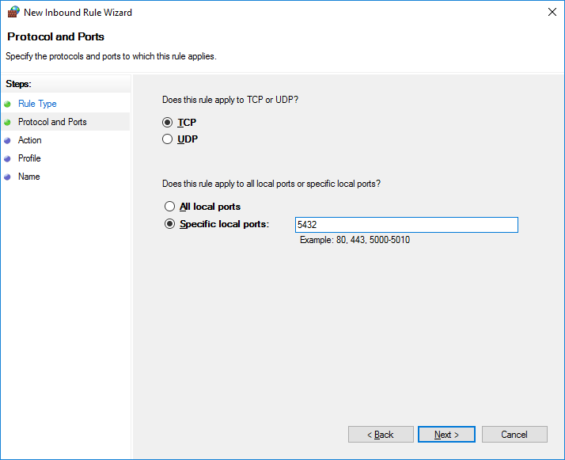

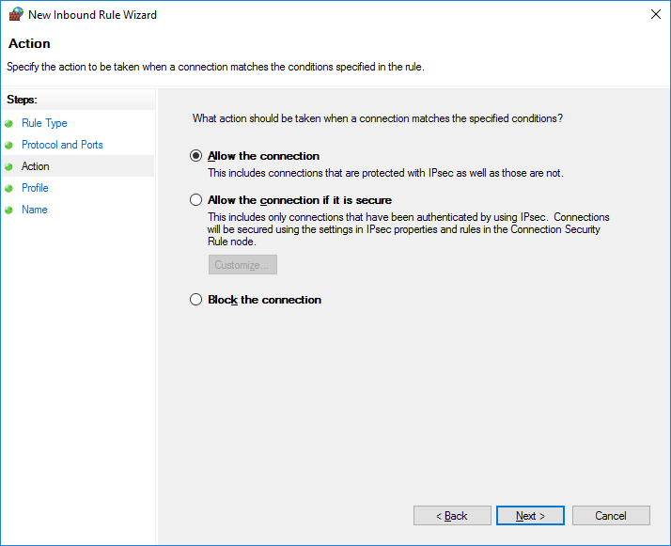

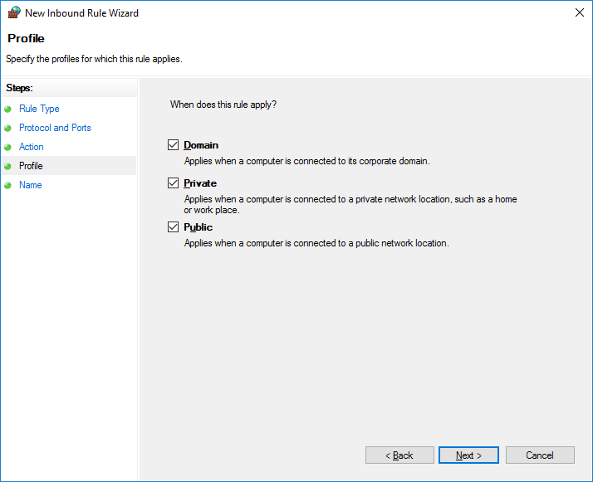

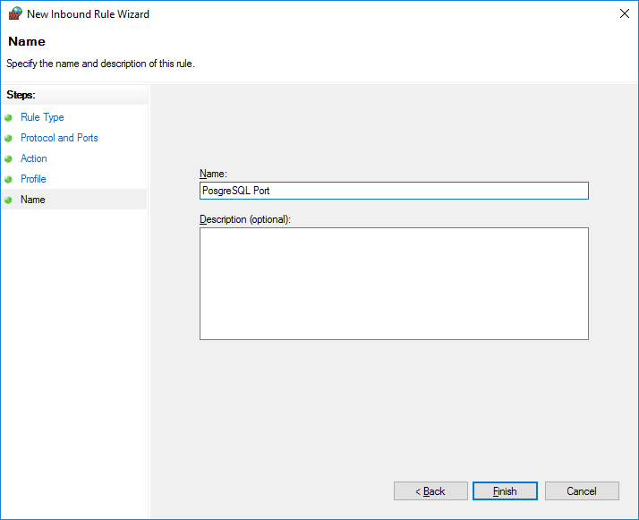

# Flags Images

The flag images are in SVG format have been taken by copying the content of a GitHub repository.

Location:

https://github.com/lipis/flag-icon-css.git

The flags are linked by the iso2 naming, for example for Switzerland it becomes ch.svg

# Database Backup

## Save

In order to save the current database open pgAdminIII and click on the ginnastica database with the right-button and select “Backup..”

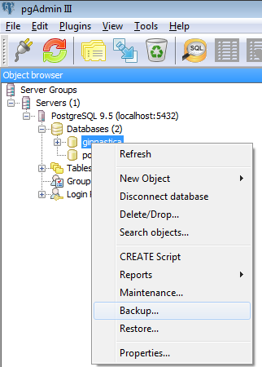

Create a new file with format “Custom”

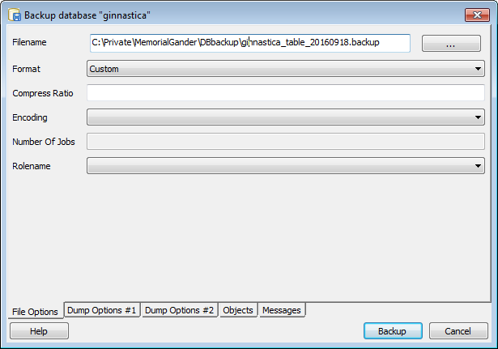

## Restore

Same as for doing a Backup, right-click on the database and select “Restore..”

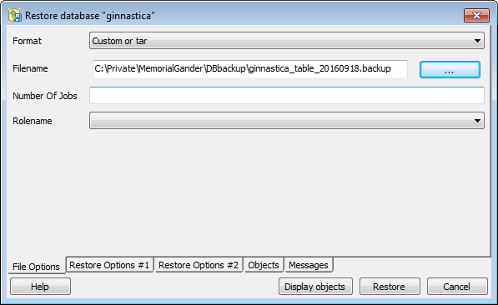

# Deploying the Application

## Windows

On windows open the Qt Terminal and go to the release folder where the executable is located.

* cd C:\Private\MemorialGander\build-MGShowRanking-Desktop_Qt_5_7_0_MinGW_32bit-Release\release

Call

* windeployqt –-quick --qmldir "..\..\MGShowRanking\src\qml ..\..\MGCommon\qml-styles" .