Setup on ODBC Data Source on application Client

Windows
Install the PostreSQL ODBC via psqlodbc_x64.msi (in MemorialGander\setup\)
In Windows 7:
- start the C:\Windows\SysWOW64\odbcad32.exe (ODBC Data Source Admin)
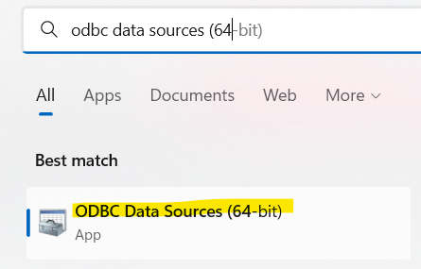
In Windows 10:
- run as administrator the application “odbc Data Sources (64 bit)”

In “System DNS” add a new Connection as shown below with the data source name:
- “PostgreSQL35W” for the R/W user “ginnastica_user” → password “marUFG$298”
- “PostgreSQL35R” for the Read Only user “ginnastica_readonly” → password “nafPL4$”
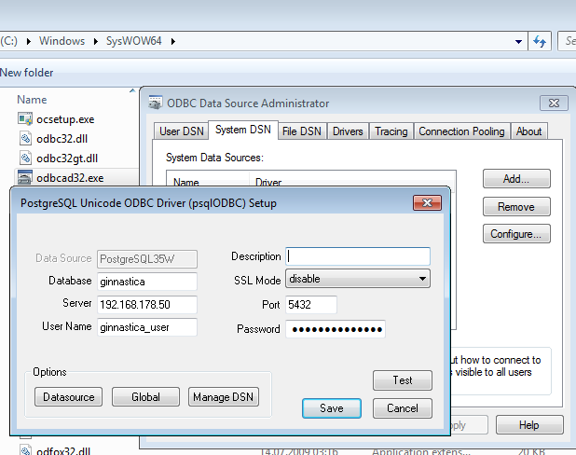

The client application will the use only the data source “PostgreSQL35W” as a DB. User/IP/Port are already defined here.

OS X

From: http://macappstore.org/psqlodbc/
- App name: psqlodbc
- App description: Official PostgreSQL ODBC driver
- App website: https://odbc.postgresql.org

Install the App
- Press Command+Space and type Terminal and press enter/return key.
- Run in Terminal app:ruby -e "$(curl -fsSL https://raw.githubusercontent.com/Homebrew/install/master/install)" < /dev/null 2> /dev/null
and press enter/return key. Wait for the command to finish.
- Run:brew install psqlodbc
Done! You can now use psqlodbc.

Setup on ODBC Data Source on Server
Add or edit the following line in your postgresql.conf :
listen_addresses = '*'
Add the following line as the first line of pg_hba.conf. It allows access to all databases for all users with an encrypted password:
# TYPE DATABASE USER CIDR-ADDRESS METHOD
host all all 0.0.0.0/0 md5
The restart the Postres Service in order to take the changes

Firewall
Add a new rule to allow the port 5432
The server requires an Inbound rule, while all clients an Outbound rule.
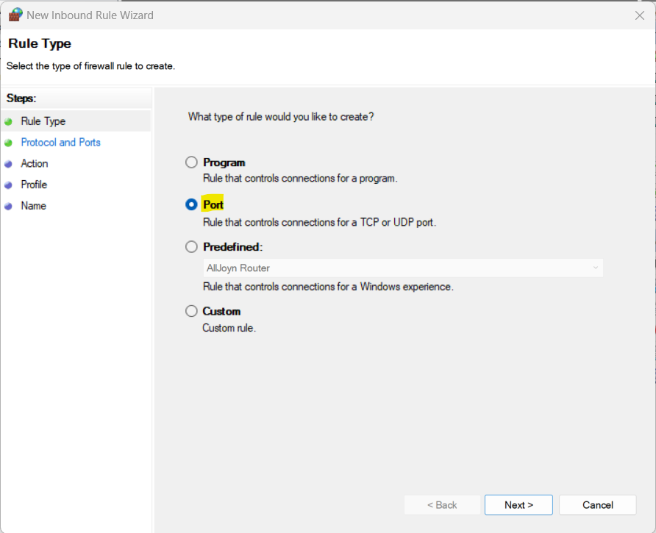
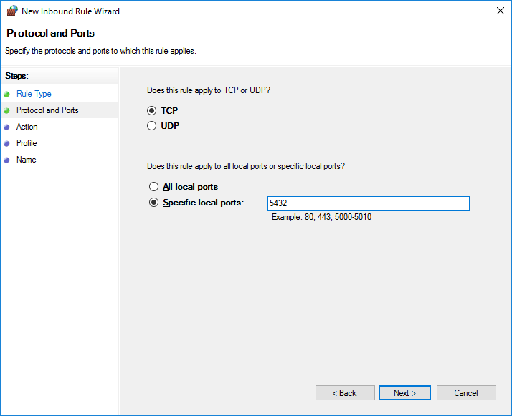
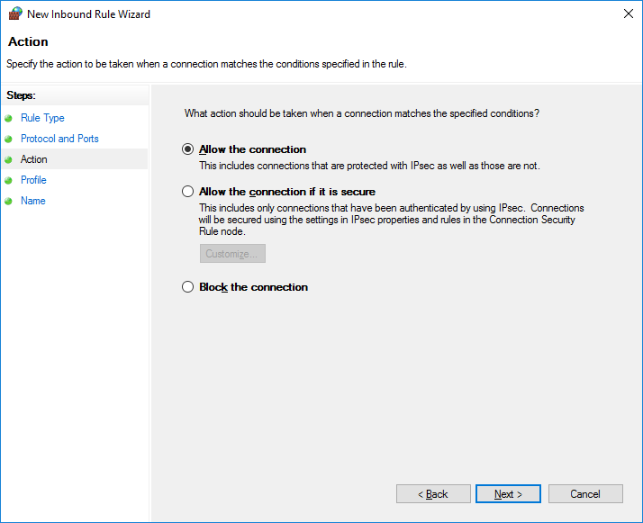
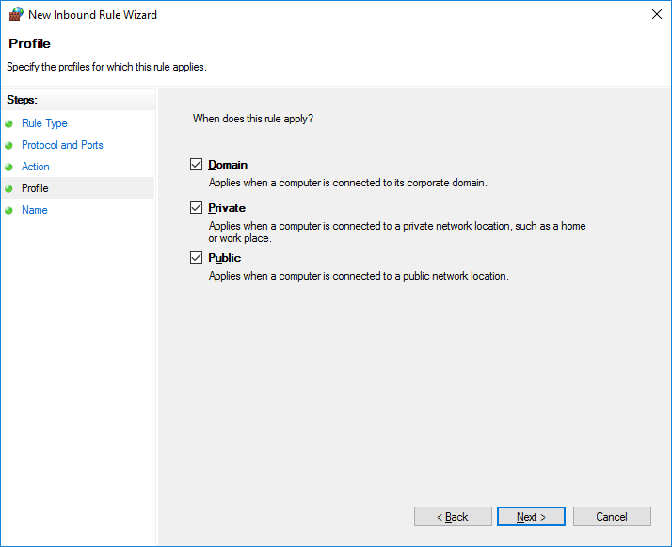

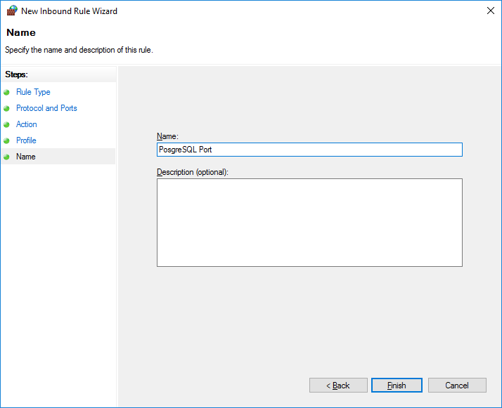

Windows App PermissionsPer lo sviluppo locale, disattivare Smart App Control da Sicurezza di Windows → Controllo app e browser → Impostazioni Smart App Control → Disattivato
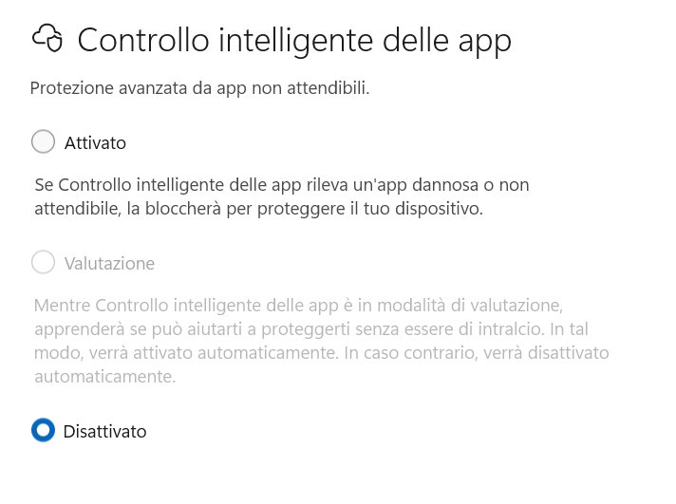

Flags Images

The flag images are in SVG format have been taken by copying the content of a GitHub repository.
Location:
https://github.com/lipis/flag-icon-css.git

The flags are linked by the iso2 naming, for example for Switzerland it becomes ch.svg

Postgres Database

Add new User
From psql console login as postgres (root) user, then:
CREATE USER ginnastica_readonly WITH ENCRYPTED PASSWORD 'blablablapasswordhere';
GRANT CONNECT ON DATABASE ginnastica TO ginnastica _readonly;
GRANT USAGE ON SCHEMA public TO ginnastica _readonly;
GRANT SELECT ON ALL SEQUENCES IN SCHEMA public TO ginnastica _readonly;
GRANT SELECT ON ALL TABLES IN SCHEMA public to ginnastica _readonly;
ALTER DEFAULT PRIVILEGES IN SCHEMA public GRANT SELECT ON TABLES TO ginnastica _readonly;

Save backup
In order to save the current database open pgAdminIII and click on the ginnastica database with the right-button and select “Backup..”
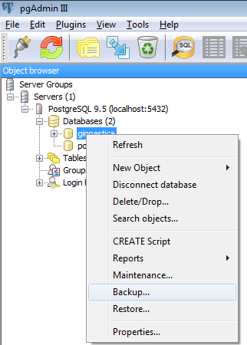
Create a new file with format “Custom”
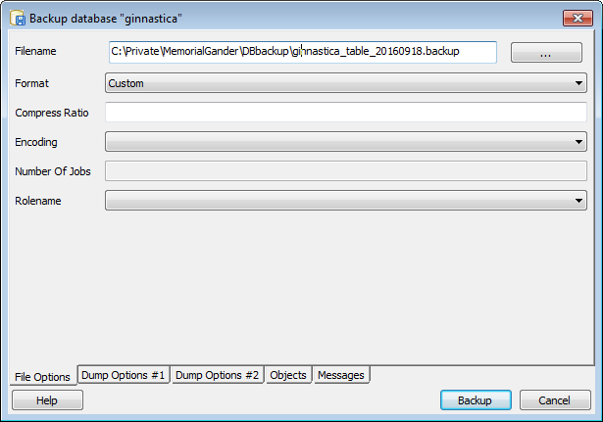

Restore backup
Same as for doing a Backup, right-click on the database and select “Restore..”
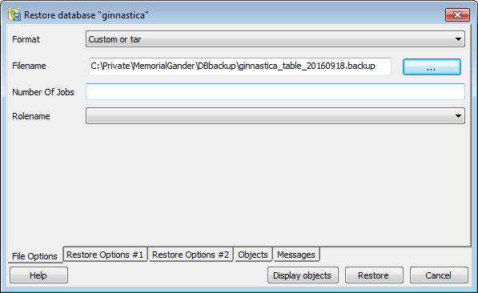

Deploying the Application

Windows
On windows open the Qt Terminal and go to the release folder where the executable is located.
- cd C:\Private\MemorialGander\build-MGShowRanking-Desktop_Qt_5_x_0_MinGW_32bit-Release\release

Call twice
windeployqt.exe --quick --compiler-runtime --qmldir "..\..\MGCommon\qml-styles" .
windeployqt.exe --quick --compiler-runtime --qmldir "..\..\MGInsertScore\src\qml" .

Update 2022 with Qt 6.4
The windeployqt
repeat the same procedure for both MGInsertScore and MGShowRanking, then copy one of them to the MGDeploy folder and remove all *.cpp/.h/.o files.
Copy both release *.exe files into the MGDeploy folder. Both applications uses the same .dll
No setup has been created, but only a deployment folder named MGDeploy containing both application (“MGInsertScore” and “MGShowRanking”). Just copy the folder on the local drive and start the corresponding *.exe manually.

When creating the final PDF the file are located on the Desktop.

Changing Pstresql views

Per modificare una view bisogna cancellarla (drop) e ricrearla. I dati non vengono persi in quanto arrivano da una tabella (questa ö solo una vista)
- Clicca la tabell
- Seleziona tab SQL
- copia il contenuto da Drop via (senza il commento “--”)
- Modica il contenuto in notepadd ++
- Incolla il nuovo contenuto nel Query Tool (rosa) ed eseguilo
- La vecchia view viene cancellata ed una nuova ricreata
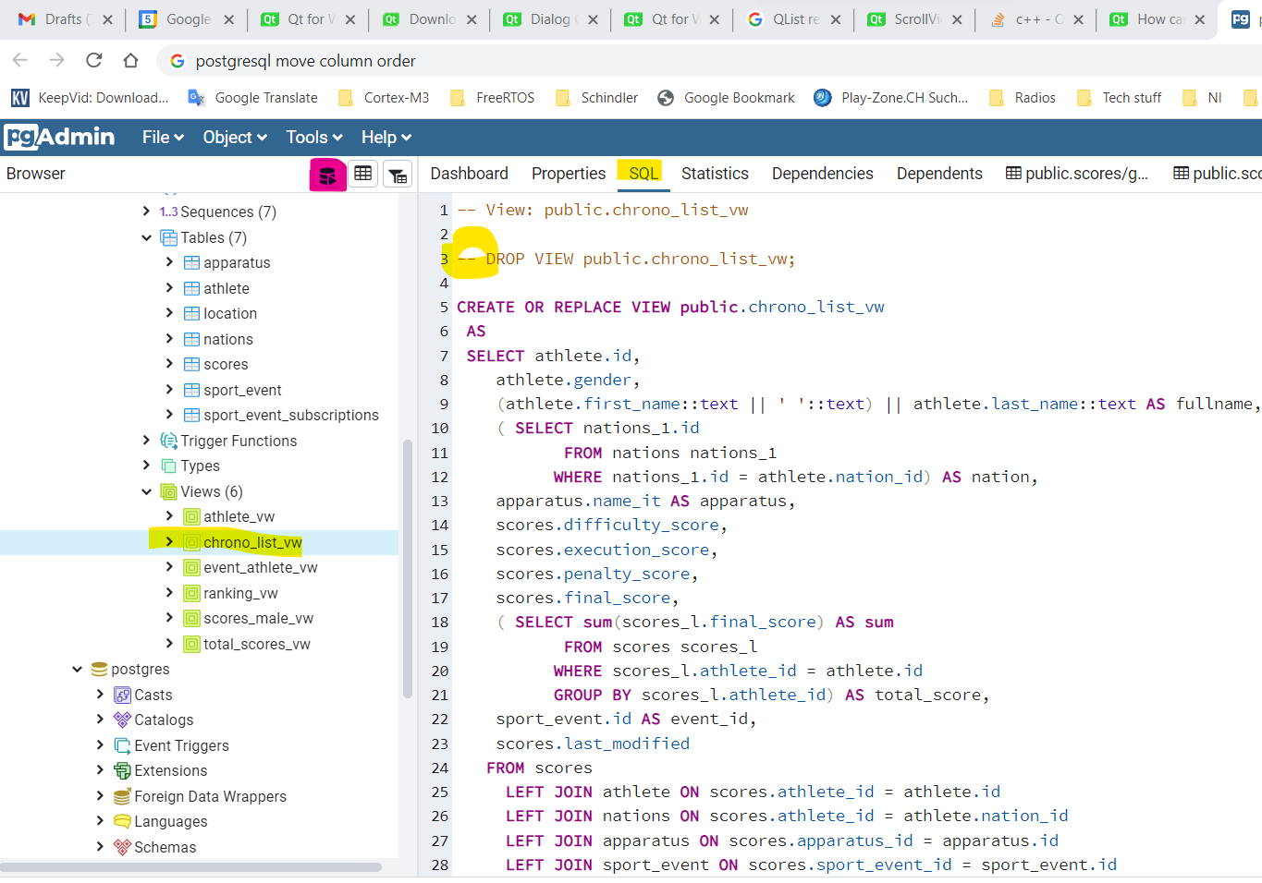

Tables to be cleaned up before starting a new competition
In case the new event hasn’t been created yet, add it manually to the “sport_event” table.
After a test or prior to the official MG competition erase the “test data”.
Table name | Action
Apparatus | None
Athlete | None
City_cup | None | Unused table -> remove it
Nations | None
Scores | Remove all scores for the current “sport_event_id”
Sport_event | None (add new event if necessary)
Sport_event_subscriptions | None

How to do it from pgAdmin
Show the table
1) select the rows to be deleted
2) click on delete (yellow)
3) save the changes (red)
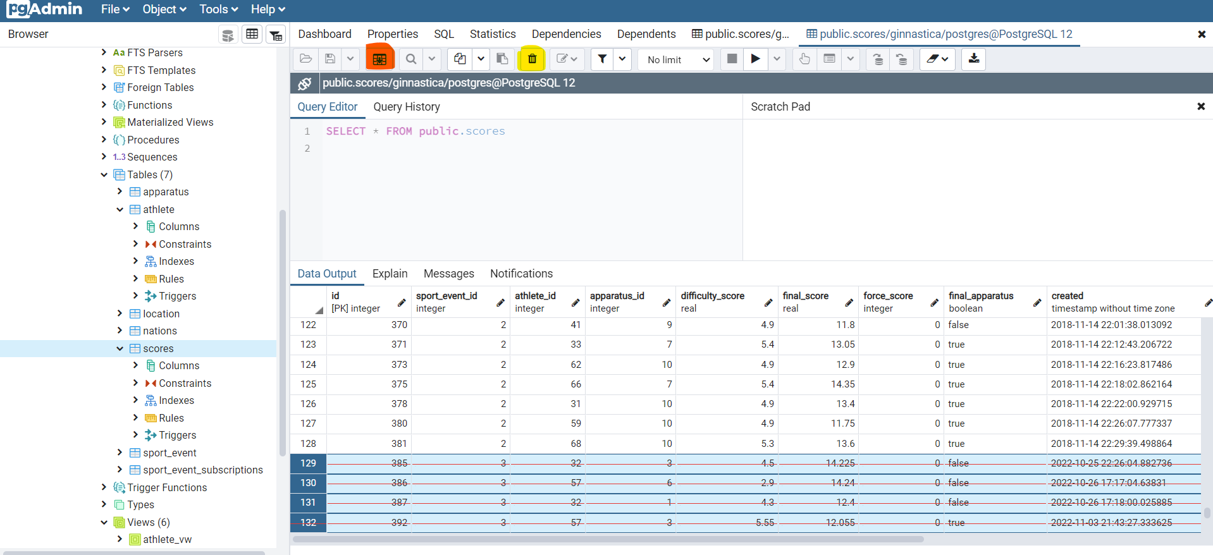

Update PostgreSQL DB
Information from https://gist.github.com/truemogician/610300dd8e86f7a8ad01f73b9da1ff1a
Here the example that updates the DB from version 12 to version 17
- Disable the old service and stop the new one during the upgrade
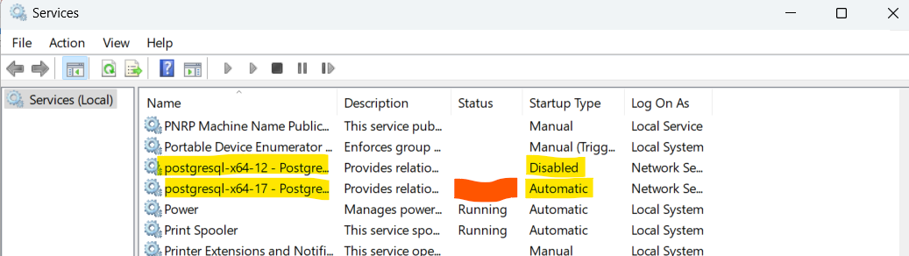

- Create a new windows local user named «postgres»New-LocalUser -Name 'postgres' -Description 'DB migration user.'
Enter «rootPG» as password
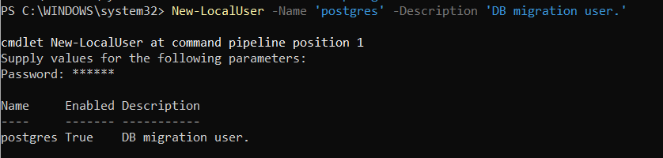
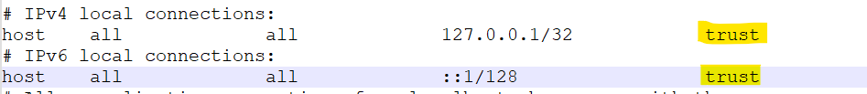
- In both «data» folders edit the pg_hba.con files and set to «trust» both IPV4 and IPV6 settings
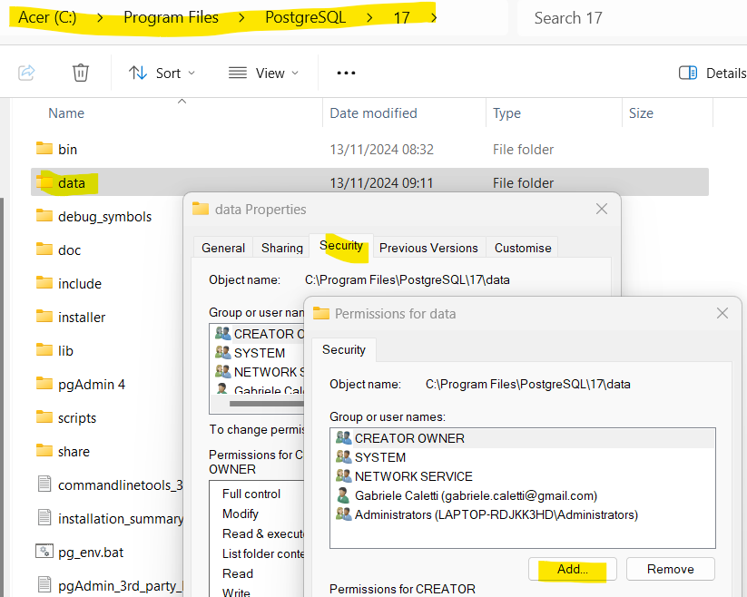
- Give full access to the «postgres» user to both data directories:
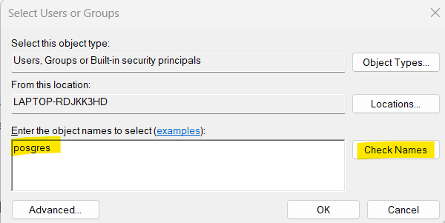

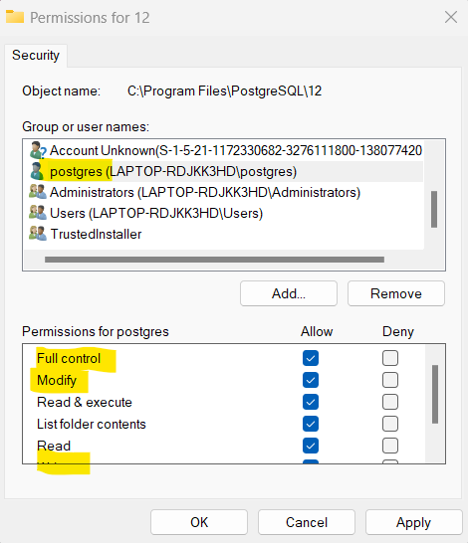
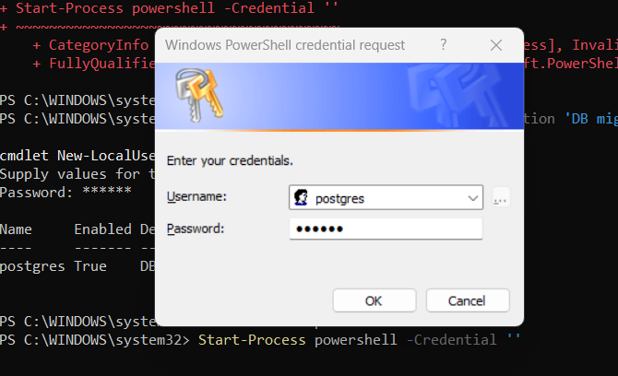
- Execute a console with postgres user:Start-Process powershell -Credential ''
This command will prompt you to enter a username and password. Once you do, a new PowerShell console will open. Make sure to close the old console, as the new one won't be able to receive input otherwise.
- In the new console:
>cd C:\Program Files\PostgreSQL\17\bin
>.\pg_upgrade.exe --old-datadir "C:\Program Files\PostgreSQL\12\data" --new-datadir "C:\Program Files\PostgreSQL\17\data" --old-bindir "C:\Program Files\PostgreSQL\12\bin" --new-bindir "C:\Program Files\PostgreSQL\17\bin"
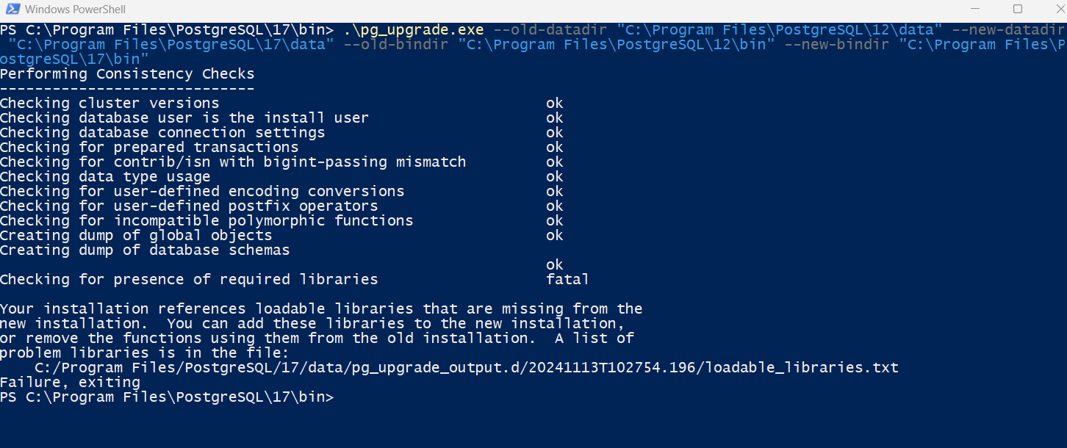
Click on «allow» when the different accesses are required
- Clean Up
To wrap up the upgrade, you'll need to revert the temporary adjustments you made. Here's a checklist:
  - Remove the file security entries for user "postgres" in both data directories.
  - Delete the Windows user "postgres."
  - Change the authentication methods of localhost back to scram-sha-256 in pg_hba.conf.
  - Start the new PostgreSQL service (or the old one if needed). With these steps, you'll have successfully upgraded PostgreSQL on Windows while ensuring a smooth transition and cleaning up any temporary changes made during the process.
- In case pgAdmin gives error at startup, try to start it as administrator

