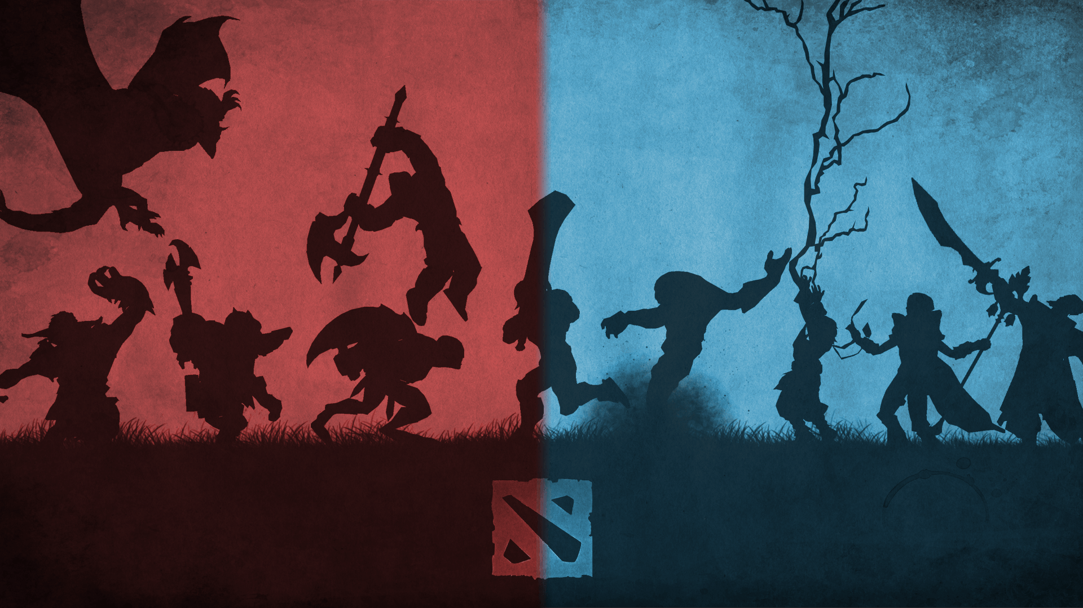

The problem i see with dota’s community is not the community themselves but the developers. They are good developers and developed a fun game. But it’s not fun to be on a team in this game. They don’t experiment with the character design enough. The purpose of the game is to be on a team till victory. They design everything to make you feel like you’re alone and on your own team. It’s an awful lot.

If you like yelling at people or insulting people. Dota is not the right game for you. That behavior just makes the work worse for people that sit on your team. If you’re lina or your storm spirit is yelling at you to buy wards. Then they don’t know the game. Wards are free right now, and I am glad because a responsible player buys wards no matter what position you’re playing. Another thing is it’s not even responsible to buy wards all the time in dota.

I only know what i felt when i played a game that actually had good art. The art was so good that i realize their was a pattern when i forgot things. And when i found it difficult to solve the puzzles. Additionally when you play the game backwards it’s completely foreign and you’re nervous to solve the puzzle again.

Games tell the news to much or try to get you interested in something. I like that they try to get you interested in something but take the pill pusher dr. mario. It’s designed to tell you that pills just fill up in your gut and eventually kill you. And the game is designed to make you think something good happens when you take pills together but no medical professional understands that the game tells you that you can’t take pills at the same time. you have to take them in a certain order. and i have no idea what this means for people that rebel against games.

There are five pieces to this game. Fill up your gut. empty your gut. get sick. get addicted. or just solve your problems. The medicine doesn’t have a side effect in the game. the game is made to make pills look cool. because you’re excited to match the different colors together.

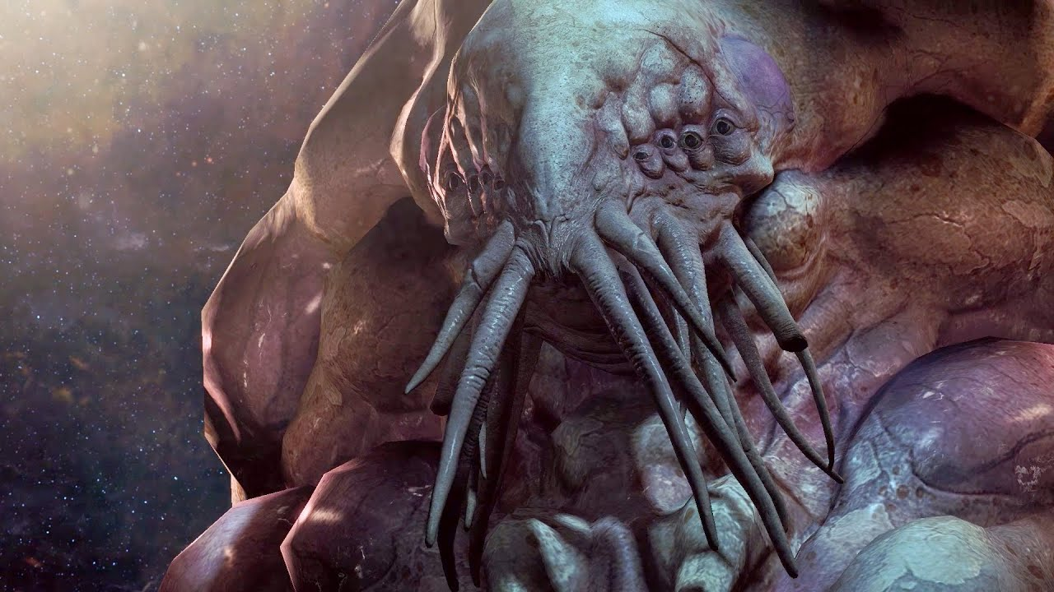

Doctors are designed wrong. They are designed to look powerful and professional but they are doing the one thing that dota does wrong.

It’s expensive and time consuming to do this but Dota and doctors need to change their art every year or even every month. im not sure because im not a professional. And when i say art i mean their entire get up. you can’t wear the same thing all the time. That’s what i learned from this new game that i play. It’s kind of like overcooked. Overcooked make you into a perfect team from what people tell me. I just haven’t played it myself because I am not on a team. I watched other people play the game, professionally.

This game requires timing and you learn from it. I don’t know why people don’t learn from the timing in dota. It’s even hard to make money in dota. Everything is timing in these games. In doctor mario positioning is crucial and you’re timing is not crucial. But in overcooked and dota positioning of your hero, timing it so you’re in position is crucial. Because you have to start over and everything or die which you’re character just sets the other characters behind.

We need to have better system in dota also. Everything is centered around killing. When most of my suggestions are centered around making it more enjoyable experience.

When i say happy, i mean feeling pleased to do the right thing. It’s not always good to kill someone in this game. It;s not always good to stay alive in this game.

Over cook forces you to make the right sacrifices in the game. Some times your character falls in the river, sometimes your character gets ran over. In real cooking it’s the same way. You might not get ran over but yo do get burned and cut. You end up wasting food sometimes. you even burn the food sometimes. You even burn yourself while cleaning out the oven.

Going back to doctor mario, my doctor treated me for the wrong ailment. I have burned skin from putting my face near a big oven at work because that was required to clean it. You can’t clean it adequately unless you put you face close.

Doctors need to learn when to predict when something goes wrong. But we’re humans so some doctors will still take advantage of people by accident and on purpose.

Doctors need to learn to wear other colors or an offset of their color. A good example of this is the Starcraft and dota interaction. Dota is designed so badly that when overwatch came out and starcraft received an influx of dota players. those games failed because dota players don’t like helpers at all.

I’m serious games need to reward for doing the right thing. A call of duty player shoots people on the floor because hes afraid they have a gun. The military doesn’t have people in buildings on the ground. People don’t think that way. I don’t know if the military punishes soldiers for shooting people on the floor. I don’t even know if cops really make people hold up their hands.

That brings up another issue. Television is designed to perfectly to cause problems. It cause so many problems in society. It makes you crave the wrong things in life. The only good show is avatar the last airbender, full metal alchemist and my little pony friendship is magic.

I Honestly think the nurse who draws blood should wear white and everyone else wear something else. Because cooks are respected and wear white and have to keep their clothes clean during the entire shift. They have to run around alot also. That’s what i thought of when i saw overcooked and doctor mario. Doctor mario the doctor gives you a bunch of capsules but nothing happens to him. In overcooked you make a mistake and either the cook your reenacting dies or someone else dies. or you run out of time. or you catch the entire kitchen on fire.

Dentists and surgeons are different. They have to get messy. They have to be precise or they could give you an infection.

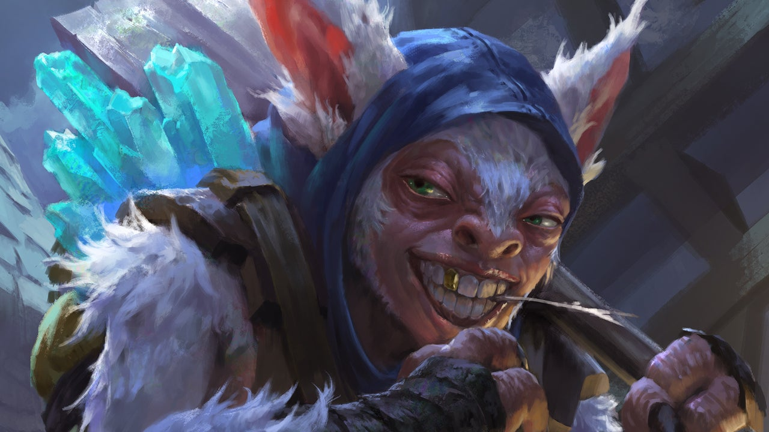

But we’re talking about dota here not the medical profession. And the biggest problem with dota is with heroes like meepo and blood seeker. Meepo is the one character that has so many people you realize hes designed wrong. You’re main meepo is the most powerful and can be killed if the other meepos die. When really, they should all be created equal. The ability designs are wrong. They are a team but they are squishy. Another problem is that they die alot after a certain level.

Blood seekers problem is thirst. It needs to be turned into an ultimate that gives all your allies boosts in speed and vision of the enemy. Or just give blood seeker vision of the enemy and have his allies have unlimited speed.  
Neither one of these heroes are team oriented.

Bring back up meepo, even the UI is not good. It’s not created for meepo players. Starcraft’s UI is perfect for multiple playable units. You can do anything with starcraft and switching between units is easy.

Another problem with the game is that a lot of heroes feel restrained in dota. You feel like you’re walking in a flood area or you’re playing elbow deep in mud. It doesn’t help that some heroes fly to you and kill you instantly like axe or storm. The art might need to change. It’s been ten years. Stuff gets old after awhile when most of the game stays the same. I have no idea how chess still interests people.

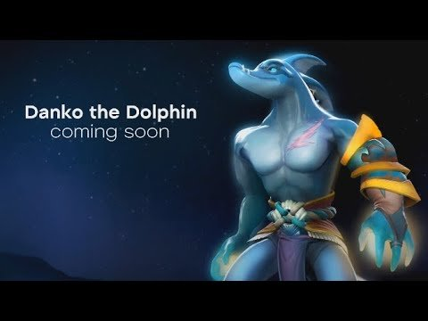Another

Another issue with the game is it doesn’t take people who don’t like music or the game’s music into consideration. Starcraft is fun whether you play it with music or not. But dota isn’t like that. Starcraft is even designed to make you imagine stuff better. You just need to do it with a person you trust. Starcraft had issues when it was first developed. That’s why i am coming out with designs for dota distant warfare and future warfare. Distant warfare is warfare on a newly settled planet. Future warfare is on a modern take on dota. I have a third name but i keeping that to my self.

But I have no idea how valve can fix this issue with Dota 2. I want them to fix the issue but they would need to release a new version with new art for models, animations, icons, sounds every year for the general public. They also need to make everyone pay a subscription.If you have a computer you can afford a cheap subscription. It’s just not fun for people who can’t afford that kind of thing. But im the rookie and the rook and just aiming at holes in the game. Bugs that i notice the game has. I just need to learn to redesign my articles so i get a bulls eye every time.

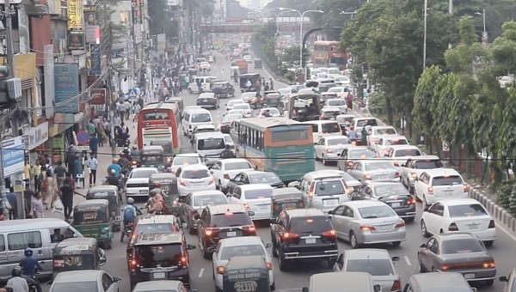

See the game above is what brought this to my attention. Every month you can buy a new car design. And the cars switch to other car designs every so often automatically for the car you have to get out of the traffic jam. I haven’t learned how to play the game backwards. Once you learn that i don’t know what will happen.

**Share this:**