Ancient Journal

Design Development Documentation

Calell A Park

November 6th 2024

**Goal:**

* To provide instruction to players who are unfamiliar or not decent at the game
* To make more heroes playable

**User:**

The user is one that covers the unique position of learning the game

**Mascot**

**Aghnims is the one explaining the game to new players.**

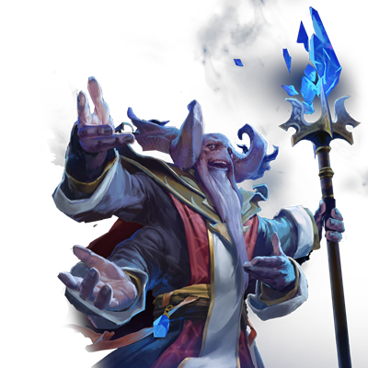

**Difficulty Level**

There are five different levels

Beginner Player

Novice Player

StarCraft Veteran Player

League Veteran Player

Casual Veteran Player

**Instruction Level**

The Outposts give advice if you hover over them..

**How to access the website**

Just DoubleClick on “main” and it should start.