|  |
| --- |
| **EECS 2070 02 Digital Design Labs 2020**  **Lab 1** |
| **學號：107062181 姓名：Calerb Louis Jean** |

1. 實作過程

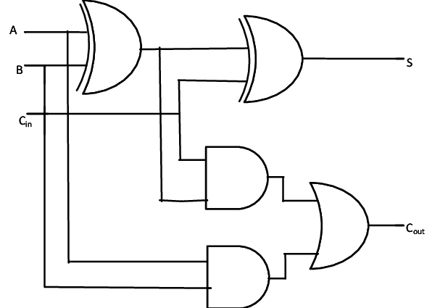

1. Full Adder

In this block diagram, A=a, B=b, Cin=c, S=d, Cout = e.

From this homework full adder regulations, we have to use the sub as a signal to toggle the value of b.

So, according to the circuit diagram, I used 1 xor gate and 2 and gates. By using the behavioral modeling, I, then use a switch case of the value of the sub to determine when to toggle the value of b.

Once the value of d and e has been assigned correctly, the output and input value, is then connected to the test bench to check whether the implementation is correct by simulating the 2n possible output.

**RESUL SNAPSHOT**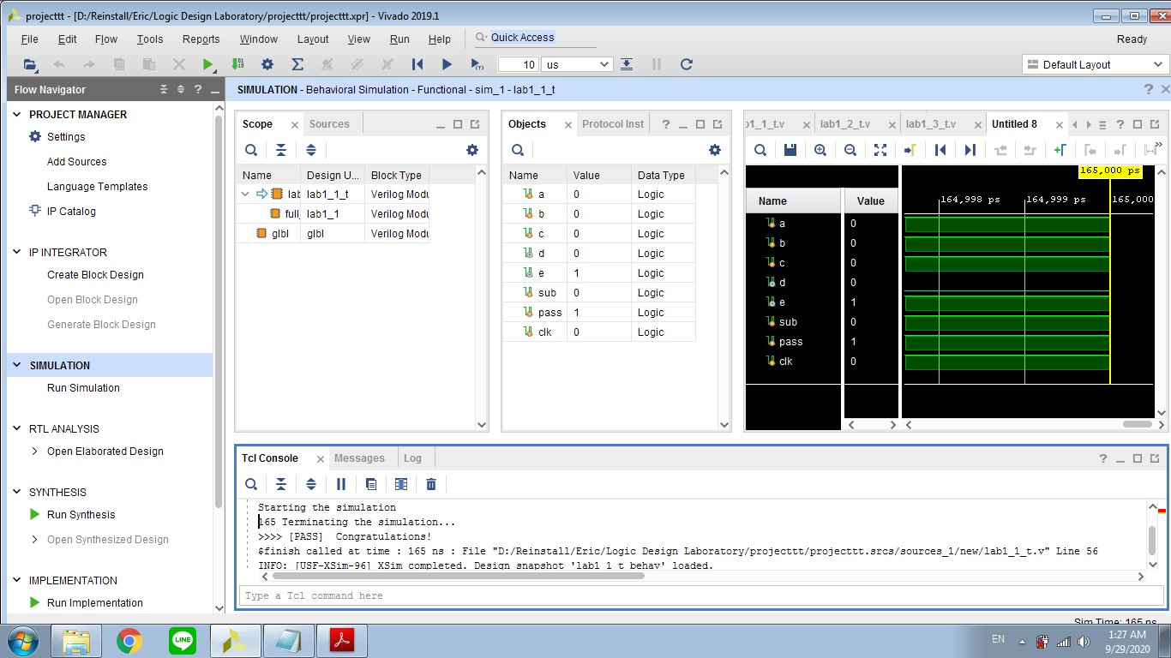

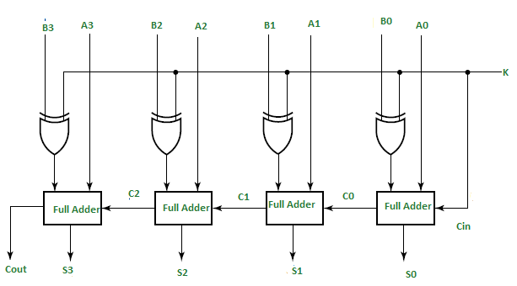

1. 4-bit Adder using 4 1-bit full Adder

In this block diagram Ai = ai, Bi = bi, K =Sub Si = di,. My implementation process is simple, since I have previously implemented a 1-bit full adder, I just make an interconnection between my previous full adder and the 4 bit –adder by importing the filename of the previous full adder followed by the module name of each different adder. I also use a 4 xor gates which helps determine whether to toggle b or not.

lab1_1 full_adder1(.e(e[0]),.d(d[0]),.a(a[0]),.b(b[0]),.c(sub),.sub(sub));

lab1_1 full_adder2(.e(e[1]),.d(d[1]),.a(a[1]),.b(b[1]),.c(e[0]),.sub(sub));

lab1_1 full_adder3(.e(e[2]),.d(d[2]),.a(a[2]),.b(b[2]),.c(e[1]),.sub(sub));

lab1_1 full_adder4(.e(e[3]),.d(d[3]),.a(a[3]),.b(b[3]),.c(e[2]),.sub(sub));

in this snippet of code, each value is being passed to the full adder inside brackets. The reason that sub is passed to c, is because the c value implemented which is the Cin of the previous full adder is being used to toggle the b in this implementation and this same sub become the Cout of the 4-bit adder.

**RESULT SNAPSHOT**

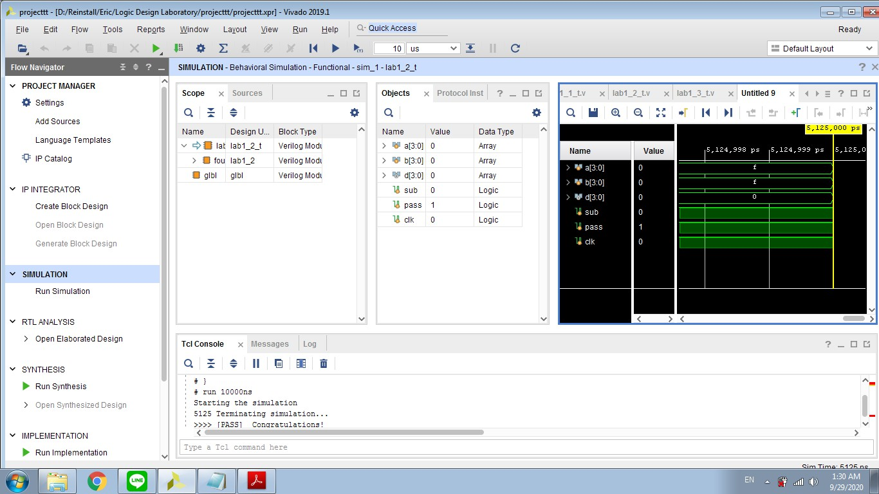

1. 4-bits ALU

I called the module of the 4-bits adder previously implemented in lab_1_2 by passing the corresponding value. I used a switch cased with the value of the aluctr to get the value of the sub and pass this value to the 4-bits adder because the sub is needed in the 4-bits adder to check whether to make addition on subtraction.

The value being return from the function call is afterward assigned to the output d according to the Aluctr conditions.

**RESULT SNAPSHOT**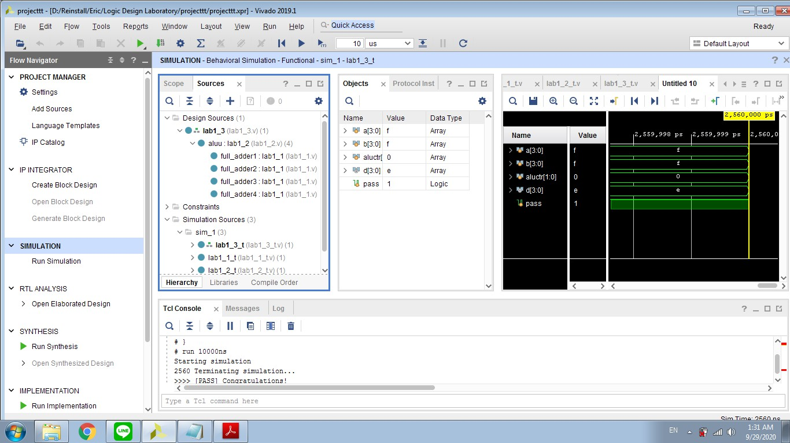

1. Full Adder

Skills of basic C programming language referring to the switch statement, using conditional operator in the if statement and function call of test and printerror.

1. 4-bit Adder using 4 1-bit full Adder

Skills of basic C programming language referring to function call of test and printerror, use of flag.

1. 4-bits ALU

Skills of basic C programming language referring to switch, function call, and ternary operation.

1. 學到的東西與遇到的困難
2. Full Adder

I was unable to use the variable declare with wire inside the always.

1. 4-bit Adder using 4 1-bit full Adder

I learned how to import and use the full adder inside the 4-bit adder.

1. 4-bits ALU

I stuck with the simulation of lab_1_2 and lab_1_3, I learned how to navigate between design and simulation module by setting them as top.

1. 想對老師或助教說的話

None!