General goals

Your goal is to implement the HTML and CSS required for the site to look exactly like the reference design.

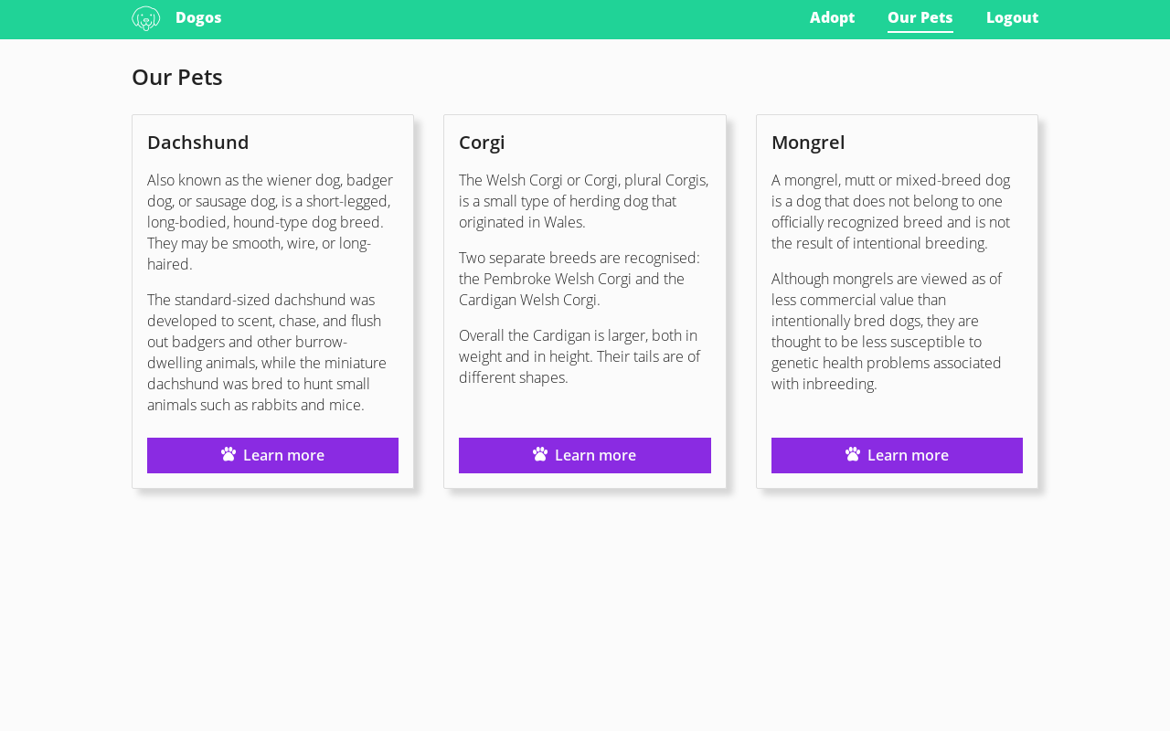Our Pets Dogos

The design is responsive, with a 3-column layout in desktop and a single-column for mobile.

There is a single breakpoint to change from 1 to 3 columns when the viewport is 768px or wider. No additional breakpoints are required.

You can see the full size reference renders with different pixel densities at different resolutions here:

* 1440 x 900: @1x normal and @2x
* 1280 x 800: @1x normal and @2x
* 480 x 960: @1x normal and @2x

The behavior of each element at different resolutions can be deduced from these images.

You do not need to support screens narrower than 480px, but your solution has to work on any screen wider than that, even if they are not listed above.

To determine the size and position of every element, you can use this image as a helper, where the background of the elements with text was replaced by a solid color.

In the index.html file, you can find some template tags (variables between { }). They are used to provide the content of your page.

Do not delete them.

The only available tags are: {navlinks}, {title}, {content1}, {content2} and {content3}.

**Delivery method**

You will have full write access to your own fork of this project at

http://interviews.magnet.cl/{your-user-name}/magnet-frontend-test.

Send us a message on GetOnBoard when you push your

last commit to the master branch and your answer is ready for review.

Pull/Merge requests are not allowed on this project to prevent your answers

from being visible by other candidates.

**Aspects to be evaluated**

Accurate layout implementation.

Accurate use of colors.

Coding style.

Repository use.

Compliance of these instructions.

**Aspects to be ignored**

Deployment to any server.

If you are faster or slower than other candidates (as long as you are within the deadline).

Animations, transitions, or any visual effects that are not apparent from the reference design.

