„CERBERUS“

JAVA Software Framework

© July. 2006 by Michael Kalkusch

Introduction

This is project aims at manipulation and visualization of DAN- Micro array data enriched by medical clinical data. The goal is to provide a tool for medical experts and micro-biologists.

Changes
1. September 2005 document was created by Michael Kalkusch.
16. January 2006 document was added to subversion.
3. July 2006 Software framework renamed to “Cerberus”
3. July 2006 Marc Streit joins the Cerberus Team.
20. July 2006 document was updated by Michael Kalkusch.
20. July 2006 document was added to subversion “Cerberus".

2. Data Management

Sort of raw data:

- *.grp Micro-Array Data file:
file size: ~ 8 MB
dimension: [38000 Genes] x [1 probe] x [ ~10 values + (15 derived statistical values) ]
format: ASCII, header, table of values
Description: One file stores one micro-array experiment containing all Genes/Proteins
- *.xls and *.csv Clinical Excel files:
file size: > 1MB
dimension: [~40 medical parameters] x [ 2000 patients]
format: EXCEL-file, Header row, table of values
Description: Each row represents one patient;
each column contains data on the patient
- *.? Pathway data file:
file size: ?
dimension: [~3000] x [ directed cyclic graph]
format: unknown
Description: Collection of Proteins, that interact with each other and thus occur co-regulated or counter-regulated in the micro-array data-sets. A pathway is a directed cyclic graph consisting of Proteins, which can be traversed in forward or backward order. One Protein may occur several times in different nodes. The edges of the graph can be tagged with additional information. For instance required or produced biochemical energy (ADP +Pi <==> ATP) or (NADP <==> NADPH). Some pathways are irreversible and thus only traverse in one direction, like “Glukose-Spalltung = Glykolyse”. Once this kind of pathway is triggered it is “executed”. Other Pathways like “Umbau von Zucker” or the Fat-Cycle can be traversed back and forth.
- *.? “Medical pathways”
file size: ?
dimension: [?] x [ directed cyclic graph]
format: unknown
Description: Like biomedical pathways describe biomedical relations between proteins also medical conditions can create such a “medical pathway”. These are well known in the field of Histology (deals with tissues) (German: Histologie, Wissenschaft von den Geweben).
- *.? Detailed knowledge on DNA:
file size: ?
dimension: ?
format: unknown, probably via database, existing web-interfaces
Description:

Software Components:

- DataStorage:
Arrays filled with INT, FLOAT, DOUBLE, STRING, BOOLEAN
- Selection:
Define region on DataStorage- Objects
Whole-Part Design Pattern (Selection,Selection2D,Selection)
- Set:
Holds a collection of Selection’s, refer to a DataStorage.
Pipe-and-Filers Design Pattern (DataStorage-Selection-Set)

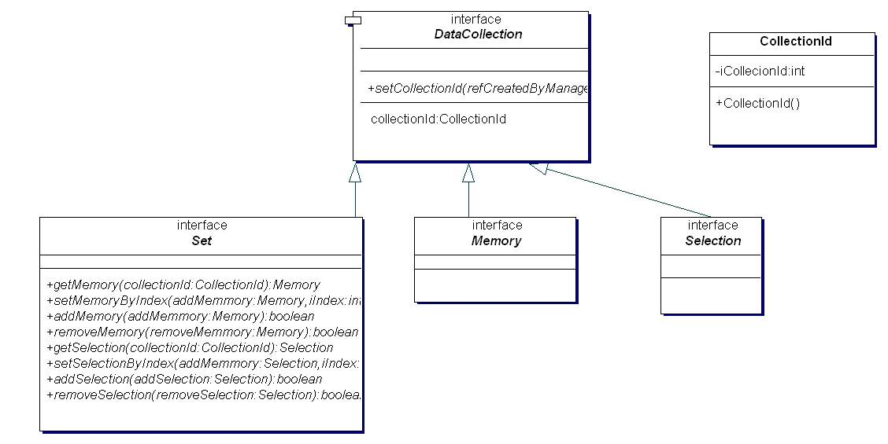
Figure 2.1: Data management components

Selection and Set can be accessed by Iterators. Design Pattern “Iterator”

Graph:

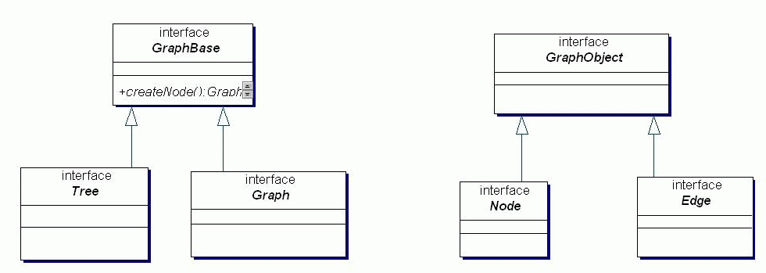
Figure 2.2: Graph UML structure

4. Model-View-Controller (MVC)
From [Buschmann1996] page 125
also [Gamma 1995] „Observer“ page 287

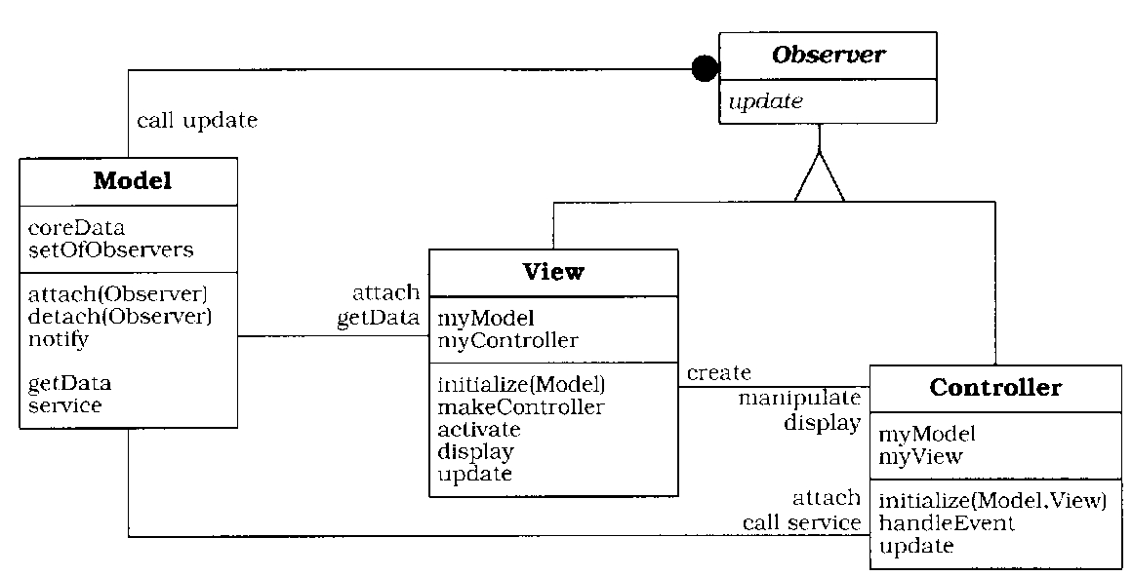
[Buschmann1996]

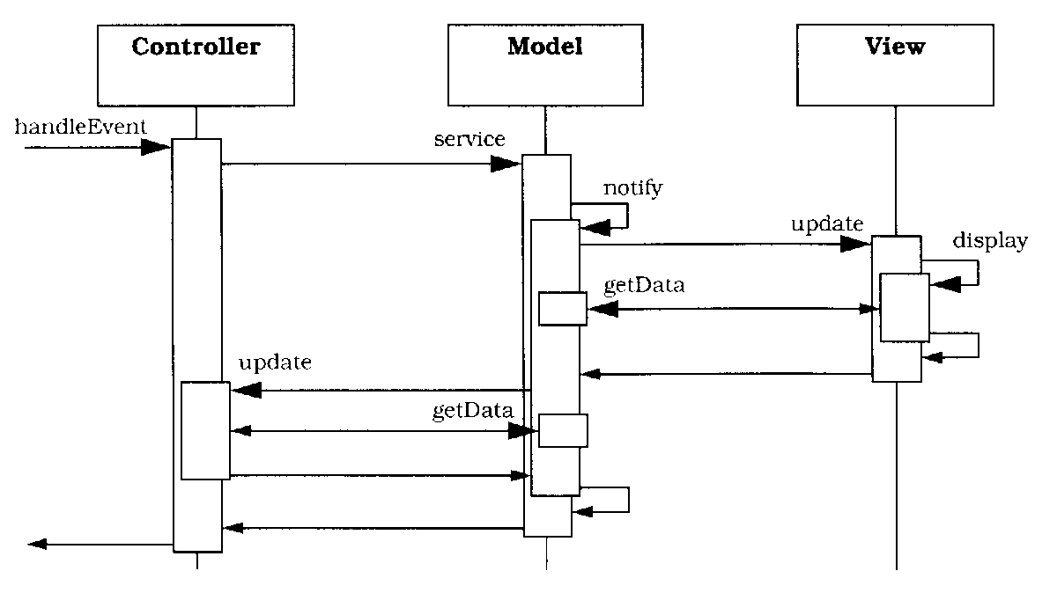
[Buschmann1996]

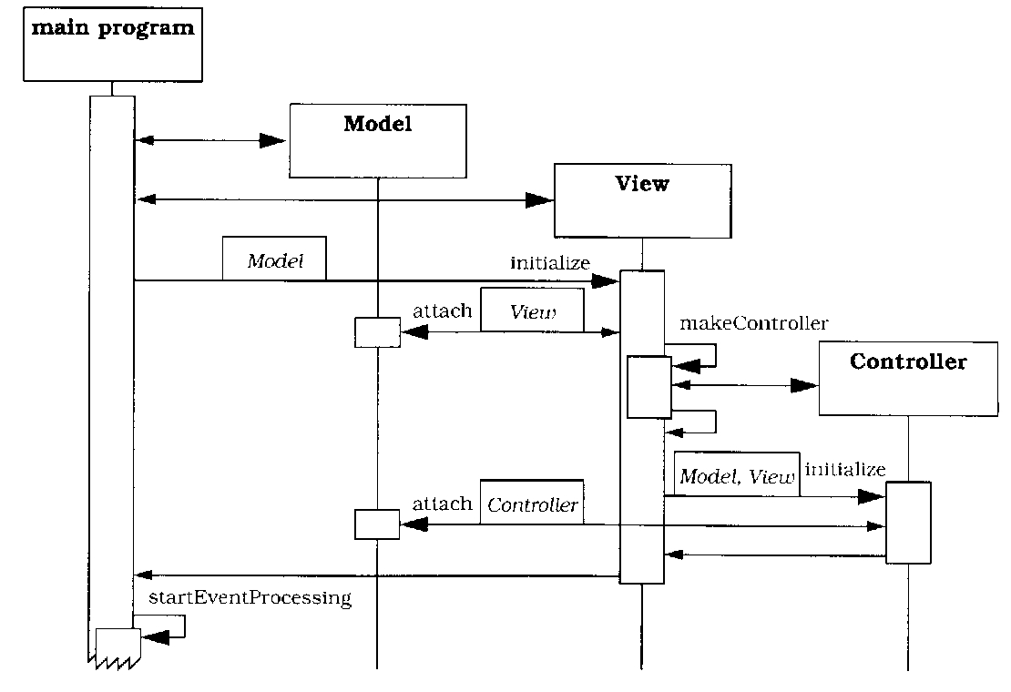
[Buschmann1996]

4.1 Apply MVC to Cerberus

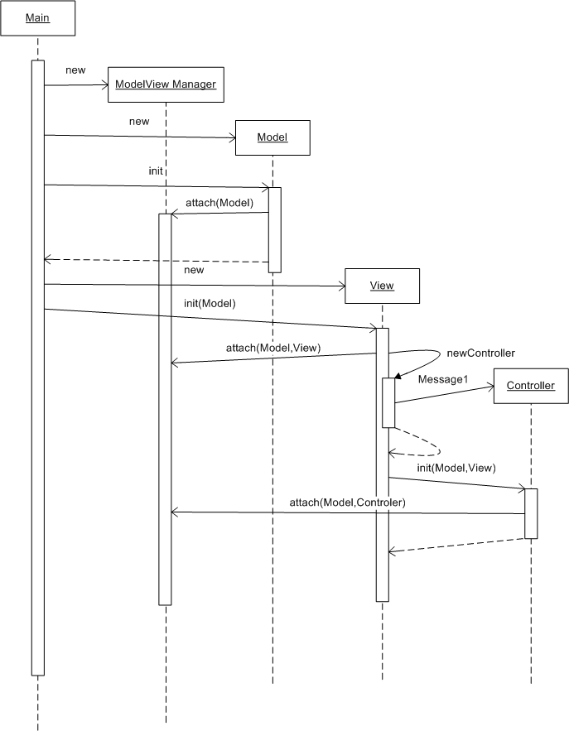
Figure 4.1 Create new Model and View with Controller

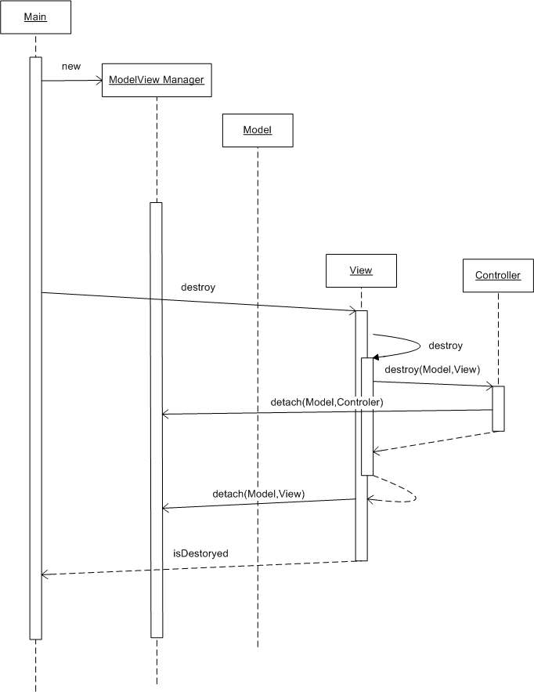
Figure 4.2 destroy / unsubscribe View

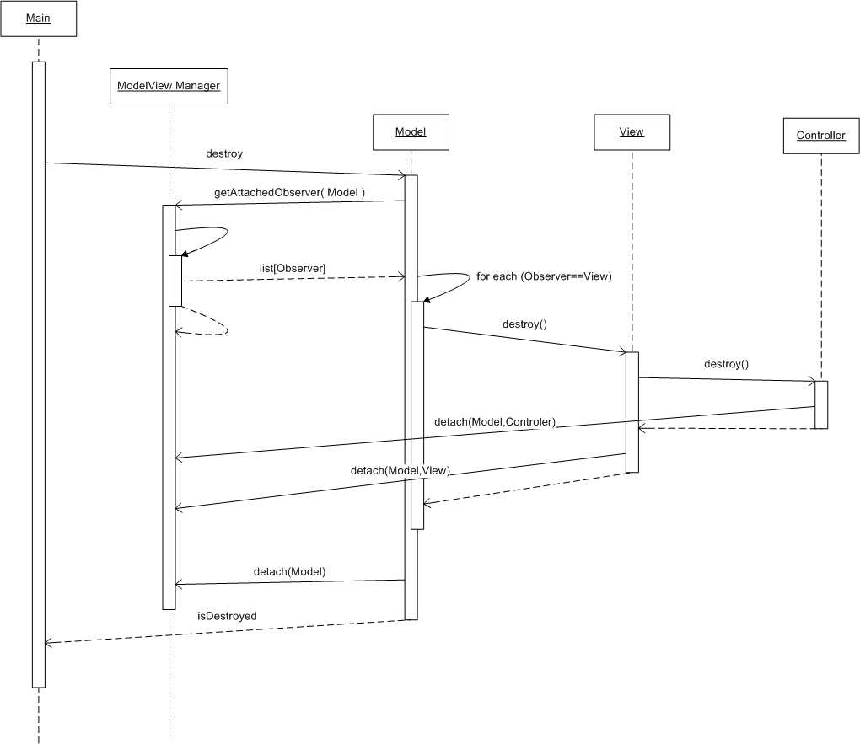
Figure 4.3 destroy / unsubscribe Model with bound View’s and Controller’s

[Buschmann1996]

[Buschmann1996]

[Buschmann1996]

[Buschmann1996]

Memento

[Gamma1995] “Memento” page 354

Memento pattern is used in several ways.
- Memento for Commands
- Memento for Set and Selection (Data)
- Memento for View’s

Basic Memento Pattern:

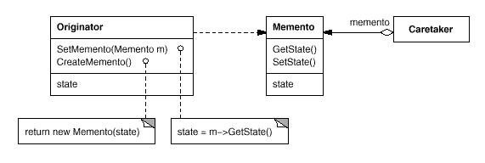

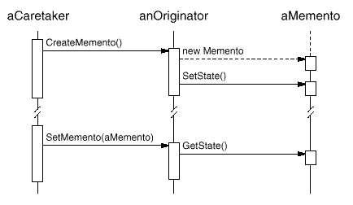

[Gamma1995] “Memento”

Managers

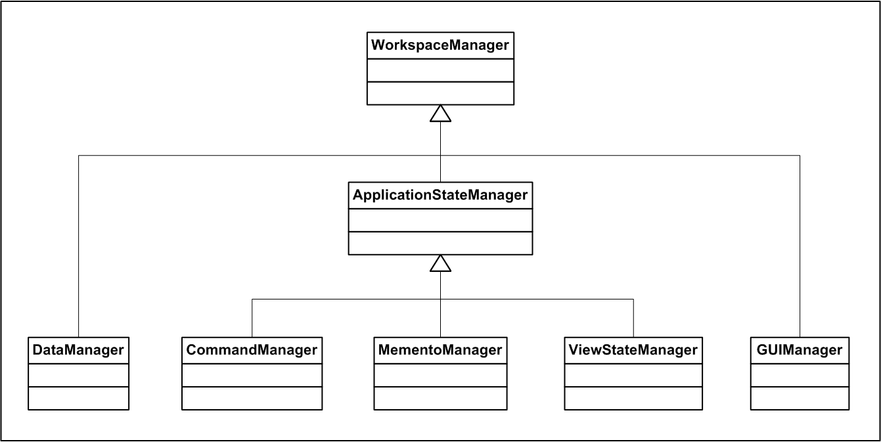
Figure 2.3: Workspace manager

All components are handled by Mangers. This opens the possibility to use Abstract Factories (Design Pattern “Abstract Factory” [Gamma1986] ). Since all above described components are only Interfaces, all components / objects can be created by factories. Design Pattern “Factory”

