Tutorial for
KEGG Online Database

DI Michael Kalkusch
kalkusch@icg.tu-graz.ac.at

Marc Streit
marc.streit@student.tugraz.at

Version 1.1

17th August, 2006

Acknowledgment:

Thanks to Dr. Peter Abuja for his expert knowledge in the area of methabolisms and pathways.

This document was created by Michael Kalkusch after a meeting on 17th August 2006 with Dr. Peter Abuja and Marc Streit.

This document is available at:

http://www.icg.tu-graz.ac.at/research/CGIS/GENVIEW/

Snapshots from KEGG web interface
http://www.genome.jp/kegg/pathway.html visited 17-08-2006

Example: Pathway „Methionine metabolism - Reference pathway „

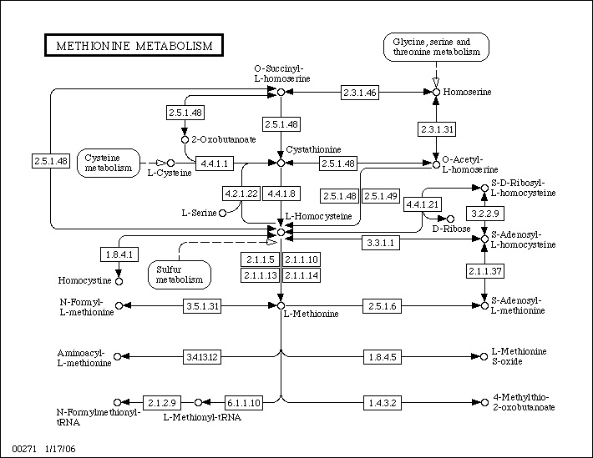
Figure 1

Klick on [2.5.1.48] opens this:

ENZYME: 2.5.1.48
 | Entry
 | Entry |  |  | EC 2.5.1.48 Enzyme
 | Name |  |  |  |  | cystathionine gamma-synthase;  O-succinyl-L-homoserine succinate-lyase (adding cysteine);  O-succinylhomoserine (thiol)-lyase;  homoserine O-transsuccinylase;  O-succinylhomoserine synthase;  O-succinylhomoserine synthetase;  cystathionine synthase;  cystathionine synthetase;  homoserine transsuccinylase
 | Class |  |  |  |  | Transferases  Transferring alkyl or aryl groups, other than methyl groups  Transferring alkyl or aryl groups, other than methyl groups
 | Sysname |  |  |  |  | O4-succinyl-L-homoserine:L-cysteine  S-(3-amino-3-carboxypropyl)transferase
 | Reaction |  |  |  |  | O-succinyl-L-homoserine + L-cysteine = L-cystathionine + succinate  [RN:R00999 R01288 R02508 R03132 R03260 R04944 R04945 R04946]
 | Substrate |  |  |  |  | O-Succinyl-L-homoserine [CPD:C01118];  L-Cysteine [CPD:C00097]
 | Product |  |  |  |  | L-Cystathionine [CPD:C02291];  Succinate [CPD:C00042]
 | Cofactor |  |  |  |  | Pyridoxal phosphate [CPD:C00018]
 | Comment |  |  |  |  | A pyridoxal-phosphate protein. Also reacts with hydrogen sulfide and  methanethiol as replacing agents, producing homocysteine and  methionine, respectively. In the absence of thiol, can also catalyse  beta,gamma-elimination to form 2-oxobutanoate, succinate and  ammonia.
 | Pathway |  |  |  |  | PATH: map00271 Methionine metabolism  PATH: map00272 Cysteine metabolism  PATH: map00450 Selenoamino acid metabolism  PATH: map00920 Sulfur metabolism
 | Ortholog |  |  |  |  | KO: K01739 cystathionine gamma-synthase
 | Genes |  |  |  |  | XLA: 494673(LOC494673)  XTR: 394634(MGC75946)  ATH: At3g01120(T4P13.19)  CME: CMF156C  SCE: YJR130C(STR2) YML082W  AGO: AER164C(AER164Cp)  CAL: orf19.1033(STR2) orf19.7297  SPO: SPBC15D4.09c  CNE: CNC01220  LMA: LmjF35.3230  EHI: 132.t00018 389.t00003 395.t00003  ECO: b3939(metB)  ECJ: JW3910(metB)  ...: reduced the list of 191 gene in total
 | Reference |  |  |  |  | 1 [PMID:5340123]  Flavin M, Slaughter C.  Enzymatic synthesis of homocysteine or methionine directly from  O-succinyl-homoserine.  Biochim. Biophys. Acta. 132 (1967) 400-5.  2 [PMID:5922970]  Kaplan MM, Flavin M.  Cystathionine gamma-synthetase of Salmonella. Catalytic properties  of a new enzyme in bacterial methionine biosynthesis.  J. Biol. Chem. 241 (1966) 4463-71.  3 [PMID:6016326]  Wiebers JL, Garner HR.  Homocysteine and cysteine synthetases of Neurospora crassa.  Purification, properties, and feedback control of activity.  J. Biol. Chem. 242 (1967) 12-23.  4  Wiebers, J.L. and Garner, H.R. Acyl derivatives of homoserine as  substrates for homocysteine synthesis in Neurospora crassa, yeast,  and Escherichia coli. J. Biol. Chem. 242 (1967) 5644-5649.  5 [PMID:9843488]  Clausen T, Huber R, Prade L, Wahl MC, Messerschmidt A.  Crystal structure of Escherichia coli cystathionine gamma-synthase  at 1.5 A resolution.  EMBO. J. 17 (1998) 6827-38.  6 [PMID:9531508]  Ravanel S, Gakiere B, Job D, Douce R.  Cystathionine gamma-synthase from Arabidopsis thaliana: purification  and biochemical characterization of the recombinant enzyme  overexpressed in Escherichia coli.  Biochem. J. 331 ( Pt 2) (1998) 639-48.
Other DBs | IUBMB Enzyme Nomenclature: 2.5.1.48  ExPASy - ENZYME nomenclature database: 2.5.1.48  ERGO genome analysis and discovery system: 2.5.1.48  BRENDA, the Enzyme Database: 2.5.1.48  CAS: 9030-70-0
LinkDB
=> Original format

DBGET integrated database retrieval system, GenomeNet
Figure 2

Klick on pathway „PATH: map00271 Methionine metabolism“ shows this:

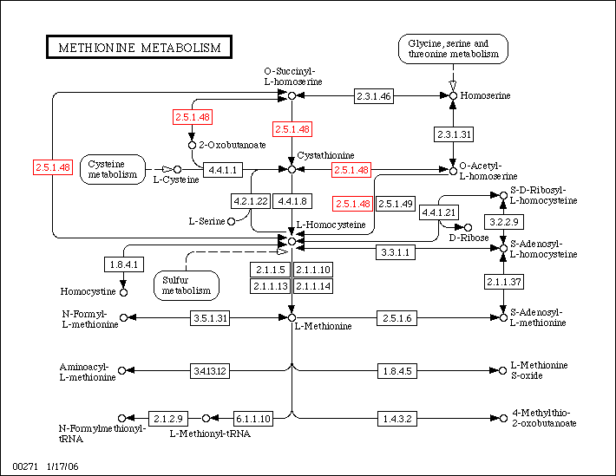
Figure 3

Klick on Cystathionine opens this page:

COMPOUND: C02291
 | Entry
 | Entry |  |  | C02291 Compound
 | Name |  |  |  |  | L-Cystathionine
 | Formula |  |  |  |  | C7H14N2O4S
 | Mass |  |  |  |  | 222.0674
 | Structure
 | Reaction |  |  |  |  | R01001 R01286 R01290 R03217 R03260
 | Pathway |  |  |  |  | PATH: map00260 Glycine, serine and threonine metabolism  PATH: map00271 Methionine metabolism
 | Enzyme |  |  |  |  | 2.5.1.48 2.5.1.49 4.2.1.22 4.4.1.1  4.4.1.8
 | Other DBs |  |  |  |  | CAS: 56-88-2  PubChem: 5347  ChEBI: 17482
 | LinkDB
 | KCF data
=> Original format

DBGET integrated database retrieval system, GenomeNet
Figure 4

Example for a reaction:

REACTION: R00999
 | Entry
 | Entry |  |  | R00999 Reaction
 | Name |  |  |  |  | O-Succinyl-L-homoserine succinate-lyase (adding cysteine)
 | Definition |  |  |  |  | O-Succinyl-L-homoserine + H2O <=> 2-Oxobutanoate + Succinate + NH3
 | Equation |  |  |  |  | C01118 + C00001 <=> C00109 + C00042 + C00014
 | RPair |  |  |  |  | RP: A00132 C00042_C01118 main  RP: A01229 C00109_C01118 main
 | Pathway |  |  |  |  | PATH: rn00271 Methionine metabolism
 | Enzyme |  |  |  |  | 2.5.1.48
 | Ortholog |  |  |  |  | KO: K01739 cystathionine gamma-synthase
 | LinkDB
=> Original format

DBGET integrated database retrieval system, GenomeNet

Figure 5

Flow Charts:

Enzyme:
ENZYME
cofactor
substrate
result
Figure 6

Regulation of enzymes and metabolism
Figure 7

Concepts:

- Inside pathway: 2 step, 3 step relations inside the graph fram a given Protein or Methabolit
- Take connectivity of methabolit into account (i.e. google principle)
- Use connectivity of methabolit as wight for its importance inside pathways
(Spring mass modell / Graviation modell)
- Interrelations/ interaction:
  - Kinase ==> Protein
  - Protein <==> Protein interrelations
- Visualize flows from:
Substrate ==>
(Enzyme/ Protein) <-- using cofactor ==>
Methabolit A ==>
(Enyzm / Protein) ==>
Methabolit B
A possibility here could be the application of Petri-Nets (http://en.wikipedia.org/wiki/Petri_net)

- Semantic Zooming:
  - hide / show methabolits
  - collapse protein chains
  - collapse pathway inside another pathway
  - magic lense for sematic zooming

- Messure activity of Methabolids:
required for detailed analysis, but not done within Micro Array analysis
- Position of enzyme inside cell
- Compartments the enzyme is present in
- Handle enzyme casscades ==> if top element of enzyme-casscade is active, the casscade might be active to. Thus only the result of the casscade is active, but not its intermediate enzyms.

- Important fields of „Enzymes“ in KEEG (see figure 2):
Entry: unique international standardized identifyier
Name: known names for this molecule and aliases for it
Reaction: chemical reaction
Substrate: Input to the Enzyme
Product: Output of the Enzyme
Cofactor: if set, it is nesseccary to activate the Enzyme
Pathway: shows only active pathways linked to one Enzyme but not pathways influenced by this enzyme!
Ortholog: special genes (see glossary)
Genes: ???
- Important fields of „Compounds“ in KEGG (see figure 4):
Entry: unique code (used by KEGG? Only or also international unique?)
Name: known names for this molecule and aliases for it
Mass: mass of this molecule (mass unit?)
Structur: chemical structure of thie molecule
Reaction: chemical reaction, were this compound is part of
Pathway: list of active pathways, were this compound can be found
Enzyme: list of enzymes capeable of handling this compound, either as input or as output; also know as „Substrate“ and „Product“
- Important fields of „Reaction“ in KEGG (see figure 5):
Entry: unique name (probably only in KEGG)
Name: name that defines this reaction
Definition: define this reaction
Equation: link to compunds of this reaction
Rpair: ??
Pathway: list of pathways were this reaction is part of
Enzyme: list of enzymes that do this reaction
Ortholog: special genes (see glossary)

Other databases aside from KEGG:

(suggested by Dr. Abuja)
Biomodal DB: http://www.ebi.ac.uk/biomodals/

Reactome „A curated knowledgebase of biological pathways“ http://www.reactome.org/

Brookhaven Protein Database http://cds.dl.ac.uk/cds/pdb.html
for structure of enzymes

EMBL „European Molecular Biology Laboratoy“ http://www.embl.org/
EMBO „European Molecular Biology Organization“ http://www.embo.org/

Other important websites:

RCSB „Research Collaboratory for Structural Bioinformatics “ http://home.rcsb.org/

RCSB PDB Protein Data Base http://www.rcsb.org/pdb/

Software we should look at:

- „Panther“ (Applied Biosoftware)
- google: „Pathway“ as well as „Pathway Heatmap“

Books:

David Fell, „Regulation of Metabolism“ („Kinetische Regulation“)

Homepage of David Fell:

http://www.brookes.ac.uk/bms/research/fell.html

Glossary:
Term | Description | Link
Substrate | a molecule upon which an enzyme acts. Enzymes catalyze chemical reactions involving the substrate(s). | http://en.wikipedia.org/wiki/Substrate_(biochemistry)
Kinase | a type of enzyme that transfers phosphate groups from high-energy donor molecules, such as ATP, to specific target molecules (substrates); the process is termed phosphorylation. | http://en.wikipedia.org/wiki/Kinase
Inhibitor | ???
Effektor | ???
Kinetische Regulation | ???
EC-Number | Enzyme Commission number (EC number) | http://en.wikipedia.org/wiki/EC_number
Homocysteine |  | http://en.wikipedia.org/wiki/Homocysteine
Ortholog | Orthologs are genes in different species which evolved from a common ancestral gene. | http://en.wikipedia.org/wiki/Ortholog

