http://www.genome.jp/brite/bconv/ncbi-gi_hsa.equ

ncbi-gi:100017706 hsa:2158

KEGG:
http://www.genome.jp/kegg/genes.html
[NCBI_gi] ==> „100017706“ ==>
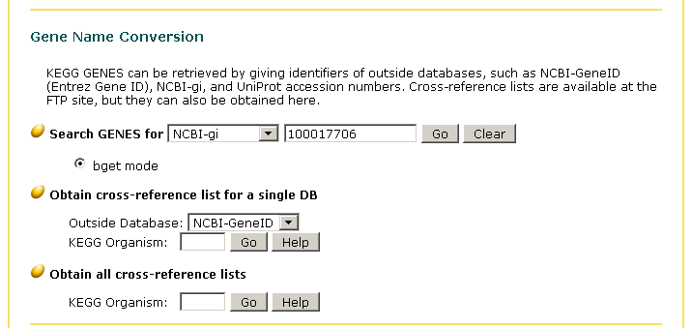
http://www.genome.jp/dbget-bin/www_bget?hsa:2158

KEGG-ID (Entry) „hsa:2158“ or „2158“
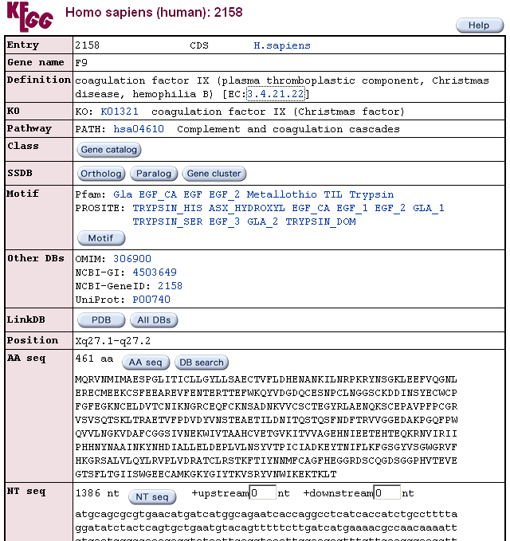

==> Link to Enzym: [EC:3.4.21.22]
==> Pathway: PATH: hsa04610

http://www.ncbi.nlm.nih.gov/entrez/query.fcgi?db=Protein&cmd=search&term=100017706

ncbi-gi: 100017706 ==> 100017706 ==>

http://www.ncbi.nlm.nih.gov/entrez/viewer.fcgi?db=protein&val=100017706

ACCESSION ABF68963
VERSION: ABF68963.1 GI:100017706

ftp://ftp.ncbi.nlm.nih.gov/gene/DATA/

List of several mappings of ID's

