Tutorial for
KEGG Online Database

DI Michael Kalkusch
kalkusch@icg.tu-graz.ac.at

Version 1.2

September 20th , 2006

Acknowledgment:

Thanks to Dr. Peter Abuja for his expert knowledge in the area of metabolisms and pathways.

This document was created by Michael Kalkusch after a meeting on August 17th 2006 with Dr.Abuja and Marc Streit. Thanks to Marc Streit for his contribution during the initial creation of this document.

The document was update 20th September,2006 by Michael Kalkusch after a meeting with Dr. Abuja.

This document will be available at:

http://www.icg.tu-graz.ac.at/research/CGIS/GENVIEW/

Snapshots from KEGG web interface
http://www.genome.jp/kegg/pathway.html visited 17-08-2006

Example: Pathway „metionine metabolism - Reference pathway „

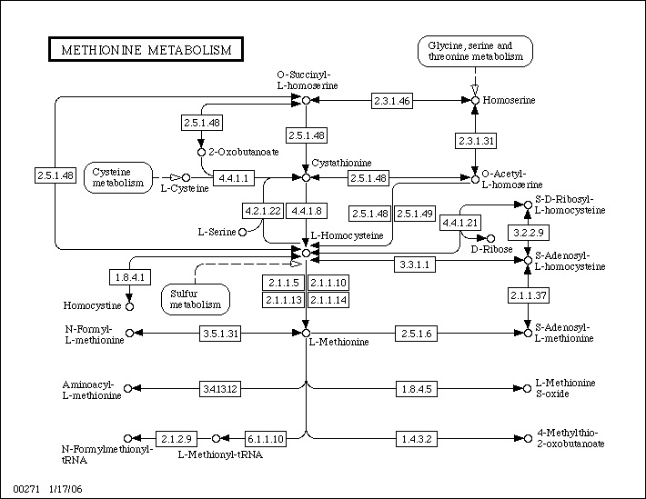Figure 1:
Klick on [2.5.1.48] opens this:

ENZYME: 2.5.1.48
 | Entry
 | Entry |  |  | EC 2.5.1.48 Enzyme
 | Name |  |  |  |  | cystathionine gamma-synthase;  O-succinyl-L-homoserine succinate-lyase (adding cysteine);  O-succinylhomoserine (thiol)-lyase;  homoserine O-transsuccinylase;  O-succinylhomoserine synthase;  O-succinylhomoserine synthetase;  cystathionine synthase;  cystathionine synthetase;  homoserine transsuccinylase
 | Class |  |  |  |  | Transferases  Transferring alkyl or aryl groups, other than methyl groups  Transferring alkyl or aryl groups, other than methyl groups
 | Sysname |  |  |  |  | O4-succinyl-L-homoserine:L-cysteine  S-(3-amino-3-carboxypropyl)transferase
 | Reaction |  |  |  |  | O-succinyl-L-homoserine + L-cysteine = L-cystathionine + succinate  [RN:R00999 R01288 R02508 R03132 R03260 R04944 R04945 R04946]
 | Substrate |  |  |  |  | O-Succinyl-L-homoserine [CPD:C01118];  L-Cysteine [CPD:C00097]
 | Product |  |  |  |  | L-Cystathionine [CPD:C02291];  Succinate [CPD:C00042]
 | Cofactor |  |  |  |  | Pyridoxal phosphate [CPD:C00018]
 | Comment |  |  |  |  | A pyridoxal-phosphate protein. Also reacts with hydrogen sulfide and  methanethiol as replacing agents, producing homocysteine and  methionine, respectively. In the absence of thiol, can also catalyse  beta,gamma-elimination to form 2-oxobutanoate, succinate and  ammonia.
 | Pathway |  |  |  |  | PATH: map00271 Methionine metabolism  PATH: map00272 Cysteine metabolism  PATH: map00450 Selenoamino acid metabolism  PATH: map00920 Sulfur metabolism
 | Ortholog |  |  |  |  | KO: K01739 cystathionine gamma-synthase
 | Genes |  |  |  |  | XLA: 494673(LOC494673)  XTR: 394634(MGC75946)  ATH: At3g01120(T4P13.19)  CME: CMF156C  SCE: YJR130C(STR2) YML082W  AGO: AER164C(AER164Cp)  CAL: orf19.1033(STR2) orf19.7297  SPO: SPBC15D4.09c  CNE: CNC01220  LMA: LmjF35.3230  EHI: 132.t00018 389.t00003 395.t00003  ECO: b3939(metB)  ECJ: JW3910(metB)  ...: reduced the list of 191 gene in total
 | Reference |  |  |  |  | 1 [PMID:5340123]  Flavin M, Slaughter C.  Enzymatic synthesis of homocysteine or methionine directly from  O-succinyl-homoserine.  Biochim. Biophys. Acta. 132 (1967) 400-5.  2 [PMID:5922970]  Kaplan MM, Flavin M.  Cystathionine gamma-synthetase of Salmonella. Catalytic properties  of a new enzyme in bacterial methionine biosynthesis.  J. Biol. Chem. 241 (1966) 4463-71.  3 [PMID:6016326]  Wiebers JL, Garner HR.  Homocysteine and cysteine synthetases of Neurospora crassa.  Purification, properties, and feedback control of activity.  J. Biol. Chem. 242 (1967) 12-23.  4  Wiebers, J.L. and Garner, H.R. Acyl derivatives of homoserine as  substrates for homocysteine synthesis in Neurospora crassa, yeast,  and Escherichia coli. J. Biol. Chem. 242 (1967) 5644-5649.  5 [PMID:9843488]  Clausen T, Huber R, Prade L, Wahl MC, Messerschmidt A.  Crystal structure of Escherichia coli cystathionine gamma-synthase  at 1.5 A resolution.  EMBO. J. 17 (1998) 6827-38.  6 [PMID:9531508]  Ravanel S, Gakiere B, Job D, Douce R.  Cystathionine gamma-synthase from Arabidopsis thaliana: purification  and biochemical characterization of the recombinant enzyme  overexpressed in Escherichia coli.  Biochem. J. 331 ( Pt 2) (1998) 639-48.
Other DBs | IUBMB Enzyme Nomenclature: 2.5.1.48  ExPASy - ENZYME nomenclature database: 2.5.1.48  ERGO genome analysis and discovery system: 2.5.1.48  BRENDA, the Enzyme Database: 2.5.1.48  CAS: 9030-70-0
LinkDB
=> Original format

DBGET integrated database retrieval system, GenomeNet
Table 1

Klick on pathway „PATH: map00271 metionine metabolism“ shows this:

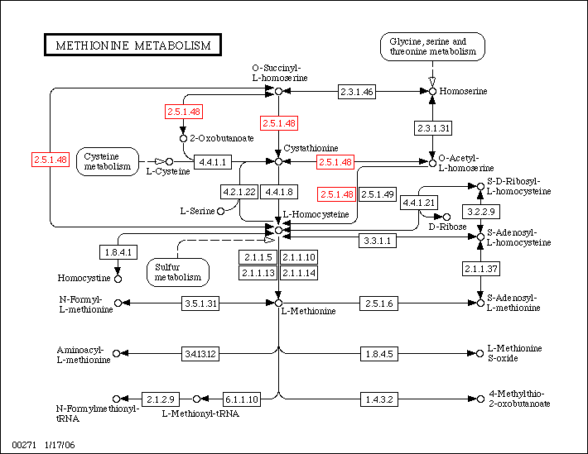Figure 2:

Klick on Cystathionine opens this page:

COMPOUND: C02291
 | Entry
 | Entry |  |  | C02291 Compound
 | Name |  |  |  |  | L-Cystathionine
 | Formula |  |  |  |  | C7H14N2O4S
 | Mass |  |  |  |  | 222.0674
 | Structure
 | Reaction |  |  |  |  | R01001 R01286 R01290 R03217 R03260
 | Pathway |  |  |  |  | PATH: map00260 Glycine, serine and threonine metabolism  PATH: map00271 Methionine metabolism
 | Enzyme |  |  |  |  | 2.5.1.48 2.5.1.49 4.2.1.22 4.4.1.1  4.4.1.8
 | Other DBs |  |  |  |  | CAS: 56-88-2  PubChem: 5347  ChEBI: 17482
 | LinkDB
 | KCF data
=> Original format

DBGET integrated database retrieval system, GenomeNet
Table 2

Example for a reaction:

REACTION: R00999
 | Entry
 | Entry |  |  | R00999 Reaction
 | Name |  |  |  |  | O-Succinyl-L-homoserine succinate-lyase (adding cysteine)
 | Definition |  |  |  |  | O-Succinyl-L-homoserine + H2O <=> 2-Oxobutanoate + Succinate + NH3
 | Equation |  |  |  |  | C01118 + C00001 <=> C00109 + C00042 + C00014
 | RPair |  |  |  |  | RP: A00132 C00042_C01118 main  RP: A01229 C00109_C01118 main
 | Pathway |  |  |  |  | PATH: rn00271 Methionine metabolism
 | Enzyme |  |  |  |  | 2.5.1.48
 | Ortholog |  |  |  |  | KO: K01739 cystathionine gamma-synthase
 | LinkDB
=> Original format

DBGET integrated database retrieval system, GenomeNet
Table 3

Flow Charts:
Figure 3: Basic graph with metabilite and enzyme regulated by cofactor
ENZYME
substrate
product
cofactor
metabolite
metabolite

Regulation of enzymes and metabolites
Figure 4: Simple network of metabolites showing activity of enzmyes
ENZYME - A
metabolite
ENZYME - B
ENZYME - C
.... metabolite
.... activity
.... enzyme
Figure 5: Exdented model of pathway
ENZYME
substrate
product
cofactor
metabolite
metabolite
may act as
influence
ATP
ADP
.... metabolite
.... activity
.... enzyme
.... energy

Figure 6: Interrelationship of mRNA, protein, enzyme and metabolism

Figure 7: Two metabolits and two enzymes form a switch, that consumes energy

Concepts:

- Inside pathway: 2 step, 3 step relations inside the graph fram a given Protein or metabolit
- Take connectivity of metabolit into account (i.e. google principle)
- Use connectivity of metabolit as wight for its importance inside pathways
(Spring mass modell / Graviation modell)
- Interrelations/ interaction:
  - Kinase ==> Protein
  - Protein <==> Protein interrelations
- Visualize flows from:
Substrate ==>
(Enzyme/ Protein) <-- using cofactor ==>
metabolit A ==>
(Enyzm / Protein) ==>
metabolit B
A possibility here could be the application of Petri-Nets (http://en.wikipedia.org/wiki/Petri_net)

- Semantic Zooming:
  - hide / show metabolits
  - collapse protein chains
  - collapse pathway inside another pathway
  - magic lense for sematic zooming

- Messure activity of metabolids:
required for detailed analysis, but not done within Micro Array analysis
- Position of enzyme inside cell
- Compartments the enzyme is present in
- Handle enzyme casscades ==> if top element of enzyme-casscade is active, the casscade might be active to. Thus only the result of the casscade is active, but not its intermediate enzyms.

- Important fields of „Enzymes“ in KEEG (see table 1):
Entry: unique international standardized identifyier
Name: known names for this molecule and aliases for it
Reaction: chemical reaction
Substrate: Input to the Enzyme
Product: Output of the Enzyme
Cofactor: if set, it is nesseccary to activate the Enzyme
Pathway: shows only active pathways linked to one Enzyme but not pathways influenced by this enzyme!
Ortholog: special genes (see glossary)
Genes: ???
- Important fields of „Compounds“ in KEGG (see table 2):
Entry: unique code (used by KEGG? Only or also international unique?)
Name: known names for this molecule and aliases for it
Mass: mass of this molecule (mass unit?)
Structur: chemical structure of thie molecule
Reaction: chemical reaction, were this compound is part of
Pathway: list of active pathways, were this compound can be found
Enzyme: list of enzymes capeable of handling this compound, either as input or as output; also know as „Substrate“ and „Product“
- Important fields of „Reaction“ in KEGG (see table 3):
Entry: unique name (probably only in KEGG)
Name: name that defines this reaction
Definition: define this reaction
Equation: link to compunds of this reaction
Rpair: ??
Pathway: list of pathways were this reaction is part of
Enzyme: list of enzymes that do this reaction
Ortholog: special genes (see glossary)

Other databases aside from KEGG:

(suggested by Dr. Abuja)
Biomodal DB: http://www.ebi.ac.uk/biomodals/

Reactome „A curated knowledgebase of biological pathways“ http://www.reactome.org/

Brookhaven Protein Database http://cds.dl.ac.uk/cds/pdb.html
for structure of enzymes

EMBL „European Molecular Biology Laboratoy“ http://www.embl.org/
EMBO „European Molecular Biology Organization“ http://www.embo.org/

SMBL „Systems Biology Markup Language“ http://sbml.org/

Other important websites:

RCSB „Research Collaboratory for Structural Bioinformatics “ http://home.rcsb.org/

RCSB PDB Protein Data Base http://www.rcsb.org/pdb/

Software we should look at:

- „Panther“ (Applied Biosoftware)
- google: „Pathway“ as well as „Pathway Heatmap“

Books:

David Fell, „Regulation of Metabolism“ („Kinetische Regulation“)

Homepage of David Fell:

http://www.brookes.ac.uk/bms/research/fell.html

Glossary:
Term | Description | Link
Substrate | a molecule upon which an enzyme acts. Enzymes catalyze chemical reactions involving the substrate(s). | http://en.wikipedia.org/wiki/Substrate_(biochemistry)
Kinase | a type of enzyme that transfers phosphate groups from high-energy donor molecules, such as ATP, to specific target molecules (substrates); the process is termed phosphorylation. | http://en.wikipedia.org/wiki/Kinase
Inhibitor | ???
Effektor | ???
Kinetische Regulation | ???
EC-Number | Enzyme Commission number (EC number) | http://en.wikipedia.org/wiki/EC_number
Homocysteine |  | http://en.wikipedia.org/wiki/Homocysteine
Ortholog | Orthologs are genes in different species which evolved from a common ancestral gene. | http://en.wikipedia.org/wiki/Ortholog
Proteomics |  | http://en.wikipedia.org/wiki/Proteomics
Metabolomics |  | http://en.wikipedia.org/wiki/Metabolomics
mRNA | Messenger RNA, transcribed DNA that leaves the cell core.  A ribosom transcribed the mRNA to a Protein. | http://en.wikipedia.org/wiki/MRNA
Nucleotide | A,G,T,C (U=T)  Adenosine  Guanin  Thymidine (DNA only)  Cytidne  Urdine (RNA only) = T | http://en.wikipedia.org/wiki/Nucleotide
Codon | Group of three Nucleotides.  A ribosom translates Codons of the mRNA to amino acids, that are linked to gethe to form a protein. | http://en.wikipedia.org/wiki/Codon
Amino acids | Amino acids build a Protein. | http://en.wikipedia.org/wiki/List_of_standard_amino_acids
Ribosom | Translates the mRNA to a Protein by reading Codons and translating them to amion acids, that are linked together forming the protein | http://en.wikipedia.org/wiki/Ribosome

