Variance is the average squared deviations from the mean, while standard deviation is the square root of this number. Both measures reflect variability in a distribution, but how they are calculated, interpreted and units differ. Variance gives an idea of how much the data points differ from the mean, but because it squares these differences, the units of variance are not the same as the units of the original data. Standard deviation is expressed in the same units as the original data showing how much data points deviate from the mean. Standard deviation is often preferred for interpretation, while variance is more commonly used in statistical analysis and theory.

Variance formula:

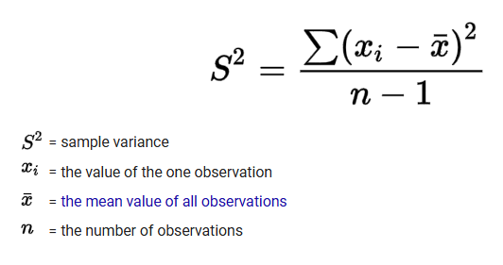

Standard deviation formula:

